AGRICULTURE
FORM 4
Answer all questions
- Define egg candling as used in poultry production (1mk)

- State four conditions necessary for artificial incubation (2mks)

- Highlight any five advantages of battery cage system in poultry production (5mks)

- State any two causes of stress in poultry and for each give a control measures (2mks)

- State the different ways of controlling cannibalism among layers in deep litter system (4mks)

- What qualities should eggs meant for incubation meet in poultry production? (3mks)

- a) What is colostrum (¹/₂mk)

b) Give four qualities of colostrum that make it suitable for new born calves (2mks)

c) State the components of artificial colostrum (2mks)

- State the characteristics of clean and high quality milk(2mks)

- State four factors that determine the quality of hay ( 2mks)

- The diagram below shows the structure of the udder, study it and answer the questions that follow
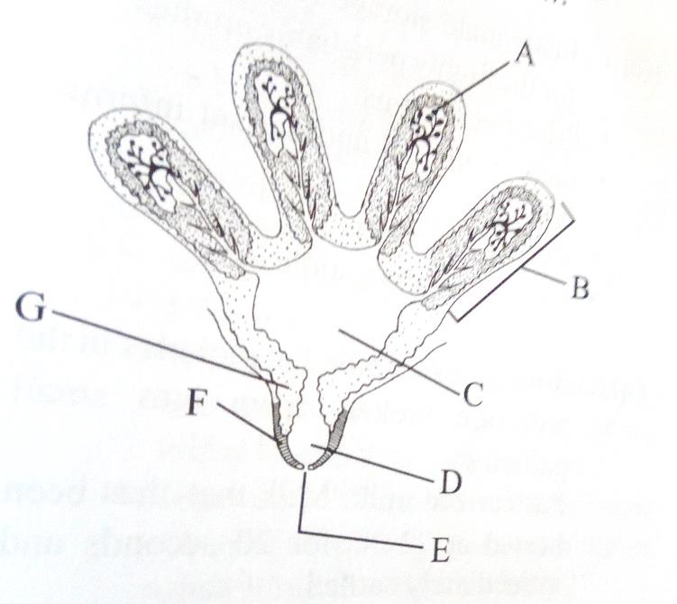
- State the parts labeled A, B, C, D, E, F (3mks)

- In which of the labeled parts does secretion take place ( 1mk)

- Name the two hormones that control milk secretion (1mk)

- For how long should milking process take? (1mk)

- Give a reason for your answer in (d) above (1mk)

- State two precautions observed in harvesting of tea (2mks)

- State two ways of weed control in rice production (1mk)

- Name three methods of conserving silage( 1¹/₂mks)

- State any four bacterial diseases affecting livestock (2mks)

- Explain five requirements of a good calf pen (5mks)

- a) Define layering in crop production (1mk)
- Name four methods of layering (2mks)

- A dairy farmer wanted to prepare 1000kg of a calf ration containing 20% DCP. The feedstuffs available were maize (10% DCP) and Sunflower (35% DCP). Using Pearson Square method, calculate the amount of each of the rearing ration ( 3mks)

