OPENER EXAMINATION YEAR 2021 TERM 2
NAME:………………………………………………………………….CLASS:…………..ADM NO:..…
AGRICULTURE
FORM 1

70MKS

INSTRUCTIONS

Answer all the questions in the spaces provided.

- Differentiate between floriculture and olericulture. (2mks)

- State three characteristics of large scale farming system. (3mks)

- List three methods of farming. (3mks)

- State five ways in which agriculture has contributed to the economic development of Kenya. (5mks)

- State four human factors influencing Agriculture. (4mks)

- State how each of the following factors affects Agriculture. (6mks)
- Decomposers

- Pollinators

- Parasites

- State three main aspects of light that are important to crop growth. (3mks)

- List four factors influencing soil formation. (4mks)

- The diagram below represents a soil profile. Study it and answer questions that follow.

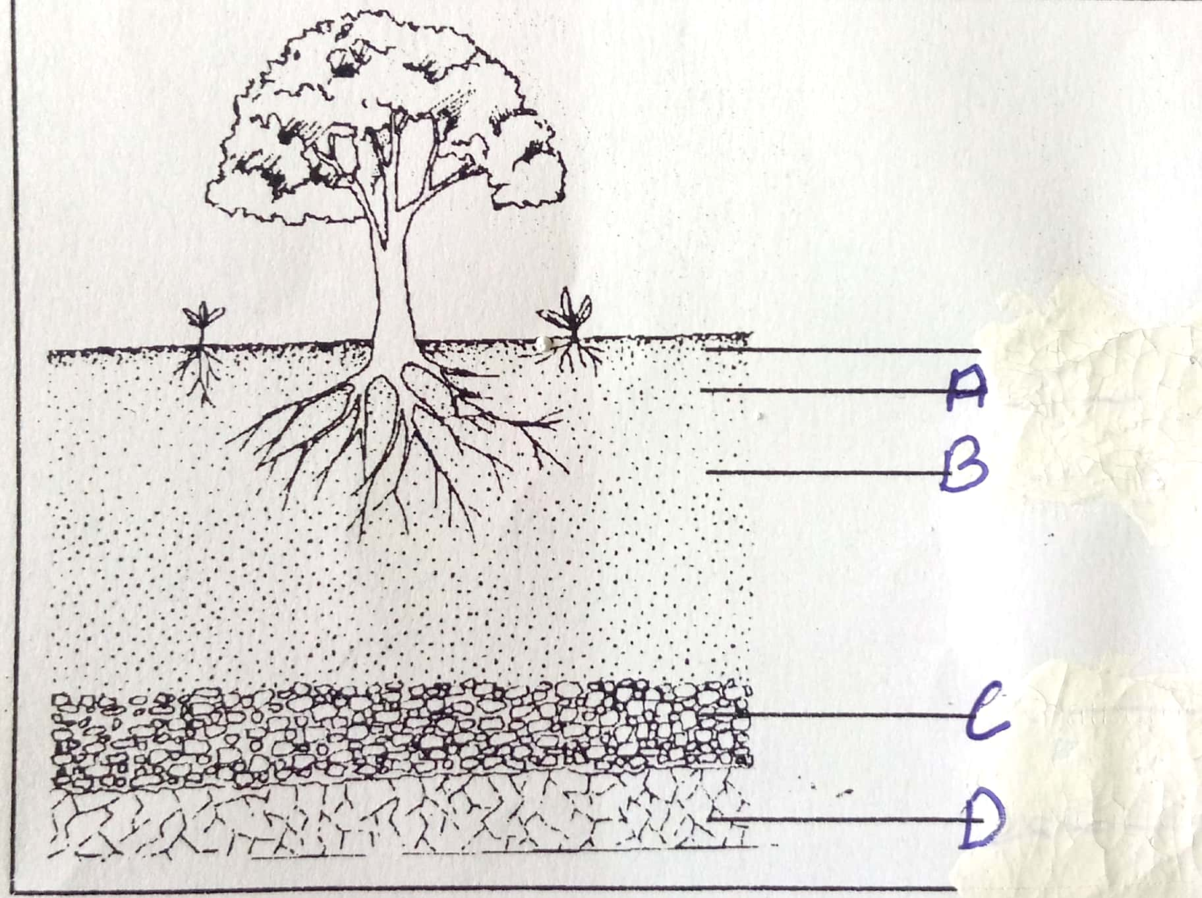

- Name the horizons. (4mks)
A
B
C
D
- Give two characteristics of horizon A. (2mks)

- State two effects of hard pans. (2mks)

- List four soil constituents. (4mks)

- Outline three types of soil structures. (3mks)

- Give two characteristics of clay soils. (2mks)

- The set-up below illustrates an experiment to study a certain physical aspect of different types of soils. Study it and answer questions that follow.

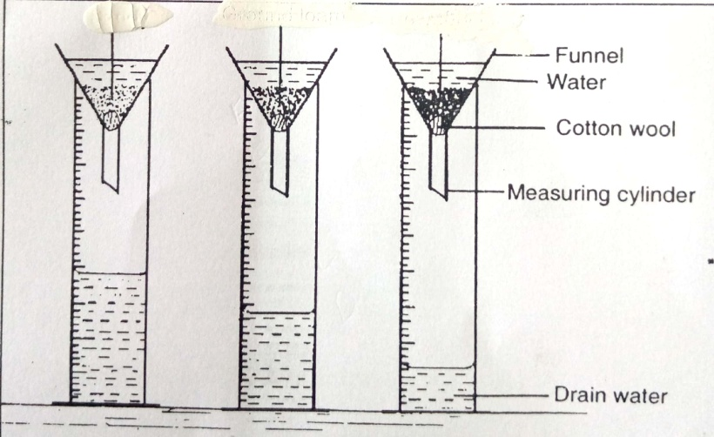
R
Q
P

- Name soils: (3mks)
P
Q
R
- What was the aim of the experiment? (1mk)

- How can the structure of soil P be improved? (1mk)

- State two ways by which soil of pH3 can be raised to a pH of 6. (2mks)

- Give four effects of high temperature in crop production. (4mks)

- List four physical agents of weathering. (4mks)

- State five categories at farm tools and equipment. (5mks)

- State three maintance practices of a wheelbarrow. (3mks)

