COMPETENCE BASED ASSESMENT
GRADE 3 YEAR 2020
(MONITORING LEARNERS PROGRESS)
MOVEMENT ACTIVITIES TIME:
NAME:
LEARNER UPI: GENDER: BOY GIRL
No. of questions correct
Performance level

SCHOOL NAME

- We wear ______________uniform when playing. (sports, school)
- We skip using a ________________ (rope, log)
Name 3 body parts involved in skipping

- What shape can you make while skipping? __________________
- ______________ is a locomotor movement in which there is a combination of a step and a leap. (leaping, Galloping)
- Draw yourself skipping in a circle

- We use our _____________ to record video of our movement activities. (radio, tablets)
Study the picture below and answer questions that follow
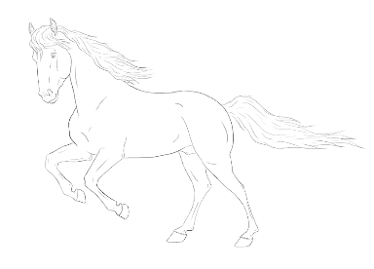
- What is the name of the animal

- What skill does the animal demonstrate?

(leaping, galloping)
- When do people use the skill?

(jumping over mud, walking)

Study the picture of the animal below and answer questions that follow.
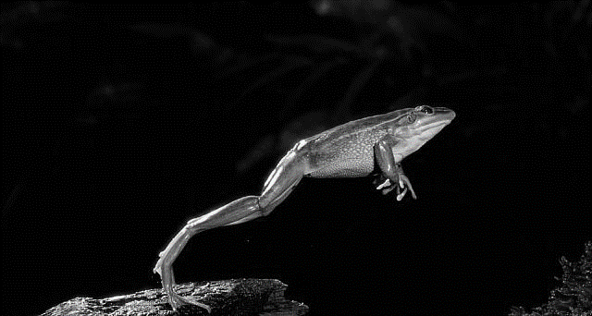

- Name the animal

- What skill does the animal show?

- We ____________ to avoid being hit by objects. (dodge, hop)

