ST. AUGUSTINE MUKUMU BOYS’ PRIMARY
HYGIENE & NUTRITION
GRADE 3 END TERM EXAM TERM 1 2019

- The things we do to keep our bodies healthy and well are known as ________ (good manners, healthy habits)
- Dirty clothes can make us smell ___________ (bad, good).
- Drinking dirty water can make us _________________ (sick, healthy)
- Sitting in the wrong posture can make our backs feel _____________ (good, pain)
- Taking enough rest is ________________ It gives us more energy and we remain healthy. (good, bad)
- Ensure you ___________ your teeth at least two times a day. (brush, remove).
- It is good to __________________ your tooth when it becomes loose. This will help them grow in line. (remove, hide).
- A ______________ is a doctor who treats our teeth when they have problems. (dentist, teacher)
- A person should sleep at least _____________ hours daily (2, 8,5,)
- We should open windows to allow in _________ (mud, water, air)
- Mosquitoes spread _______________ (malaria, typhoid)
- Always stay in a _____________classroom. (dirty, wet, clean)
- Dirty classrooms may attract __________ which carry germs. (bees, flies, butterfly)
- We learn ______________ in a clean classroom (badly, well)
- We put collected rubbish in the ________________ (desk, dustbin)
- We use a ________________ to wipe desks and the teacher’s table. (cloth, mop).
- After the floor dries, we _____________ the desks neatly. (arrange, leave)
- We empty the dustbin into a __________________ (toilet, rubbish pit)
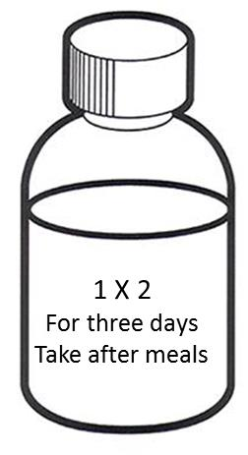

- How many times in a day should the medicine be taken? _____________ (1,2,3)
- For how many days should the medicine be taken? _____________ (two, three, four)
- Is the medicine taken before eating or after eating? _____________ (before, after)
- To kill germs we should __________________ water (boil, play, mix).
- You should wash your _____________before and after eating (face, hands, feet).
- Filtering water removes _________________ (germs, dirt)
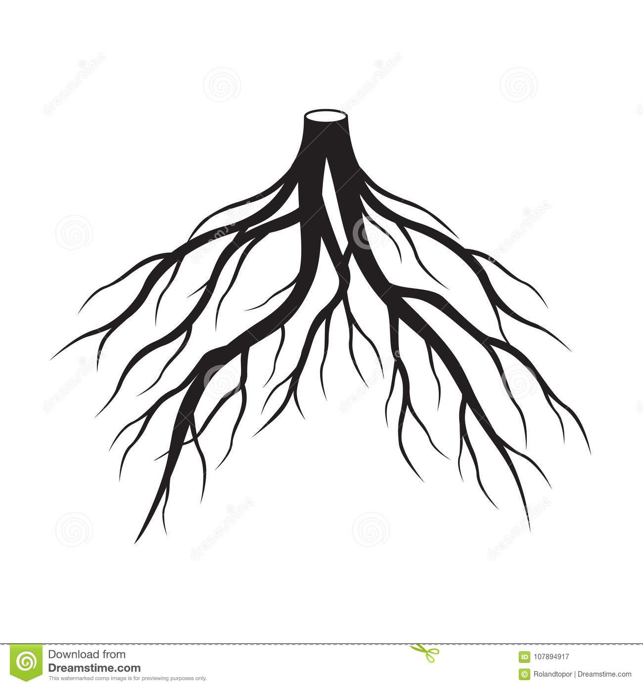

This part of a plant is known as _______________ (flower, root, fruit).
- Dirty feet will keep __________________ (lice, ticks, jiggers)
- Hygiene is the rule of ____________ (first aid, cleanliness, walking)
- We wear _____________ clothes when it is sunny (heavy, light)
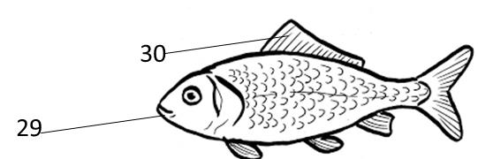
Name the parts

(eye, mouth, gills, tail)

