**ST. AUGUSTINE MUKUMU BOYS’ PRIMARY**

**ENVIRONMENTAL ACTIVITIES**

**GRADE 3 END TERM EXAM TERM 1 2019**

1. ___________ can cause fire ( sun, gas)

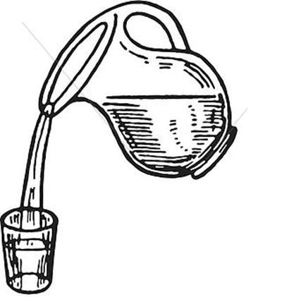

1. The process of making water safe is called ____________ (filtering, decantation)
2. A leaking gas causes __________ (shock, explosion)
3. A _______________________ gives us security (cat, dog)
4. __________________________ participates in sports (horse, donkey)





This is a _______________ (glove, hand)

1. A __________________ is an edible plant

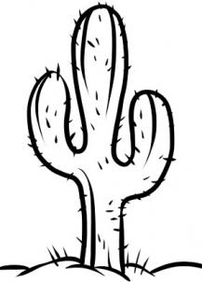

1. This is a ______________ (sisal, cactus)
2. The plants that we do not eat are called __________________ (edible, non edible).
3. Soil that is rough and loose is called ________________ (course soil, fine soil)
4. A long period without rain causes ____________ (floods, drought)
5. ___________________ soil has big particles (sand, loam).
6. The weather that interferes with our day to day activities and cause harmful effect is called ____________ conditions. (favorable, unfavorable).

|  |  |  |
| --- | --- | --- |
| DAY | MORNING | AFTERNOON |
| MONDAY | Image result for drawing of the sun |  |
| TUESDAY | Image result for drawing of RAIN FROM A CLOUD | Image result for drawing of RAIN FROM A CLOUD |
| WEDNESDAY |  | Image result for drawing of the sun |

**Use the above diagram to answer question 14 – 16**

1. Which day did people carry umbrellas?__________________
2. Which day was sunny in the morning?___________________
3. The above table is called _______ (weather chart, weather table).

**Match the source of energy with its fuel**

1. Gas cooker kerosene
2. Jiko firewood
3. Kerosene charcoal
4. Fire electricity
5. Electric cooker gas

**Group the following plants**

|  |  |  |  |  |  |  |  |  |  |  |  |  |  |  |  |  |  |  |  |  |  |  |  |  |  |  |  |  |
| --- | --- | --- | --- | --- | --- | --- | --- | --- | --- | --- | --- | --- | --- | --- | --- | --- | --- | --- | --- | --- | --- | --- | --- | --- | --- | --- | --- | --- |
| |  |  |  |  | | --- | --- | --- | --- | |  |  |  |  | |  |  |  |  |  |  |  |  |  | | --- | --- | --- | --- | | **Non edible** | **Edible** | **Poisonous** | **Thorny** | | 22. |  |  |  | | 23. |  |  |  | | 24. |  |  |  | | 25. |  |  |  | |

(Sodom apple, sisal, kale, grass)