**ST. AUGUSTINE MUKUMU BOYS’ PRIMARY**

**ENVIRONMENTAL ACTIVITIES**

**GRADE 1END TERM EXAM TERM 1 2019**

1. ______________ is seen in the sky during the day (stars, sun, moon)
2. We go to school during ________________ (day, night)



1. This is a _____ ( (moon, stars, sun)
2. We carry an umbrella when it is ___________(sunny, windy, rainy)

Match the pictures with the name

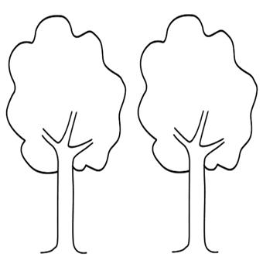

1. Windy

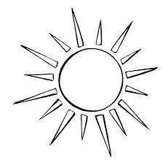

1. Calm

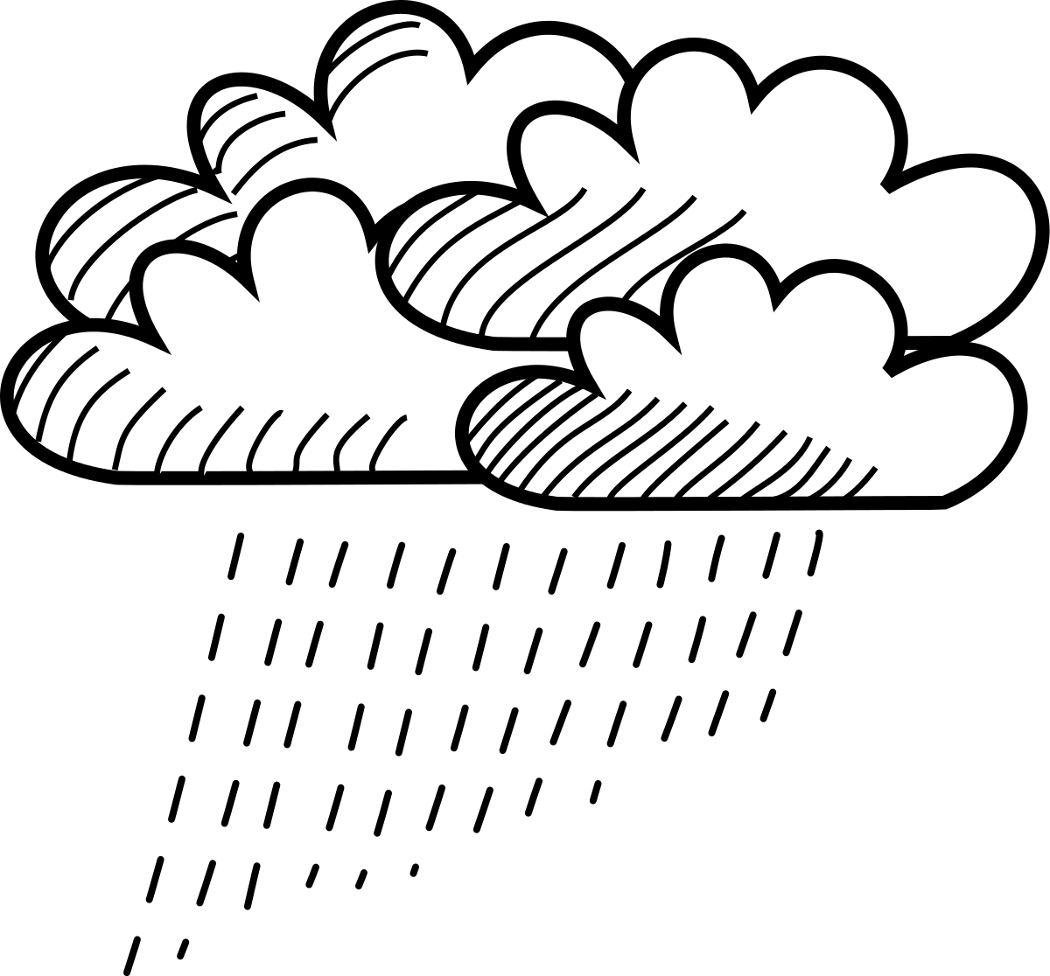

1. Sunny



1. Rainy
2. A ____________ is a source of water. (tap, rain)

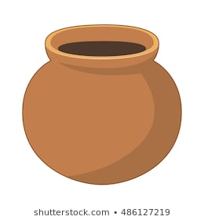

1. We use __________ soil to model the pot. (clay, sand)
2. A hen gives us ________________ (milk, eggs).

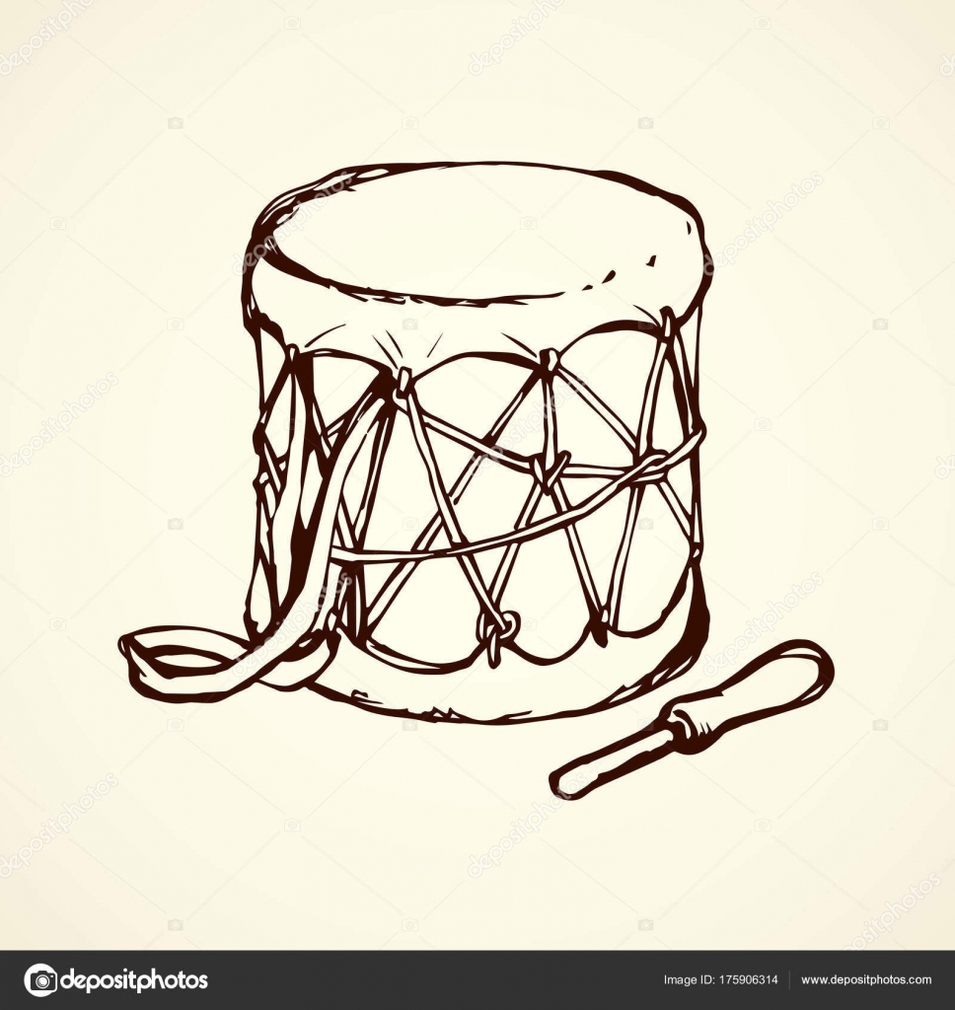

1. This drum produces sound by ______________ (beating, plucking)

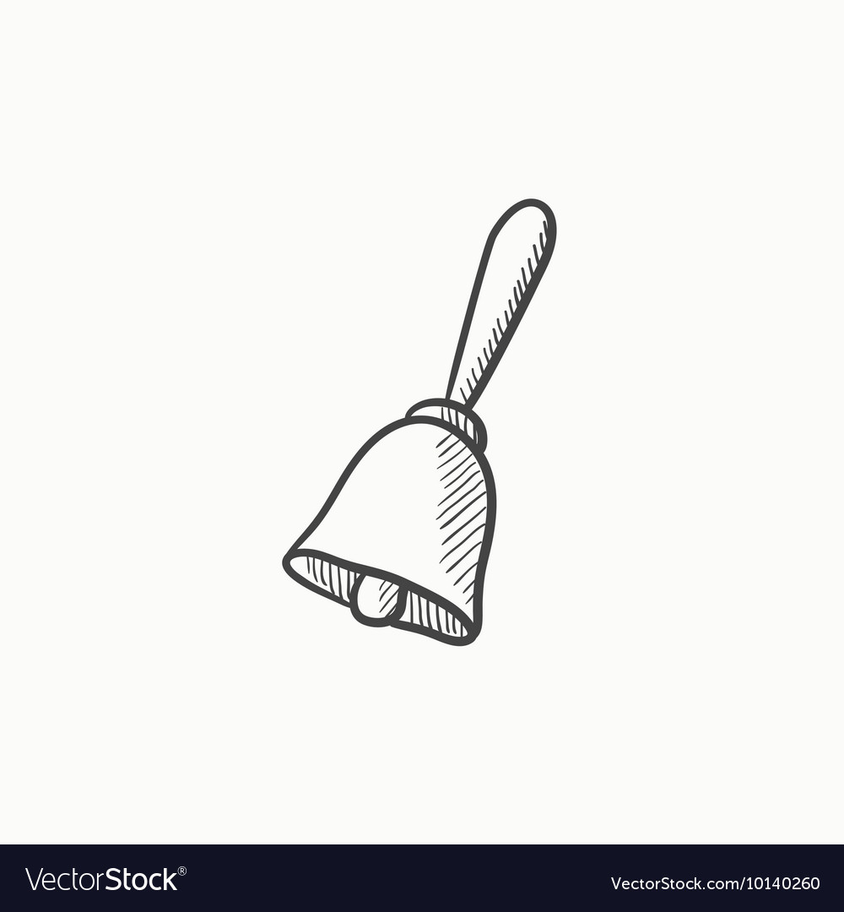

1. This is a __________ ( (bell, key)

14.A ____________gives us meat and milk (cow, sheep)

15. We should use a ______ to wash clothes (bucket, basket)

16. Nights are always ________________ (white, dark).

17. Draw one domestic animal

18. Draw a rainy day

Match the pictures

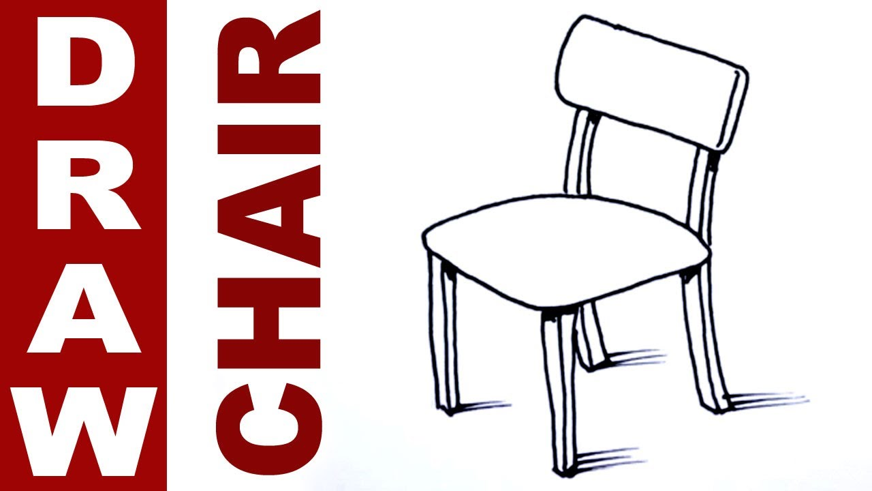

19. glass

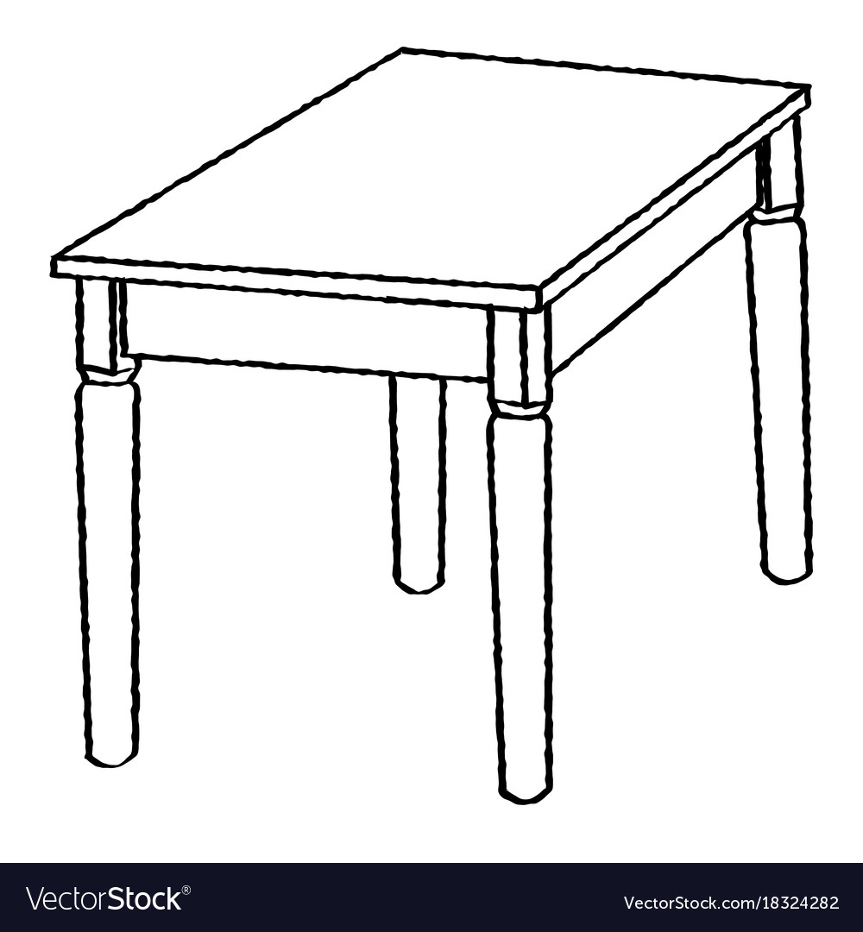

20. cooking stick



21. table

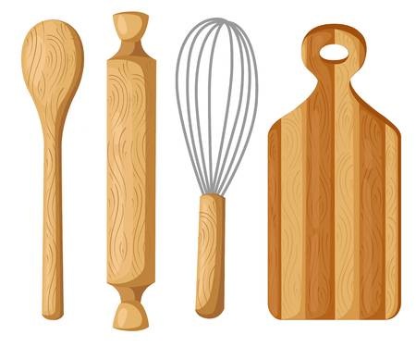

22. chair

23. All children should go to __________________ (work, school)

24. It is your responsibility to ______________ in the family. (play, help)

25. When they fall sick, children should go to ______________(hospital, school).