COMPETENCE BASED ASSESMENT
GRADE 2 YEAR 2020
(MONITORING LEARNERS PROGRESS)
MOVEMENT ACTIVITIES TIME:
NAME:
LEARNER UPI: GENDER: BOY GIRL
No. of questions correct
Performance level

SCHOOL NAME

Name 3 animals that hop.

- We hop for ______________ and coordination. (strength, happiness)
- We should observe____________ when playing any game. (safety, time)
Give 3 animals that moves by leaping

- I___________ over stream to avoid stepping in water. (leap, cross)
Name 3 body parts used in hopping

Name the following types of hop
- 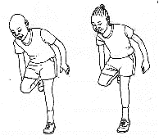

- 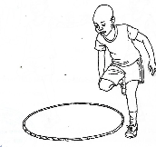

(hopping round a circle, hopping on one foot)
- We __________ over a log to avoid getting injured. (jump, walk)
- We__________ objects on the floor. (pull, push)
- ____________ makes the body fit. (Exercise, reading)
Name the body parts labelled.
18
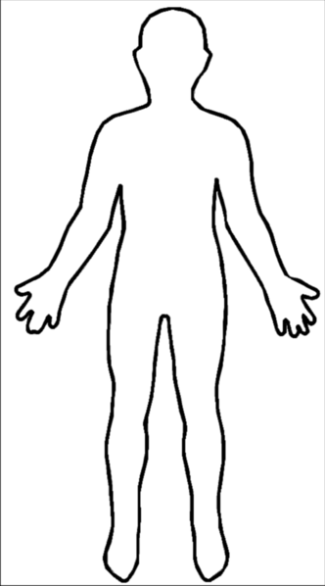
20
19

