COMPETENCE BASED ASSESMENT
GRADE 1 YEAR 2020
(MONITORING LEARNERS PROGRESS)
HYGIENE AND NUTRITION ACTIVITIES TIME:
NAME:
- We wash our ______________ before removing teeth. (hands, mouth)
- Sick people take ____________ to feel better. (water, medicine)
- Teeth that we remove are _____________ teeth. (milk, good)
- Use _____________ water to take medicine. (dirty, clean)
- We clean our bodies to remove _________ (soap, dirt)
- We use a ____________ to clean our nose. (sweater, handkerchief)
- Electricity can cause __________________ (electric shock, drowning)
- ______________ can cause accidents in the kitchen. (Knife, Blanket)
- We should wash our hands _____________ visiting the toilet. (before, after)
- A hen gives us meat and _______________ (milk, egg)
- We should ____________ fruits before eating them. (cut, wash)
- ______________ is good food for strong teeth. (sweet, Milk)
- Always brush your teeth ___________ meals. (before, after)
- A place where meat is sold is called ________________ (market, butchery)
Name the pictures below.
- 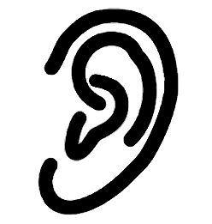_____________________

- 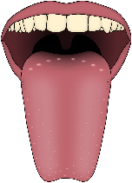____________________

- 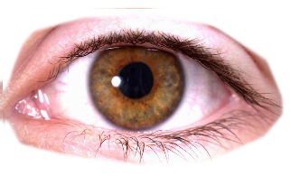_________________

(tongue, ear, eye)

- Wash your hands before ____________
(bathing, eating, playing)
- Vegetables are _______________ for health (bad, good, sick)
- We eat to grow and _________________ (sleep, be healthy)
- Dirty hands may have ________________ (germs, cut, water)
- Too much sugar is ______________ for your health. (good, bad)
- Dirty fruits can make us _______________ (healthy, sick)
- We should always keep medicine in a _____________ cupboard. (closed, open)
Draw a fruit found in your locality

