COMPETENCE BASED ASSESMENT
GRADE 3 YEAR 2020
(MONITORING LEARNERS PROGRESS)
ENVIRONMENTAL ACTIVITIES TIME:
NAME:
LEARNER UPI: GENDER: BOY GIRL

SCHOOL NAME

Answer all questions in the spaces provided.
- Flooding makes people to? _________________
(migrate, live)
- We harvest during ________________ season?
(rainy, dry)
- When there is no rain animals become__________. (fat, thin)
- We should ________________ water. (recycle, waste)
- We should wear _____________clothes when it’s raining? (wet, warm)
- We should drink a lot of _______________ during dry season? (tea, water)
- What has the weather caused in the picture below?
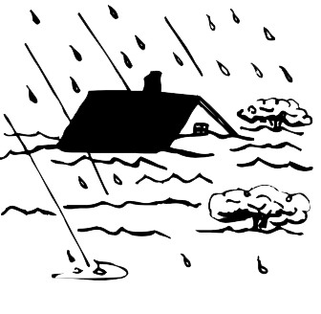
- Where do you get water at home?______________ (river, trees)
- We make water safe for drinking through?____________(boiling, freezing)
- There are _____________ types of soil. (two, three, one)
- ______________ soil has fine particles (clay, loam, sand)
- The smoothness or roughness of soil is known as______________(colour, texture, size)
Name 3 things that plants give us

- We should protect ourselves from dangerous plants by wearing?_____________ (gloves, blanket)
- _______________ is a flowering plant? (sunflower, pine)
Name three things that the animal below give us
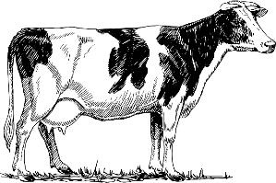
- ____________________________
- ____________________________
- ____________________________
- We should ______________ourselves when it is very cold. (warm, run, jump)
- In the past most people used ______________ to cook. (gas, firewood, kerosene)
- Which one is a source of heat?_______________(air, water, firewood)
- We use _______________ to put out fire when there is fire outbreak. (kerosene, oil, fire extinguisher)
- ________________can cause fire outbreak. (clothes, kerosene, water)
- ______________gives us companion in the house. (cow, cat)
- Which one is not a safe place?_______________ (highway, home, school)
- We should ________________strangers to our parents, guardians or teachers. (report, forgive, forget)
- We should not leave the tap_____________ to avoid wasting water.(running, pouring)
- We should not_____________under a tree when it’s raining.(shelter, cut)
- The type of plant below is called?
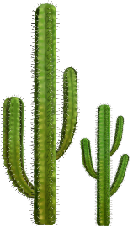_____________ (flowering, thorny)
- Which soil is best for farming?_______________(clay, sand, loam)
- On which weather day do we use the object below?
___________ (windy, rainy)

