COMPETENCE BASED ASSESMENT
GRADE 3 YEAR 2020
(MONITORING LEARNERS PROGRESS)
CHRISTIAN RELIGIOUS EDUCATION ACTIVITIES TIME:
NAME:
LEARNER UPI: GENDER: BOY GIRL
No. of questions correct
Performance level

SCHOOL NAME

ANSWER ALL QUESTIONS
- I should always make__________choices. (wrong, right)
- __________made the parts of my body. (God, man)
Name 3 people in your family

- The first man to be created was?_________(Eve, Adam)
- Adam and Eve___________God. (disobeyed, obeyed)
- When we obey our parents we will be__________(sad, happy)
- Grandparents are part of my____________ family. (nuclear, extended)
- The bible is the word of ___________(God, man)
- The bible is divided into_______parts. (2, 3)
- The first four books of the New Testament are called ____________ books. (Law, gospel)
- ____________ saw the burning bush. (Joshua, Moses)
- Moses was looking after _________when he saw a burning bush. (cattle, sheep)

Name the following creation of God.
- 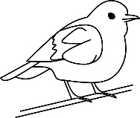

- 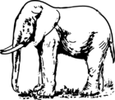

- 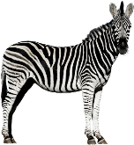

- We show respect to holy places when we stay__________ and listen. (silent, noisy)

- We should show respect to our_________(elders, animals)

- ___________was swallowed by a big fish. (Joseph, Joshua)

- The bible teaches us to __________God. (hate, respect)

- We should __________our parents (deny, obey)

- Adam and Eve were put in the garden of ___________(Gethsemane, Eden)

