END OF TERM 1 2020
SOCIAL STUDIES
GRADE 4
1.An instrument used to show direction is called __________________ (2mrks)
2. The sun sets in the________________________ (1mk)
3. A high flat land is called a ______________ (2mrks)
Study the diagram below and answer the questions (10marks)
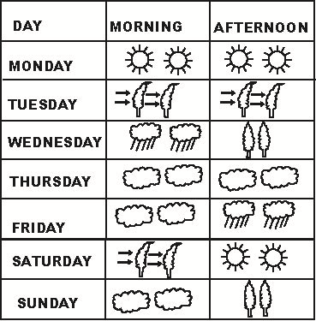
4. The above diagram is called a _______________
5. Which day did the pupils wear gumboots in the morning? _______________
6 The weather on Thursday was _______________________
7. Which day was sunny throughout? ________________
8. The best day for winnowing was _________________
9. A representation of a large area on a small flat surface is called _______________ (1mark)

10. Name two social insects (4marks)
________________________
________________________
11. Identify and name any three physical features (6marks)
________________________
________________________
_________________________
12. Your social studies teacher has asked you to draw a map. Name any three important elements
that are supposed to be in your map (6marks)
______________________
_______________________
_______________________
13. Kenya is made up 47 counties. Name any 3 counties you know (6marks)
_____________________________
______________________________
______________________________
14. The head of a given country is called a ____________________ (1mk)
15. I live in ___________ county (1mk)
16. The green color found in the national flag represents _____________________ (1mk)
17. People who kill our wild animals are called ________________________ (1mk)
18.Draw a compass direction and show the 4 main cardinal points (8marks)

