OPENER EXAM TERM 1 2020
SOCIAL STUDIES STANDARD 8
ELGON AREA
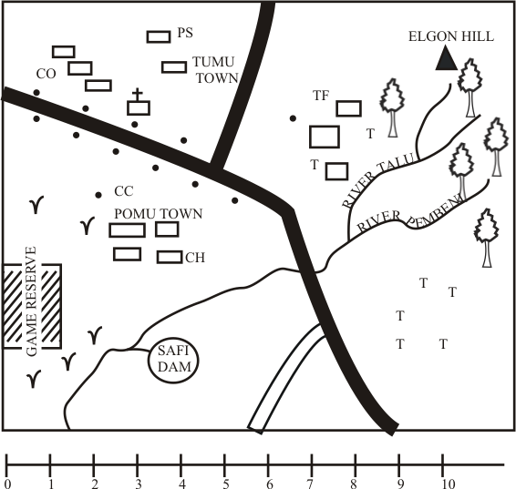

KEY
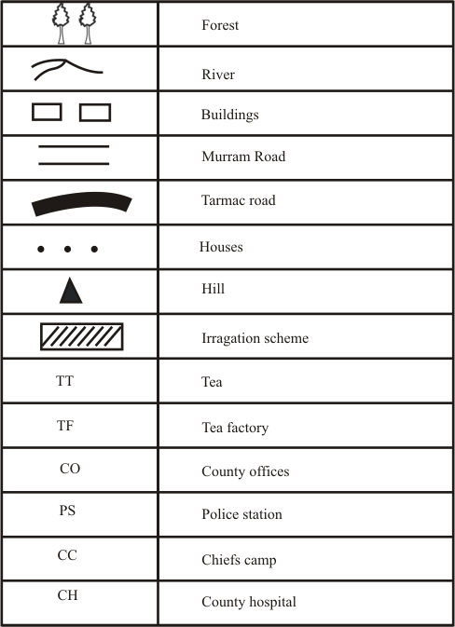

Use the map of Elgon Area to answer questions 1 to 7.
1. The factory in Elgon area is
A. an assembly plant
B. a processing plant
C. a manufacturing plant
D. is a Jua Kali plant
2. Three of the following shows that Elgon area lies in a cool and wet zone. Which one
does not?
A. Presence of boreholes
B. Presence of forest
C. permanent rivers
D. Presence of a cash crop
3. What is the direction of the game reserve from the hill?
A. North West B. North East
C. South East D. South West
4. Which economic activity is NOT practiced in Elgon area?
A. Mining B. Tourism
C. Trading
D.Cash crop farming
5. The highest point in Elgon area is
A. around safi area
B. around the forested area
C. around the game reserve
D. around the tea growing zone
6. What has contributed MOST to the growth of the town in Elgon area?
A. Nearness to Safi dam
B. Availability of water
C. Flatness of the land
D. Adequate means of transport
7. The dam in Elgon area
A. is a source of a river
B. increases floods
C. is a reservoir
D. is a natural feature
8. Which one of the following is a result of Bantus interaction with the people of Saudi Arabia?
A. Introduction of Swahili culture
B. Introduction of Christianity
C. Establishment of Mission Schools
D. Abolition of slave trade

9. The following are characteristics of prominent leaders in Africa
(i) He was a trader
(ii) He was a medicine man
(iii) He was a military leader
(iv) He was a famous religious leader
(v) He died in 1904
Which one are for Masaku?
A. (i) (iii) (v) B. (ii) (iv) (v)
C. (i) (ii) (iv) D. (i) (ii) (v)
10. Which one is the BEST way of conserving wildlife?
A. Educating people on the importance of wildlife
B. Erecting electric fences around national parks
C. Protection of the endangered species
D. Increasing the area under forests

Use the map of Africa below to answer question 11-13

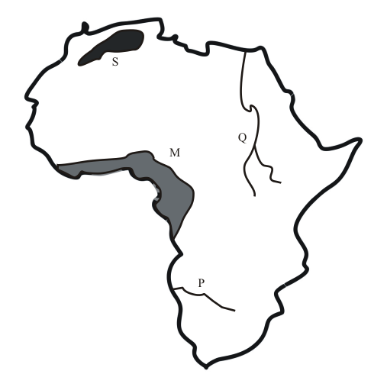

11. The climatic region marked M is?
A. Mediterranean climate
B. Mountain climate
C. Equatorial climate
D. Tropical climate
12.The physical feature marked S is a
A. a volcanic mountain
B. a block mountain
C. a fold mountain
D. a residual mountain
13.Which of the following is not true of the river marked Q?
A. It drains in East Africa
B. It has an artificial lake
C. It is used for irrigation
D. It starts in East Africa

14. Three of the following are problems facing ECOWAS, which one is NOT?
A. Brought limited movement of people in member countries
B. Production of similar goods
C. Inefficient infrastructure connecting member countries
D. Lack of a common currency among member states
15. Which is the capital of South Africa?
A. Johannesburg B. Soweto
C. Pretoria D. Witwatersrand
16.The following are description of a certain river in Africa
(i) It originated from a lake
(ii) It forms a delta
(iii) Its water is used for irrigation
The river described above is?
A. R. Volta B. R. Zambezi
C. R. Nile D. R. Tana

17. Dairy farming is BEST practiced in areas that are.
A. High in altitude.
B. Hot and dry.
C. Hot and wet.
D. Near urban centres.
18. The history of a community was passed from generation to another MAINLY through?
A. Imitation. B. Work.
C. Apprenticeship. D. Story telling.
19.The pre-historic site that is found in Tanzania is
A. Oldvuai Gorge
B. Nariokotene
C. Hyrax Hill
D. Olorgesaillie
20.Which one of the following is not a function of Mombasa town?
A. An administrative centre
B. An industrial centre
C. A tourist centre
D. It is a lake port centre
21. Three of the following are requirements of presidential candidates except?
A. Must present nomination papers to the returning officer.
B. Must be 35 yrs and above.
C. Be a registered voter in a constituency.
D. Must be nominated by a registered political party.
22.A false statement about the Portuguese rule in Africa is:-
A. They considered their colonies as overseas provinces.
B. The grouped their colonies to form federations
C. Laws in their colonies were made in Portugal.
D. The provinces were governed from Portugal
23. The first prime minister in Kenya was
A. Uhuru Kenyatta
B. Raila Odinga
C. Jomo Kenyatta
D. Oginga Odinga

Use the map of Eastern Africa below to answer questions 24-26

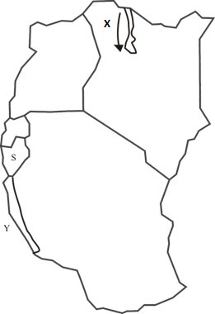

24. Which of the following communities migrated through roure X?
A. Bantu B. Kalenjin
C. Somali D. Luo
25. Which of the following lakesis marked Y?
A. Victoria B. Malawi
C. Rukwa D. Tanganyika
26. The Eastern African country marked S is?
A. D.R.Congo B. Uganda
C. Rwanda D. Burundi
27. Taxes collected by the Kenya government are used in all the following except?
A. Providing education
B. Buying private property
C. Maintaining law and order
D. Building roads
28. Three of the following are TRUE about the flag of Kenya except
A. the Kenyan flag was adopted in December 1963.
B. The green color stands for our natural wealth.
C. It is a factor that promotes national unity.
D. It has four colors each with a different meaning.
29. During which month is the sun overhead the tropical of Capricorn?
A. March B. December
C. September D. June
30. Three of the following are factors influencing climate change except?
A. Pollution B. Overstocking
C. Deforestation
D.Rural-urban migration

31.Cloves are largely grown in
A.Zanzibar B. Uganda
C. Eritrea D.Tanzania
32. Three of the following are TRUE of the legislature in Kenya EXCEPT?
A. Its main duty is to make laws.
B. It formulates government policies.
C. It has elected as well as nominated MPS.
D. It controls government spending.
33.Which one of the following countries has a traditional government?
A. Zimbabwe B. Uganda
C. Somalia D. Swaziland
34.The Aswan high dam was established MAINLY to?
A. Control the flooding of river Nile
B. Produce hydro-electric power
C. Provide water for irrigation
D. Create fishing grounds
35. Which one is NOT a problem facing forests in Kenya?
A. Government allocation of forest land
B. Silting of rivers and dams
C. Illegal logging
D. Forest fires

36. Three of the following are importances of population data. Which one is NOT?
A. Helps the government to plan for enough food supplies
B. The government knows the expected money to correct from individuals
C. Planning for social services (eg) schools and hospitals
D. Planning for free primary education
37.Pyramids are a famous tourist attraction in
A. Algeria B. Kenya
C. Egypt D. Zimbambwe
38. During the pre-colonial period virtues were encouraged through
A. Bible readings B. Local courts
C. Scared rituals D. Moral laws
39. The factor that has mainly influenced the location of Webuye paper industry is?
A. Nearness to raw materials
B. Good transport means
C. A ready market
D. Provision of skilled labour
40. Which one of the following countries achieved her independence through constitutional means?
A. Zimbabwe B. Ghana
C. Kenya D. Mozambique

41.Female Genital Mutilation is discouraged in Kenya Mainly because
A. It leads to barrenness
B. It promotes disunity
C. It encourages immorality
D. It is health hazard
42.The following are descriptions of a certain mineral in Kenya
(i) It is the second most important mineral
(ii) It is used in the manufacture of sulphuric acid and toothpaste
(iii) It is used to make non-stick cooking pans
(iv) The mineral is mined using open cast method
The mineral described above is?
A. Limestone B. Soda Ash
C. Diatomite D. Fluorspar
43. The 12 members of parliament are nominated by?
A. Registered political parties
B. Public service commission
C. Attorney General
D. President
44. Majority of foreigners become citizen of Kenya MAINLY through
A. Birth B. Naturalization
C. Registration D. Identification

45. Who among the following is BEST suited to help end a civil dispute
A. Local administrator
B. Chief justice
C. Arbitrator
D. Member of parliament
Use the diagram below to answer question 46.
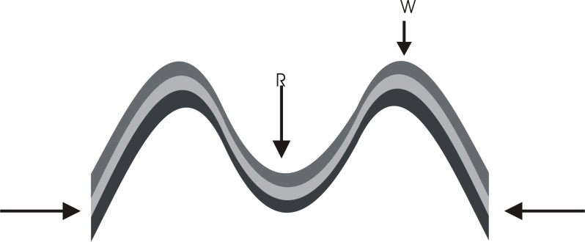

46. Which of the following physical feature was formed through the above process?
A. Mt. Kenya B. Mt.Kilimanjaro
C. The Atlas mts D. the Ahaggar mts
47. Which one of the following was NOT practiced in traditional agriculture?
A. Plantation farming
B. Mixed farming
C. Subsistence farming
D. Shifting cultivation

48.Three of the following are true of customary marriage. Which one is NOT?
A. It is the most common type of marriage
B. Marriage certificates are issued
C. It takes place according to African customs and traditions
D. Polygamy is allowed
49. Three of the countries below are members of the common wealth EXCEPT
A. Britain B. New Zealand
C. France D. Canada
50. Three of the following are true statements about a general election. Which one is FALSE?
A.Returning officers announce election results in constituencies
B. Presiding officers announce election results in constituencies
C.Presidential, parliamentary and civic elections held at the same time.
D. The electoral commission supervises the election
51. Which one is TRUE of Mzee Jomo Kenyatta?
A. He supported freedom fighters in other parts of Africa
B. He was the first chairman of the Kenya African Union KAU
C. He was the secretary general of Kenya African National Union KANU
D. He introduced the 8:4:4 system of education
52. The ocean currents that creates a cooling effect on the South Western tip of Africa is
A. Mozambique B. Canary
C. Guinea D. Benguela
53. Which one is a challenge facing African economies
A. Underpopulation
B. Urbanization
C. Inadequate capital
D. Shortage of labor
54. Which one of the following climatic regions mainly receives convectional rainfall throughout the year?
A. Mountain climate
B. Equatorial
C. Savanna
D. Mediterranean
55.Which one of the following is NOT true about the speaker?
A. He is elected by members of parliament
B. He chairs parliamentary debates
C. He swears in the members of parliament
D. He is elected after two terms of five years each

56.Three of the following are reasons why Lenana of the Maasai collaborated with the British except?
A. To be recognized as the Maasai political leader
B. To receive food supplies due to famine
C. So that the Maasai could be moved to reserves
D. To get military support against his brother
57. Which one is NOT an organ of the Kenya Defence Forces (KDF)
A. The Army
B. The General Service Unit
C. The Navy
D. The Administration Police
58. Three of the following are TRUE about coffee growing in Ethiopia EXCEPT
A. The main variety grown is Arabica
B. The main growing area is Ethiopia Highlands
C. Coffee is the second foreign exchange earner
D. Most of the coffee is grown by small scale farmers
59.Three of the following are advantages of roads transport except one. Which one?
A. Faster and cheaper over shorter distances
B. It is free from noise and air pollution
C. It is the most widespread form of transport
D. It is a flexible form of transport
60. Mary a HIV infected orphan has been refused playing with anybody by her aunt. Which freedom has Mary been denied?
A. Freedom of playing
B. Freedom of speech
C. Freedom of worship
D. Freedom of association

CHRISTIAN RELIGIOUS EDUCATION
61. Noah a man of God had the ability to?
A. control rain
B. create a rainbow
C. build
D. sing
62.Who among the following people asked for permission to bury the body of Jesus?
A. Simon of Cyrene
B. Cleopas
C. Joseph of Arimathea
D. Peter
63. Jesus made himself known as the resurrected Lord to the two men at Emmaus when he?
A. broke the bread
B. showed them the scars
C. washed their feet
D. healed them
64. What did Moses find the Israelites doing when he brought the first tablets of the TenCommandments?
A. Sacrificing a lamb
B. Praying God
C. Building the tower of Babel
D. Worshipping an idol
65. Who among the following men was a judge as well as a prophet in Israel?
A. Isaiah B. Elijah
C. Samuel D. Gideon
66.King Saul annoyed God by?
A. planning to kill David
B. consulting a medium
C. killing of prophets
D. marrying foreign wives
67.How many brothers had Joseph son of Jacob?
A. Eleven B. Twelve
C. Ten D. One
68. Which one is a common miracle done by Jesus, Elijah and Elisha?
A. Multiplying of flour
B. Multiplying of oil
C. Raising of sons
D. Healing of lepers
69.Which of the following are prophetic biblical books?
A. Ruth, Judges, Micah
B. Amos, Hosea, Job
C. Esther, Nahum, Jeremiah
D. Isaiah, Revelation, Ezekiel
70. Which name did Angel Gabriel give to baby Jesus during his annunciation? Matthew 1:23
A. Prince of peace
B. Emmanuel
C. Christ
D. Messiah

71. Which of the following miracles did Jesus do after his resurrection?
A. Feeding the four thousand
B. Calming of a storm
C. Miraculous catch of fish
D. Walking on water
72. Where was Jesus when he was tempted by Satan?
A. In the garden of Gethsemane
B. In mount olives
C. In the temple
D. In the wilderness
73. During the sermon on the mountain Jesus taught?
A. Christian values
B. Ten Commandments
C. Secular values
D. Lord’s prayer
74. A parable that teaches Christians on Jesus second coming is about?
A. the lost sheep
B. the mustard seed
C. the ten virgins
D. the prodigal son
75.Which disciple did Jesus ask to take care of his mother Mary when he was on the cross?
A. James B. John
C. Peter D. James

76.Who among the twelve disciples of Jesus doubted his resurrection?
A. Judas B. Peter
C. John D. Thomas
77.Fasting does not help a Christian to
A. be respected . B. pray.
C. help the needy.
D. have self-control .
78.Which one of the following benefits can a Christian get from the Holy Spirit?
A. Selfishness B. Courage
C. Disobedience D. Bitterness
79.The early missionaries did not train one of the following workers
A. Clergy B. Doctors
C. Medicinemen D. Laity
80.Which among the following cannot bring conflict in our communities?
A. Ethnic differences B. Poverty
C. Religion difference D. Patriotism
81.Discernment is an important Christian value when practicing?
A. judgment B. self- control
C. humanity D. self esteem
82. Who among the following people would not be involved during sacrifices in Traditional African society?
A. Priest B. Elder
C. Sorcerer D. Rainmaker

83. Children in Traditional African Society were named from all the following except?
A. ancestors B. saints
C. seasons D. events
84.The major role of youngmen in Traditional African Society was?
A. grazing cattle
B. settling disputes
C. offering sacrifices
D. providing security
85.Which one of the following Traditional Africa society practice can’t agree with Christianity?
A. Burnt offering
B. Singing and dancing
C. Offering farm produce
D. Daily prayers
86. Peter a class seven pupil has had a cough for the last two weeks. His deskmate is spreading a rumor that he is HIV positive. What advice can you give to them
A. Peter should start taking ARVs
B. They should both visit a VCT center
C. HIV/AIDS doesn’t affect pupils
D. Coughing is not necessarily a symptom of HIV/AIDS

87. Mary is a class seven girl who likes to spend her leisure time with boys in isolated places. Which one of the following is likely to be a result?
A. Female genital mutilation
B. Academic improvement
C. Teenage pregnancy
D. Family cooperation
88. Tom attends a school where the teacher uses sign language. This is likely to be a school for the
A. visually impaired
B. hearing impaired
C. physical handicapped
D. mentally handicapped
89. Who among the following does manual work?
A. John who is a farmer
B. Michael who is a watchman
C. Karen who is a policewoman
D. Jane who is a teacher
90. The Great commission refers to?
A. Jesus miracles and healings
B. Jesus sending out his disciples
C. Jesus being born on earth
D. Jesus ascension into heaven

ISLAMIC RELIGIOUS EDUCATION
61. Among the following Surahs which one has more verses
A. Ikhlas B.Kauthar C. Falaq D. Naas
62. Suratul Fatiha is also called__________
A. RahimB. Hamdu C. Fatah D. Iyaaka
63. Suratul Alaq mentions man as being created from_____________
A. Clay B. Clot of Blood C. Ribs D. woman
64. The word Bayyinah means __________
A. Clear evidence B. good advice
C. Clear lessons D. good tidings
65. Which verse is recommended for a Muslim to recite?
A. Fatiha B. Naas C. Yasin D. Kursiyyuh
66. Complete the following hadith; '' whoever is not thankful to _______is not thankful to ______''
A. Allah , peopleB. people , Allah
C. Prophet , AllahD. Allah, prophet
67. The following are nullifiers of swalah. Which one is not?
A. Turning away from the Qibla
B. Leaving out a pillar of swalah
C. Reciting a chapter of Qur-an
D. Following maamuma
68. If you do nothing and expect everything to be done by Allah is ___________
A. TawakkulB. Taqwa
C. TawheedD. Tawaakul
69. The first Wahyi which came from Allah was on ________________
A. AlaqB. Creation
C. KnowledgeD. Clot of blood
70. The main reason why muslims fast is_______
A. To keep away from eating
B. Is a pillar of Islam
C. To gain taqwa
D. All prophets fasted
71. Hafswa got 249 marks in Std. 7 End year exam. Her parents told her to repeat. She refused. What best advice would you give her?
A. Tell her to obey her parents and repeat
B. Advice her to transfer to another school
C. Tell her to quit school
D. Inform her to discuss the issue with her parents
72. Those who keep away from worldly affairs are known as ______________
A. MuttaqinB. Auliyyaa
C. ZuhdD. Abideena
73. Which among the following is connected to Zakkat ( fitr, tawaf, qiyam, nisab, sunnah, takbir)
A. fitr, sunnah
B. Sunnah, takbir
C. Fitr, nisab
D. nisab, takbir

74. We should say jazakallah when__________
A. Helping othersB. Eating
C. SneezingD. Thanking others
75. Who among the following is a grandson of the prophet?
A. IbrahimB. Ali
C. FatmaD. Hassan
76. One of the Islamic measures in controlling HIV/AIDS is _____________
A. marrying one wife
B. Avoiding people of the opposite gender
C. prayers
D. Being faithful to married partner
77.Hijjatul widaa is known as_________
A. last hajj
B. farewell Hajj
C. blessed Hajj
D holy Hajj
78. Nabii Nuh(a.s) was sent to the people of ________ in Iraq
A. AdilB. Baghdad
C. BasraD. Mesopotamia
79. Inna lillahi wa inna illahi rajiunis mostly recited by muslims __________________
A. When calamity strikes
B. When they hear bad news
C. When in pain
D. When they are informed of the death of someone

80. Ali ate unintentionally during Ramadhan. What is the immediate action for him to take?
A. Continue eating
B. Stop eating and continue fasting
C. Take a glass of water
D. Call a friend and share the meal
81. The sunnah prayer only performed during Ramadhan is known as ____________
A. witrB. tahajjud
C. BaadiyahD. taraweh
82. During the battle of Uhud the muslim army had __________ soldiers with coats of armour.
A. 1000B. 300
C. 700D. 200
83. Which among the following events is not associated with Friday
A. Creation of Adam
B. Admission of Adam to paradise
C. Death of Nabii Issa
D. Day of judgement
84. Qaarun was a ralative of nabii __________
A. Issa (a.s)
B. Suleiman (a.s)
C. Nuh (a.s)
D. Musa (a.s)

85. The early migration of Muslims from Makkah to Madinah is known as_________
A. Hijrah
B. Isra
C. Swafah
D. Hajj
86. The companions of the prophet who migrated from Makkah were called_________
A. Answar
B. Muhajiruun
C. Swahabas
D. Muuminun
87. When electing leaders we should choose those with
A. Alot of money
B. Cars
C. Honesty
D. degrees
88. In Kenyan coast the counties with high population of muslims are Kilifi,Mombasa, Kwale, Lamu. Which one has the highest muslimpopulation?
A. Lamu
B. Kwale
C. Kilifi
D. Mombasa

89. Which fardh prayer has no baadiyyah optional prayer?
A. Isha
B. Maghrib
C. Dhuhur
D. Subh
90. When is it most appropriate to say Kalimah?
A. When reciting Quran
B. When about to sleep
C. Before taking bath
D. Before eating

