OPENER TERM 1 2020
MATHS STANDARD 8

1. What is the place value of digit 9 in the difference between three million, six hundred and eighty two thousand, four hundred and two and one million six hundred and ninety four thousand, six hundred and eighteen.
A. Hundred thousand
B. Ten thousand
C. Millions
D. Thousands
2. Write forty two millions six hundred and eighteen thousand four hundred and two and seven thousandth in figures.
A. 42618402.07
B. 42680402.007
C. 42618402.007
D. 42618420.007
3. In a town there were three thousand and thirty men, two thousand five hundred and eighty women. The number of children was twice that of men. How many people altogether were in the town?
A. 5610 B. 11,670
C 6060 D. 10770
4. What isthe least denominator that can be used in the addition of$\frac{3}{4}$ ,$\frac{2}{3}$ and $\frac{5}{8}$
A. 32 B. 18
C. 36 D. 24
5. The area of a square plot is 1764m². Poles are planted at intervals of 4m. How much money does a farmer require to fence the plot if one pole cost sh. 220?
A. sh 9240 B. sh 36,960
C. sh. 880 D. sh 168
6. What is the next number in the pattern?
0.6, 0.7, 1.3, 2.0
A. 4.7 B. 3.3
C. 4.2 D. 3.8
7. The figure below holds 24.948 liters. If its diameter is 42cm. What is its height?
Take pi = $\frac{22}{7}$
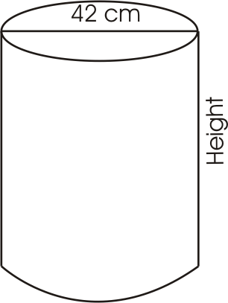

A. 16cm B. 14cm
C. 12cm D. 18cm
8. What is 36.098 rounded to two decimal places?
A. 36.010 B. 36.1
C. 36.10 D. 36.09
9. In 2004, the number of HIV patients recorded in a certain hospital was 360. After HIV awareness, the patients decreased by 30% in 2005. How many HIV patients were there in 2005?
A. 252 B. 108
C. 216 D. 300
10. Peter sent his son to a supermarket to buy the following items
2kg sugar @ sh 60.00
2-2kg kasuku @ sh 380.00
2 packets of pishori rice @sh 70.00
2 packets exe flour for 220.00
He gave the shopkeeper sh. 1500. How much should he give the shopkeeper so as to get a balance of sh. 300?
A. sh 260 B. sh 20
C. sh. 40 D. sh 140
11. When 7.156 is divided by 1000, what is the place value of digit 1?
A. Tenth B. Thousandth
C. Hundredth D. Ten thousandth
12. Ann scored 48% in mathematics and 46% in science. Express the total scores as a decimal
A. 94.0 B. 0.94
C. 9.4 D. 9.40
13. A circular table of diameter 91cm was decorated all round with flowers placed at intervals of 11cm. How many flowers were used? Take pi = 22/7
A. 26 B. 13
C. 297 D. 37
14. A tank has a volume of 6.075m³. How many liters of water can it hold when full?
A. 607.5 B. 60.75
C. 6075 D. 0.6075
15. What is the total value of digit 8 in 4386507?
A. 8000 B. 800000
C. 800 000 D. 80000
16. After increasing the number of animals in a farm in the ratio of 5:2, there were 140 animals in the farm. What was the increase?
A. 56 B. 112
C. 140 D. 84
17. What is the total value of 4 in the sum of 8326825 and 4818430?
A. Forty thousand
B. 4000
C. Four thousand
D. Four thousandth
18. The following are properties of quadrilaterals
(i) All sides are equal
(ii) Diagonals are equal
(iii) All angles are equal
(iv) Has a pair of parallel lines
(v) Diagonals are perpendicular bisectors
(vii) Opposite sides are equal and parallel
(vii) The sum of interior angles equals 360⁰
Which properties are for all quadrilaterals?

A. v and vii
B. viiC. iii
D. iii and vii
19.What is the value of
15.675 ÷ 0.015
26.325 ÷ 1.17 (give your answer to 2 decimal places)
A. 46.44 B. 464.04
C. 464.40 D. 46.45
20. What is the perimeter of the figure below?
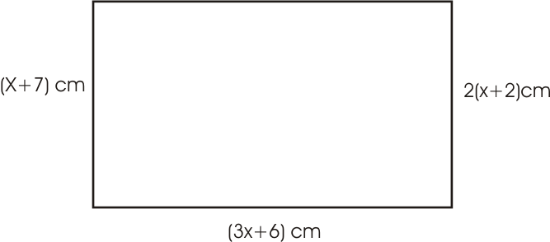
A. 30 cm B. 300 cm
C. 50 cm D. 150 cm
21. What is the area of the shaded part in the figure below?
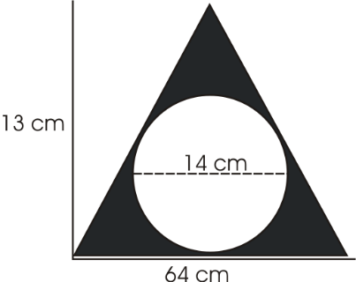

A. 262 m² B. 154cm²
C.416 m² D. 448m²

22. What is 0.4 + 0.8 as a fraction?
A. 1 $\frac{1}{5}$ B. 1.2
C. 1 $\frac{3}{5}$ D. 3.2
23. An athlete running at an average speed of 36km/h covered a certain distance in 7 minutes. What distance did he cover?
A. 4.2km B. 21.6km
C. 1.512km D. 15.12km
24. What is the value of?
6$\frac{1}{2}$ - $\frac{1}{3}$ x $\frac{1}{4}$ ÷ $\frac{2}{5}$
A. 5$\frac{7}{8}$ B. 6$\frac{7}{24}$
C. 3$\frac{7}{30}$ D. 3$\frac{41}{48}$

25. Below are the number of students who were admitted into various Kenya public universities in year 2014.
Maseno = 9500
Nairobi = 10250
Jomo Kenyatta = 2500
Egerton = 1250
How many more students were admitted in Nairobi than in both Jomo Kenyatta and Egerton?
A. 26250 B. 5000
C. 2500 D 6500
26. A rectangular plot has a diagonal of 39m and a width of 15m. What is its area in Ares?
A. 540 B. 548
C. 58.5 D. 5.4
27. What is the simplified form of?
$$\frac{6x + 9 - (2y +4) }{\left(4+2x\right)-(7-4y)}$$
- $\frac{6x - 2y + 13}{2x-4y+3}$
B. $\frac{6x - 2y + 5}{2x+4y-3}$
C. $\frac{6x + 2y - 13}{2x+4y+3}$
D. $\frac{6x - 2y -5}{2x-4y-3}$
28. Construct triangle XYZ whereby XY=8cm; ZX=6.5cm and angle ZXY=750. On the triangle , draw a circle touching the three vertices. What is the measure of the radius?
A. 9.2cm B. 4cm
C. 4.6cm D. 2cm
29. What is the product of faces and vertices of a square prism?
A. 48 B. 40
C. 72 D. 72
30. Two lorries each weighing 3.8 tonnes when empty were each loaded with 320 bags of cement. What was the total mass of the lorries and cement if each bag of cement has a mass of 50kg?
A. 35.8 tonnes
B. 39.6 tonnes
C. 32 tonnes
D. 23.6 tonnes

31. Martin a newspaper vendor earns a salary of sh 2800. He is also given a 15% commission on all the papers sold. In one month he sold 200 newspaper at sh 35 each. What was his commission that month?
A. sh 1050
B. sh 3000
C. sh 3850
D. sh 1750
32. Wayne borrowed sh. 50,000 from a bank that charged compound interest at the rate of 12⁰/₀ p.a. How much did she pay back at the end of 30 months?
- sh 15,123.20
- B. sh 15,000
- sh. 66,483.20
- D. sh 65.000
33. Musa thought of a number. After subtracting 5 from its square, he got 139. What number had he thought of?
A. 144 B. 12
C. 139 D. 36
34. What is the value of?
1.5 of 0.25 ÷ 1.5 + 4.5
A. 45.25 B. 4.525
C. 7.5 D. 4.75
35. The line below is drawn to scale 1:250 000.What is the actual distance in kilometers?

A. 162.50 B. 12.6
C. 16.25 D. 1625
36. The pie chart below shows Harriet’smonthly expenditure.
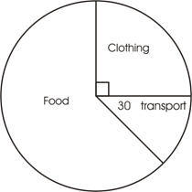
If she spends sh. 750 on transport, how much more does she spend on food than on clothing?
A. sh. 750 B.sh. 6000
C. sh. 3750 D. sh. 2250
37. The marked price of a refrigerator is sh. 30000. Mary bought it on hire purchase terms, which is 30% more than the marked price. She paid a deposit of sh. 10000 plus ten monthly installments. How much did she pay as installment?
A. sh 900 B. sh 9000
C. sh 9200 D. sh 2900
38.Construct quadrilateral PQRS whereby PQ=8cm and PS=10cm. Angle SPQ=70. Draw the two diagonals to meet at point x. Measure angle SXR.
A. 1030 B. 400
C. 790 D. 760
39. A square of side 12cm has the same area as a triangle with a base of 9cm. What is the height of the triangle?
A. 64cm B. 32cm
C. 24cm D. 16cm
40. What is the volume of the cylinder below in cm³? Take pi= 22/7

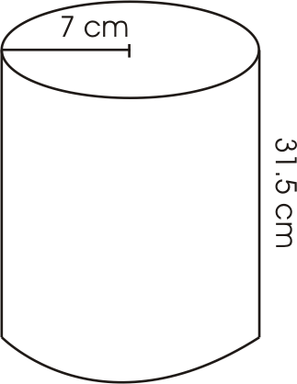
A. 9702 cm³ B.1270.5 cm³
C. 4851cm³ D. 1617cm³
41. January 28th year 2008 was a Monday. Which day was March 14th the same year?
A. Friday B. Tuesday
C. Thursday D. Wednesday
42. A businessman bought 4 sacks of beans @ sh 5000 and later sold them at a profit of 33%. What was the selling price of the 4 sacks.
A. sh 6600 B. sh 26600
C. sh 6650 D. sh 24600
43. Mary borrowed sh 30000 from a bank which paid simple interest at the rate of 20% per year. How much interest had the money earned at the end of 2 years?
A. sh 6000
B. sh 12000
C. sh 114000
D. sh 144000
44. After sleeping for 5hrs 55min. Peter woke up at 3.40am. At what time had he gone to bed in 24hrs clock system?
A. 2145hrs B. 0340hrs
C. 0945hrs D. 945hrs
45. Eighteen workers working at the same rate were to complete a piece of work in 15days. How much more days would it take if six workers failed to attend?
A. 7$\frac{1}{5}$ B. 4$\frac{1}{2}$
C. 7$\frac{1}{2}$ D. 7$\frac{4}{5}$
The following are properties of a quadrilateral.
i. Diagonals bisect each other 90⁰
ii. Diagonals do not bisect each other at 90⁰
iii. All sides are equal
iv. Opposite sides are equal and parallel
46. Which properties are for squares only?
A.I, iv B. I, iii
C.I, ii D. I only
47. Mary paid sh. 7600 for a carpet after getting a discount of 20%. What percentage discount would she get if she paid sh. 7220?
A. 24% B. 28%
C. 76% D. 34%

48. The father’s age is 10 years older than his son while that of the mother was 5 years younger than the father. If the son is x years. What will be their total age in five years to come?
A. 3x - 35 B. 3x + 15
C. 3x + 25 D. 3 x + 30
49. The temperature of a liquid was recorded as 150⁰ C. It was first cooled at the rate of 60⁰ C per min for the first 8 minutes and then heated at the rate of 5⁰ C for the rest of the period. What was its temperature after 15 minutes?
A. 28⁰ C B. 68⁰ C
C. -295⁰ C D. 63⁰ C
50. How many triangles are in the figure below?
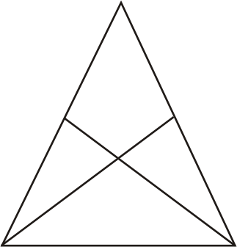
A. 5 B. 4
C. 8 D. 9

