STD SEVEN (7) - 2020
SSRE TIME: 2 HRS 15 MI
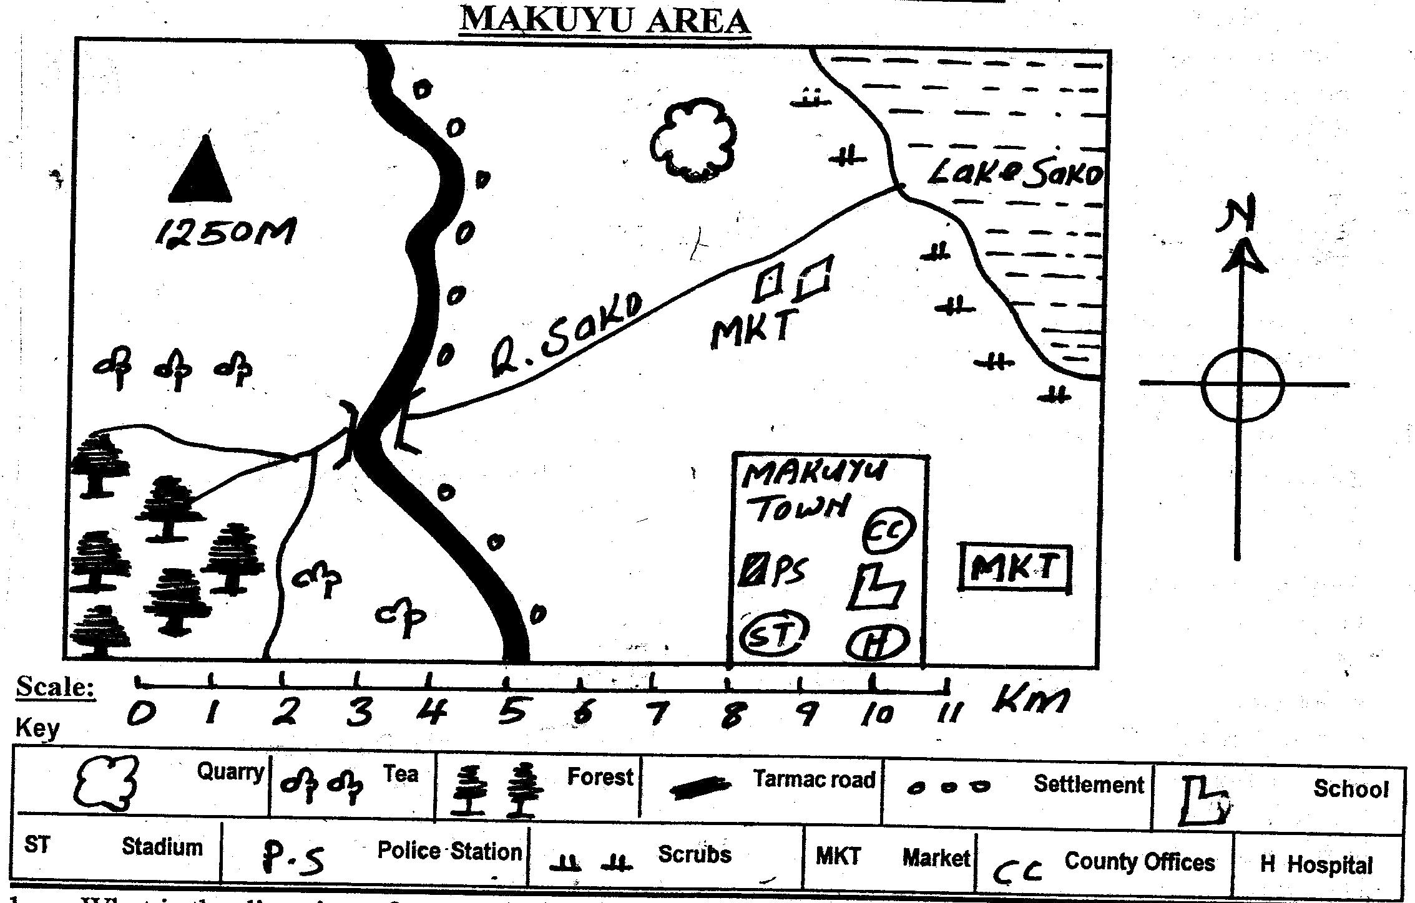

Study the map of Makuyu Area and use it to answer question 1-7
- What is the direction of quarry from Makuyu town?
- North
- South
- South East
- North East
- Which climate can best fit North Eastern side of Makuyu area?
- Hot and wet
- Hot and cool
- Hot and dry
- Cool and wet
- The road in Makuyu area MAINLY meanders because the place is ____.
- rocky B. flat
C. hilly D. smooth
- The chief administrator of National government in Makuyu area is the ____.
- Assistant Chief
- Chief
- County Commissioner
- County Governor
- Which social service is NOT provided in Makuyu town?
- Education B. Security
C. Health D. Religion
- Kamau wanted to start a business in Makuyu town, the best place for him to get a trading licence is from?
- Police Station
- County Government
- Chief
- Elders
- River Sako ends in ____.
- estuary B. confluence
C. delta D. distributary
- The smallest country in Africa is ____.
- Sudan B. Seychelles
C. Algeria D. Rwanda
- The headquarters of East African Communities are situated in _____.
- Kampala
- Nairobi
- Dar es salaam
- Arusha
- Three of the following are effects of revolution EXCEPT:-
- Causes differences in length of day and night
- Causes occurrence of day and night.
- Causes four seasons
- Causes changes of position of day and night
- The following are descriptions of longitudes except one which one?
- They run from north to south
- They meet at the poles
- They are parallel
- Are measured and named from prime meridian
- During a std 7 lesson at Handidi primary, Mr. Lunani asked his pupils to state different colours used to represent drainage features. Who gave the correct answer.
- Khatambe – orange
- Grazil – purple
- Isutsa – blue
- Byrons – green
- The most southerly point of Africa is called ___.
- Cape Ras Hafun
- Cape of Bon
- Cape of Guadafui
- Cape Agulhas
- Which country is CORRECTLY matched with its capital city?
- Tunisia – Tunis
- Algeria – Bujumbura
- Egypt – Rabat
- Morocco – Lusaka

Use the map of Africa to answer questions 15-19
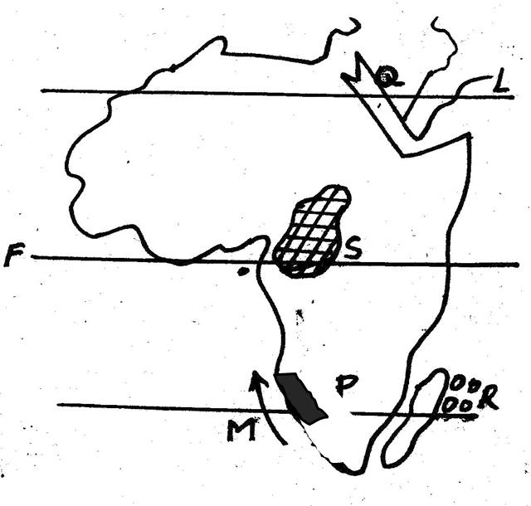

- The ocean current marked M is called ____.
- Somali
- Equatorial Guinea
- Benguela
- Canary
- The country marked P is called ____.
- Angola
- Congo
- S. Sudan
- Namibia
- Which one of the following countries is NOT passed by the latitude marked F?
- Sudan
- Uganda
- DRC
- Kenya
- The Islands marked R are called ____.
- Ethiopia
- Somali
- Uganda
- Kenya
- When regions in the southern hemisphere experiences summer, which one of the following seasons is experienced in the Northern hemisphere?
- Summer B. autum
C. winter D. spring
- The basin marked S is called ____.
- Chad
- Malagarasi
- Okavango
- Congo
- Which one of the following group of people belong to the highland Nilotes?
- Akamba, Nuer, Alur
- Nandi, Kipsigis, Marakwet
- Japadhola, Luo, Ameru
- Alur, Luo, Gusii

- The below fishing method is known as ____.
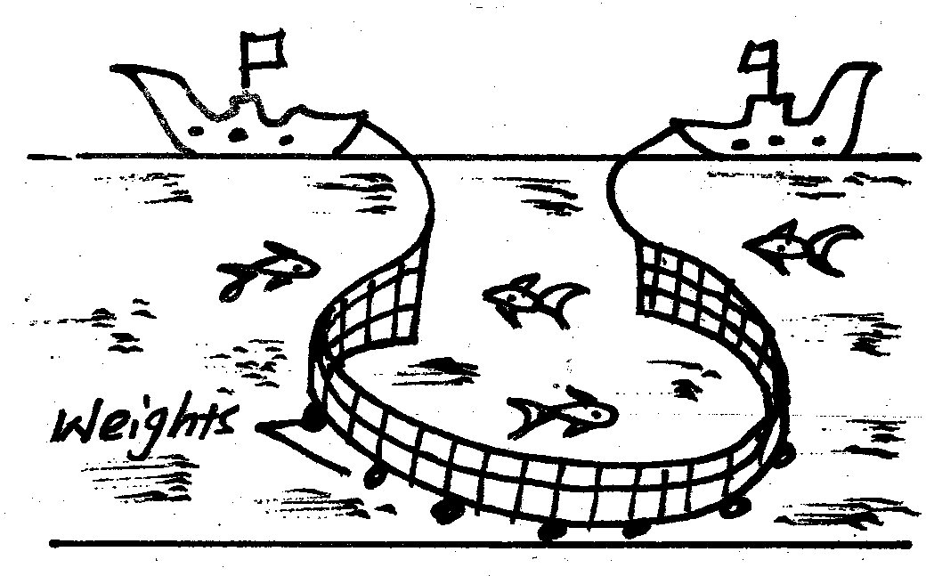

- Trawling
- Longlining
- Purse –seining
- Net-drifting
- The MAIN problem facing wildlife in Kenya is ____.
- Drought
- Pests and diseases
- Poaching
- Human activities in wildlife areas
- Three of the following are inland fishing ground in Kenya. Which one is NOT?
- Lake Baringo
- Lake Naivasha
- Lake Victoria
- Lake Bogoria
- Which one of the following fish is caught in marine fishing grounds?
- Nile perch
- Trout
- Tuna
- Tilapia
- Lawlessness will lead to all the following EXCEPT:-
- Rapid development
- Loss of life and property
- Fear
- Slow development
- Which of the following was MAINLY acquired through apprenticeship?
- Iron-smelting
- Social values
- The history of the community
- Herding
- The Hehe community were led by ____ during the colonial times.
- Oloibon
- Abawanga
- Chief Mkwawa
- Nabongo
- Which instrument is used to measure air pressure?
- Wind vane B. thermometer
C. raingauge D. barometer
- The following are factors which influence climate. Which one is NOT?
- Latitude
- Longitudes
- Ocean currents
- Winds

- Which of the following is CORRECTLY matched with its place of mining?
- Limestone –Kerio Valley
- Fluorspar – Kariandusi
- Anemometer – Lake Victoria
- Soda ash – lake Madadi

- Which one of the following is a role of the head teacher in the school management committee?
- Writes down committee proceedings
- Admits new pupils who satisfy the school regulations
- Disciplines pupils who fail to observe school regulations
- Supervises the other workers in the school
Use the mountain vegetation below to answer questions 33-34
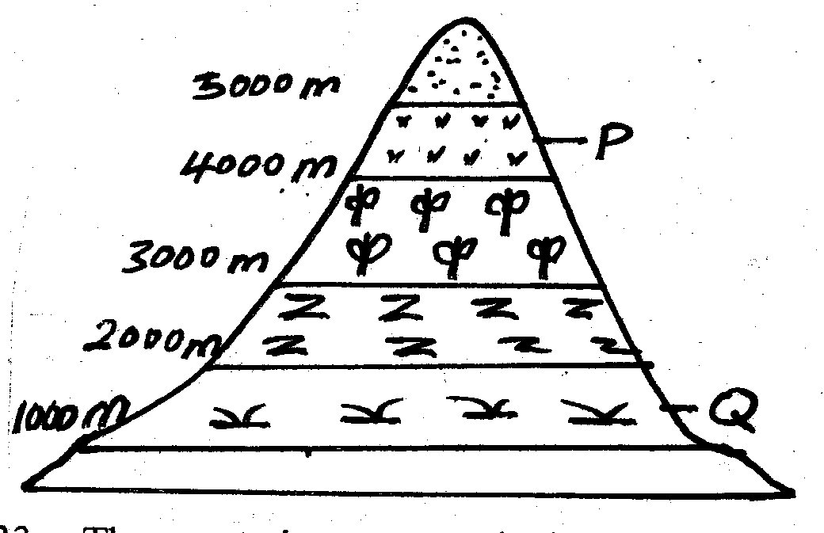

- The vegetation zone marked P is called ____.
- Health and moorland
- Bamboo
- Snow and bare rocks
- Savanna grasslands

- The main vegetation located in the area marked Q is ____.
- Bamboo
- Canopy trees
- Grass
- Thorny trees
- The origin home of Gabbra was ____.
- Bah-el-Ghazal
- South Africa
- Congo Basin
- Horn of Africa
- Lake Chad was formed as a result of ____.
- Downwarping
- Faulting and sinking
- Deposition
- Volcanic activity
- Who among the following Nyamwezi leader was charged with the collection of tax?
- Mtwale
- Kikoma
- Mganwe
- Minule
- The MAIN tourist attraction along the coast of Kenya is ____.
- Pre-historic sites
- Sandy beaches
- Beautiful scenery
- Wildlife
- In the Buganda kingdom the treasurer was known as ____.
- Lukiiko
- Katikiro
- Omuwanika
- Omulamuzi
- Who among the following is NOT presidential appointee?
- Principal Secretaries
- Attorney General
- Cabinet Secretaries
- Speaker to the National Assembly
- The person who controls debates in the parliament is the ____.
- The speaker
- The Clerk of the National Assembly
- Sergeant at Arms
- President
- The vegetation found in Central Tanzania with a lot of tsetse flies is called _____.
- Savanna
- Miombo Woodland
- Nyika
- Shrubs
- Which one of the following is the best wildlife conservation measure in Kenya?
- Putting up animal orphanages
- Establishmen of National parks
- Establishing game sanctuaries
- Creating awareness among people on wildlife conservation
- Pastoralists in Africa MAINLY migrate in search of ____.
- Good fishing grounds
- Fertile land for farming
- Meat and blood
- Pasture and water
- Who among the following people founded the African Socialism philosophy?
- Daniel Moi
- Jomo Kenyatta
- Jaramogi Oginga
- Mwai Kibaki
- Which one of the following is not one of the sections of the Great Rift Valley
- The Ethiopian Rift Valley
- The Eastern Branch
- The Lake branch
- The Western Branch

Use the physical feature below to answer questions 47 and 48.
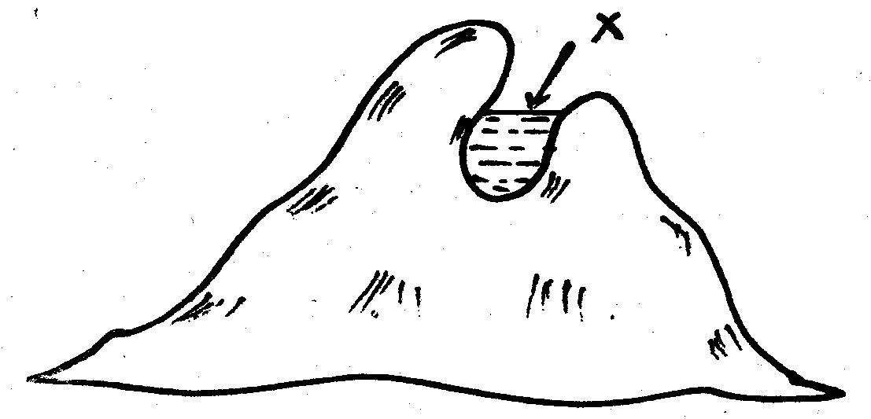

- The type of lake formed through the above process is called ____.
- Ox-bow B. faulting
C. crater D. corrie
- An example of the lake marked X is ____.
- Chad B. Teleki
C. L. Gambi D. L. Tana
- Which of the following types of marriage allows one to marry upto four wives?
- Civil marriage
- Hindu marriage
- Muslim marriage
- Christian marriage
- The isolated hills in a plateau are called ____.
- Inselberge
- Plains
- Nyika
- Escarpment
- The earth rotates from ___ to ___
- North to South
- South to North
- East to West
- West to East
- Which of the following is NOT a hardwood tree?
- Mahogany B. Oak
C. Mvule D. Cypress
- The winds which blow in Sahara region are known as ____ winds
- South East trade winds
- Harmattan winds
- South Westerlies
- Westerlies
- Calculate the approximate time at Marsabit town at longitufe 38⁰E when it is 8.00 a.m. at Cape Verde which is 18⁰W.
- 4.16 a.m. B. 11.40 a.m.
C. 4.16 a.m. D. 11.44 a.m.
- Elections in Kenya are held after ___ years.
- 18 B. 10
C. 5 D. 2
- Which colonial power colonized Tanganyika?
- Spain B. Italy
C. Britain D. Germany
- Which of the following factors undermine peace in society?
- Tolerance
- Bribes
- Equality before the law
- Equal distribution of resources
- During a general election, the wining county representatives are announced by the _____.
- Poling clerks
- Presiding officer
- Returning officer
- IEBC chairman
- The Kenyan parliament is divided into ____.
- Senate and National Assembly
- National Assembly and parliament
- Upper house and senate
- Lower house and the National Assembly
- The following are voted for during the General election except ____.
- President
- Governor
- Woman representative
- Deputy president

SECTION II: C.R.E
- According to the Bible story of creation all types of sea creatures were created on ___ day.
- 5th B. 6th
C. 8th D. 4th
- Who among the following people used their God given abilities to build a sacred tent?
- Bazalel and Joshua
- Bazalel and Caleb
- Bazalel and Oholiab
- Samuel and Oholiab
- “This is my own dear son with whom I am pleased.” These words were spoken by God about ____.
- Jesus Christ
- John the baptist
- Angel Gabriel
- King David
- Abraham was commanded by God to offer his son Isaac in the land of _____.
- Olives B. Ararat
C. Moriah D. Midian
- Which of the following is a secular value?
- Riches B. joy
C. Chastity D. Humility
- God revealed himself to prophet Samuel through ____.
- Burning bush B. Dazzling light
C. Still small voice D. Loud-voice
- Where was Zacharia when the angel told him about the birth of John the Baptist?
- On the journey to Bethlehem
- In the temple
- Herding sheep
- At his house
- The Jew attacked by the robbers was travelling to ____.
- Samaria B. Jericho
C. Bethany D. Jerusalem
- Where was the man who was last healed by Peter and John (Acts 3:1-10) at?
- Bethsaida
- Antioch
- The Beautiful Gate
- The Lake of Galilee
- Who among the following was a Judge in Israel?
- Naomi B. Esther
C. Ruth D. Deborah
- The first miracle of Jesus was performed at ___.
- Bethany B. Cana of Galilee
C. Jericho D. Bethlehem
- Ruth was married to ___ when they came from land of Moab.
- Boaz B. King Xerzes
C. Elimelech D. Naomi
- King Saul was not happy with David mainly because:-
- David had written many Psalms
- David had succeeded as King
- Feared that David might marry his daughter
- David had become very famous
- Which miracle of Jesus teaches Christians about forgiveness?
- The ten virgins B. The fig tree
C. The mustard seed D. The prodigal son
- Jesus was baptized in River Jordan because he wanted to _____.
- Join other in repenting their sin
- Show that John the Baptist was a powerful man
- Encourage others to be baptized
- Fulfill the will of God
- Jesus referred to two sons of Zebedee as ‘Boarnegos’. This means sons of ____.
- thunder B. moon
C. pity D. evil
- Who among the following disciples of Jesus was a tax collector?
- Thomas B. James
C. Judas D. Matthew
- The following are fruits of the Holy Spirit. Which one is NOT?
- Prophecy B. kindness
C. joy D. love
- Who led the Israelites to the promised land?
- Joshua B. Miriam
C. Abraham D. Moses
- A lesson that Christians learn from the parable of the talents is to ____.
- Help their workmates
- Use their abilities
- Love one another
- Obey their leaders
- Who helped Jesus to carry the cross?
- Cleopas C. Judas
C. Joseph Arimathea D. Simon of Cyrene
- We acquire socially acceptable behavior by _____.
- Learning from our parents and others
- Going to school
- Confessing our sins
- Playing with our friends
- Feeling sorry after having done wrong and deciding to repent is called _____.
- Resurrection
- Eternal life
- Repentance
- Baptism
- Which one of the following events happened during the Passover night?
- Egyptians left Egypt
- The Israelites shared a meal
- A voice was heard from heaven
- Moses saw a burning bush
- How can Christians share new life with others?
- Obeying the school rules
- Telling them about God and Jesus
- Avoid talking to sinners
- Respecting their parents
- To express peace in African Traditional Society people ____.
- Forgave others B. Shook hands
C. Told stories D. Kept animals
- Your deskmate James is always instructed by his friend to disobey school rules. What Christian values does he lack?
- Critical thinking
- Decision making
- Creative thinking
- Assertiveness
- In African Christianity new life started after ____.
- Joining the church
- Baptism
- Death
- Believing in Jesus
- In both the Apostles creed and the Lord’s prayer we say ____.
- God is the father
- Jesus died for our sins
- Jesus is our Lord
- I believe in Holy Spirit
- How can a std 7 pupil help to control HIV and AIDs?
- Avoid girl/boy relationship
- Helping the sick
- Loving the sick
- Getting baptized

