IDM EVALUATION TEST

**SCIENCE STD 7 2020 Time: 1 hour 40 Mins**

1. Drugs can be misused in the following ways **EXCEPT:-**
2. Taking wrong dosage
3. Taking wrong medicine
4. Buying medicines without doctor’s prescription
5. Taking drugs to prevent diseases
6. The following are all sides effects of abusing cocaine **EXCEPT**:-
7. Lack of sleep
8. Hallucination
9. Loss of appetite
10. Liver cirrhosis
11. The diagram below shows a blood vessel. Which of the following is **LIKELY** to be the vessel shown?

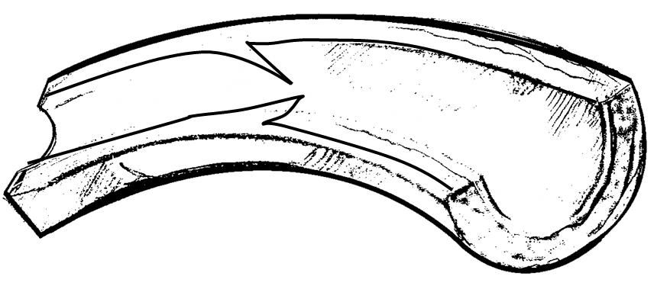

1. Venacava
2. Aorta
3. Pulmonary artery
4. Valve
5. Children born of mothers who smoke are likely to suffer from one of the following. Which one?
6. Lung cancer
7. Over weight
8. Stigma
9. Weak immune system
10. Which component of cigarette leads to addiction?
11. Ash
12. Nicotine
13. Carbon dioxide
14. Tar
15. Nambia drunk a glass of milk for her lunch. In which part of her digestive system did the digestion of milk start?
16. Mouth
17. Stomach
18. Ileum
19. Duodenum
20. All the following components are carried by the plasma **EXCEPT:-**
21. Urea
22. Salts
23. Dissolved food materials
24. Oxygen
25. Which of the following body fluids is **NOT** a likely medium of transmission of HIV/AIDS?
26. Semen B. saliva
27. Blood D. urine
28. The white bold cells are produced in the part of the body called
29. Heart
30. Yellow borne marrow
31. Kidney
32. White bone marrow
33. A certain water bone disease has the following signs and symptoms:-
34. Violent diarrhea with mucus
35. Several abdominal pains
36. Dehydration

The disease is **LIKELY** to be:-

1. Cholera
2. Typhoid
3. Dysentery
4. Bilharzia
5. The diagram below illustrates the human breathing system. Which part represents the bronchus?

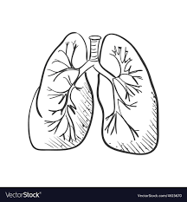

1. U B. V C. W D. X
2. Bile is manufactured in the ____.
3. Intestines
4. Stomach
5. Live r
6. Mouth
7. In which part does fertilization take place in plants?
8. Anthers
9. Stigma
10. Pollen tube
11. Ovary
12. Which of the following is the correct order of development stages of a baby during pregnancy?
13. Foetus, embryo, zygote
14. Embryo, zygote, foetus
15. Zygote, foetus, embryo
16. Zygote, embryo, foetus
17. The type of roots found near the base of maize stems are used for
18. Absorbing water
19. Absorbing mineral salts
20. Breathing
21. Offering extra support
22. Which of the following feeds is not common in zero grazing?
23. Fodder
24. Silage
25. Pasture
26. Hay
27. The diagram below shows a form of soil erosion.

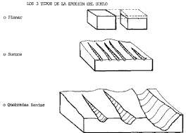

What is the name given to this type of erosion?

1. Rill erosion
2. Sheet erosion
3. Gulley erosion
4. Splash erosion
5. The **MOST** appropriate weather instrument to use when measuring the strength of wind is the
6. Thermometer
7. Raingauge
8. Windvane
9. Windsock
10. The soil that drains water slowest
11. Has small air spaces
12. Has poor capillarity
13. Has rough texture
14. Does not make ribbons
15. The following are functions of the nose **EXCEPT:-**
16. It helps to warm the air
17. It moistens the air
18. It filters the air
19. It protects the air sacks
20. Which one of the following drugs is **NOT** obtained from the cocoa plant?
21. Heroine
22. Cocaine
23. Hashish
24. Mandrax
25. Which one of the following is **NOT** a myth about AIDS?
26. AIDS is caused by witchcraft
27. AIDS is a curse from gods
28. AIDS does not affect fat people
29. AIDS is real
30. Plants which feed on dead decaying matter are called _______
31. Mushrooms
32. Saprophytes
33. Parasites
34. Creepers
35. Which one of the following livestock feeds is prepared by the fermentation process?
36. Hay B. Pasture
37. Fodder D. silage
38. Which one of the following drugs is a preventive drug?
39. B.C.G B. Panadol

C. Penicillin D. Malaraquin

1. Which one of the following is **NOT** part of a food chain?
2. Photosynthesis B. Consumer

C. Producer D. Decomposer

1. Which one of the following blood vessel carries blood to the right side of the heart?
2. Pulmonary vein
3. Aorta
4. Venacava
5. Pulmonary artery

**Use the diagram below to answer questions 28-32**



1. Which statement below is **CORRECT** about the blood vessel marked W? It carries _______.
2. blood from the lungs
3. blood to the lungs
4. blood to the body parts
5. de-oxygenated blood
6. Which chamber pumps blood that is scarlet red in color?
7. U B. V
8. X D. Y
9. The blood vessel marked X is the
10. Aorta
11. Vena cava
12. Pulmonary vein
13. Pulmonary artery
14. Which of the following statements is **NOT** correct. The blood vessel marked Y
15. Carries deoxygenated blood
16. Is the major artery in the circulatory system
17. Carries blood to the body organs
18. Is the aorta
19. The blood vessel marked Z is
20. carries blood from the lungs
21. is the pulmonary artery
22. is the aorta
23. carries dull red blood
24. Which one of the following is **NOT** a narcotic drug?
25. Tobacco
26. Mandrax
27. Heroin
28. Cocaine
29. The diagram below represents a tooth of a human being. Which is the function of the tooth?

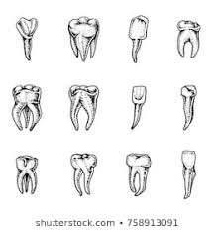

1. Grinding
2. Chewing
3. Crushing
4. Biting
5. A patient had pale finger nail, shortness, of breath and felt dizzy. The patient as most likely suffering from
6. Kwashiorkor
7. Marasmus
8. Anaemia
9. Rickets
10. How does heat from a fire reach a person sitting two metres away?
11. By convection
12. By radiation
13. By conduction
14. By absorption
15. When HIV attacks the body.

Which blood component is mostly affected?

1. Red cells
2. White cells
3. Plasma
4. Platycoelous
5. The green colored substances that plant use during photosynthesis is called
6. Stomata
7. Chlorophyll
8. Wax
9. Pollen grains
10. The gas necessary for combustion in the air has a percentage of
11. 0.97% B. 21%

C. 0.03% D. 78%

1. Through which of the following is the transmission of sound poorest?
2. Metal B. wood

C. Air D. water

1. Std 5 pupils carried out the experiment below:

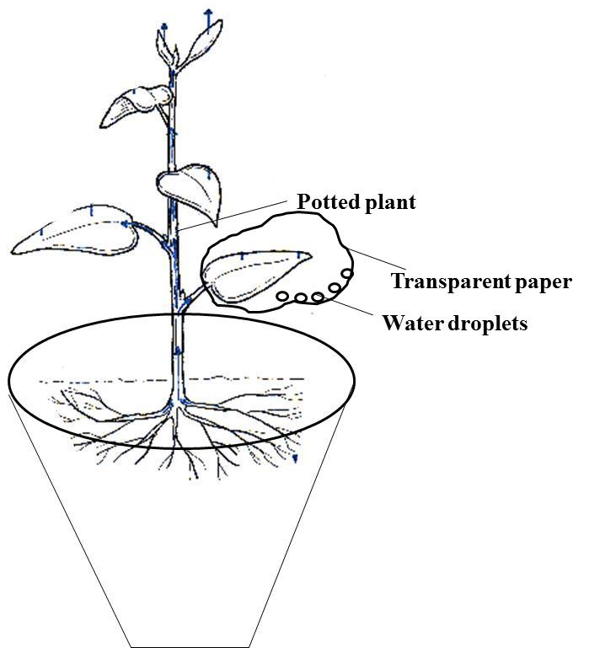

The pupils were investigating?

1. Transpiration
2. Evaporation
3. Respiration
4. Absorption
5. All the following are **TRUE** about all mammals **EXCEPT:-**
6. They all give birth
7. They suckle their young ones
8. Their bodies are covered by fur
9. They have constant body temperature
10. Which of the following planets is nearer to the earth?
11. Mercury
12. Saturn
13. Neptune
14. Uranus
15. Which one of the following is the main difference between a fruit and a seed? Fruit have
16. Two cotyledons
17. Many seeds
18. Flesh
19. A pair of scars
20. Which of the following is **NOT** an importance of HIV testing?
21. To enable one to overcome fear
22. To plan for future
23. To campaign against the spread
24. To transmit to others
25. The 3rd polio vaccine is given to infants at the age of
26. 6 weeks
27. 9 weeks
28. 14 weeks
29. 10 weeks
30. The part of the plant that anchors the plant to the soil also
31. Carries out photosynthesis
32. Carries out transpiration
33. Supports the crown
34. Absorbs water and mineral salts
35. Which one of these is **NOT** a function of the micropyle during germination?
36. Lets in air into the seed
37. Lets in water into the seed
38. Allows the radicle to grow out
39. Allows the plumule to grow out
40. All the following are characteristics of insects pollinated flowers **EXCEPT:-**
41. Scented
42. Large feathery stigma
43. Sticky pollen grains
44. Sticky stigma
45. The state in which matter exists depends on:-
46. Temperature and pressure
47. Freezing and melting
48. Size and density
49. Temperature and materials