JARAMOGI OGINGA ODINGA UNIVERSITY OF SCIENCE AND TECHNOLOGY

SCHOOL OF INFORMATICS AND INNOVATIVE SYSTEMS

DEPARTMENT OF COMPUTER SCIENCE & SOFTWARE ENGINEERING

UNIVERSITY EXAMINATION FOR THE DEGREE OF MASTERS OF IT SECURITY & AUDIT

1ST YEAR 2ND SEMESTER 2016/2017 ACADEMIC YEAR

KISUMU LEARNING CENTER

COURSE CODE: IIT 5113

COURSE TITLE: TCP/IP ARCHITECTURE & ENTERPRISE

EXAM VENUE: STREAM: IT SECURITY & AUDIT

DATE: EXAM SESSION:

TIME: 3 HOURS

INSTRUCTIONS

Answer ANY THREE questions

Candidates are advised not to write on the question paper

Candidates must hand in their answer booklets to the invigilator while in the examination room

Question 1 [20 marks]
- Each IP address has 65,536 associated port numbers for each transport protocol that uses port numbers (most do), and they are used for determining the correct receiving application. Briefly identify any five common port numbers and corresponding applications associated with these ports (5 marks)
- Discuss three types of IP addresses in reference to forwarding of packets. (3 marks)
- Using a diagram discuss the TCP/IP protocol stack. Identify the functions, protocols or applications in each layer. (12 marks)
Question 2 [20 marks]
- Using a diagram briefly discuss the following terms:
  - TCP Flow control (4 marks)
  - TCP Error control (4 marks)
  - TCP Congestion control (4 marks)

- Although TCP and UDP are found in the same layer, they differ considerably in the way they function. State at least two differences on how the two work. (2 marks)

- The diagram below represents a somewhat idealized small internet showing two end systems, and two devices. In this diagram, each number corresponds to a type of protocol at a particular layer. As we can see, each device implements a different subset of the layer stack. (6 marks)

  - Identify the two devices.
  - Briefly explain how the two devices implement different layer protocols.

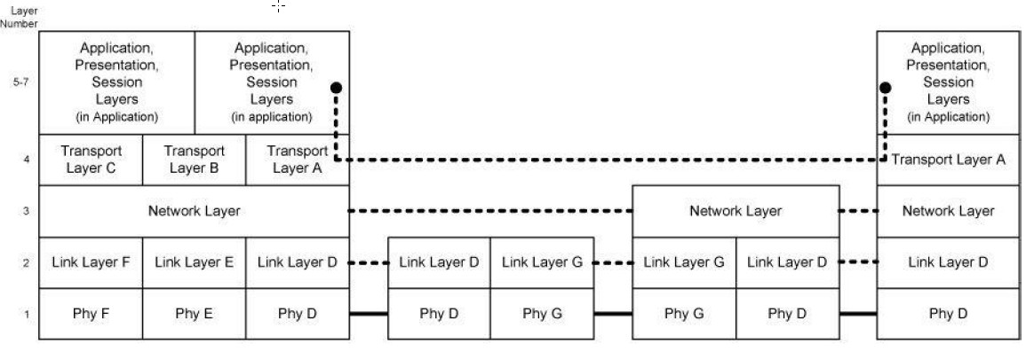

Question 3 [20 marks]
- Identify two ways TCP sender can detect lost packets. Briefly explain how TCP responds when packet loss is caused by congestion? (10 marks)
- Using a diagram briefly discuss the differences between IPv4 header and IPv6 headers. (10 marks) (6 marks)

Question 4 [20 marks]
- The network engineer gives you the following network address and subnet mask: 192.168.1.0/27 (6 marks)
i) Determine the number of subnets that can be created from this network address (show your work)
ii) Calculate the number of assignable IP addresses for each subnet created (show your work).
- Using a diagram differentiate between the following three common ARQ retransmission schemes: Stop-and-Wait ARQ , Go-Back-N ARQ, and Selective Repeat ARQ (9 marks)

- You are provided with a url address as shown below. Describe this url in terms of the port number, TCP/IP protocols and applications involved. http://[2001:0db8:85a3:08d3:1319:8a2e:0370:7344]:443/. Identify the number of bits and the version of IP address. . (5 marks)

Question 5 [20 marks].
- Briefly discuss security vulnerability issues associated with the following: (12 marks)
  - TCP Error control
  - TCP Congestion control
  - TCP Flow control
- Understanding Layer 3 protocols and services is critical to troubleshooting many issues. Briefly discuss common Layer 3 issues. (3 marks)
- You have been appointed to act as the network admin for JOOUST. Troubleshooting network issues is one of the responsibilities of the network administrator. This is typically in response to a problem report in the form of a trouble ticket. The system has generated a ticket for a problem experienced by the lecturer using the JOOUST e-learning platform. The basic model of troubleshooting may follow the structured troubleshooting approach which articulates 7 steps in troubleshooting. Identify any five of the 7 stages you would follow to solve the problem. (5 marks)

