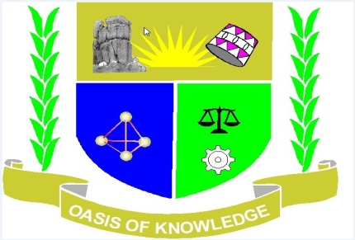

JARAMOGI OGINGA ODINGA UNIVERSITY OF SCIENCE AND TECHNOLOGY
SCHOOL OF HUMANITIES AND SOCIAL SCIENCES
UNIVERSITY EXAMINATION FOR MASTER OF ARTS IN GEOGRAPHY
YEAR 1 SEMESTER 1 2016/2017ACADEMIC YEAR
KISUMU LEARNING CENTRE
SCHOOL BASED
_____________________________________________________________________________
COURSE CODE: NGE 803
COURSE TITLE: GEOGRAPHIC THOUGHT
EXAM VENUE: - STREAM: MA GEOGRAPHY
DATE: 27/04/2017 EXAM SESSION: 9.00 – 12.00 NOON
TIME: 3 HOURS

Instructions:
- Answer any THREE Questions
- Candidates are advised not to write on the question paper.
- Candidates must hand in their answer booklets to the invigilator while in the examination room.

Question 1
To what extent is geography an inclusive discipline? (20 marks)
Question 2
Assess the contribution of the Greeks in the discipline of geography. (20 marks)
Question 3
Justify the claim that Strabo (64 BC-20 AD) was the only true geographer of his times. (20 marks)
Question 4
“Models are very difficult aspects of geography so should be avoided by any novice geographer.” Discuss (20 marks).
Question 5
(a) Assess the role of philosophy in geography (10 marks).
(b) Discuss the use of systems in geography (10 marks).

