Name………………………………………………………... Adm No…………………
Class……………………………… Date ………………………..

451/1
COMPUTER STUDIES
Paper 2
June 2014
2 ½ Hours
NJORO BOYS HIGH SCHOOL
FORM FOUR MARATHON EXAMINATIONS – TERM 2 2014

INSTRUCTIONS TO CANDIDATES

- Write your Name and Index number in the spaces provided at the top of the page.
- Write your name and index on the CD / Removable storage media.
- Write the Name and version of the Software used for each question attempted in the answer sheet.
- Answer all the questions.
- All questions carry equal marks.
- Passwords should not be used while saving in the CD / Removable media.
For Examiners use only.
Section | Question | Candidates Score
1
2
Total Score

This paper consists of 7 Printed pages.
Candidates should check the question paper to ensure that all the
Papers are printed as indicated and no questions are missing

1.The table below shows a section of St. Francis Xavier fee payment by the students.
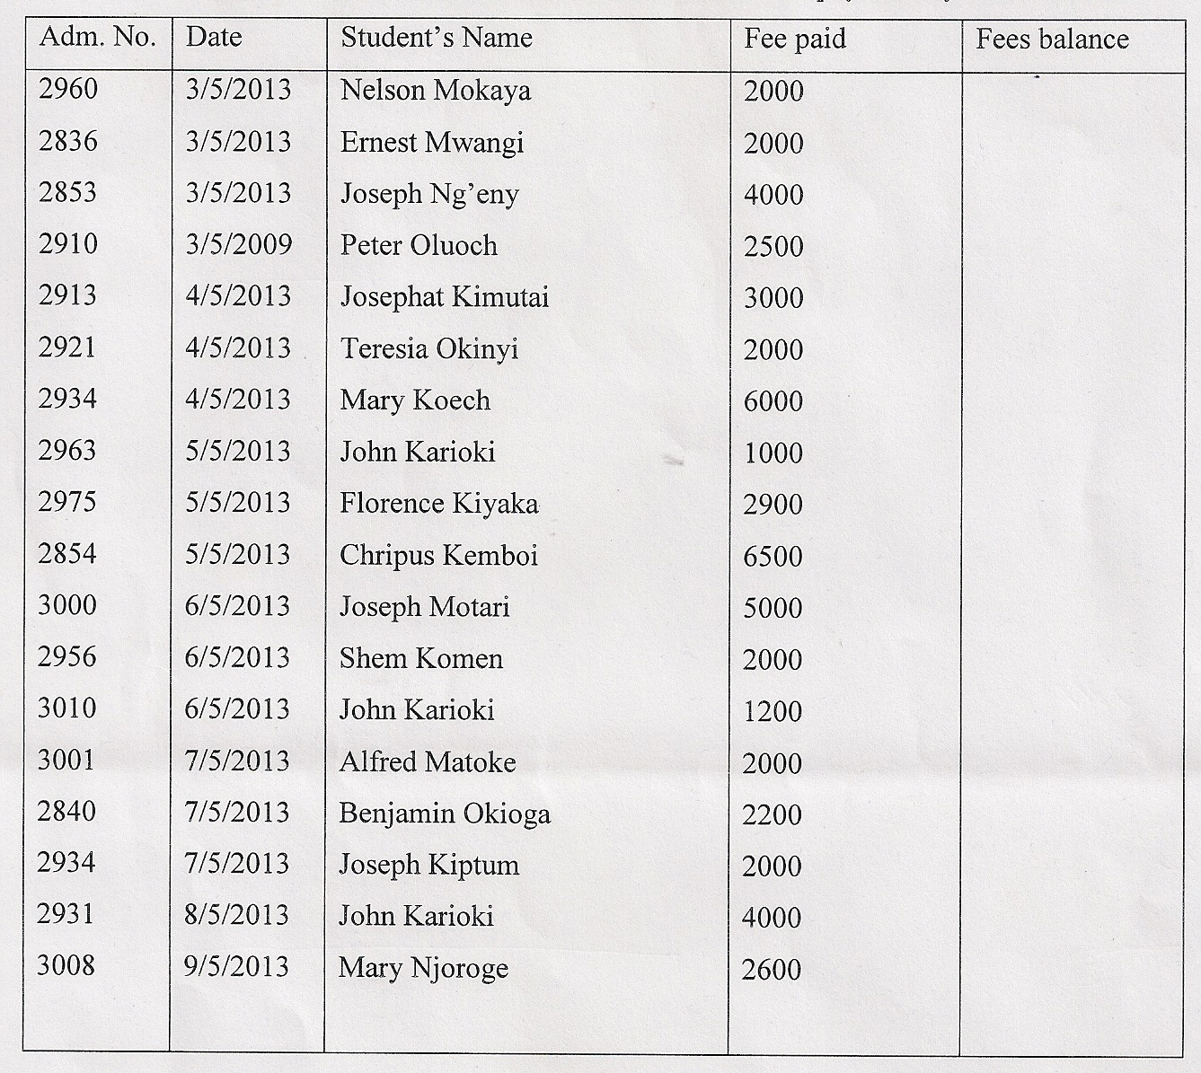
- Using a spreadsheet package, enter the information given in the table into a work sheet and rename the worksheet as FEEENTRY. Save the workbook as DETAILS. (12mks)

- Copy the worksheet and paste it in sheet 2. Rename the worksheet as TOTALS. (4mks)

- Format the column headers so that they are aligned at 45⁰ and bold them. Let the figures in thousands be separated by a coma and format the figures so that they read $. (6mks)

- Sort the file in alphabetical order and using a function determine the total amount paid by all students for this month. (10mks)
- Filter the database above to show the names of those students whose names start with J. Copy the list and paste it in sheet three. Rename the sheet to THEJ’S. (5mks)

- Find a list of all the students who have paid a fee of more than 5000. Paste them in a new sheet and rename the sheet as TOSTAY.(2mks)

- Copy the worksheet FEEENTRY and paste it in a new worksheet and rename it FEEPAID. Draw a pie chart to display:
(i) Names and Fee paid.
(ii) Place a legend at the bottom of the chart. ( 6 mks)

- Using a formula, find the fee balance for each student as per the end of this month given that the total fee is 17,000. (2mks)

- Print the workbook. (3mks)

QUESTION 2. DATABASE
- Prepare a Database called secondary school with the following tables ( 11 mks)

Table name | Table field Name | Field type | Remarks
students | Student id | Numeric | Key field
 | Student Name | Text
 | Male | Logic
 | Parent id | Numeric
parents | Parent id | Numeric | Key field
 | Parent Name | Text
Class | Class id | Numeric | Key Field
 | Class Name | Text
House | House id | Numeric | Key Field
 | House Name | Text
House_Members | House id | Numeric
 | Student id | Numeric
Class_Members | Class id | Numeric
 | Student id | Numeric
Subjects | Subject id | Numeric | Key Field
 | Subject Name | Text
Subject Enrolment | Subject id | Numeric
 | Subject id | Numeric
Teachers | Teacher id | Numeric | Key Field
 | Teacher Name | Text
Subject Teacher | Teacher id | Numeric
 | Subject id | Numeric
House Master | House id | Numeric
 | Teacher id | Numeric

Enter the following records into stipulated tables ( 14 mks)
Student table
Subject Enrolment table
Subject id student id
1 1
1 3
1 5
1 6
1 8
1 10
2 2
2 4
2 7
2 9

Student id | Name | Male | Parent id
1 | James Kimani | Yes | 1
2 | Irene Kimani | No | 1
3 | Walter Otieno | Yes | 2
4 | Pauline Otieno | No | 2
5 | Erick Sang | Yes | 3
6 | Faith Sang | No | 3
7 | Daniel Kyalo | Yes | 4
8 | Mercy Kyalo | No | 4
9 | Thomas Kimoro | Yes | 5
10 | Josephine Kimoro | No | 5

Teacher id | Name
1 | Mr. Kones
2 | Mrs. Chao
3 | Mr. Kuria
Teacher id | Name
1 | Mr. Kones
2 | Mrs. Chao
3 | Mr. Kuria
Teachers table
Subject Teacher
Teacher id Subject id
1 2
2 1
3 1
Prepare the following reports
i)List of male students. The report details should include Student’s id, name, and gender ( 3 mks)
ii) List of students whose parents are Sang. The report details should include student id, Name, and Parent id and Parent as its title. ( 3 mks)
iii)List of all students in form one. The details of the report should include the house name and class name as its title. ( 3 mks)
iv) List of the students in chaka house. The details of the report should include the house name as its title, Student id and student name. ( 3 mks)
v) List of students taught by mrs Chao. The report title should be the name of the teacher and its body should include student id and student name. ( 3 mks)
vi) List of students taking physics. Pront this list. The details of the report should include the subject name as its title, student id and student name. ( 3 mks)
vii) List of teachers teaching mathematics. Report should include the subject name, Teacher id and name as its details. ( 4 mks)
viii) List of houses and their house master details. The report should include house name and house masters name. ( 3 mks)

Parent table
Parent id Name
1 Kimani
2 Otieno
3 Sang
4 Kyalo
5 Kimoro
House Master Table
House id Teacher id
1 3
2 2
3 1

House table
House id Name
1 Gikubu
2 Chaka
3 Mboya
Class table
Class id Name
1 Form one
2 Form Two
3 Form Three
4 Form four
Subject Table
Subject id Subject Name
1 Mathematics
2 Physics
Class members table
Class id student id
1 10
1 5
1 2
2 9
2 4
2 1
3 8
3 6
3 3
4 7
House Members Table
House id Student id
1 1
1 3
1 5
2 2
2 4
2 6
3 7
3 8
3 9
3 10

