SUNSHINE SECONDARY SCHOOL

FORM 2
ENGLISH
END TERM EXAM – MAY/JUNE 2014

NAME: ……………………………………………………..CLASS:……..ADM NO:………….

Answer ALL questions.

QUESTION | MAXIMUM MARK | MARK OBTAINED
COMPREHENSION | 20
POETRY | 20
ORAL SKILLS | 20
GRAMMAR | 20
TOTAL | 80

- COMPREHENSION
Read the following passage and answer the questions that follow.
EMPLOYMENT
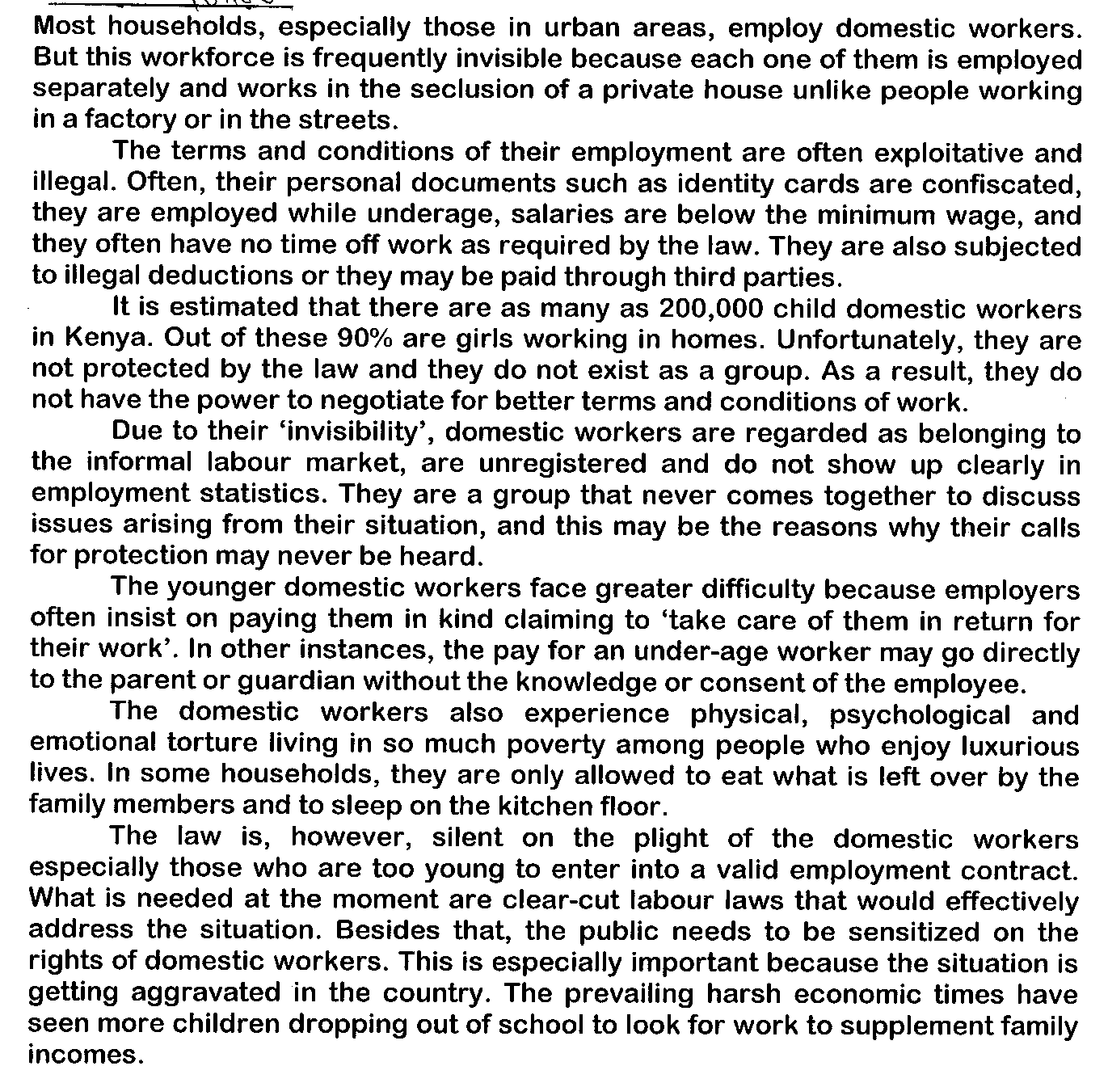
Questions.

- Why does the writer refer to domestic workers as an invisible workforce? (2 mks)

- Give exploitative and illegal conditions that domestic workers go through. (5 mks)

- Why are domestic workers unable to negotiate for better working conditions? (1 mk)

- What are the unique problems of younger domestic workers? (2 mks)
- Which examples of conditions does the writer give that domestic workers can live in so much want amid luxury? (2 mks)

- What solution does the writer suggest to the problem? (2 mks)

- Rewrite the following sentences according to the given instructions. (2 mks)

- The law, however, is silent on the plight of the domestic workers.
(Rewrite beginning: However…)

- They are also subjected to illegal deductions. (Rewrite as a questions).

- Explain the meaning of the following words and phrases as sued in the passage.(4 mks)

- Seclusion
- Confiscated
- Paying them in kind
- Aggravated

- POETRY

Read the poem below and answer the questions that follow.

Never get up till the sun gets up,
Or the mist will give you a cold.
And a parrot whose lungs have once been touched
Will never live to the old.

Never despise the power of speech,
Learn every word as it comes,
For this is the pride of the parrot race,
That it speaks in a thousand tongues.

Never stay up when the sun goes down,
But sleep in your own home bed,
And if you’ve been good, as a parrot should
You will dream that your tail is red.

- Give this poem an appropriate title. (2 mks)

- In note form write down what we learn from the poem about the habits of a parrot. (4 mks)

- Identify and illustrate two poetic devices used in the poem and show their effectiveness. (4 mks)

- Explain the meaning of the following lines: (2 mks)

- And a parrot whose lungs have been touched will never live to be old.

- For this is the pride of the parrot race. That it speaks in a thousand tongues.

- Who is the person in the poem? (2 mks)

- Describe the character of mother parrot. (4 mks)

- ORAL SKILLS

- Mention any three features that are usually lost when a poem is read silently as opposed to when it is performed on stage. (3 mks)

- ………………………………………………………………………………………...
- …………………………………………………………………………………………
- ………………………………………………………………………………………….
- Identify three skills that a good narrator can use to sustain the interest of the audience.
- mks)
- ………………………………………………………………………………………...
- …………………………………………………………………………………………
- ………………………………………………………………………………………….
3. Give any three sound qualities usually used in a poem. (3 mks)
- ………………………………………………………………………………………...
- …………………………………………………………………………………………
- ………………………………………………………………………………………….
4. Write other words that are pronounced the same as the one written below but spelt differently. (3 mks)

- cue……..……………………………………………………………………………...
- new….…………………………………………………………………………………
- heir…………………………………………………………………………………….

5. For the following words provided, write two sentences to bring out two different meanings for
each. (8 mks)
- Refuse
- ………………………………………………………………………………………………………………………………………………………………………………
- ………………………………………………………………………………………………………………………………………………………………………………
- Abuse
- ………………………………………………………………………………………………………………………………………………………………………………
- ………………………………………………………………………………………………………………………………………………………………………………
- Conduct
- ………………………………………………………………………………………………………………………………………………………………………………
- ………………………………………………………………………………………………………………………………………………………………………………
- Project

- ………………………………………………………………………………………………………………………………………………………………………………
- ………………………………………………………………………………………………………………………………………………………………………………

- GRAMMAR

- Rewrite the following sentences as instructed. (4 mks)
- Toys belongs to the children of Mwangi have been stolen. (Write correctly).
………………………………………………………………………………………………..
………………………………………………………………………………………………..

- The matatu owned jointly by Kaczeda and Opiyo has been impounded. (Use possessives correctly.)
………………………………………………………………………………………………..
………………………………………………………………………………………………..
- The squared stool’s legs have been broken. (Correct the error).
………………………………………………………………………………………………..
………………………………………………………………………………………………..
- Any graduate who is unemployed should take his documents to the chief’s office. (Rewrite getting rid of gender bias).
………………………………………………………………………………………………..
………………………………………………………………………………………………..
- Complete each of the following sentences with one of the options in brackets. (4 mks)
(a lot of, much, many, lots, a little)
- This was a very tiring day. There were …………………………of issues to solve.
- ………………………the milk in the mornings delivery has been used.
- There wasn’t ………………….milk left for the evening tea.
- The matatu strike on Wednesday last week inconvenienced ……………………people.

- Fill in the blanks below using a primary auxiliary verb to show tense. (4 mks)
- Do you know that I ………………………(travel) to Uganda tomorrow?
- I …………………………….buy some bread from the shops.
- The teacher told me that my son …………………………change) a lot.
- Brian ………………………………(visit) mara national park last year.

- Arrange the adjectives in the following sentences in the correct order. Fill in the blank spaces. (4 mks)
- Her mother bought a …………………………………………………………….………….. hand bag for her.
- It was a …………………………………………………journey.
- Kanari owns a ………………………………………………dog.
- My father bought a ……………………………………………………………………..seat.
- Pick out the correct irregular verb and fill in the blanks. (4 mks)
- The government engineers ………………….(struck / strack) the oil at fifty feet.
- The gentleman in red at the auction …………………..(bid / bidding) so high a price I had to give up.
- During the Biology practicals, our teacher thrust the scarpel into the frog and …………… (slit / slitted) the abdomen.
- They ………………………….(past / passed) by the Mugumo tree and heard strange sounds.

