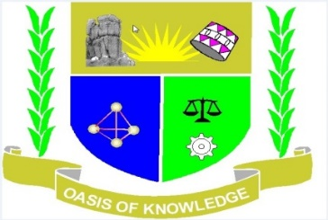
JARAMOGI OGINGA ODINGA UNIVERSITY OF SCIENCE AND
TECHNOLOGY
SCHOOL OF HUMANITIES AND SOCIAL SCIENCES
UNIVERSITY EXAMINATION FOR THE DEGREE OF BACHELOR OF
EDUCATION ARTS WITH IT
1ST YEAR 1ST SEMESTER 2016/2017 ACADEMIC YEAR
KISII LEARNING CENTRE
______________________________________________________________________________
COURSE CODE: DPS 101
COURSE TITLE: BASIC CONCEPTS IN POLITICAL SCIENCE
EXAM VENUE: LR 17 STREAM: BED-ARTS
DATE:20/04/17 EXAM SESSION: 2.00 – 4.00 PM

TIME: 2.00 HOURS
______________________________________________________________________________
Instructions
1. Answer question 1 (COMPULSORY) any other 2 questions
2. Candidates are advised not to write on the question paper
3. Candidates must hand in their answer booklet to the invigilator while in the exam

1. (a) Define the term politics (4marks)
(b) Explain the distinctions between formal and informal politics (8marks)
(c) Briefly explain the origin of the state (10marks)
(d) The king often, even in absolute monarchies, ruled his kingdom with the aid of an elite group of advisors, a council without which he could not maintain power. Outline the invaluable aid rendered to the institution of kingship by the council. (8marks)
2.(a) Define Pressure or interest groups (2marks)
(b) State and explain two ways in which pressure groups influence political parties (8marks) (c)State and briefly explain the functions of pressure groups (10marks) 3. State five the characteristics of stateaspostulated by Christopher W. Morris (1998) (20marks)
4. Discuss the role of middle level bureaucrats in policy formulation (20marks)
5. Explain the differences between Authoritarian and Libertarian politics (20marks)

