Name: ………………………………………………………….. Index No. ……………………………………

Date: …………………………………………………………. Candidate’s Sign. …………................................

443/1
AGRICULTURE
Paper 1
OCT/NOV 2013
Time: 2 Hours

Kenya Certificate of Secondary Education (K.C.S.E.)
FORM THREE

INSTRUCTIONS TO THE CANDIDATES:
- Write your name, index number and school in the spaces provided above.
- Sign and write the date of examination in the spaces provided.
- This paper consists of Three Sections: A, B and C.
- Answer ALL the questions in section A and B and any TWO questions from section C.
- Answers should be written in the spaces provided.
- This paper consists of 11printed pages.
- Candidates should check the questions paper to ascertain that all the pages are printed as indicated and that no questions are missing.

For Examiners’ Use Only
SECTION | QUESTIONS | MAXIMUM SCORE | CANDIDATE’S SCORE
A |  | 30
B |  | 20
C |  | 20
 |  | 20
 |  | 90

This paper consists of 11 printed pages. Candidates should check to ascertain that all pages are printed as indicated and that no questions are missing.

SECTION A (30 MARKS)
Answer ALL the questions in this section in the spaces provided
1. State four ways by which plant nutrients may be lost from the soil (2mks)
……………………………………………………………………………………………………….
……………………………………………………………………………………………………….
……………………………………………………………………………………………………….
……………………………………………………………………………………………………….
2. State two characteristics of a good not stock for grafting (1mk)
……………………………………………………………………………………………………….
……………………………………………………………………………………………………….
3. Give two factors which characterize small scale farming (1mk)
……………………………………………………………………………………………………….
……………………………………………………………………………………………………….
4. State two limitations of mixed farming (1mk)
……………………………………………………………………………………………………….
……………………………………………………………………………………………………….
5. Name two basic economic concepts (1mk)
……………………………………………………………………………………………………….
……………………………………………………………………………………………………….
6. State four advantages of keeping farm records (2mks)
……………………………………………………………………………………………………….
……………………………………………………………………………………………………….
……………………………………………………………………………………………………….
……………………………………………………………………………………………………….
7. Outline four pieces of information contained in a land title deed (2mks)
……………………………………………………………………………………………………….
……………………………………………………………………………………………………….
……………………………………………………………………………………………………….
……………………………………………………………………………………………………….
8. Give two ways in which land consolidation help to promote sound farm management (1mk)
……………………………………………………………………………………………………….
……………………………………………………………………………………………………….
9. Mention four aspects of rainfall that influence agriculture (2mks)
……………………………………………………………………………………………………….
……………………………………………………………………………………………………….
……………………………………………………………………………………………………….
……………………………………………………………………………………………………….
10. State four effects of HIV/AIDS and ill health on Agricultural production (2mks)
……………………………………………………………………………………………………….
……………………………………………………………………………………………………….
……………………………………………………………………………………………………….
……………………………………………………………………………………………………….
11. State factors to consider when designing acrop rotation programme (2mks)
……………………………………………………………………………………………………….
……………………………………………………………………………………………………….
12. Mention two forms in which nitrogen is taken by plants (1mk)
……………………………………………………………………………………………………….
……………………………………………………………………………………………………….
13. Name two field practices carried out to obtain optimum plant population in a crop field (1mk)
……………………………………………………………………………………………………….
……………………………………………………………………………………………………….
14. Give four factors that would determine the number of tillage operations when preparing a seed bed (2mks)
……………………………………………………………………………………………………….
……………………………………………………………………………………………………….
……………………………………………………………………………………………………….
……………………………………………………………………………………………………….
15. What causes late blight in tomatoes (1mk) ……………………………………………………………………………………………………….
16. Give two factors that would influence the time of planting beans (1mk)
……………………………………………………………………………………………………….
……………………………………………………………………………………………………….
17. Name the vegetative parts each of the following crops which is propagated
(i) Sweet potatoes…………………… ½ mk
(ii) Cassava………………………….. ½ mk
(iii) Bananas………………………….. ½ mk
18. State four advantages of drainage as a method of land reclamation (2mks)
……………………………………………………………………………………………………….
……………………………………………………………………………………………………….
……………………………………………………………………………………………………….
……………………………………………………………………………………………………….
19. Name a chemical used to achieve the following during water treatment
(a) Coagulation of solid particles…………………. (1mk)
(b) Softening of water…………………………. (1mk)
(c) Killing of pathogens……………………….. (1mk)
SECTION B (20 MARKS)
Answer ALL the questions in this section in the spaces provided.
20. The illustration below shows a method of making compost manure. Study it and answer the questions that follow.
Field
D
B
C
A

(a) By use of arrows show how the decomposed materials should be transferred (1mk)
……………………………………………………………………………………………………….
(b) Identify the above shown method (1mk)
……………………………………………………………………………………………………….
(c) Give one reason for turning the materials regularly (1mk)
……………………………………………………………………………………………………….
(d) Give one reason for sprinkling water on the structure (1mk)
……………………………………………………………………………………………………….
(e) Outline three characteristics of plants used for green manuring (3mks)
……………………………………………………………………………………………………….
……………………………………………………………………………………………………….
……………………………………………………………………………………………………….
21. The diagram below represents a ground surface after a tertiary operation
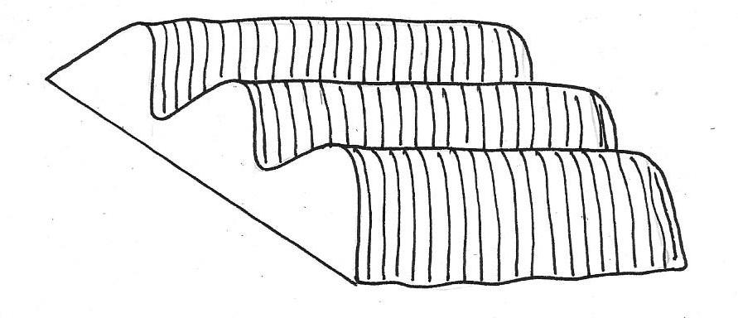

(a) Identify the tertiary operation (1mk)
……………………………………………………………………………………………………….
(b) Give two types of crops that can be established on the structure above (2mks)
……………………………………………………………………………………………………….
……………………………………………………………………………………………………….
(c) State three advantages of using the above for growth of crops (3mks)
……………………………………………………………………………………………………….
……………………………………………………………………………………………………….
……………………………………………………………………………………………………….

22. The diagram below illustrates a field management practice. Study it carefully and answer the
questions that follow
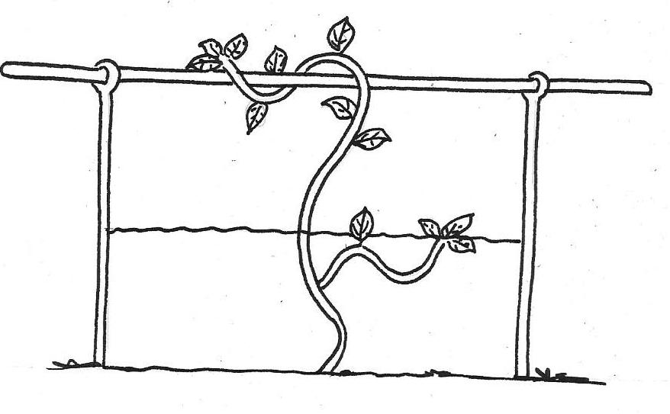

(a) Identify the field practice above (1mk)
……………………………………………………………………………………………………….
(b) Name one type of crop trained using above methods (1mk)
……………………………………………………………………………………………………….
(c) Give two reasons for carrying out the practice above (2mks)
……………………………………………………………………………………………………….
……………………………………………………………………………………………………….
23. A farmer was adviced to apply compound a fertilizer 20:30:10 on a plot measuring 5m by 4m at the rate of 200kg/ha
(a) Calculate the amount of fertilizer the farmer would require for the plot (2mks)

(b) What do the figures 30, and 10 in the fertilizer stand for? (1mk)
……………………………………………………………………………………………………….
SECTION C (40 MARKS)
Answer any two questions in this section in the spaces provided at the end of the section.
24. (a) Explain cultural methods used in controlling crop diseases (10mks)
(b) Describe the production of dry beans under the following sub headings
(i) weed control (3mks)
(ii) Harvesting (3mks)
(iii) Marketing (4mks)
25. (a) Explain the factors that influence spacing in crops (10mks)
(b) Describe the practices that a farmer should carry out to ensure uniform germination of seeds(10mks)
26. (a) Explain ten farming practices which help to conserve soil on the farm (10mks)
(b) Explain the factors that influence the type of irrigation to the farm (10mks)
……………………………………………………………………………………………………….
……………………………………………………………………………………………………….
……………………………………………………………………………………………………….
……………………………………………………………………………………………………….
……………………………………………………………………………………………………….
……………………………………………………………………………………………………….
……………………………………………………………………………………………………….
……………………………………………………………………………………………………….
……………………………………………………………………………………………………….
……………………………………………………………………………………………………….
……………………………………………………………………………………………………….
……………………………………………………………………………………………………….
……………………………………………………………………………………………………….
……………………………………………………………………………………………………….
……………………………………………………………………………………………………….
……………………………………………………………………………………………………….
……………………………………………………………………………………………………….
……………………………………………………………………………………………………….
……………………………………………………………………………………………………….
……………………………………………………………………………………………………….
……………………………………………………………………………………………………….
……………………………………………………………………………………………………….
……………………………………………………………………………………………………….
……………………………………………………………………………………………………….
……………………………………………………………………………………………………….
……………………………………………………………………………………………………….
……………………………………………………………………………………………………….
……………………………………………………………………………………………………….
……………………………………………………………………………………………………….
……………………………………………………………………………………………………….
……………………………………………………………………………………………………….
……………………………………………………………………………………………………….
……………………………………………………………………………………………………….
……………………………………………………………………………………………………….
……………………………………………………………………………………………………….
……………………………………………………………………………………………………….
……………………………………………………………………………………………………….
……………………………………………………………………………………………………….
……………………………………………………………………………………………………….
……………………………………………………………………………………………………….
……………………………………………………………………………………………………….
……………………………………………………………………………………………………….
……………………………………………………………………………………………………….
……………………………………………………………………………………………………….
……………………………………………………………………………………………………….
……………………………………………………………………………………………………….
……………………………………………………………………………………………………….
……………………………………………………………………………………………………….
……………………………………………………………………………………………………….
……………………………………………………………………………………………………….
……………………………………………………………………………………………………….
……………………………………………………………………………………………………….
……………………………………………………………………………………………………….
……………………………………………………………………………………………………….
……………………………………………………………………………………………………….
……………………………………………………………………………………………………….
……………………………………………………………………………………………………….

