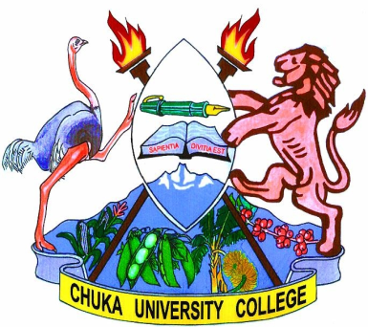
CHUKA UNIVERSITY

COLLEGE

UNIVERSITY EXAMINATIONS

EXAMINATION FOR THE AWARD OF DEGREE OF
BACHELOR OF SCIENCE (COMMUNITY DEVELOPMENT)

COMS 101: COMMUNICATION SKILLS

STREAMS: B.SC. (CDEV) TIME: 2 HOURS
DAY/DATE: FRIDAY 14/12/2012 11.30 A.M. - 1.30 P.M.
INSTRUCTIONS:

Answer question ONE and any TWO others from the rest.

- (a) Explain the following types of communication citing examples from community
based programs:

- Interpersonal communication [4 marks]
- Public communication [4 marks]
- Non-verbal communication [4 marks]
- Grapevine communication [4 marks]

(b) Why is it necessary for a community program’s officer to research the audience
before giving a speech? [10 marks]

(c) Why is plagiarism such a great academic crime? [8 marks]

- Describe the main types of non-verbal communication giving examples from community organization. [20 marks]

- As an interviewee for a job, what are the Dos and Don’ts in the process? [20 marks]

- Discuss any five characteristics of effective communication. [20 marks]

- (a) Explain the main reasons of citing references in academic writing. [10 marks]

(b) Why is it advisable to combine both real library research with internet search in your studies? [10 marks]
---------------------------------------------------------------------------------------------------------

----------------------------------------------------------------------------------------------

