TRIAL ONE EVALUATION TEST

PHYSICS PAPER TWO MARKING SCHEME

1. Angle of incidence = $\frac{{70}^{0}}{2}$ = 35⁰
Angle of reflection = 35⁰
New angle of reflection = 35° + (2 x 20)°
= 75⁰

2. Magnetism is easily induced in them. The dipoles of the keepers form a closed loop with those in
the magnets hence protecting the magnets from being demagnetized;
3.(a) W – Microwave
(b) Uses – Cooking
- Communication Any one @
4.(a) Transverse waves are waves whose particles are displaced perpendicular to the direction of travel whereas longitudinal waves are waves whose particles are displaced parallel to the direction of travel.
(b) T= 2.0 sec, $f=\frac{1}{T}=\frac{1}{2}=0.5 hz$
5. a) speed= 2d/t
= 400 x 2
2.5
= 320 mls

b) 320 = 2 (x - 400)
4.5
x- 400 = 320 x 4.5
2
X - 400 =720
x = 1120m
6.To concentrate the magnectic field

7. More information can be transmitted at the same time since there is
minimal loss of energy during transmission.
8.-number of turns on the coil
-strength of magnet

9.

10.
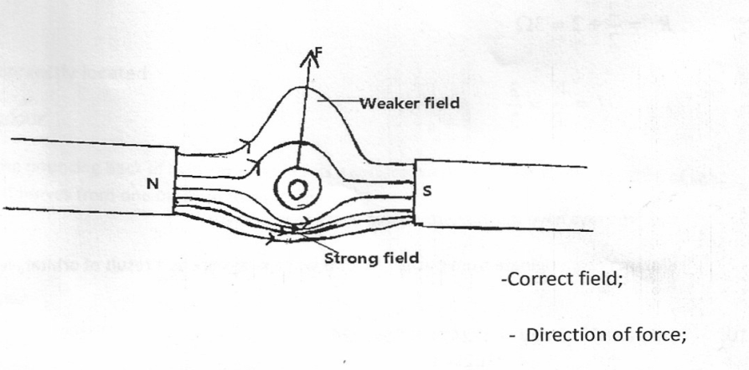

11.-The relative density
-The voltage

12. Accumulation of hydrogen gas on the copper plate insulates the copper plate which prevents further reaction

13(a) (i) = V = IR ⇒ R = $\frac{V}{I}$
= $\frac{12}{2}$
= 6Ω
(ii) Y, Z are parallel
$\frac{1}{R_{P}}$ = $\frac{1}{6}$ + $\frac{1}{6}$
$P_{P}$ = 3Ω
X in series with $P_{P}$
⇒ $R_{T}$ = (6 + 3)
= 9Ω
(iii) I = $\frac{V}{R}$
= $\frac{12}{9}$
= 1.33A
X
Y
Z
(iv)

(b) (i) E.m.f = 1.5V
(ii) Terminal voltage = 1.3V
(iii) R = $\frac{V}{I}$
= $\frac{1.3}{0.5}$
= 2.6Ω
15. a) state two factors that determine the capacitance of parallel place capacitor
-area of plates
-nature of dielectric
-distance between the plates
b) A 5μ capacitor is charged to a potential of 200v and isolated . it is then connected to a 10μF capacitor
i) find the resultant potential difference across combination

Q = Q₁ + Q₂ 1x10⁻³ v 1x10 ⁻³ = 15 x10⁻⁶
Q = 5x10 ⁻⁶ x200 1x10⁻³/5x10⁻⁶ = 6667v ( 3MKS)

ii) energy stored in the capacitors after connection
E= ½ x 15 x10⁻⁶ x 200 ² = 0.1 joules ( 2mks)
ii0)total energy in the capacitors after connection
E= ½x 15x 10⁻⁶ x 66.67²
⁼ 0.00333367 joules ( 2mks)

(14)(i) Long sighted.
(ii) Using converging lens to shortly converge he rays from a near object on the retina
O
I
√
√
(iii)

(c) Eye lens is variable, camera is fixed

- Give one application of capacitors
– smoothening rectified circuits
- Reduction of sparking in induction coils in tuning
- Circuits /delay /camera flash@1 mark

16 a)(i) Is to provide coherent sources √1
ii) - Alternating dark and bright fringes√1
- Dark fringes due to destructive interference√1
- Bright fringes due to constructive interference√1

iii) I. Increased distance between the fringes √1
II) Coloured fringes are formed√1

b) Sound becomes fainter√1 on cooling ,steam condenses creating√1 vacuum hence can’t be transmitted √1

17.(a) (i) Dispersion of white light
(ii) X – Red
Y – Violet

(b) (i) _{a}n_{g} = $\frac{C}{V}$
= $\frac{{3.0 X 10}^{8}}{{1.8 X 10}^{8}}$
= 1.6667
(ii) Sin C = $\frac{1}{n}$
= $\frac{1}{1.667}$
C = Sin⁻¹0.5999
= 36.86
C
(
60⁰
r
θ

