MATHEMATICS 121/1 MARKING SCHEME

1. | $$\frac{23.4-2 (10.5) }{3.84}$$  = $\frac{23.4-21.0}{3.84}$  = $\frac{2.4}{3.84}$  = 0.625 or $\frac{5}{8}$ | M1  A1 | 6 | (a) Sum of interior angles = number of triangles x 180  Let t be the number of  triangles  ⇒1080 = t x 180  t = 6  But t = n – 2 where n =  Number of sides  n = 6 + 2 = 8  (b) The size by one interior angle = $\frac{{360}^{0}}{n}$  $\frac{{360}^{0}}{n}$ = ${45}^{0}$  Size of one interior angle  180 = $\frac{{360}^{0}}{n}$  180 – 45  = 135⁰ | M1  A1  M1  A1
 |  | 2 Marks
2. | M:F = 2:3  ∴ m = $\frac{2}{3}$F ---- (i)  Sunday service ratio =  $\frac{M-10}{F+6}$ = $\frac{1}{3}$  ∴3m – 30 = f + 6  m = $\frac{f}{3}$ + 12 …. (ii)  also m = $\frac{2}{3}$f  ∴$\frac{2}{3}$f = $\frac{f}{3}$ + 12  $\frac{1}{3}$f = 12  f = 36  m = 24  Total no. = 60 | B1 or equivalent  B1 or equivalent  B1
 |  | 3 marks |  |  | 4 Marks
3. | 5000 x 84.15  = 420,750  420 750  289 850  130 900  $\frac{130900}{80.43}$ = 1627.50  ≈ 1628 | M1  M1  A1 | 7 | (3^{x})² – 4(3^{x}) + 13 = 0  Let 3^{x} = t  t² – 4t + 3 = 0  t² – 3t – t + 3 = 0  t(t – 3) -1(t - ) = 0  (t – 3) (t – 1) = 0  ∴ t = 3 or t = 1  but 3^{x} = 3  x = 1  or  3x = 1 (3⁰)  x = 0 | M1  M1  A1
 |  | 3 Marks
4. | $$\frac{{4x}^{2}-{16x}^{2} }{{6x}^{2}- 8xy- {8y}^{2}}$$  $$\frac{\left(2x+4y\right)\left(2x-4y\right)}{\left(2x+4y\right)\left(3x-2y\right)}$$  $$\frac{2x-4y}{3x-2y}$$ | M1 for factorizing numerator and denominator M1  A1
 |  | 3 Marks |  |  | 3 marks
5  3cm  2cm  2cm  3cm  2cm  5cm  5cm  2cm | Surface area =  3 x 5 x 2 = 30  2 x 5 x 2 = 20  2 x 3 x 2 = 12  = 62cm² | B2 Check for other alternatives  M1  A1 | 8. | HCF of 240, 320 and 380  120 320 380  2 120 160 190  2 60 80 95  5 12 16 19  HCF = 2 x 2 x 5 = 20 cm  Area = 20² = 400cm² | M1 alternative methods may be applied  M1  A1
 |  | 4 Marks |  |  | 3 Marks
9 | Let the digits be x and y  x + y = 16 ……….. (i)  original no. = 10x + y  reversed no. = 10y + x  (10y + x) – (10x + y) = 18 ii  x + y = 16  9y – 9x = 18  9y + 9x = 144  9y – 9x = 18  18x = 126  x = 7  y = 9  The no. is 79 | B1 both equations (i)  and (ii)  M1  A1 | 14 | Let the cost price (C.P) be Sh. x  Profit ⇒ Sh (420 – x)  Loss ⇒ Sh (x – 320)  Cost price = Sh. 345  420 – x = 3x – 960  -x – 3x = - 960 – 420  -4x = - 1380  4x = 1380  x = $\frac{1380}{4}$  = 345  Cost price = Sh. 345 | M1 for both profit and loss  M1 for forming the equation and solving it  A1 for correct answer
 |  | 3 Marks |  | 420 – x = 3(x – 320) | 3 Marks
10. | ${Log}_{10}$(x – 1) + ${Log}_{10} 10$ = ${Log}_{10}$ (x – 4)  ${Log}_{10}$ $\left(\left(x-1\right)10\right)$  = ${Log}_{10} \left(x-4\right)$  10 (x – 1) = x – 4  10x – 10 = x – 4  x = $\frac{2}{3}$ | M1  M1  A1 | 15. | (a) 4² = 9² + 6² – 2 x 6 x 9 Cos Q  108Cos Q = 101  Cos Q = 09352  Q = Cos-1 0.9352  Q = 20.74⁰  (b) ∠PSQ = 20.740  Area of triangle PQS = $\frac{1}{2}$ x 9 x 10sin 20.74⁰ = 15.94cm² | M1  A1  M1  A1
 |  | 3 Marks |  |  | 4 Marks
11. | 3P + 4e = 87 ………. (i)  2P + 5e = 93 ………. (ii)  2(2P + 4e = 87)  3 (2P + 5e = 93)  6P + 8e = 174 (iii)  6P + 15e = 279 (iv)  7e = 105  e = 15  Substitute in (ii)  2P + 75 = 93  2P = 18  P = 9  Cost of exercise book Sh. 15  Cost of a pen Sh. 9 | M1  M1  M1  A1 | 16. | Cost (x – 20)⁰ = Sin (2x + 32)⁰  x – 20 + 2x + 32 = 90  3x + 12 = 90  3x + 78  x = 26⁰  Tan (x – 4) = Tan (26 – 4)  = Tan 22  = 0.4040 | M1  A1  B1
 |  |  |  |  | 3 marks
 |  |  | SECTION II
 |  |  | 17.  A  D  C  C  E | Sketch  (c) (i) AE = 6.5 ± 0.1cm  (ii) Bearing of E from A = 102⁰±1⁰  KINDLY SEE DRAWING ON PAGE 4
 |  | 4 Marks
12. | 45 cows can feed for 3 days  ∴ 1 cow can feed (30 x 45) days  ⇒ 50 cows can feed $\frac{30 x 45}{50}$  = 27 days | M1  A1
 |  | 2 Marks
13. | 7y = 3x – 20  y = $\frac{3}{7}$x - $\frac{20}{7}$  g = $\frac{3}{7}$  Gradient of tar = $\frac{-7}{3}$  (512) (x.y) = $\frac{-7}{3}$  $\frac{y-2}{x-5}$ = $\frac{-7}{3}$  3y – 6 = -7x + 35  3y = -7x + 41  y = $\frac{-7}{3}$x + $\frac{41}{3}$ | M1 rewriting in y = mx + C  M1 or equivalent  A1 or equivalent  3y + 7x = 41,  7x + 3y – 41 = 0
 |  | 3 Marks

18. | (a) 100q + 80r = 25600  50q + 160r = 18200  (b) 200q + 160r = 51200  50q + 160r = 18200  150q = 33000  q = 220  r = 45  (c) $\frac{110}{100}$ x 220 = 242  $\frac{120}{100}$ x 45 = 54  100(242) + 80 (54)  = 28,520  Profit = 28520 – 25600  = 2920  (d) Percentage profit $\frac{2920}{25600}$  = 11.41% |  |  |  | B1 or Any other letter  B1  M1 Simultaneous equations  M1  M1  A1  M1  A1 |  |  | L = $\sqrt{637.25}$  ∴ l = 25.24  Curved surface area larger cone  $πrL$ = $\frac{22}{7}$ x 3.5 x 25.24  = 277.64cm²  Curved S.A of the small cone  $\frac{16}{25}$ x 277.64 = 99.9cm²  Total surface area of frustrum  $\left\{\frac{22}{7} x 2.8 x 2.8\right\}$ + $\left\{\frac{22}{7} x 3.5 x 3.5\right\}$ + 99.95 cm²  24.64 + 38.5 + 99.95  = 163.09cm²  (b) Volume of small cone  $\frac{1}{3}r^{2}$h = $\frac{1}{3}$ x $\frac{22}{7}$ x 2.8 x 2.8 x 20 = 164.3cm³  Using volume scale factor (V.S.F)  Volume of larger cone  = $\frac{125}{64}$ x 164.3cm³  ∴Volume of frustrum  = $\left\{\frac{125 }{64}-1\right\}$ x 164.3  $\frac{61}{64}$ x 164.3  = 156.6cm3 | B1  B1  B1  M1  A1  B1  B1  M1  A1
 |  |  |  |  | 10 Marks
19. | Length  (cm) | Mid pt  (x) | F | xf | CF
 | 118 -126 | 122 | 3 | 366 | 3
 | 127 – 135 | 131 | 4 | 524 | 7
 | 136 – 144 | 140 | 10 | 1400 | 17
 | 145 – 153 | 149 | 12 | 1788 | 29
 | 154 – 162 | 158 | 5 | 790 | 34
 | 163 – 171 | 167 | 4 | 668 | 38
 | 172 – 180 | 176 | 2 | 352 | 40
 |  |  | 40 | 5888
 | (a) (i) Modal class ⇒ 145 – 153  (ii) Median class 145 – 153  (b) (i) Mean of feeding  x = $\frac{ x f}{f}$  = $\frac{5888}{40}$  147.2  (ii) Median = L ($\frac{\frac{n+1}{2}-c}{f}) i$  = 144.5 + ($\frac{\frac{41}{2}- 17}{12}$)9  144.5 + $\frac{20.5-17}{12}$ x 9  144.5 + 2.625  = 147.125 |  |  |  | B1  B1 C.F column  B1 median class  B1 mid point  B1 xF column  M1  A1  M1 Substitution  M1 attempt to simplify  A1 |  |  |  | 10 Marks
 |  |  |  |  |  |  | 21. | A₁ (-4,6) B₁ (-8,3) C₁ (-4, 3)  A₂ $\left(\begin{matrix}-4 \\ 6\end{matrix}\right)$ + $\left(\begin{matrix}10 \\ 2\end{matrix}\right)$ = $\left(\begin{matrix}6 \\ 8\end{matrix}\right)$, A₂ $\left(6,8\right)$  B₂ = $\left(\begin{matrix}-8 \\ 3\end{matrix}\right)$+ $\left(\begin{matrix}10 \\ 2\end{matrix}\right)$= $\left(\begin{matrix}2 \\ 5\end{matrix}\right)$, B₂ (2,5)  C₂ = $\left(\begin{matrix}-4 \\ 3\end{matrix}\right)$+ $\left(\begin{matrix}10 \\ 2\end{matrix}\right)$ =$\left(\begin{matrix}6 \\ 5\end{matrix}\right)$, C₂ (6,5)  (a) Transformation is a reflection  on the line y = 1  (b) Simple transformation is  rotation centre (2,0) through  ± 180⁰  KINDLY SEE PAGE 5 | 2 Marks correct co-ordinates  2 marks  2 Marks
 |  |  |  |  | 10 marks
20. | 2.80cm  3.5cm  h  5cm  (a) Linear scale factor (L.S.F)  $\frac{2.8}{3.5}$ = $\frac{4}{5}$  Area scale factor (A.S.F) ($\frac{4}{5}$)² ⁼ $\frac{16}{25}$  Volume scale factor (V.S.F)  $({\frac{4}{5})}^{3}$ = $\frac{64}{125}$  From similar triangles  $\frac{h}{h+5}$ = $\frac{4}{5}$  5h = 5h + 20  h = 20cm  Length of larger cone  L² = 25² + 3.5² = 625 + 12.25 |  |  |  |  |  | 22 | (a) (i) ∠BAC = ∠BCA = 45⁰  ABC = 90⁰ and Δ ABC is  isosceles  ∠DAC = 180⁰- (90⁰ + 35⁰)  = 180 – 125  = 55  ∴∠BAD = 45 + 55 = 100⁰  (ii) Reflex ∠BOD = 2 x 100 = 200⁰  ∴ Obtuse ∠ BOD = 360⁰ – 200⁰ =  160⁰  (iii) BDG  ABGD is a cyclic quad.  ∴BGD = 180 – 100 = 180⁰  (b) ∠ABE = ∠CBF  ∠ABE = 45⁰ (∠S in alt. segment)  ∠CBF = 45 (∠S in alternate segment)  ∴∠ABE = ∠CBF | M1  M1  A1  M1  A1  M1  A1  M1  M1  A1
23 | (a) $\frac{1}{2}$ x 30hr $\frac{1}{2}$x40hr 60h = 2090  95h = 2090  h = 22m/s  max speed = $\frac{22 x 3600}{1000}$  = 79.2 km/h  (b) a = $\frac{22}{30}$  = $\frac{11}{30}$  (c) $\frac{1}{2}$ x 20 x 11 = $\frac{220}{2}$  = 110m  (d) Time for half journey  $\frac{1}{2}$ x 22 (30 + t + t) = $\frac{1}{2}$ x 2090  11 (30 + 2t) = 1045  330 + 22t = 1045  22t = 919  t = 32.5 |  |  |  | M1  A1  B1  M1  A1 v 0.7333 m/s  accept km/h  M1  A1  M1  M1  A1 |  | 24. | (a) Let no. of members be = n  Each member was to contribute Shs. $\frac{4000}{n}$  When 15 members failed to pay  No. of members who contributed was n – 15  Each member had to contribute  Sh. $\frac{400}{n-5}$  But this was Sh. 60 more  ⇒ $\frac{4000}{n-15}$ - $\frac{4000}{n}$ = 60  n(4000) = (n -15) (4000) + 60(n² – 15n)  4000n = 4000n – 60000 + 60n² – 900n  n² – 40n + 15n – 1000 = 0  (n – 40) (n + 25) = 0  n = 40 or n = 25  ∴ = 40 There are 40 members  (b) Each member was to contribute  Sh. $\frac{4000}{40}$ = Sh. 100  Increase was 60  ∴% increase $\frac{60}{100}$ x 100 = 60% | M1  M1 expression  M1  A1 simplified  M1 factorisation  A1  M1A1
 |  |  |  |  | 10 Marks |  |  |  | 10 Marks
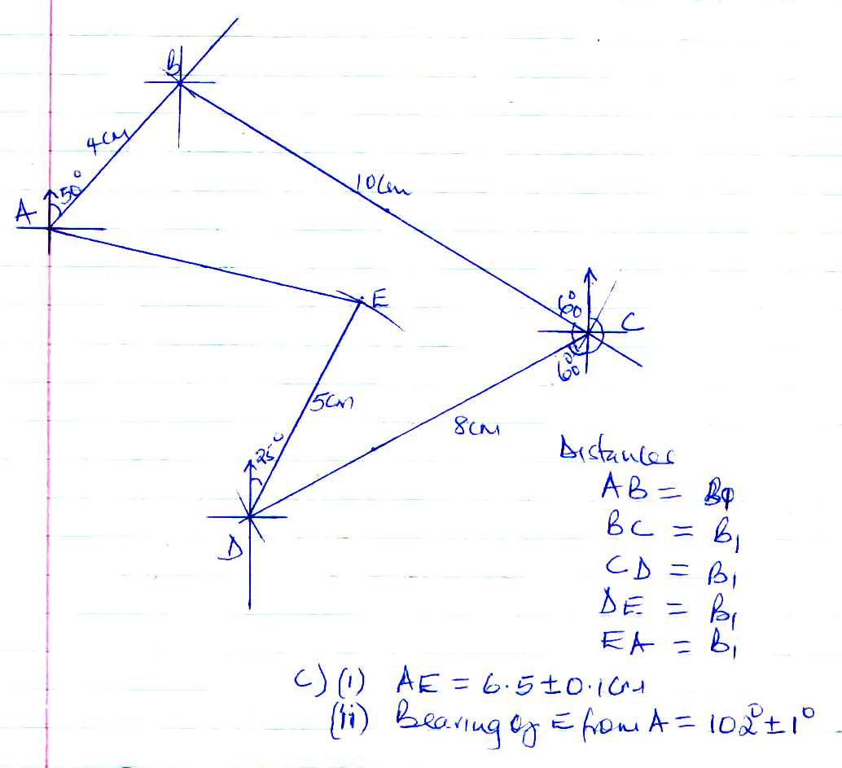
No. 17

No. 21
