TRIAL ONE EVALUATION TEST 2019

CHEMISTRY PAPER 2 MARKING SCHEME

- a) B√ ½ and E ½
b) D√ ½
c) F √ ½ has smallest atomic radius hence electrons are strongly attracted by
positive nucleus √ ½
d) D and G //J and G//D and C//K and G (Any one above award 1mk for both)
e) B and C //I and C//E and C (Any one above award 1 mk for both)
f)
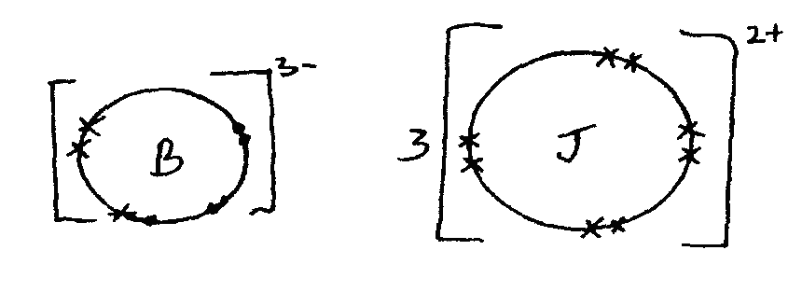
1 mk for showing all charges
1 mk for drawing and labeling the atoms
g) Number of neutrons is not equal to the number of protons.
h) K has stronger metallic bonds √ 1 since it has smaller atomic size √ l hence
more energy is needed to break them.
i) - Add water to the mixture and stir √ ½
- Sulphate of K dissolves while lead (II) sulphate does not √ ½
- Filter √ ½ , lead (II) sulphate as the residue while sulphate of K is the filtrate √ ½
- Evaporate the filtrate to dryness √ ½ to obtain solid sulphate of K√ ½

- a) Carbon (iv) oxide, sulphur (iv) oxide, dust particles Any two 1 mk each
b) To increase surface area√1
c) Reduces wastage √1
d) Temperature of 450 – 500⁰ C
e) - As a fertilizer
- Manufacture of nitrogenous fertilizers
- Softening water
- Manufacture nitric (v) acid
- Remove stains in laundry
- Manufacture of hydrazine used as rocket fuel
f. (i) Platinum – rhodium /Platinum (ii) 4NH_{3(g)} +5O_{3(g)} 4NO_{(g)} + 6 H₂O_{(g)}
(iii) NO reacts with oxygen to form NO₂ which dissolves in moisture forming HNO₃ which falls as acid rain.// NO₃⁻ in water bodies encourages rapid growth of algae leading in a reduction in oxygen content in water. This causes death of aquatic life.
g. (i) Heat is not required 1 (ii)There would be no change in both red and blue litmus papers. Dry chlorine does not have acidic property and does not bleach. (iii) Freshly prepared chlorine water has chloric (i) acid) and therefore bleaches. But when exposed to sunlight chloric (i) acid decomposes into hydrochloric acid and oxygen gas is released

(iv) - heat - the acid must be concentrated
- a) S1
P1
C1

b) i) Zn_{(s)} + 2HCl_{(aq)} Zncl_{2(aq)} + H_{2(g)}
  - Extinguishes a burning splint with a ‘pop’ sound1
  - To ensure that all the zinc granules reacted1
- i) Correct value read from graph1
ii) At 180th minute1
- i) To the right of the curve in (a) 1
ii) To the left of the curve in (a) 1
e) Zn_{(s)} + 2HCl _{(aq)} Zncl_{2(aq)} + H_{2(q)} ½
1 1
65 g of zinc product 24 litres
∴ 13g ” ” x
X=$\frac{13 X 24}{65}$
= 4.8 liters

H H H
- Q C₃H₆// CH₂CHCH₃ 1 C=C---C----H1
H H
H H H H
P C₄H₁₀//CH₃CH₂ CH₂CH₃ 1 H------ C------- C------- C------- C------- H
H H H H

c) Ethanol ½ and Conc. Sulphuric ½ acid 1 mk acc. Correct formula of the compounds
ii) a) Carbon hydrogen Oxygen
% 64.86 13.51 100 – 78.37 = 21.63
RAM 12 1 16
Moles $\frac{64.86}{12}$ = 5.405 $\frac{13.51}{1}$ = 13.51 $\frac{21.63}{16}$ = 1.352
Mole ratio $\frac{5.405}{1.352}$ = 4 $\frac{13.51}{1.352}$ = 10 $\frac{1.352}{1.352}$ = 1
Empirical formula C₄H₁₀O
Molecular formula (C₄H₁₀O)n
N = $\frac{74}{74}$ = 1
Molecular formula = C₄H₁₀O ½
- Alcohols / Alkanols 1

- (a) - Heating value
- Availability
- Cost
- Ease of storage
- Ease of transporting
(b) (i) Heat produced = MC∆T
Mass of water = 100 x 1 = 100g
∆T = 46.5 = 25 = 21.5⁰C
∆H = $\frac{100}{1000}$ x 450 x 21.5
= 40.635kJ
(ii) Molar heat = $\frac{40.635 x 46}{1.5}$= 1246.47kj/mol
(c) C₂H₅OH_{(l)} + 3O_{2(g)} 2CO_{2(g)} + 3H₂O_{(l)} ∆H = 1246.72kJ/mol
(d) - Heat lost to the surrounding
- Heat absorbed by the apparatus
- Experimental errors when reading thermometer

- a) i) To remove carbon (iv) oxide
ii) To dry the air/remove water vapour
b) i) Colour changes from red brown to black
ii) 80 – 63.2 = 16.8 cm³
c) Nitrogen

- a) L - Dilute hydrochloric acid ½
S - Iron (II) Sulphide ½
b)
Anhydrous calcium chloride Dry hydrogen sulphide gas c) Fes_{(s)} + 2HCl_{(aq)} FeCl_{2(aq)} + H₂S_{(g)}
Anhydrous CaCl₂
½
d) i) H₂S turns wet blue litmus paper red ½ but has
No effect on red litmus. 1
ii) A white precipitate is formed 1
e) i) Frasch process
ii) i) Super heated – To melt ½ the sulphur deposits
ii) To force a froath of molten sulphur and water to the surface ½
f) 2NH_{3(g)} + H₂SO_{4(aq)} (NH₄)₂SO_{4(aq)} ½
98g 132g

132 (NH₄)₂SO₄ ≡ 98
125.2 ≡ $\frac{98 x 125.2}{132}$
= 95.95tons

