

**FORM FOUR TRIAL 2, 2019**

**Kenya Certificate of Secondary Education**

**232/2 PHYSICS (Theory)**

**PAPER TWO**

**TIME: 2HRS**

**INSTRUCTIONS TO CANDIDATES**

* This paper consist of two sections: A and B
* Answer all questions in section A and B in the spaces provided
* All workings must be clearly shown. Mathematical tables &electronic calculators may be used

**FOR EXAMINERS USE ONLY**

|  |  |  |  |
| --- | --- | --- | --- |
| **PART** | **QUESTION** | **MAX SCORE** | **STUDENT’SSCORE** |
| A | 1 - 11 | 25 |  |
| B | 12 | 11 |  |
|  | 13 | 07 |  |
|  | 14 | 10 |  |
|  | 15 | 11 |  |
|  | 16 | 11 |  |
|  | **TOTAL** | **80** |  |

**SECTION A (25 MARKS)**

**ANSWER ALL THE QUESTIONS IN THE SPACES PROVIDED**

1. Figure 1 below shows two plane mirrors inclined at an angle x from each other. A viewer counts a total of seven images by looking directly from the object O. Determine value of angel x. (2mks)

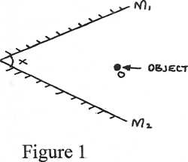

1. A charged metal sphere is connected to an uncharged electroscope as shown in the figure 2 below. State and explain the observations made. (2mks)

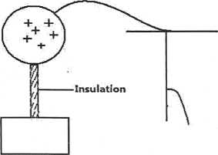

…………………………………………………………………………………………………………………………………………………………………………………………………………………………………………………………………………………………………………………………………………………………………………………………………………………………………………………………………………………………………………………………………………………………………………………………………………………………………………………………………………………………

1. A metre rule is suspended by a thread such that it in equilibrium balanced by a permanent magnet attached to the metre rule and some weight as shown in figure 3 below.

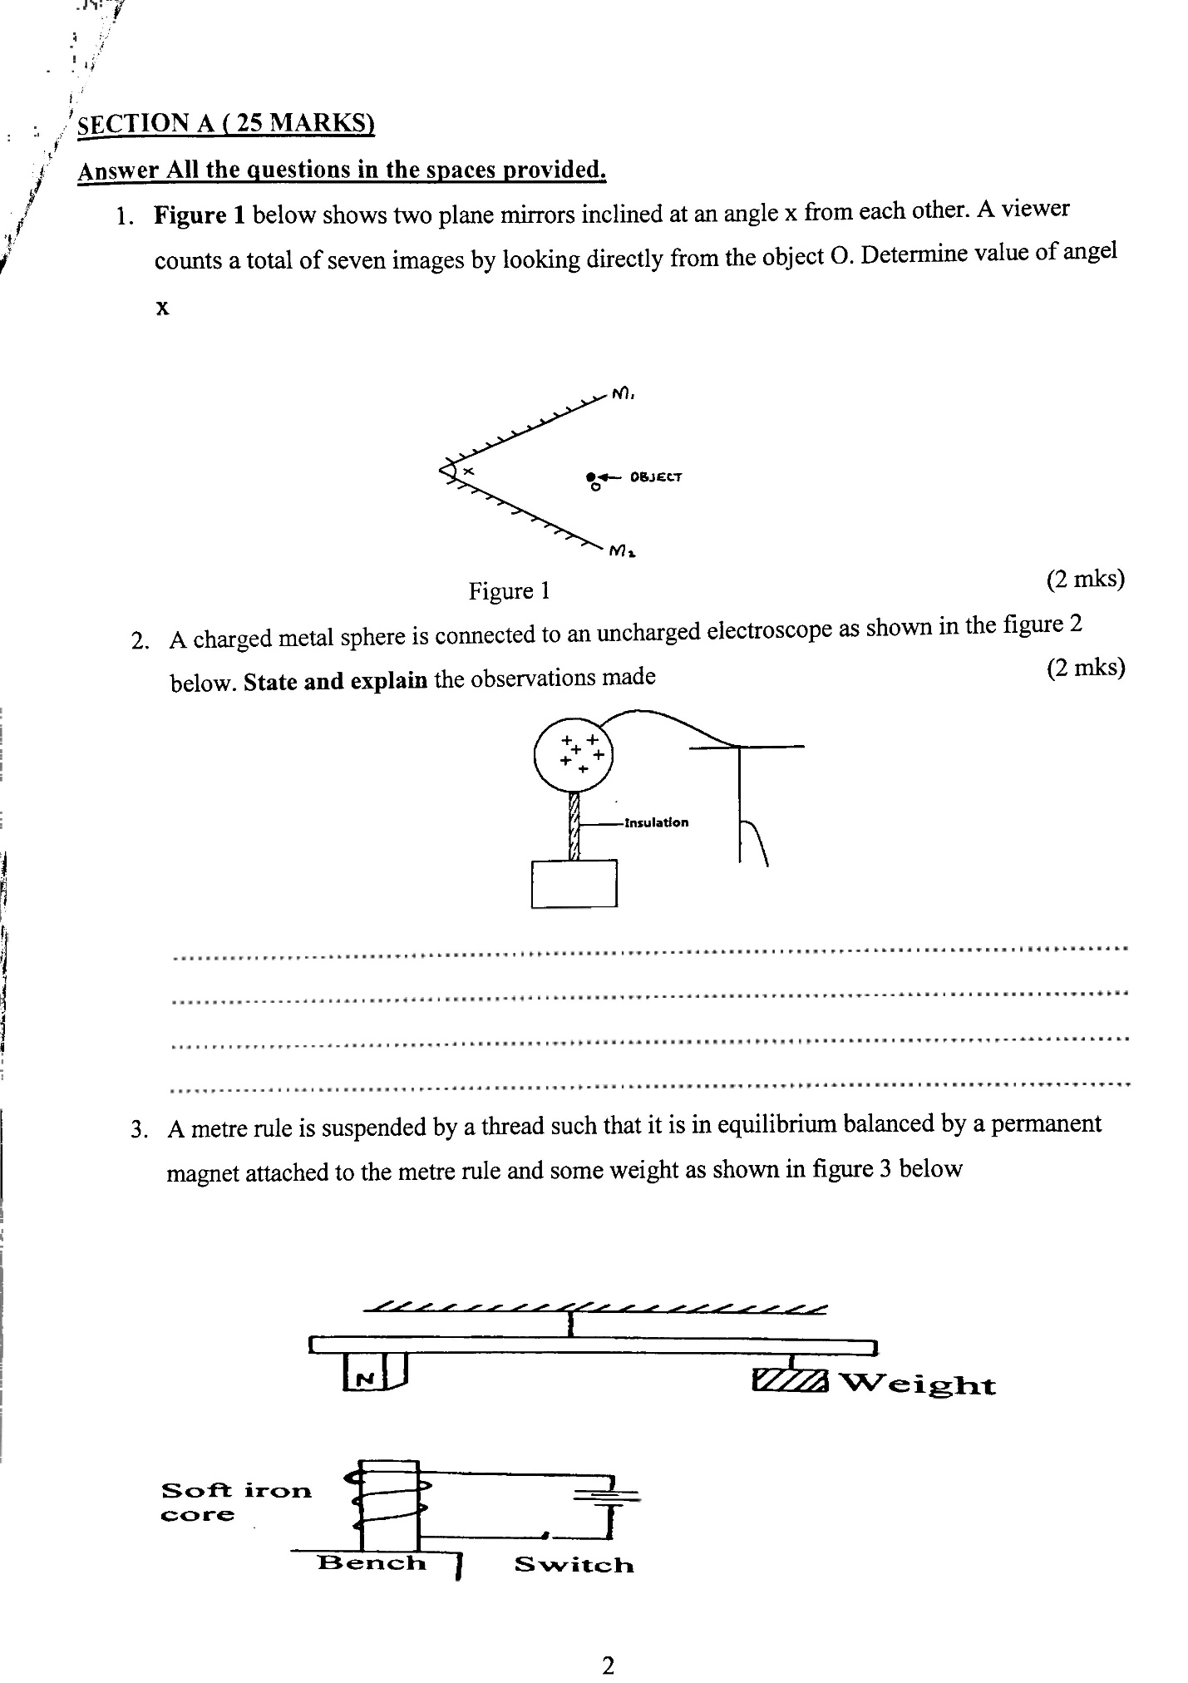

If the soft iron is fixed to the bench, state and explain the effect on the metre rule when the switch is close. (2mks)

………………………………………………………………………………………………………………………………………………………………………………………………………………………………………………………………………………………………………………………………………………………………………………………………………………………………………………

……………………………………………………………………………………………………………………………………………..

1. a) Explain why convex mirrors are preferred to plane mirrors as vehicle side mirrors.

(1mk)

…………………………………………………………………………………………………………………………………………

…………………………………………………………………………………………………………………………………………

b) A part from images being formed behind the mirror, state any other two similarities of images formed by a plane mirror and a convex mirror. (2mks)

………………………………………………………………………………………………………………………………………………………………………………………………………………………………………………………………………………………………………………………………………………………………………………………………………………………………

1. i) Differentiate between polarization and local action in a simple cell (2mks)

……………………………………………………………………………………………………………………………………………………………………………………………………………………………………………………………………………………………………………………………………………………………………………………………………………..

ii) State the use of manganese IV oxide in a dry cell (1mk)

…………………………………………………………………………………………………………………………………..

1. Other than progressive waves travelling in opposite direction at the same speed, state any other two conditions necessary for the formation of stationary (2mks)

……………………………………………………………………………………………………………………………………………………………………………………………………………………………………………………………………………………

1. A gun is fired and an echo heard at the same place 0.6s later. How far is the barrier, which reflected the sound from the gun? (Speed of sound in air=330ms-1 (3mks)
2. In an attempt to make a magnet, a student used the double stroke method as figure 4 shown below. (2mks)

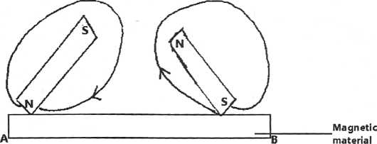

State the polarities at the ends A and B

A………………………………………………………………………

B………………………………………………………………………

1. a) The figure 5 below shows an electromagnetic relay.

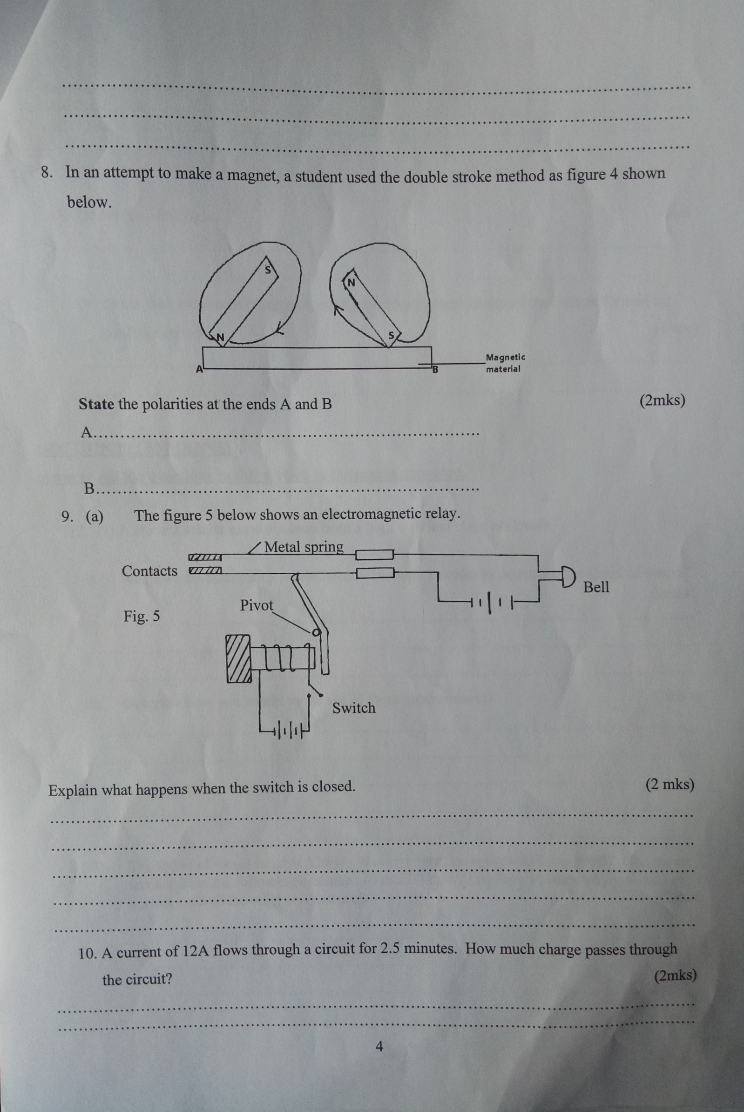

Explain what happens when the switch is closed. (2mks)

………………………………………………………………………………………………………………………………………………………………………………………………………………………………………………………………………………………………………………………………………………………………………………………………………………………………

1. A current of 12A flows through a circuit for 2.5 minutes. How much charge passes through the circuit. (2mks)
2. a) Define term light (1mk)

…………………………………………………………………………………………………………………………………………………………………………………………………………………………………………………………………………

b) Other than the image being real, state any other characteristics of the images formed by pin-hole camera (1mk)

……………………………………………………………………………………………………………………………………

**SECTION B(55MARKS)**

**ANSWER ALL THE QUESTIONS IN THIS SECTION IN THE SPACES PROVIDED**

1. a) A student stands some distance from a high wall and claps his hands
2. What two measurements would need to be made in order to determine the speed of sound? (2mks)

…………………………………………………………………………………………………………………………………………………………………………………………………………………………………………………………….

1. Describe how you would make use of these measurements (2mks)

……………………………………………………………………………………………………………………………………………………………………………………………………………………………………………………………………………………………………………………………………………………………………………………………………………………………………………………………………………………………………………………………..

1. The speed of sound in air is 330m/s. How far from the wall would you stand? Choose an answer from the following distances 10m, 200m,500m. Give reasons why you did not choose each of the other two distances. (2mks)

………………………………………………………………………………………………………………………………………………………………………………………………………………………………………………………………………………………………………………………………………………………………………………………………

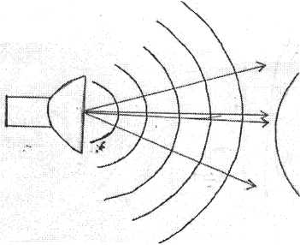b) The balloon filled with carbon dioxide can act like a lens and focus sound from a loud speaker. On to the microphone, Figure 6 show waves produced by loud speaker moving toward the balloon.

1. Complete the diagram to show what happens to the sound waves when they have passed through the balloon and moves towards the microphone. (2mks)
2. The loud speaker is now moved toward the balloon. This results in less sound at the microphone. Explain why there is less sound at the microphone (1mk)

………………………………………………………………………………………………………………………………………………………………………………………………………………………………………………………………

iii) The frequency of the sound emitted by the loud speaker is 1020Hz. Calculate the wavelength of the sound wave in air where its velocity is 340m/s (2mks)

1. a) Define critical angel (1mk)

…………………………………………………………………………………………………………………………………………………………………………………………………………………………………………………………………………

b) Figure 7 below shows a ray of light incident on the face of a cube made of glass reflactive index 1.50

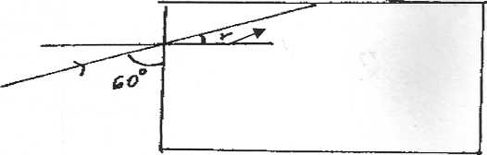

300

Calculate

1. The angle r: (2mks)
2. The critical angle for the glass air interface (2mks)

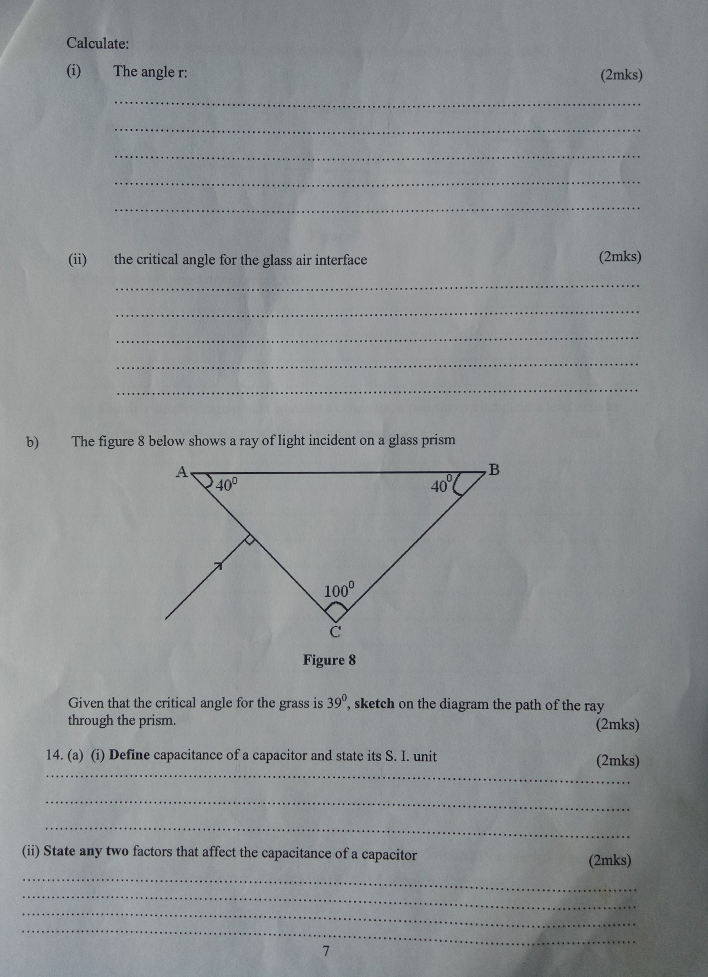c) The figure 8 below shows a ray of light incident on a glass prism. Given that the critical angle for the grass is 39o, sketch on the diagram the path of the ray through the prism. (2mks)

1. a) i) Definecapacitance of a capacitor and state its S.I unit (2mks)

………………………………………………………………………………………………………………………………………………………………………………………………………………………………………………………………………………………………………………………………………………………………………………………………………………

ii)State any two factors that affect the capacitance of a capacitor

…………………………………………………………………………………………………………………………………………………………………………………………………………………………………………………………………

1. The figure 9 below shows three capacitors connected between two points A and B. (3mks)

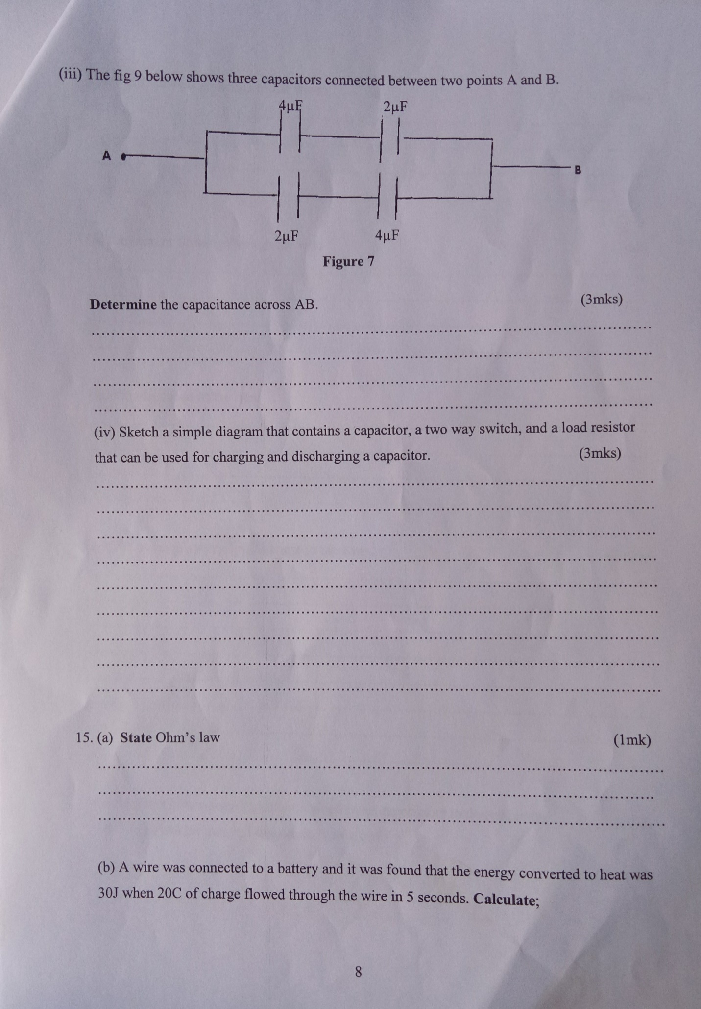

Determine the capacitance across AB

1. Sketch a simple diagram that contains a capacitor, a two way switch, and a load resistor that can be used for charging and discharging a capacitor. (3mks)
2. a) State Ohm’s law (1mk)

……………………………………………………………………………………………………………………………………………………………………………………………………………………………………………………………………….

b) A wire was connected to a battery and was found that the energy converted to heat was 30J when 20C of charge flowed through the wire in 5 seconds. Calculate;

i) The p.d between the ends of the wire (2mks)

ii) The current flowing through the wire (1mk)

iii)The resistance of the wire (2mks)

iv)The average power development in the wire (2mks)

c) The graph below shows results obtained in an experiment the emf (E) and the internal resistance, r, of a cell. Given that the equation of the graph is E = r + 1

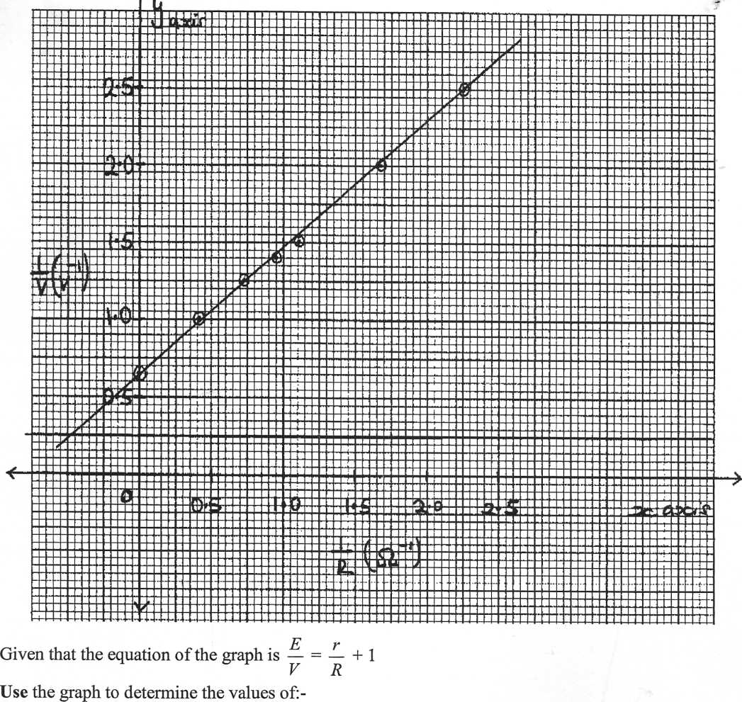1

Use the graph to determine the values of:-

Given that the equation of the graph is $\frac{E}{V}=\frac{r}{R}+$ 1

Use the graph to determine the values of:=

1. E (2mks)
2. R
3. a) Distinguish between stationery waves and progressive waves. In terms of their propagation (2mks)

……………………………………………………………………………………………………………………………………………………………………………………………………………………………………………………………………………………………………………………………………………………………………………………………………………………………..

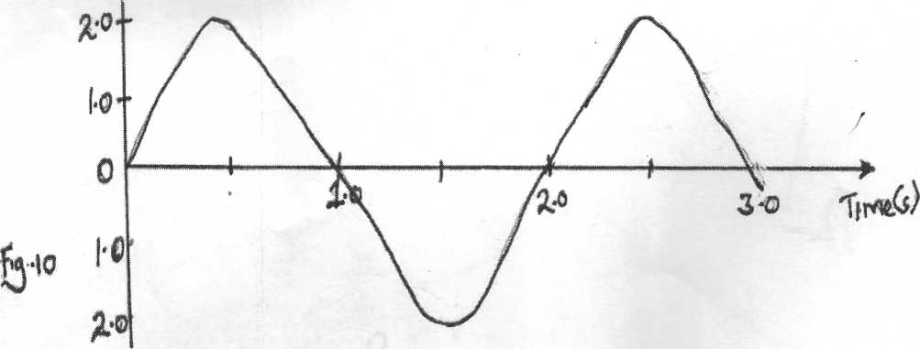b) The figure 10 represents an oscillation taking place at a particular point while a wave in a gas passes the point. The vertical axis is labeled displacement.

1. Explain what is meant by displacement in this context. (1mk)

………………………………………………………………………………………………………………………………………………………………………………………………………………………………………………………………

1. From the figure determine
2. The period (1mk)
3. The frequency (1mk)

c) Calculate the wavelength of the sound wave in the figure. Take the velocity of sound in the gas to be 340m/s (3mks)

d) State two factors that can increase the speed of sound in solids (2mks)

………………………………………………………………………………………………………………………………………………………………………………………………………………………………………………………………………………………………