SMARTPASS EXAMINATION
Kenya Certificate of Secondary Education (KCSE)
MODEL ONE 2019

441/2 - HOME SCIENCE - Paper 2
(CLOTHING CONSTRUCTION) (PRACTICAL)
- TIME: 2 ½ hours

INSTRUCTIONS TO CANDIDATES
(a) This paper consists of 3 printed pages.
(b) Candidates should check the question paper to ascertain that all pages are printed as indicated
and that no questions are missing.
(c) Candidates MUST use machine stitches appropriately in the construction of the garment. Hand stitches
used INSTEAD of machine stitches will not be marked.
(d) Hand stitches will only be allowed for the making of hemming, tacking and loop stitches.

Turn over
A pattern of an apron is provided. You are advised to study the sketches, instructions and the
Layouts carefully before you begin the test.

Materials provided

1. Pattern pieces:
A Apron skirt
B Waistband
C Pocket
D Frill

2. Plain light weight cotton fabric 70 cm long by 90 cm wide,
3. Sewing thread to match the fabric.
4. A button 1.5 cm diameter
5. One large envelope

THE TEST
Using the materials provided, cut out and make the apron to show the following:

a) Work presentation (6 marks)
b) Cutting out (14 marks)
c) Preparation of the interfaced waistband (14 marks)
d) Working the side hems. Machine stitch (8 marks)
e) Making of the two darts on the skirt (8 marks)
f) Attaching the apron skirt to the interfaced waistband (4 marks)
g) Preparation of the patch pocket and attaching the pocket at the centre of the skirt (10 marks)
h) Working of gathers on the frill. Do not machine stitch the outer edge. (4 marks)
i) Attaching the frill onto the skirt using overlaid seam. Neaten half of the seam. (12 marks)
j) Making of the worked buttonhole (6 marks)
k) Attaching the button. (4 marks)
At the end of the examination, firmly sew on your work, a label bearing your name and index number.
Remove the needles and pins from your work, then fold your work neatly and place it in the envelope provided.
Do not put scraps of the fabric in the envelope. Do not seal the envelope.

APRON
FRONT VIEW

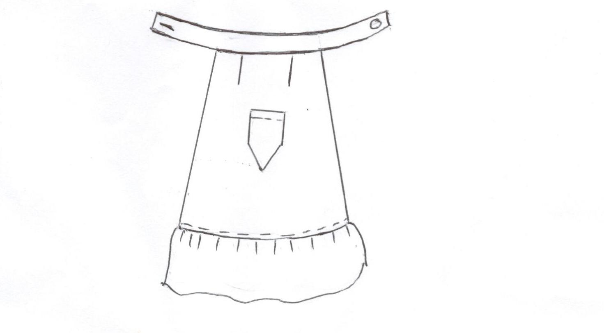

LAYOUT (Not drawn to scale)

