MARKING SCHEME PHYSICS PAPER THREE
QUESTION 1 PART A
- You are provided with the following
- A micrometer screw gauge (to be shared)
- Nichrome wire mounted on a mm scale labeled AB
- A voltmeter (0-3v or 0-5v)
- Ammeter (0-1A)
- A switch
- A jockey/long wire with crocodile clip attached
- TWO new dry cells and cell holder
- 8 connecting wires with crocodile clips attached to one end
Proceed as follows
- Set up the circuit as shown below ensure that when the switch is open, both meters read zero, keep the switch open when readings are not being taken.

Switch
A
B

A
V
L
Jockey or crocodile clip
- Measure and record the diameter d of the nichrome wire AB using the micrometer screw gauge.

$d=_______0.0035_±0.3________________m$
4sf a must (1mk)

- Disconnect the jockey from wire AB and close the switch. Record the value E of the voltmeter reading.

$E=_____________3.0±0.2___________v$
1dp a must (1mk)

- Now, connect the jockey on AB at a distance L=10cm. Close the switch and record the voltmeter and ammeter readings, V and I respectively in table 1 below.

Table 1
L(cm) | 10.0 | 20.0 | 30.0 | 40.0 | 50.0 | 90.0
V(v) | 2.0 | 2.2 | 2.3 | 2.4 | 2.5 | 2.6 | ±0.2 (2mks)
I(A) | 0.9 | 0.6 | 0.5 | 0.4 | 0.3 | 0.2 | ±0.2 (2mks)
IV(watts) |  |  |  |  |  |  | 3sf or exert all correct (1mk)
    - Complete the table
    - Plot a graph of IV (vertical axis) against L

Axes both labelled with quantity and units or units (1mk)
Scale simple and uniform (1mk)
Plotting within one small square (2mk)
L/C passing via atleast ¾ of the plotted line or curve (1mk)

- Using your graph, find the value L_{o} from your graph (the horizontal axis)

$L_{0}=FROM THE GRAPH __________________cm$ (1mk)

- Now, place the jockey on AB such that the length L is equal to the value of L= 63cm. close the switch and record both the voltmeter reading, V and the ammeter reading, I

$V=______2.5__________________$Unit a must, 1dp (1mk)

$I=__________0.3______________$ Unit a must, 1dp (1mk)

- Work out the values r where $r=\frac{E-V}{I}$
Correct substitution (1/2mk)
Evaluation (1/2mk)
Answer
Answer with units (1mk)
Answer without units (1/2mk)
Answer with wrong units (0mk)

- Work out the value of e where $e=\frac{{πrd}^{2}}{2.52}$
Correct substitution (1mk)
Evaluation (1mk)
Answer
Answer with units (1mk)
Answer without units (1/2mk)
Answer with wrong units (0mk)

Question 2
You are provided with the following apparatus
- two metre rules
- two stands and two clamps
- two bosses
- three pieces of thread
- a spring
- one mass of 100g
- a stopwatch
i) Set the apparatus as shown in figure1 below.
ii) Suspend one end of the metre rule with a thread at 5cm mark from the end.
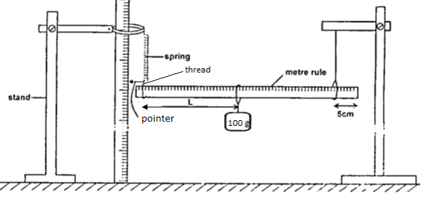
Figure 1
iii) Suspend the other end with a spring also 5cm from the end so that the metre rule is horizontal.
iv) Hold the other rule vertically on the bench so that it is near the end with a pointer as shown in the diagram above.
v) Read the pointer position, Lo ...student value correct to 1dp............... cm (1 mk)
vi) Hang on the horizontal metre rule, the 100g mass at a length, L = l0cm from the spring. Record the pointer position X, in the table below.
vii) Displace the mass slightly downwards and release it to oscillate vertically. Take time for 20 oscillations and record in the table below,
viii) Repeat the procedures above for other positions of L, and record the values in the table below

Length L (cm) | 10 | 20 | 30 | 40 | 50
Pointer position X |  |  |  |  |  | Students values correct to 1dp each ½ mk
Extension (m) |  |  |  |  |  | All correct evaluation to 1dp 1mk
Time of 20 oscill,t (s) | 21.77 | 19.39 | 17.71 | 16.83 | 15.46 | ±2.00 each ½ mk correct to 2dps
Periodic time,T (s) |  |  |  |  |  | All correct evaluation to atleast 3sf or exact 1mk
T² (s²) |  |  |  |  |  | All correct evaluation to atleast 3sf or exact 1mk

ix) Plot a graph of extension, e (y – axis) against T²
axes laballed with units (1mk)
scale simple and uniform (1mk)
plotting (2mk)
line to pass through atleast 3 correctly plotted ponts (1mk)

x) Calculate the gradient of the graph.

Change in y axis (1/2mk)
Change in x axis (1/2mk)
Evaluation (1mk)
Units (1mk)
Wrong units (0mk)

ix) Given that $e= \frac{RT^{2}}{4π^{2}}$determine the value of R
Relating$slope= \frac{R}{4π^{2}}$ (1mk)
Correct substitution (1mk)
Evaluation (1mk)

