MARKING SCHEME
GATUNDU EVALUATION 2019 EXAMINATION PHYSICS PAPER 232/2

232/2
PHYSICS
PAPER 2
JULY / AUGUST, 2019
2 HOURS

SECTION A (25MARKS)
- a)

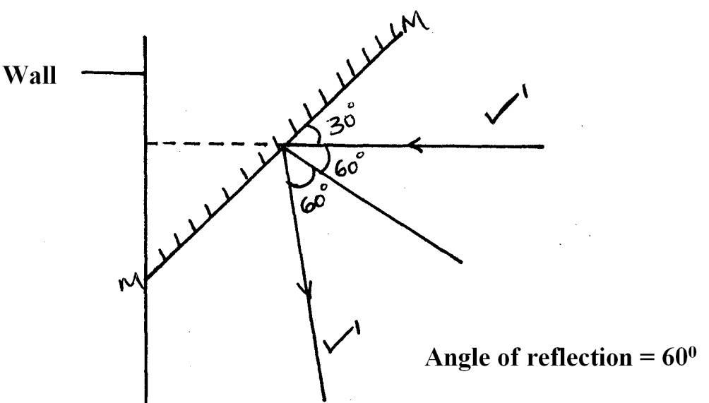

b) When moon covers the sun it obstructs both the light and heat since both move with same velocity.✔

- A is positively charge while B is negatively charged
- Circuit A, internal resistance in circuit A is less than in circuit B and same current flow through bulbs in A while current divide in B through the bulbs.
- (i) South

(ii)
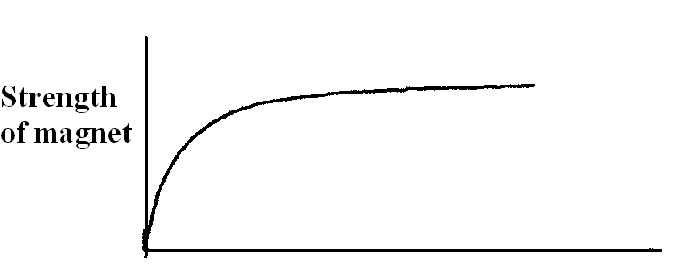
No of stroke

X

Pattern
Direction

- Arsenic shares 4 of its 5 electrons with germanium ✓ and the extra electron is free for conduction. ✓
- r =beta particle, c=206 d= 82
- a) - Galvanometer shows defection ✔1
Reason; When UV radiation energy falls on a metal surface, some electrons absorb this energy and are dislodged from the surface. ✔1 deflection shows current flow.
b) - Galvanometer shows no deflection ✔1mk
- Daily consumption = 4 x 40 + 6 x100 x5
1000 1000
= (0.16 + 0.6) x5 = 3.8 KW✔
Monthly consumption = 3.8 x30
= 114KW or units✔
Monthly bill = 150 + 114 x 5.5
= 150 + 627 = sh. 777✔
- Infrared ✔– Source of heat, used for photography✔
- a) Frequency remains CONSTANT ✔1
b) V = λf
24cm/s = f × 8cm ✔1
f = 3Hz ✔1
- Wider field of view, upright disadvantage is that the image is smaller

SECTION B (55 MARKS)

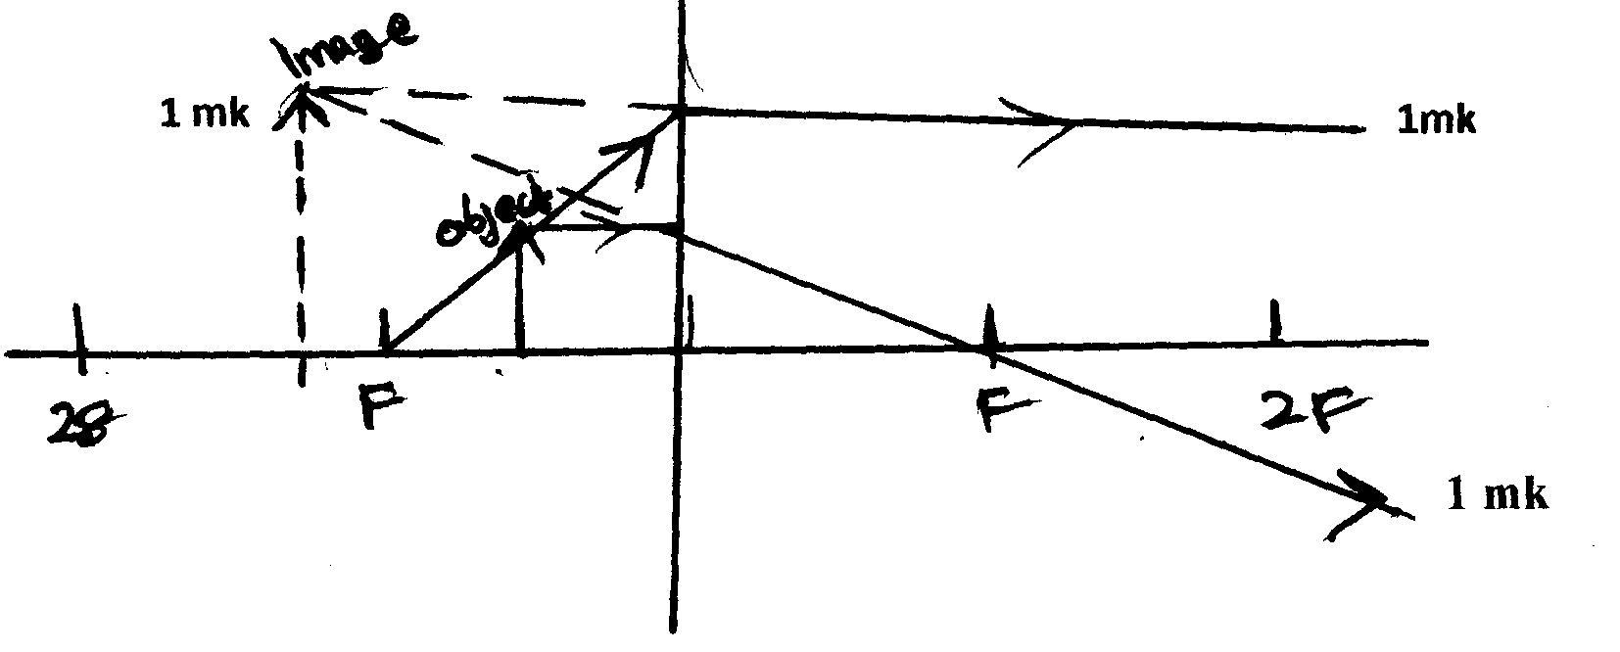

(a) Virtual, magnified and on the same side as object . Any two
(b) (i) Reciprocal of the focal length power of the lens

(ii) 1/f = gradient => f = 1/gradient
f= 13cm
iii v =u= 27cm
(c)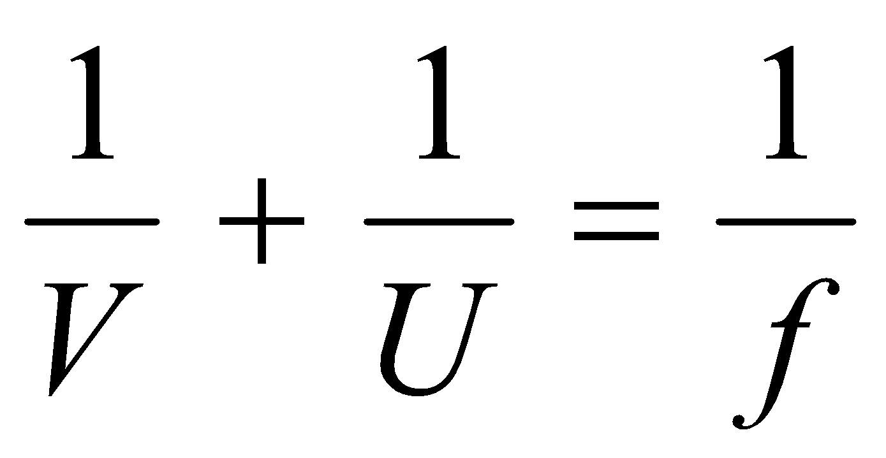 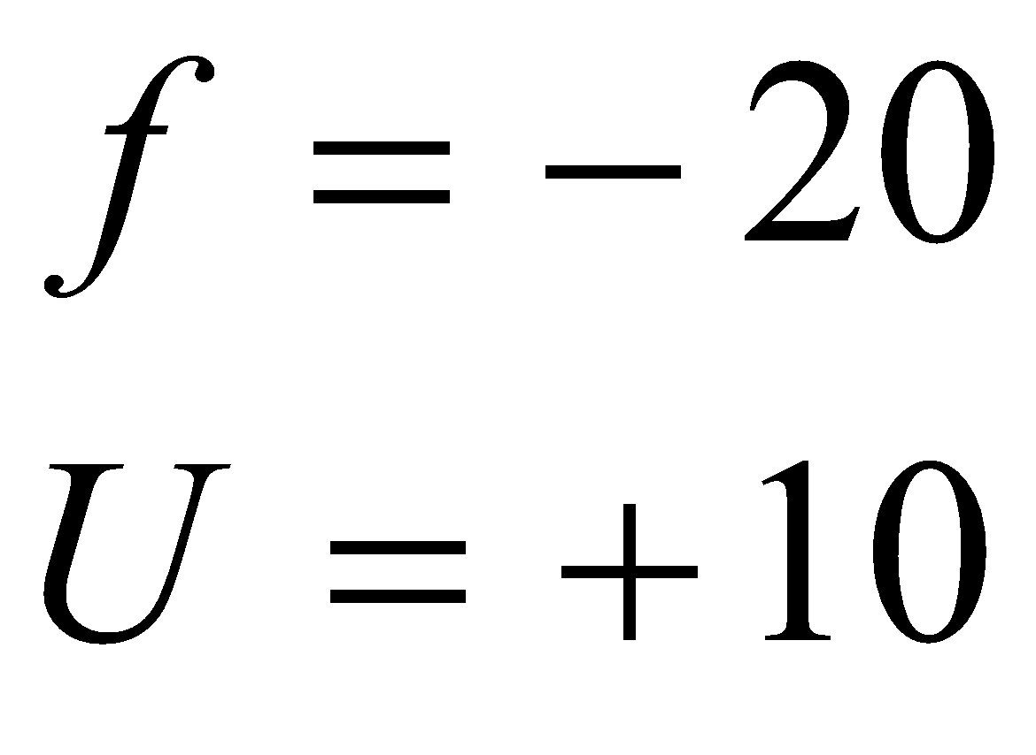
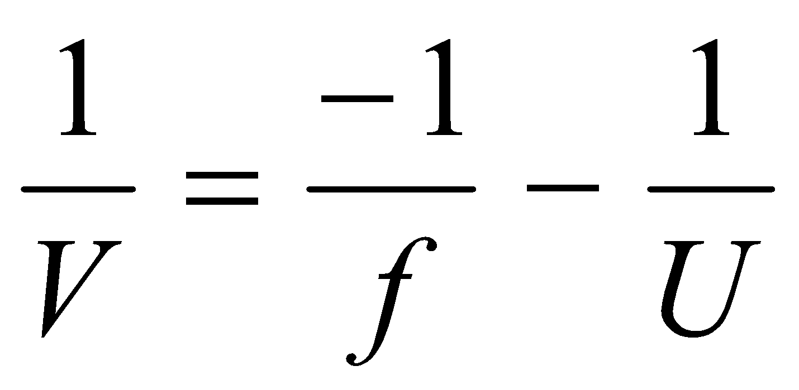 ✓¹
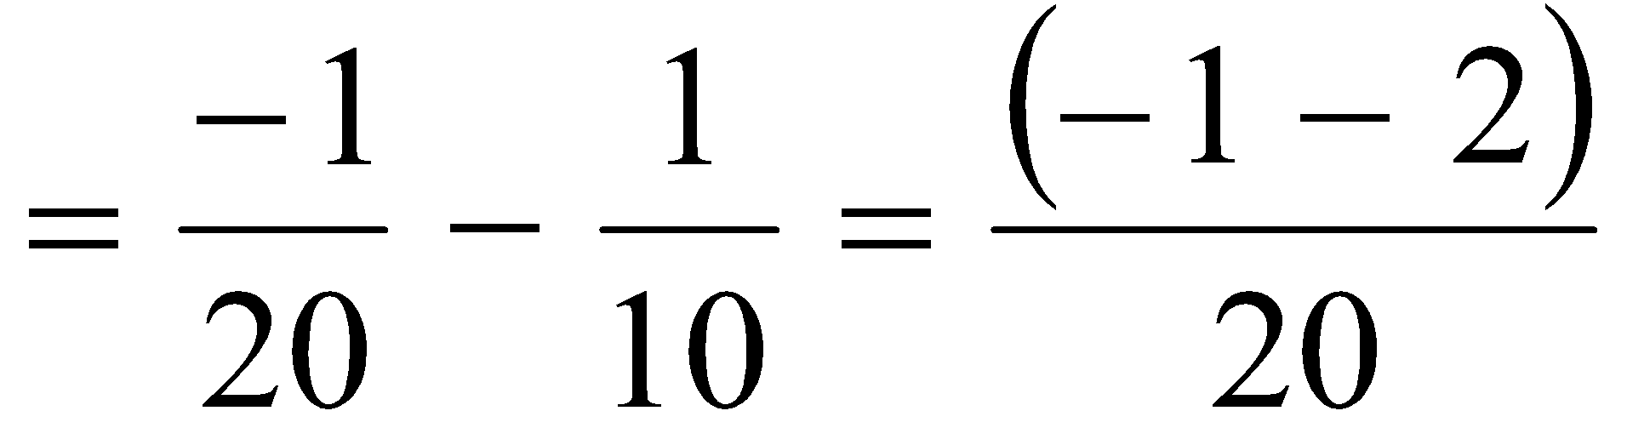
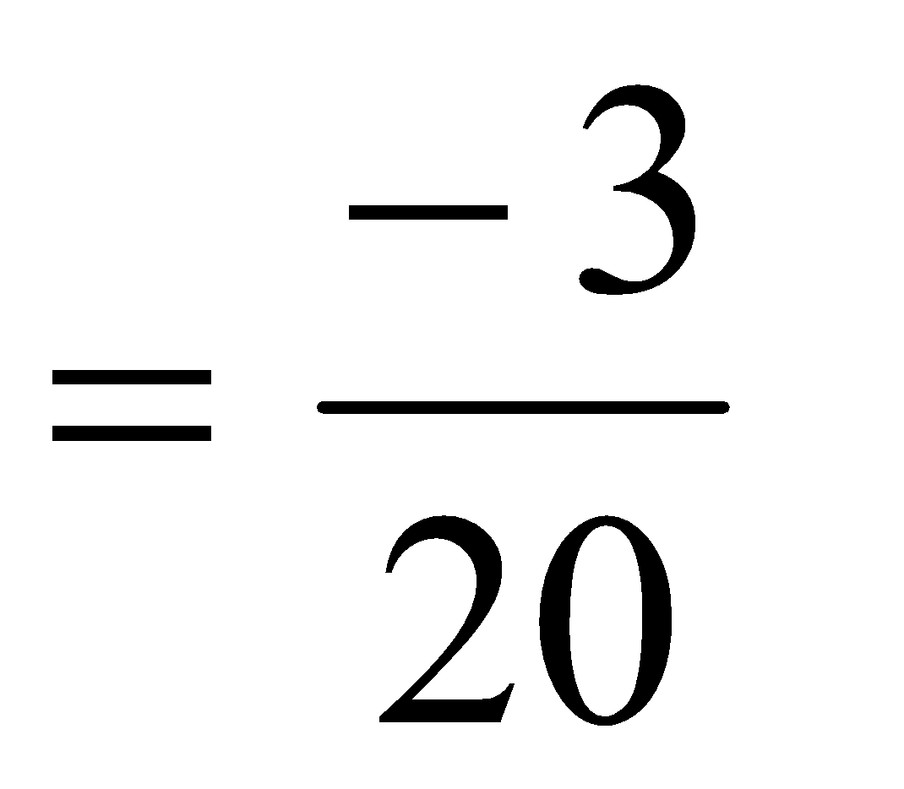
V = 6.67cm ✓¹
- (a) 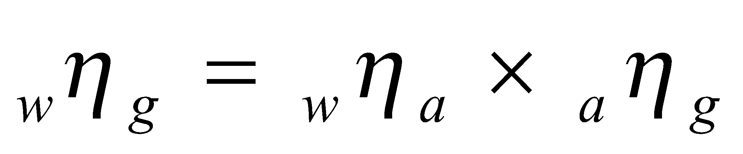
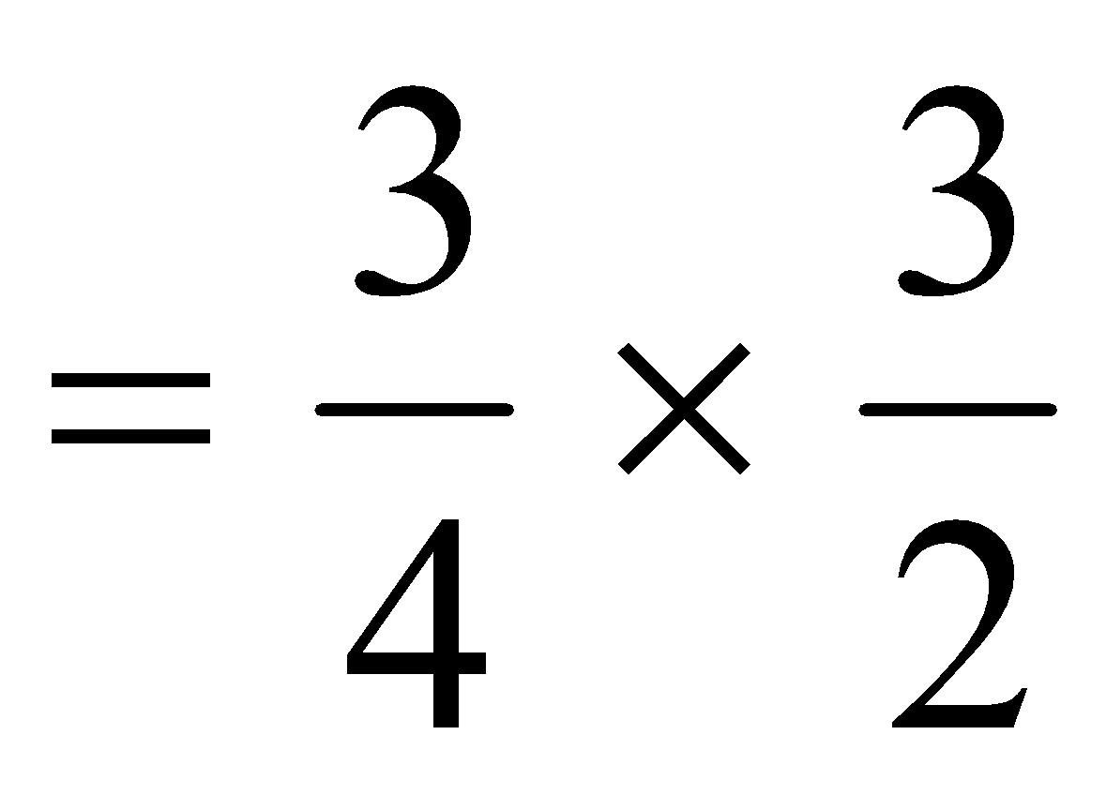
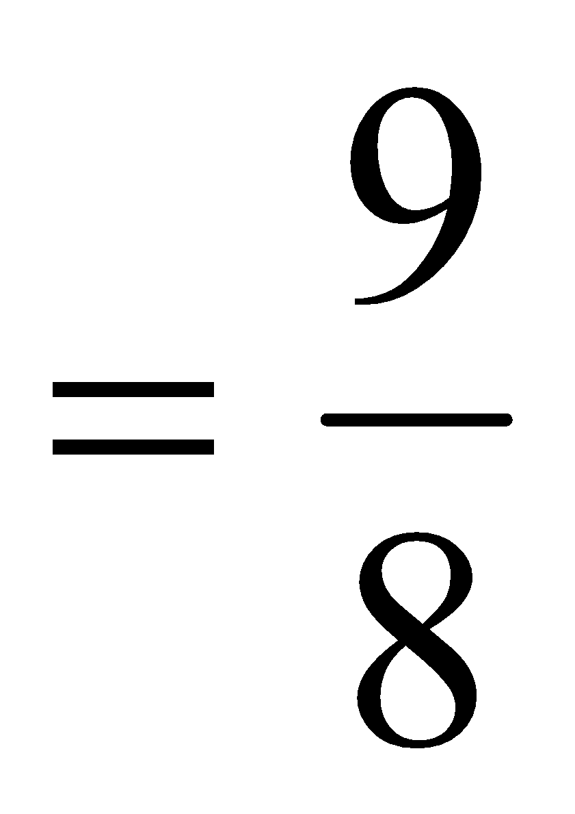
= 1.13
(b) (i) 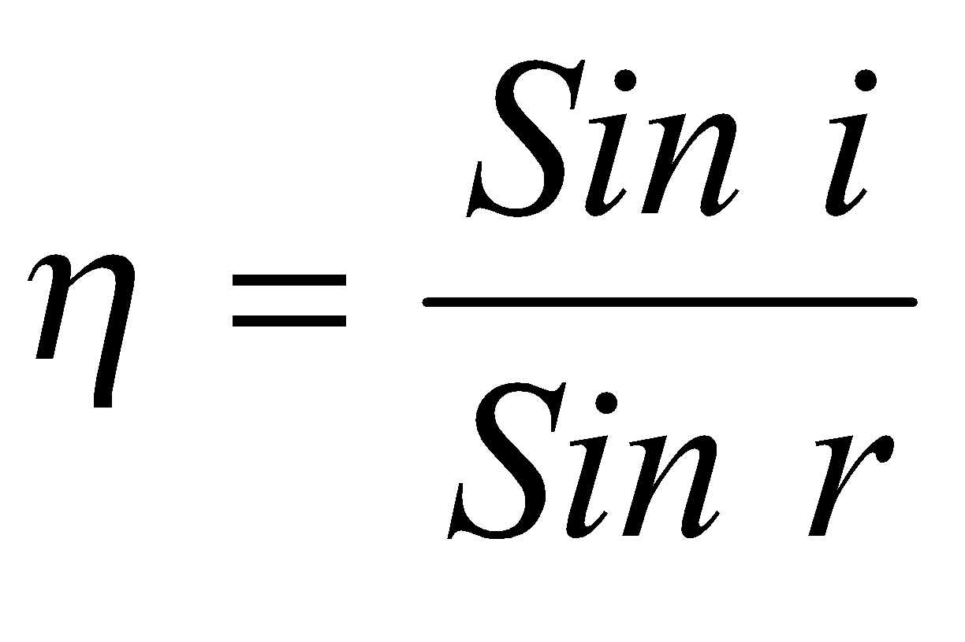
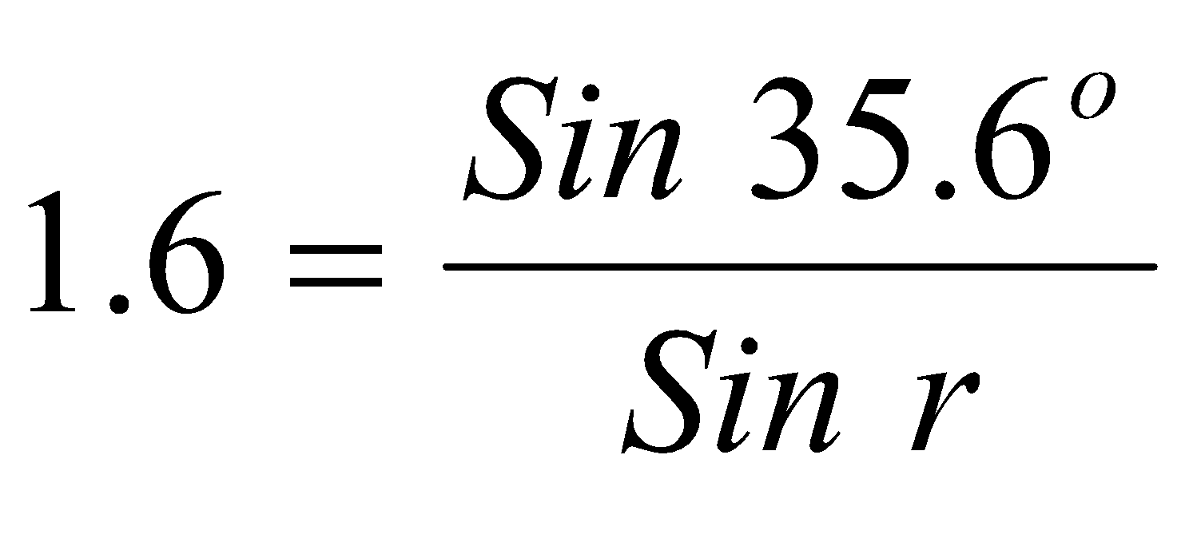
r = 21.3º
- Angle of incidence = 38.7º (show working)
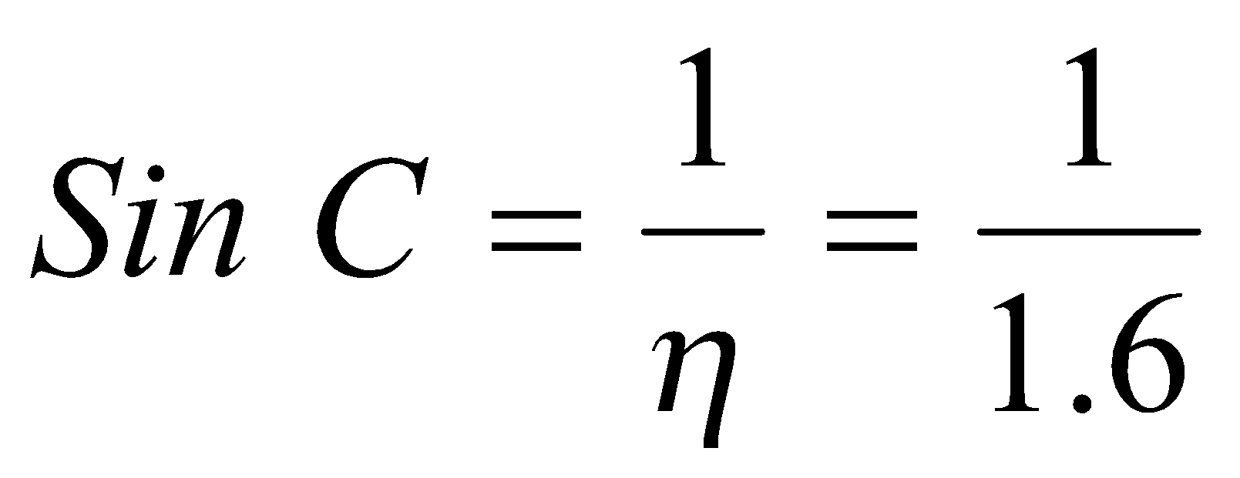
= 38.7º

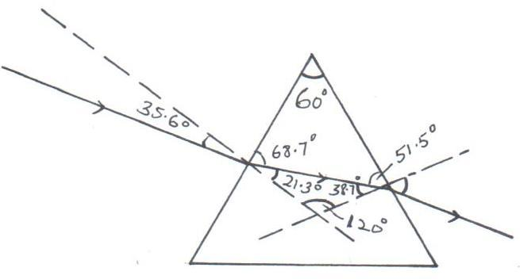
(iii)

(iv) - The critical angle must be exceeded. ✓¹
- Light must be travelling from a dense medium to a less dense medium. ✓¹
(c)
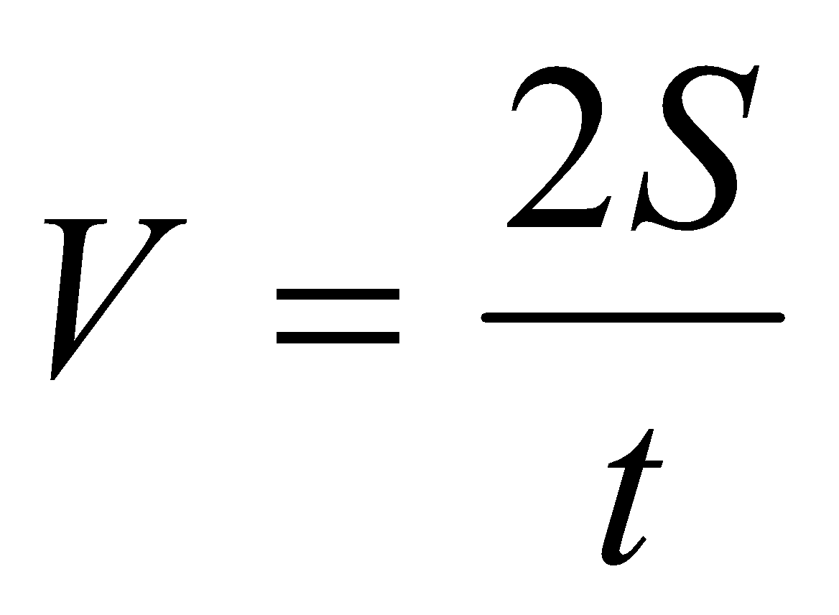 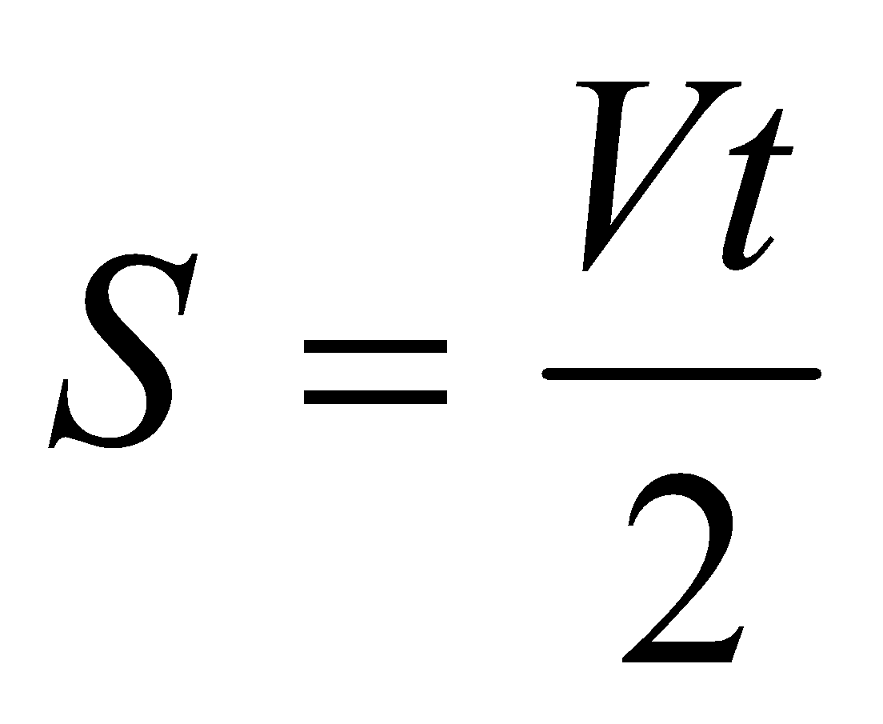 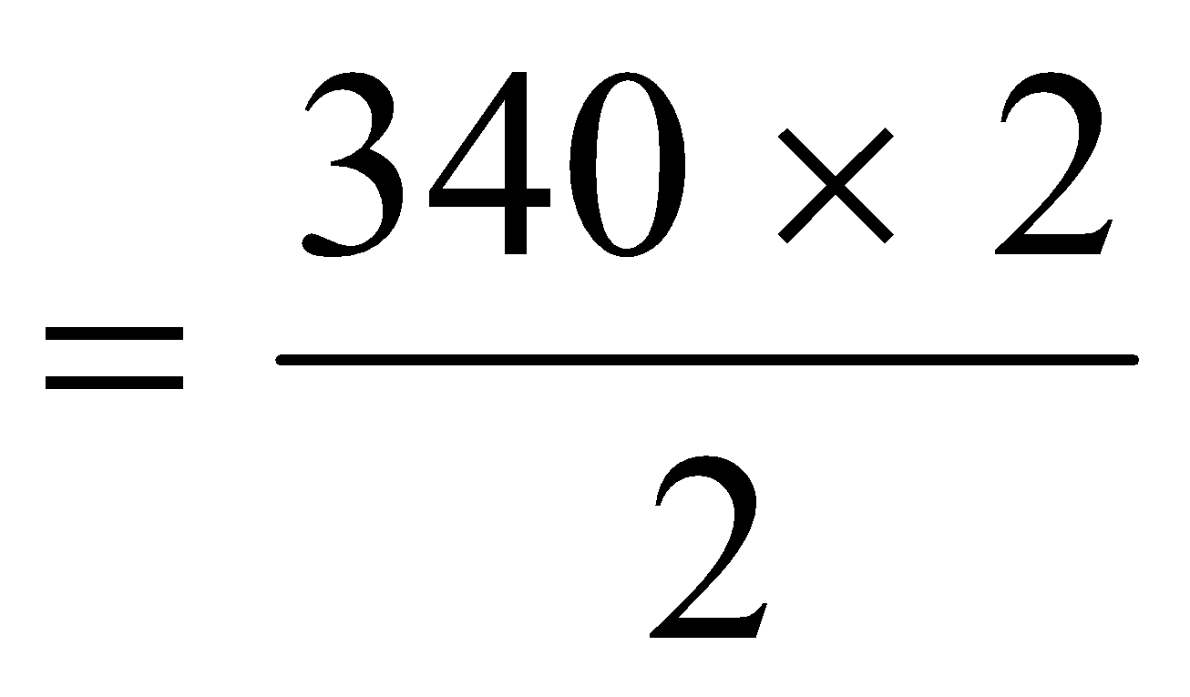✓ = 340m ✓
- a) Capacitors are used in
- rectification smoothing circuits
- tuning circuits
- camera flash
- reduction of sparking in induction coil contact
any one 1

b) i) 2 x 8 = 16 = 1.6μF
2 + 8 10
1.6 + 3.2 = 4.8μF ✔
C_{T} = 5 x 4.8 ✔ = 24 = 2.45 x 10⁻⁶F ✔
5 + 4.8 9.8
ii) Q = CV
= 2.45 x 10⁻⁶ x 12 = 2.94 x 10⁻⁵C ✔
charge on 3.2μF = ²/₃ x 2.94 x 10⁻⁵
= 1.96 x 10⁻⁵C ✔
iii) p.d on 5mF = Q = 2.94 x 10⁻⁵ = 5.88volts ✔
C 5 x 10⁻⁶
iv) energy = $\frac{1}{2}$CV² ✔
= ½ x 2 x 10⁻⁶ x 6.12²
= 3.75 x 10⁻⁵J ✔
(c) (i) Capacitance will also increase
(ii) capacitance will decrease.
- a) Lenz’s Law states that the direction of induced current is such that it opposes the charge producing it.✔
b) i) When switch S is closed, the magnetic field strength increases (magnetic flux) from zero to maximum ✔^{1/2} This changing magnetic flux (field) induces an e.m.f
in the secondary coil ✔1When the switch is opened, the magnetic field strength decreases (magnetic flux) from maximum to zero ✔^{1/2} This produces an induced current in the secondary coil
ii) Having more turns on the coil connected to the cell ✔
c) i) - Hysterisis
- Eddy currents
- Resistance of wire
- Loss of magnetic flux linkage
ii) Power Primary x 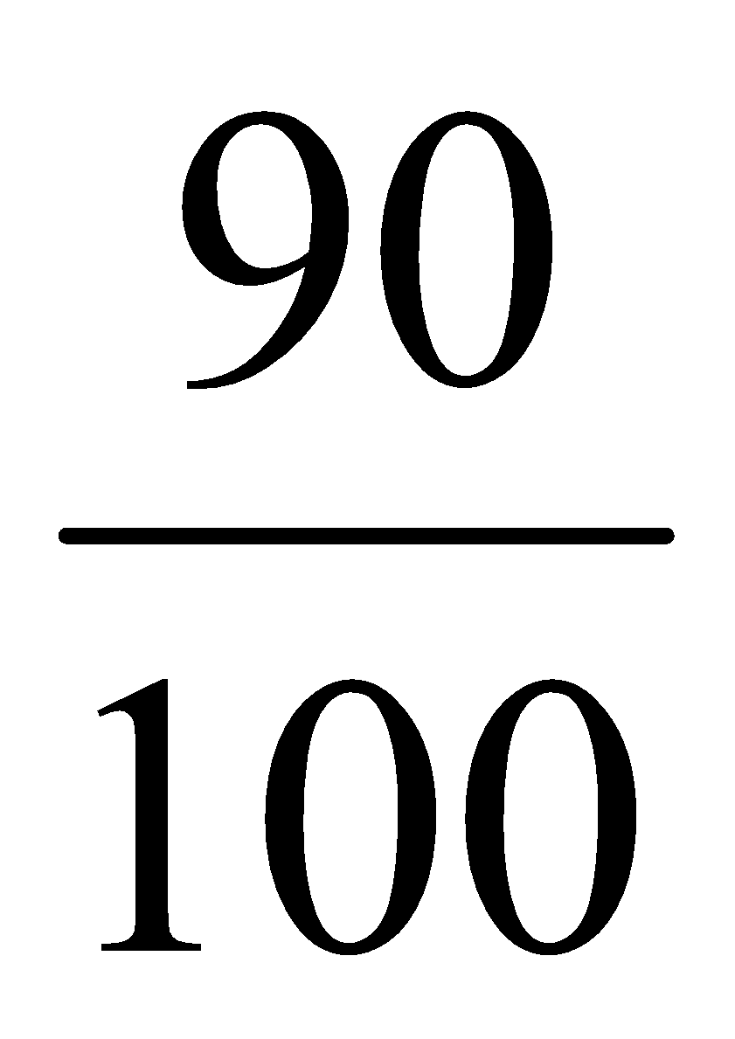= VsIs ✔1
240 x IP x = 80 x 9
IP = 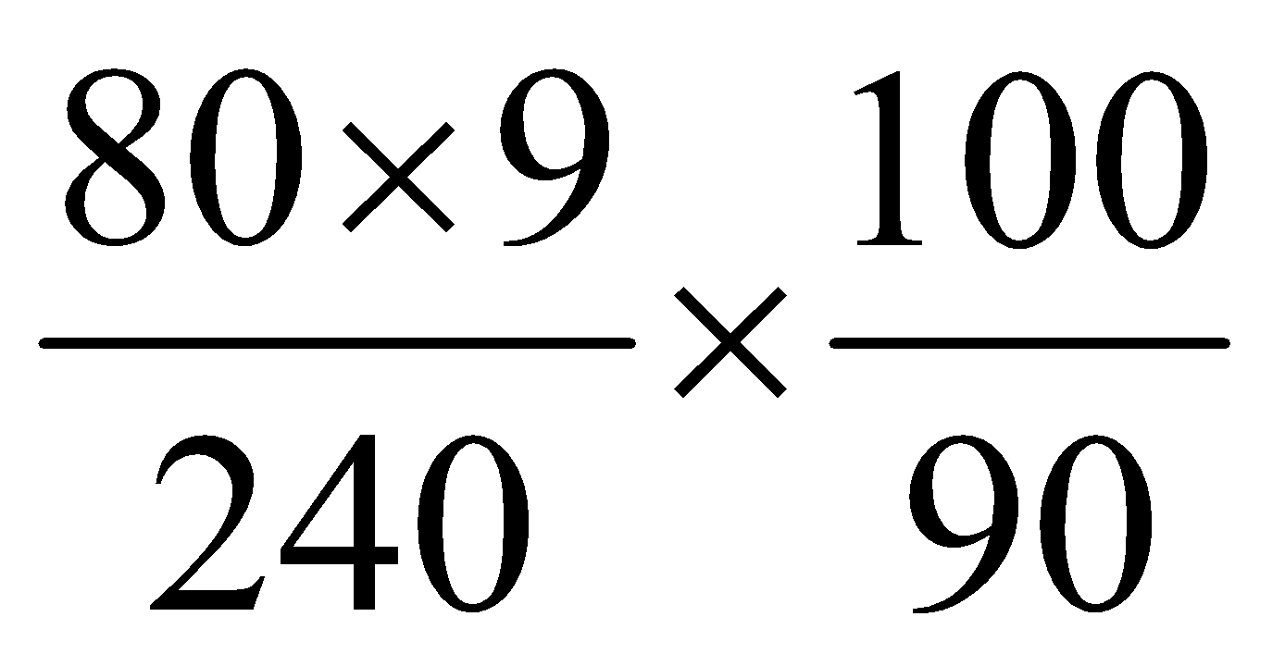✔1 = 3.33A ✔1

d) (i) Emf of the battery equal to v intercept 9.2V
(ii) internal resistance = gradient of the graph .
r = 2.5 3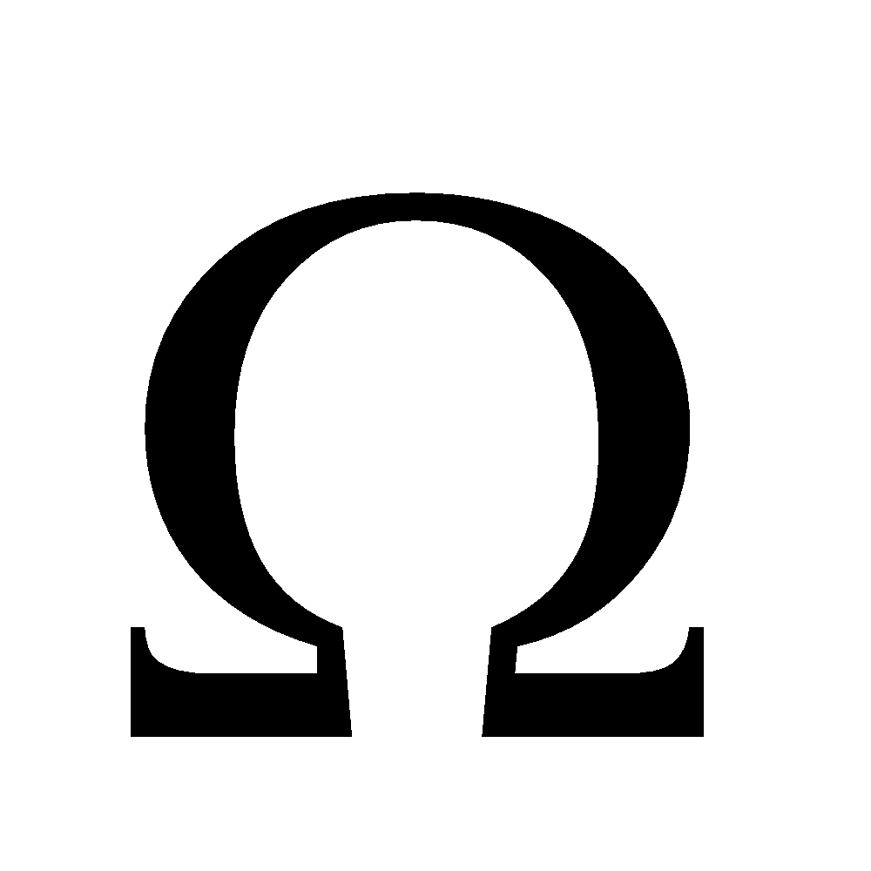
- a) Most of the Kinetic Energy of the electrons is converted into Heat Energy
b) High density

c) E = QV = hf ✔$\frac{1}{2}$
1.6 x 10¹⁹ x 1,200 = 6.63 x 10³⁴ x f ✔$\frac{1}{2}$
f = 2.9 x 10¹⁸ Hz ✔
d) Hard X-Rays ✔ – They have high penetrating power. ✔
e) i) 4x5x2 = 40 V✔
ii) T = 8x10 ✔
= 8x10⁻² s
iii) f = $\frac{1}{T}$ ✔
= $\frac{1}{{8x10 }^{-2} }$ = 12.5 Hz ✔

