GATUNDU SOUTH SUB - COUNTY FORM FOUR JOINT EVALUATION TEST 2019
Kenya Certificate of Secondary Education
312/1
GEOGRAPHY
PAPER 1
MARKING SCHEME
SECTION A
Answer all the questions in this section.
1. (a) List down two isothermal layers of the atmosphere. (2 marks)
Tropopause
stratopause
Mesopause

(b)State any three characteristics of the lowest layer of the atmosphere. (3marks)
-temperature decrease with height
-atmospheric pressure decreases with height
-speed of wind increase with increase in height
-supports life
-contains most of the weather making elements
2. (a) Differentiate between faulting and folding (2 marks)

Faulting is the fracturing / breaking of crustal rocks due to tectonic forces while folding is the bending / crumbling of crustal rocks due to compressional forces.
(b) Apart from Fold Mountains name three other land forms resulting from folding (3 marks)

    - Intermontane basins.
    - Intermontane Plateau
    - Rolling plains
    - Ridge and valley landscape
3. (a) What is mass wasting? (2 marks)
Down slope movement of weathered materials under the influence of gravity.
(b) State three economic benefits of weathering process. (3 marks)

- Weathering cause break up of parent rock to form soil used for agriculture.
- Weathering produces natural resources e.g. clay used for pottery.
- Weathering produce features e.g. granitic tons which attract tourists.
- Weathering weakens the rocks making it easy to exploit through
quarrying / mining.

4. (a) What is soil degeneration? (2 marks)

Soil degeneration is the decline in the usefulness of a soil due to soil mismanagement, environmental causes or even both.

(b)Identify three types of soil degeneration. (3 marks)
- physical degeneration
- chemical degeneration
- biological degeneration
5. (a) Name the type of delta found at the mouth of: (2 marks)
(i) River Nile. Arcuate delta
(ii) River Omo. Bird's foot / digitate
(b) State one effect for each of the following types of erosion. (3 marks)

i)headward erosion_____increase the length of the river valley when the river cuts back upstream
ii)lateral erosion____river erodes its banks leading to the widening of the river valley
iii)vertical erosion______ -takes place at the bed of the river leading to the deepening of the channel
SECTION B
Answer question 6 and any other two questions
- Study the map of Taita Hills 1:50000 (sheet 189/4) provided and answer the questions that follow.
a. (i) Calculate the area (in square kilometers) enclosed by the railway line to the south Eastern part of the area shown. (2 marks)

Complete squares=17 17+ 30/2=32 squares
Incomplete squares= 30 32 x 1km² = 32km²

(ii) Give the four figure grid reference of the school at Mrabenyi. 4223 (1mark)

(iii) Identify the adjoining sheet number to the south East of Taita Hills. 196/1 Sagala (1 mark)

(iv) Name the vegetation type in grid square 3314. Scrub (1 mark)

b. (i) Citing evidence from the map, give two economic activites carried out in the area covered by the map. (4marks)

Economic activity | evidence
trade | Shops, market
Transport & communication | Roads, railway line, post office
Agriculture | Seed farm, agriculture office, teita plantation

(ii)Briefly explain three factors influencing the distribution of settlement in
the mapped area. (6marks)
vegetation/forest-forested areas in the eastern part of taita Hills have no settlemments which may be due to
attacks by wild animals in the forest.
Transport-there are many settlements along roads eg road C04 for easy movement of gods and people from one place to the other.
Terrain/hills- There are no/few settlements in mragua hills due to the steepness which discourages establishment of settlements\
Social amenities- there are many settlements around Bura due to availability of social amenities such as schools and dispensaries which provide medical and education services.

c. (i) cross-section

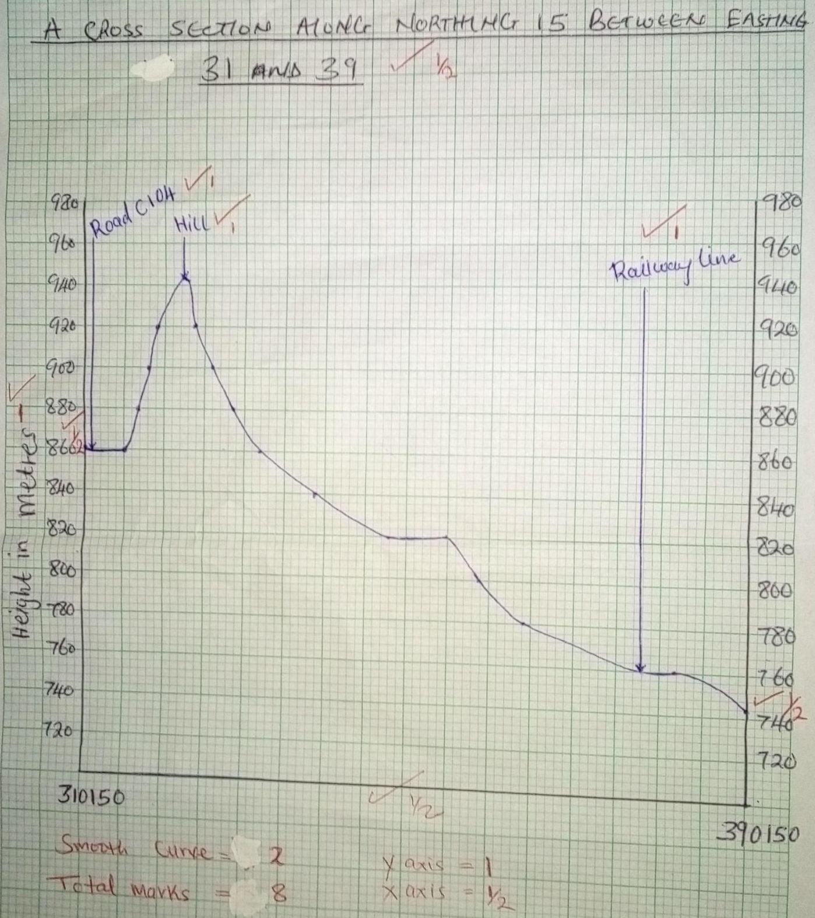

(iii) Calculate the vertical exaggeration for the cross-section. (2marks)

1:2000/1:50000= 25times

7. (a)(i) State four factors which influence the development of a karst landforms. (4 marks)
- The surface is not conducive to settlement because it is rocky.
- The surface in most places has thin soils which would not encourage agriculture.
- The vegetation in most places is poor and would not support livestock rearing.
- Karst landscapes experiences inadequate water supply both on the surface and underground.
- The surface is rugged, thus hindering construction of transport lines.
(ii) The diagram below shows some surface features in a karst region. Name the features marked P, Q
and R. (3marks)
P- Clint Q-Grike R- Limestone
(b) Using a well labelled diagram describe the occurrence of an artesian basin. (6marks)
- An artesian basin is a saucer-shaped depression which consists of a layer of permeable rock sandwiched between two layers of impermeable rocks.
- aquifer outcrops in a region that receives high rainfall or beneath a lake
- aquifer dips from a region of water intake and the rock layers form a broad syncline or basin called artesian basin
- water flows up the artesian basin through pressure without pumping
- one or more aquifer are sandwiched by an impermeable strata to enable retain water
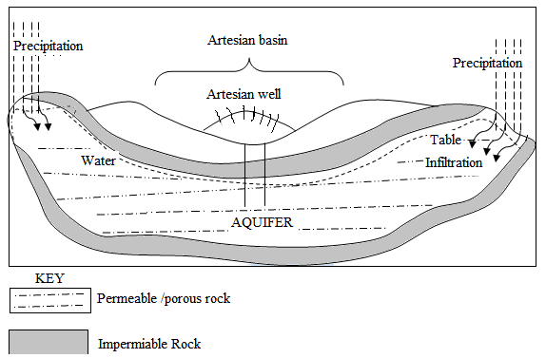

Text=4mks
Diagram =2mks

(c) Give three reasons why there are few settlements on a Karst landscape. (6marks)
- Presence of hard and well-jointed limestone, chalk or dolomite rocks for maximum water permeability.
- Hot and humid climate /abundant rainfall to increase rate of solution.
- Water table should be below/deep the earth’s surface to allow more water percolating down the rocks cracks enhancing formation of features.
- Long period of time the area has been subjected to weathering and erosion processes.
(d) Form four students of your school undertook field work on a karst landscape.
(i) State two objectives of their study. (2marks)
- To find out the features formed in karst landscape.
- To identify the different features within the landscape.
- To establish the economic importance of features in karst scenery.
- To find out the effects of water action in limestone areas on settlement.
(ii) Prepare a simple working schedule for the field study. (4marks)

8:00 am Assembling in class with necessary equipment
8:10 am You are briefed and depart for the area of study.
10:00 am Travel and arrival to the field
10:30 am Embark on data collection and recording
11:30 am Assemble for tea
12:00 am End the field study and depart for school.

(Accept any well written work schedule relevant to the study)
8. (a) Define the term glacier (2mks)
mass of ice of limited width which moves outward from an area of ice accumulation under influence of gravity
(b)Explain three ways in which glaciation negatively influence the human environment (6marks)
Boulder clay deposits create a marshy landscape in some places resulting to poor drainage and the land cannot be fully utilized for agriculture
Infertile sand deposits in outwash plains make the soil unsuitable for agriculture
Morainic deposits result in the formation of numerous lakes thereby reducing the land available for agriculture and settlement
Glaciation results in rugged landscape which discourages settlement

(c) With the aid of well labelled diagrams describe the formation of a cirque. (7marks)
Snow accumulates in a pre-existing depression on the mountain side; it’s compacted to form a cirque glacier
Frost action by the cirque glacier enlarges the hollow/depression,
abrasion at bottom deepens the hollow,
plucking steepens the sides and back wall
A depression resembling an arm chair having a concave floor forms a cirque

Text 4marks
Diagram 3marks

(d) The figure below shows a feature formed in a glaciated landscape. Use it to answer the questions that follow.
- Identify the feature. (1mark)
Crag and tail
- Describe how the above feature is formed. (4marks)
formed when a resistant block stands out on the direction of the glacier.
Resistant side is ended to form the crag.
Deposition occurs on the opposite side to form the tail.
The tail is composed of rock materials of various sizes
(e) The form four class planned to conduct a field study on glaciation in Mount Kenya
(i)Identify any two types of moraines they are likely to see (2marks)
-medial moraines -terminal moraines -lateral moraines
(ii)State any three problems they are likely to encounter (3marks)
- sudden Change of weather eg heavy rainfall or extremely cold
-thick vegetation that hinders movements
-attack of wild animals
-fatigue due to climbing
-difficulties adjusting to low atmospheric pressure
9. (a) (i)Explain 3 factors that influence distribution of vegetation in Kenya (6mks)
soil types____different soil types support different plants
drainage___waterlogged areas support swamp vegetation
Climate ___high rainfall supports dense forests while cool areas have fewer species warm areas more species
Aspect__Leeward sides of slopes have different vegetation from those on windward slope because they receive different amount of rainfall and sunshine
Human activities:__Settlements mining and farming interfere with the original vegetation leading to growth of secondary vegetation and desertification
(ii)State three major vegetation regions in Kenya. (3mks)
-forest vegetation
-heath and moorland
-savannah vegetation
-arid and semi arid vegetation
b(i).Describe any four characteristics of the tropical rainforests. (4mks)
-little or no undergrowth because no sun light reaches the ground
-trees are at different stages of development because there are no seasons
-evergreen since trees shed leaves at different time s throughout the year
-straight and smooth trunks since they compete for sunlight
-wide variety of species
- most trees are hardwoods taking long to mature
-shallow and extensive roots to tap nutrients near the surface
-most have broad leaves
(ii) Give four factors that limit the exploitation of tropical rainforest in Africa. (4marks)
  - Tree take long to mature which discourages exploitation.
  - The forest has a thick undergrowth which make penetration / development of roads difficult.
  - Trees occur in mixed form making it difficult to exploit valuable species.
  - The Climbers / thick vegetation obstruct the felling of trees / huge buttress roots obstruct felling operation / slow felling of trees.
  - Water logged / swampy ground makes construction and maintenance of roads expensive /impassable.
  - Hot and humid conditions are uncomfortable / encourage breeding of disease carrying pests which affect human beings.
  - Some wild animals found in the forest are dangerous and may attack people.
  - Logs are heavy / bulk hence difficult to transport.
(c) (What is climax vegetation? (2 marks)
This refers to plant cover that has established itself without interference/modification in relation to particular/given physical environment (e.g. relief and soil)

(d) Explain three factors that have led to a decline of natural grassland in Kenya. (6 marks)
- The frequent outbreak of bush fires destroys the grass retarding its regeneration.
- The increasing human population / human encroachment into the grassland replacing them with settlement and cultivation land.
- Pests such as army worms / locusts destroy the grass reducing the rate of growth and regeneration.
- Frequent drought experienced in the country destroy the grass and the vegetation degenerate into a semi-desert type.
- Wild and domestic animals overgraze and cause stunted growth of grass.
10. (a) (i) Define the term Aridity. (2 marks)

refers to the state of land being deficient in moisture leading to scanty vegetation
(ii) With the aid of well labeled diagrams describe how a rock pedestal is formed. (5marks)
  - Wind abrassion attack a rock outcrop with alternating layers of hard and soft rocks (heterogeneous)
  - The softer rocks are eroded faster than hard rocks.
  - Wind abrassion is more effective nearer the ground surface where abrassive materials are heavier.This leads to the formation of rock outcrop of different shape called rock pedestal.

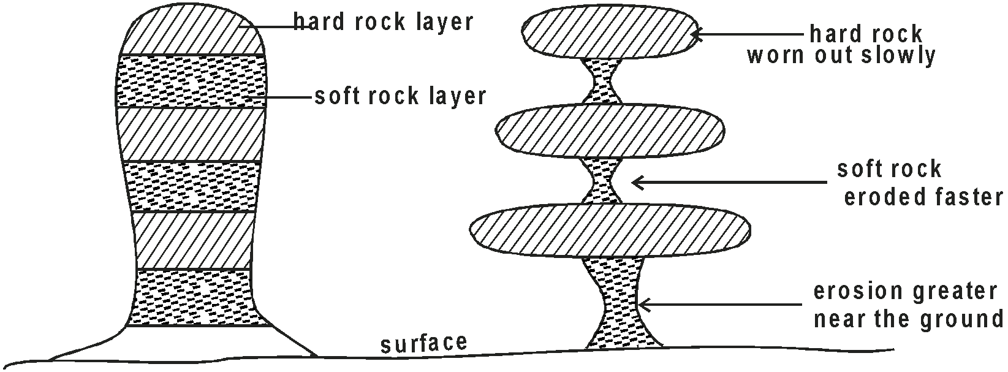

Text 3mks and diagrams 2mks

(b) Your class intends to carry out a field study in an arid area near your school.
- How would you prepare for the field study? (3 marks)
- Ask for permission from the relevant authorities.
- To carry out previsit.
- Prepare a working schedule.
- Formulate objectives and hypothesis.
- Hold discussions in class on aridity
- Prepare questionnaires
- Organize participants into groups
- Prepare necessary documents for the study.

- What are the advantages of studying aridity through field study? (3marks)
- Enables students to collect first hand information
- Enables students to develop manipulative skills. (know how).
- Enables students to learn how weather is recorded using weather instruments.
- Enables students to apply knowledge learned in class room.
- Makes learning interesting /real
- Enables one to collect accurate data
- What advice would you give the residents of the area on curbing the spread of Aridity and desertification? (4marks)
- A fforestation and reafforestastion to reduce the rate of evaporation.
- Irrigating dry lands
- Introduction of energy saving jikos to reduce pressure on forests.
- Stabilizing sand dunes by planting barriers at the fringes of deserts
- Introduction of alternatives forms of fuel to reduce wood consumption
- Name two main wind depositional features they are likely to have identified. (2 marks)
- Loess.
- Drass
- Sand dunes.
(c)Explain three physical factors causing aridity and desertification. (6marks)
  - Insufficient rainfall which doesn't support luxuriant growth of vegetation.
  - High temperature / very low temperature lead to aridity due to little precipitation / drought.
  - Relief barrier / rain shadow effect.
  - Influence of wind system
  - Cold ocean currents
  - Continentality

