NAME ………………………………………………………INDEX NO …………………………….
Candidates signature …………………
Date ………………………………………
233/2
CHEMISTRY
PAPER 2
(THEORY)
JULY/AUGUST 2019
TIME: 2 ¼ HRS
GATUNDU SOUTH JOINT EXAM Kenya Certificate of Secondary Education
CHEMISTRY PAPER 2

Instructions to candidates
- Answer ALL questions in the spaces provided in the question paper
- Electronic calculators and mathematical tables may be used
- All working must be clearly shown where necessary
- Answer the questions in English

For Examiner’s use only
QUESTION | MAXIMUM SCORE | CANDIDATES SCORE
1
2
3
4
5
6
7
8
TOTAL SCORE

Please turn over
- The following diagram represents an incomplete setup of apparatus that can be used to prepare and collect dry sulphur (IV) oxide gas.
Liquid Y
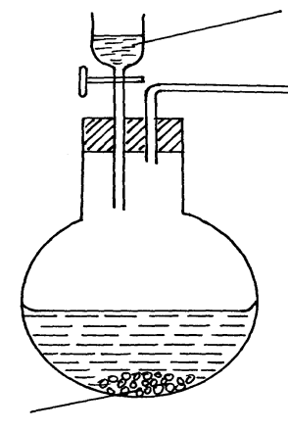

Sodium Sulphite

- Complete the diagram to show how dry sulphur (IV) oxide gas may be collected (3mks)
- Identify Liquid Y (1mk)

- Write an equation for the reaction which takes place in the round-bottomed flask (2mk)

- State the precaution that should be taken during this experiment (1mk)

b) State and explain the observations made when a piece of burning magnesium is lowered into a gas jar full of sulphur (IV) oxide gas (2mks)

c) The following equation represents the reaction that occurs during the contact process.
2SO₂ (g) + O₂ (g) ======= 2SO₃ (g) ∆H = -197kJmol⁻¹
i) Name the catalyst used in this reaction (1mk)

ii) State and explain the effect of increased pressure on the yield of sulphur (VI) oxide (2mks)

iii) The sulphur (VI) oxide is normally absorbed in concentrated sulphuric (VI) acid and not in water. Explain (1mk)

2. (A) i) Write the equation for complete combustion of one mole of ethane (1mk)

ii) Give one use of ethanol (1mk)

B. Use the flow chart below to answer the questions that follow.
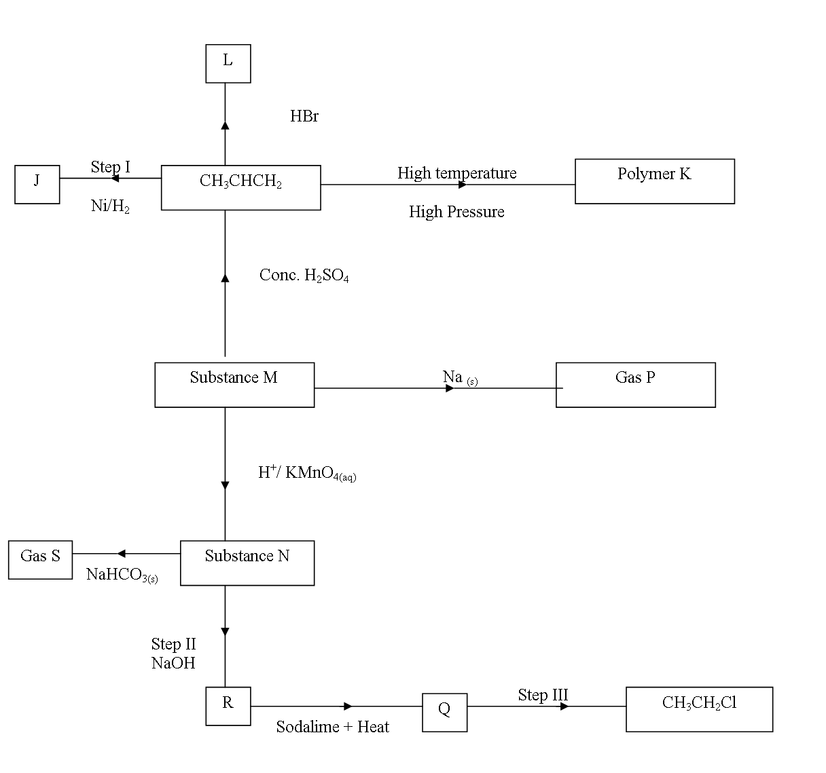
(a) Name the following
(i) Gas S (1mk)

(ii) Gas p (1mk)

(iii) J (1mk)

(b) Name process in
(i) Step I (1mk)

(ii) Step II (1mk)

(iii) Step III (1mk)

(c) Draw two structural Isomers of compound L. (2mks)

(d) Write a chemical equation for the complete combustion of Substance M. (1mk)

(e) Name the reagent and condition in step III.
(i) Reagent. (1mk)

(ii) Condition

(f) Calculate the mass of salt R that would be formed by using 21.9 tonnes of N when it reacts with excess Sodium hydroxide. (C=12.0, H=1.0, Na=23.0, O=16.0) (2mks)

3. a) Study the following energy cycle diagram and then answer the questions that follow.

C (graphite) + ½ O₂ (g) ∆ H₂ CO (g)

∆H₁ ∆H₃
+ ½ O₂ + ½ O₂

CO₂ (g)

- Name the enthalpy change represented by∆H₂? (1mk)

- Use the following information to calculate the value of ∆H₁ for 144g of graphite.
∆H₂ = - 110kjmol⁻¹ ∆H₃ = - 283kjmol⁻¹ (2mks)

- The following table gives molar enthalpies of combustion of some substances. Study it and answer the questions that follow.
C₄H₁₀ (g) + 13 O₂ (g) 4CO₂ (g) + 5 H₂O (l) ∆H^{θ}_{c} = - 2877kjmol⁻¹
2
C (s) + O₂ (g) CO₂ (g) ∆H^{θ}_{c} = - 399kjmol⁻¹

H₂ (g) + 1 O₂ (g) H₂ O (l) ∆H^{θ}_{c} = - 286kjmol⁻¹
2
- What is molar enthalpy of combustion of a substance? (1mk)

(ii)Calculate the molar enthalpy of formation of butane (C₄ H₁₀₎ using the information given above? (3mks)

(c ) The following results were obtained in an experiment to determine the heat of neutralization of 25 cm³ of 2M sodium hydroxide using 25 cm³of hydrochloric acid.
Initial temperature of acid = 25.0ºC
Initial temperature of alkali = 26.0ºC
Final temperature of the mixture of acid + alkali = 38.5ºC
Density of solution = 1gcm⁻³
Specific heat capacity of solution = 4.2 Jg⁻¹K⁻¹
- Define molar heat of neutralization (1mk)

- Write an ionic equation for the neutralization reaction involving hydrochloric acid and sodium hydroxide solution. (1mk)

- Calculate
- The enthalpy change during this experiment. (2mk)

- The molar enthalpy of neutralization for this reaction. (2mks)

4. a) The following are standard electrode potentials for some electrodes. The letters do not represent the actual symbols of the elements.
Element 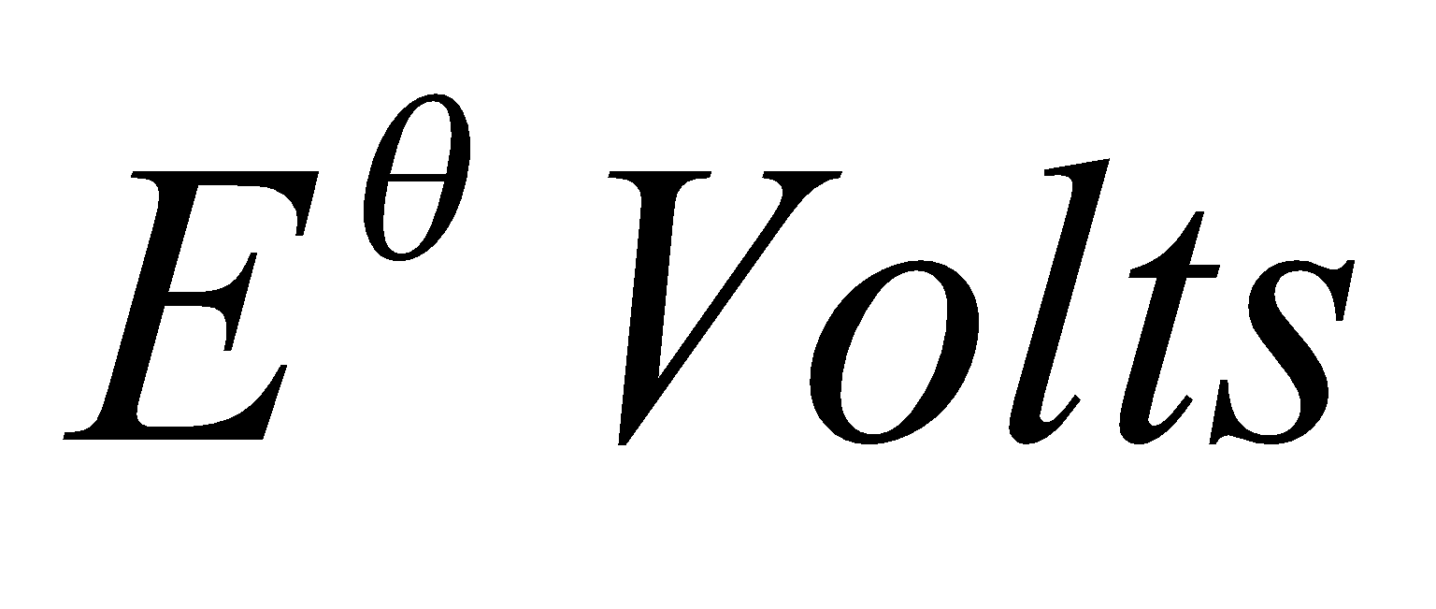
A²⁺_{(aq)} + 2e⁻ A_{(s)} -2.92

B²⁺_{(aq)} + 2e⁻ B_{(s)} -2.28

C²⁺_{(aq)} + 2e⁻ C_{(s)} 0.00

D²⁺_{(aq)} + 2e⁻ D_{(s)} +0.34

E²⁺_{(aq)} + 2e⁻ E_{(s)} +2.87
(i) Which is the weakest reducing agent? Explain. (1 mk)

(ii) Calculate the e.m.f of the cell obtained by combining the half cells of B and D.
(2 mks)

(iii) Write the cell representation for the electrochemical cell obtained in 2 b (ii) above. (1 mk)

(iv) Is it possible to store E nitrate in a container made of A. Give a reason for your answer. (2 mks)

(b) An element X forms a stable ion X²⁺. 14.125g of element X was electrolyzed completely by passing a current of 1.34 A for 150 minutes. Calculate the Relative Atomic Mass (RAM) of X. (3mks)

(c) In another experiment copper was purified using electrolysis. Draw a diagram to show how the
process would be carried out. (3mks)

5. The following flow chart represents the process of extraction of copper metal from copper pyrites. Study it and answer the questions that follow.
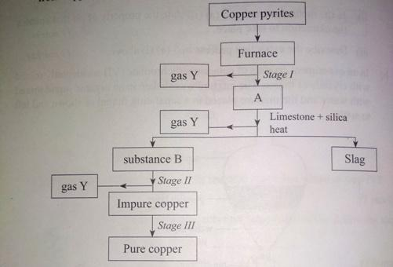
- Name two substances produced in the furnace. (1mk)

- Identify
- Gas Y (½mk)
- Substances B (½mk)

(c ) Write an equation for the reaction that occurs in stage II. (1mk)

(d)What is the role of silica in this extraction process? (1mk)

(e) Name the process that takes place stage III. (1mk)

(f) (i) Explain how copper conducts electricity. (1mk)

(ii)State the composition of bronze. (1mk)

(g) Name the gas produced when copper metal reacts with 50% concentrated nitric (iv) acid. (1mk)

(h) Give any two uses of copper. (2mks)

(i) Name one other copper ore. (1mk)

6. Study the table below and answer the questions that follow.
Element | A | B | C | D | E | F | G
Atomic radius (nm) | 0.156 | 0.136 | 0.125 | 0.110 | 0.110 | 0.104 | 0.099
Ionic radius (nm) | 0.095 | 0.065 | 0.050 | - | - | 0.184 | 0.181
1st Ionization energy KJ/mol | 492 | 743 | 790 | 791 | 1060 | 1063 | 12.54
Mpt (ºC) | 97.8 | 650 | 660 | 1410 | 44.2 | 119 | -101
Atomic number | 11 | 12 | 13 | 14 | 15 | 16 | 17
I Explain why
(i) A has a larger atomic radius than its ionic radius? (½mk)

(ii) G has a smaller atomic radius than its ionic radius? (½mk)

II Comment on the trend of melting points from A to C. Explain. (1mk)

III What is the general trend of the 1st ionization energies for elements A – F. Explain? (1mk)

IV Explain why D has the highest melting point. (1mk)

(b) The grid below is a section of the periodic table. The letters do not represent the actual symbols of the elements. Use it to answer the questions that follow.

 |  |  |  |  |  |  |  | Q
Y |  |  |  | M |  |  | N
K | L |  |  |  |  | S | O | R
 |  |  |  |  |  |  | P

(i) How does electro negativity vary from N to P? Explain (2mks)

(ii) Give the formula of the compound formed between L and P. (1mk)

iii) An oxide of Y was dissolved in water to form a solution. How would you distinguish between this solution and a solution made by dissolving an oxide of S in water? Explain. (2mks)

iv) Write the electron arrangement of the ion L²⁺ (1mk)

7. (a) Define radioactivity? (1mk)

(b) The following diagram shows the effect of an electric field on radiations from a radioactive source.

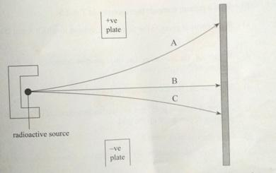

- Identify the radiations marked A, B and C. (3mks)
A
B
C
- With a reason compare the deflection of the radiations A and C. (2mks)

- Which of the radiations has the highest penetration power? (1mk)

(c) Give one use of radioactivity in agriculture. (1mk)

