NAME …………………………………………………INDEX NO …………………………….
Candidates signature ……………………...
Date ………………………………………
233/1
CHEMISTRY
PAPER 1
(THEORY)
JULY/AUGUST 2019
TIME: 2 ¼ HRS
GATUNDU SOUTH JOINT EXAM Kenya Certificate of Secondary Education
CHEMISTRY PAPER 1
Instructions to candidates
- Answer ALL questions in the spaces provided in the question paper
- Electronic calculators and mathematical tables may be used
- All working must be clearly shown where necessary
- Answer the questions in English

For Examiner’s use only
QUESTION | MAXIMUM SCORE | CANDIDATES SCORE
1-29
TOTAL SCORE

Please turn over

- A mixture of hexane and water was shaken and left to separate as shown in the diagram below:

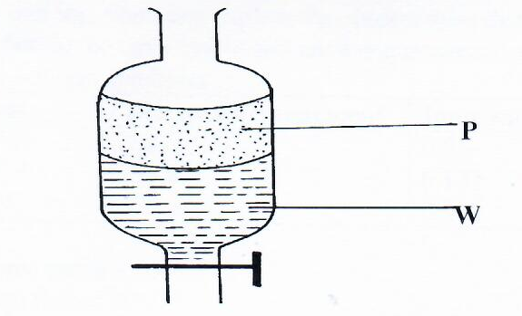

State the identity of;
- P ………………………………..……………….
(ii) W ………………………………….……………. (2mks)

- Copper (II) oxide and charcoal are black solids. How would you distinguish between the two solids? (2mks)

………………………………………………………………………………………………………………………………………………………………………………………………………………………………………………………………………………………………………
- Cooking oils comprise of a mixture of compounds which have a boiling point range of 23ºC to 27ºC.
(i) What evidence is then to support the statement that cooking oil is a mixture? (1mk)
……………………………………………………………………………………………………………………………………………………………………………………………………………………………………………………………………………………………………………………………………………………………………………………………………………………………………………………………………………………………………………
(ii) Name another experimental technique that could be used to confirm your answer in part (i) above. (1mk)

…………………………………………………………………………………………………
…………………………………………………………………………………………………
- State two uses of hydrogen gas that are also uses of carbon (II) oxide gas. (2mks)

…………………………………………………………………………………………………
…………………………………………………………………………………………………

- The setup below was used to investigate the reaction between metals and water.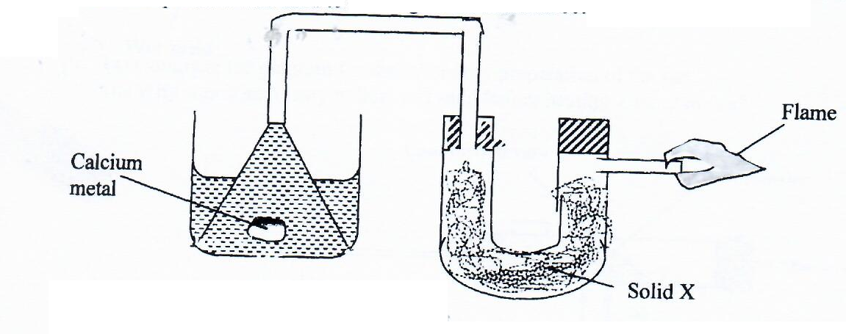

Identify solid X and state its purpose
Solid X ………………..……………………………………………………………….. (1mk)

Purpose ………………………………………………………………………………….. (1mk)

- (a) Explain why aluminium is a better conductor of electricity than magnesium (2mks)

………………………………………………………………………………………………………………………………………………………………………………………………………………………………………………………………………………………………………
(b) Other than cost and ability to conduct, give a reason why aluminium is used for making cables while magnesium is not (1mk)

……………………………………………………………………………………………………………………………………………………………………………………………………

- Differentiate between the bleaching effect of chlorine and sulphur (IV) oxide gases. (2mks)

…………………………………………………………………………………………………………………………………………………………………………………………………………………………………………………………………………………………………………………………………………………………………………………………………………
- . (a) The scheme below shows some reactions starting with magnesium oxide. Study it and answer the questions that follow:-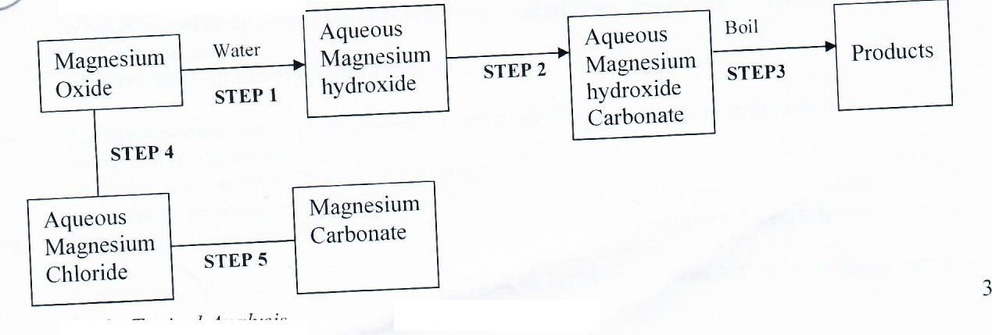
Aqueous Magnesium hydrogen carbonate
- Name the reagents used in steps 2 and 4 (2mks)
Step 2…………………………………………………………………………………
Step 4………………………………………………………………………………….
- Write an equation for the reaction in step 2 (1mk)

………………………………………………………………………………………………
………………………………………………………………………………………………
………………………………………………………………………………………………
- Describe how a solid sample of anhydrous magnesium carbonate is obtained in step 5 (2mks)
………………………………………………………………………………………………
………………………………………………………………………………………………
………………………………………………………………………………………………
………………………………………………………………………………………………
- The formula below represents two cleaning agents M and N.

-
M: R C OSO₃Na⁺ N: R C COO⁻Na⁺

H H

- Identify the one that would be suitable to use with water containing calcium ions. Explain. (2mks)
…………………………………………………………………………………………………………………………………………………………………………………………………………………………………………………………………………………………………………………………………………………………………………………………………………………………………………………………………………………………………………………………………………………………………………………………………………………………………………………………
- Identify the one that has a longer pollution effect. (1mk)
……………………………………………………………………………………………………………………………………………………………………………………
- (a) State Graham’s Law of diffusion. (1mk)

……………………………………………………………………………………………………………………………………………………………………………………………………
(b) 240cm³ of oxygen diffused through an orifice in 100 seconds. How long will it take 300cm³ of sulphur (IV) oxide to diffuse through the same orifice? (S = 32, O = 16)(3mks)

- A hydrated salt has the following composition by mass. Iron 20.2 %, oxygen 23.0%, sulphur 11.5%, water 45.3%. Determine the formula of the hydrated salt (Fe=56, S=32, O=16, H=1). (3mks)

- When propane is passed over heated broken porcelain, it decomposes into ethane and methane.
(a) What name is given to this type of reaction? (1mk)
………………………………………………………………………………………………………………………………………………………………………………
(b) State one application of this reaction. (1mk)
……………………………………………………………………………………………………………………………………………………………………………………
(c) Name a reagent that can be used to differentiate ethane and methane. (1mk)
……………………………………………………………………………………………………………………………………………………………………………………
- (a) Complete the nuclear equation below. (1mk)
24
24
Q R +
11
11

(b) It was found that only ¹/₃₂ of radioactive compound I was remaining after a period of
131
53
150 days; determine the length of the half-life. (2mks)

- The diagrams below represent two allotropes of Sulphur. Study them and answer the questions which follow:-

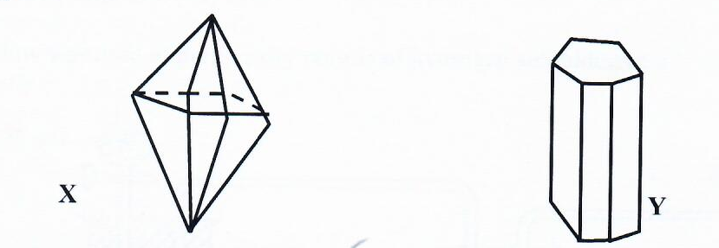

- Name the two allotropes labelled X and Y. (1mk)

X ………………………………………………………………………………
Y ……………………………………………………………………………..

(ii) Explain why a piece of burning magnesium continues to burn in a gas jar of Sulphur (IV) Oxide. (2mks)
………………………………………………………………………………………………………………………………………………………………………………………………………………………………………………………………………………………………
- Describe how you would prepare a dry sample of crystals of potassium sulphate starting with 100cm³ of 1M sulphuric (VI) acid. (3mks)

………………………………………………………………………………………………………………………………………………………………………………………………………………………………………………………………………………………………………………………………………………………………………………………………………………………………………………………………………………………………………………………………………………………………………………………………………………
- The solubility of potassium nitrate in water at 70ºc is 155g/100g H₂O while at 20ºc, the solubility is 31g/100g water. 50g of a saturated solution of potassium nitrate at 70ºc was cooled to 20ºc, calculate the mass that crystallized out. (2mks)

- Bond energies for some bonds are tabulated below:-

BOND | BOND ENERGY KJ/mol
H-H | 436
C=C | 610
C-H | 410
C-C | 345

Use the bond energies to estimate the enthalpy for the reaction. (3mks)
C₂H₄ _{(g)} + H_{2 (g)} C₂H_{6 (g)}

- Nitrogen reacts with hydrogen according to the equation below:-
N₂ _{(g)} + 3H₂ _{(g)} 2NH₃ _{(g)} ΔH = -92KJ
How would the yield of ammonia be affected by increase in:-
i) Pressure (1mk)

ii) Temperature (1mk)

- In an electrolysis, a current of 200A was passed through molten oxide of metal Q for 58 minutes and 64.8g of the metal deposited. Determine;
- Charge on metal Q. (RMM of Q = 27) (1mk)

ii) The volume of oxygen gas produced at standard temperature and pressure
IF = 96500C, molar gas volume s.t.p. =22.4dm³. (2mks)

- . Consider the reduction potentials below.

Pb²⁺ + 2e Pb = -O.13V
(s)
(aq)
(aq)
Mg²⁺ + 2e Mg = -O.76V
(s)

- Write the overall Redox reaction that takes place when the above half cells are connected. (1mk)

- Determine the Eθ value of the above cell. (2mks)

- (a) CFCs have become a big pollution concern this days, what are CFCs. (1mk)
………………………………………………………………………………………………………………………………………………………………………………………………………………………………………………………………………………………………………
(b) State two examples of substances that contain CFCs. (1mk)
……………………………………………………………………………………………………………………………………………………………………………………………………
(c) State one negative effect of CFCs. (1mk)
……………………………………………………………………………………………………………………………………………………………………………………………………
- The set-up below was used to investigate reaction between copper (II) oxide and ammonia gas
Copper II oxide

Combustion tube

Ammonia gas

Gas T

heat
heat

Water

a) Identify gas T (1mk)
……………………………………………………………………………………………………………………………………………………………………………………………………

b) Write an equation for the reaction that took place in the combustion tube. (1mk)

c) State the observation made in the combustion tube. (1mks)
………………………………………………………………………………………………………………………………………………………………………………………………………………………………………………………………………………………………………
23. a) Name the process by which propanol is converted to propanoic acid. (1mk)
…………………………………………………………………………………………………………………………………………………………………………………………………… b) Explain why solubility of propanol is higher than that of propane. (2mks) ………………………………………………………………………………………………………………………………………………………………………………………………………………………………………………………………………………………………………………………………………………………………………………………………………… 24. Study the set up below and answer the questions

Flame

Glass tube

Bunsen burner
i) What does the experiment show? (1mk) ……………………………………………………………………………………………………………………………………………………………………………………
ii) Name the type of flame shown above (1mk) ……………………………………………………………………………………………………………………………………………………………………………………
iii) Name one characteristic of the flame (1mk) ……………………………………………………………………………………………………………………………………………………………………………………………………
25. a) Sodium chloride dissolves in water to give a neutral solution but aluminium chloride dissolves in water to form Acidic solution. Explain. (2mks)

……………………………………………………………………………………………………………………………………………………………………………………………………………………………………………………………………………………………………………………………………………………………………………………………………………………………………………………………………………………………………………
b) Aluminium (III) chloride has a relative formula mass of 267 when in gaseous state. Explain (1mk)
……………………………………………………………………………………………………………………………………………………………………………………………………………………………………………………………………………………………………………………………………………………………………………………………………………………………………………………………………………………………………………
26. Write the electronic arrangement of sulphur in the following: (s=16) (3mks)
i) SO₃²⁻

ii) SO₃

27. a) What is an acid base indicator. (1mk)
………………………………………………………………………………………………………………………………………………………………………………………………………………………………………………………………………………………………………

b) Explain why universal indicator may be preferred to acid base indicator. (2mks) …………………………………………………………………………………………………………………………………………………………………………………………………………………………………………………………………………………………………………………………………………………………………………………………………………………………………………………………………………………………………………………………………………………………………………………………………………………………………………………………………………………………………………………
28. In the very cold countries, salts are sprinkled on the roads during winter.
i) Explain why this is important. (1mk) ………………………………………………………………………………………………………………………………………………………………………………………………………………………………………………………………………………………………………………………………………………………………………………………………………………………………………………………………………………………………………………………………………………………………………………………………………………
ii) Give one negative effect of this. (1mk)
……………………………………………………………………………………………………………………………………………………………………………………………………
29. Chlorine gas reacts with cold dilute sodium hydroxide to form a bleaching agent W.
a) Write the formula of the substance W (1mk)

………………………………………………………………………………………………………………………………………………………………………………………………………………………………………………………………………………………………………
b) Write an equation to show how substance W bleaches. (1mk)
………………………………………………………………………………………………………………………………………………………………………………………………………………………………………………………………………………………………………

