GATUNDU SOUTH JOINT EVALUATION TEST.
FORM FOUR END OF TERM TWO EXAM.
THIS PAPER COMPRISE OF THREE COMPULSARY QUESTIONS. ATTEMPT ALL FOR MAXIMUM SCORE.
BIOLOGY PAPER 231/3

1 (A) During a field study, a student took a photograph of a flower before and after removing some petals as shown below.
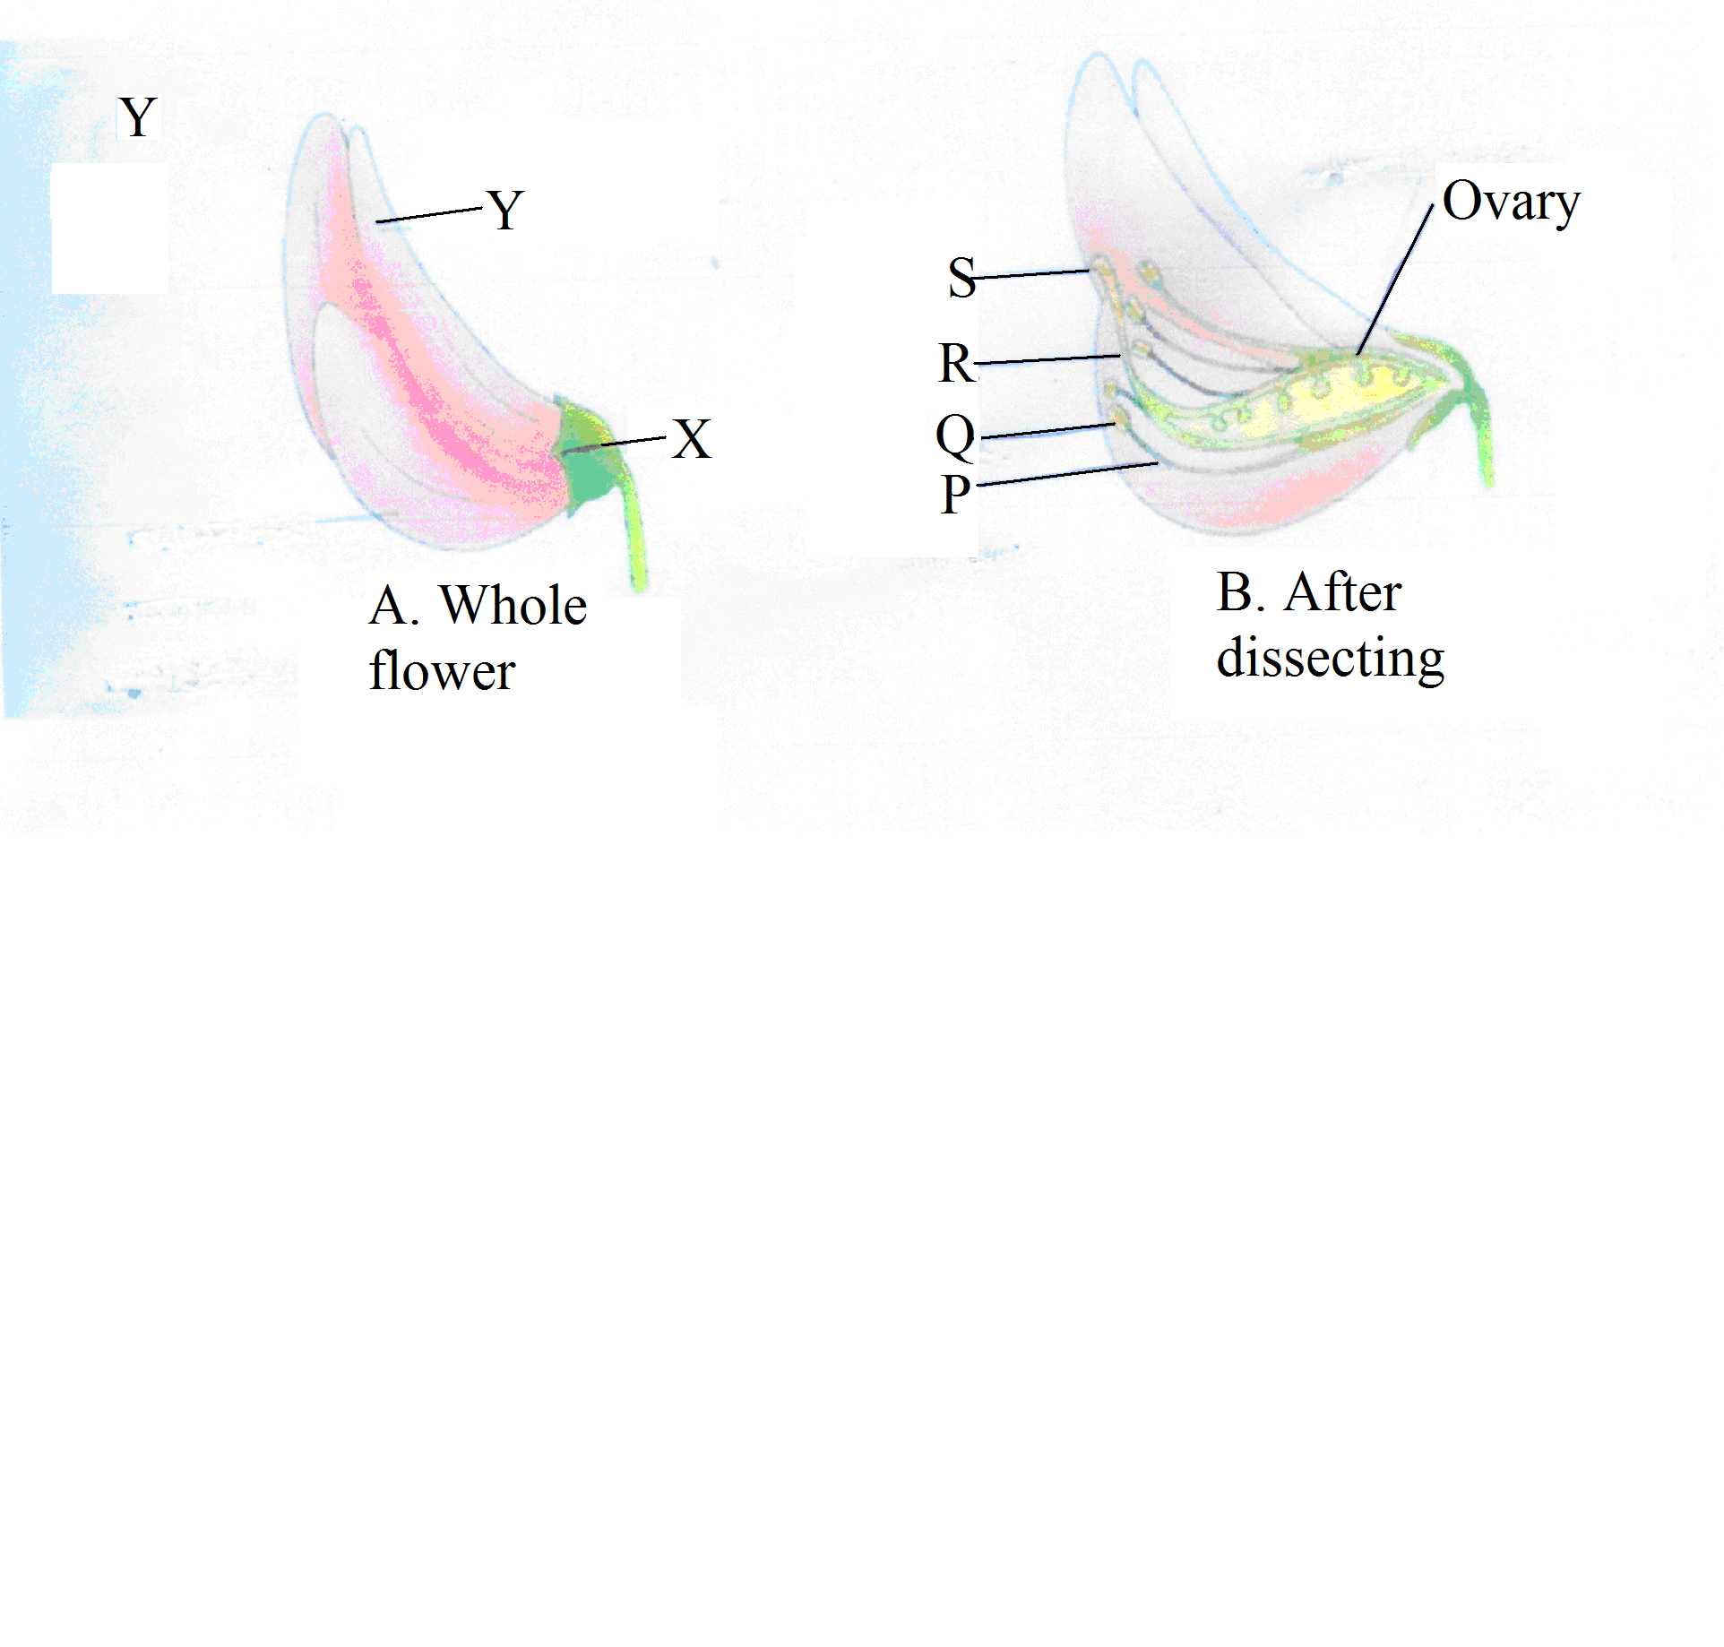
T

(a) Name the parts marked Q,R,S and X (4mks)

(b) State the functions of parts X ,Yand R . (3mks)

(c) Briefly describe the nature of the corolla of the flower above (2mks)

(d) Which term best describe the nature of the calyx of the flower above (1mks)

(e) What type of ovary does the flower have? (1mks)

(ii)Give a reason to support your answer in f(i) above (1mks)

(g) Giving reasons state the agent of pollination in this flower
(i) Agent (1mks)

(ii) Reasons (1mks)

2. You are provided with olive oil, liquids labelled L₁ and L₂ and Irish potato. Label two test tubes A and B. Place 2cm³ of water into each test tube. Add 4 drops of olive oil into each test tube. To test tube labelled A, add 4 drops of liquid L1. Shake both test tubes. Allow to stand for 2 minutes.
a) i)Record your observations.
Test tube A (1 mark)

Test tube B. (1 mark)

ii) Name the process that has taken place in test tube A. (1 mark)

iii) State the significance of the process named (a)(ii) above . (2 mark)

iv) Name the:
digestive juice in humans that has the same effect on oil as liquid L1.(1 mark)

region of alimentary canal into which the juice is secreted. (1 mark)

b) Label two test tubes C and D.
Place 2cm³ of liquid L2 into each. Add a drop of iodine into each test tube.
i) Record your observation. (1 mark)

ii) Suggest the identity of L2. (1 mark)

From the Irish potato provided, cut out a cube whose sides are 1cm. Crush the cube to obtain a paste. Place the paste into a test tube labelled C. Leave the setup for at least 30 minutes.
iii) Record your observations. (1 mark)

iv) Account for the results in (b) (iii) above. (3 marks)

3(a) Name the parts labeled N,X and Z on photograph G. (4mrks)
M……………………………………………………………………………………………..
N………………………………………………………………………………………….

X………………………………………………………………………………………

X……………………………………………………………………………………….
(b).State the function of the structures labeled M , N and Y
M………………………………………………………………………………………………………………………………(2 mrks)

N……………………………………………………………………………………………………………………………….(1 mrk)

Y……………………………………………………………………………………………………………………………………….(1mrk)

(c). State three functions of the organ labeled Z. (3 mrks)

(d). (I) Name the class to which the dissected animal in photograph G belongs to. (1mrk)

(ii) Give a reason for your answer in c (I) above (1 mrk)

