PHOTOGRAPHS FOR QUESTION ONE.

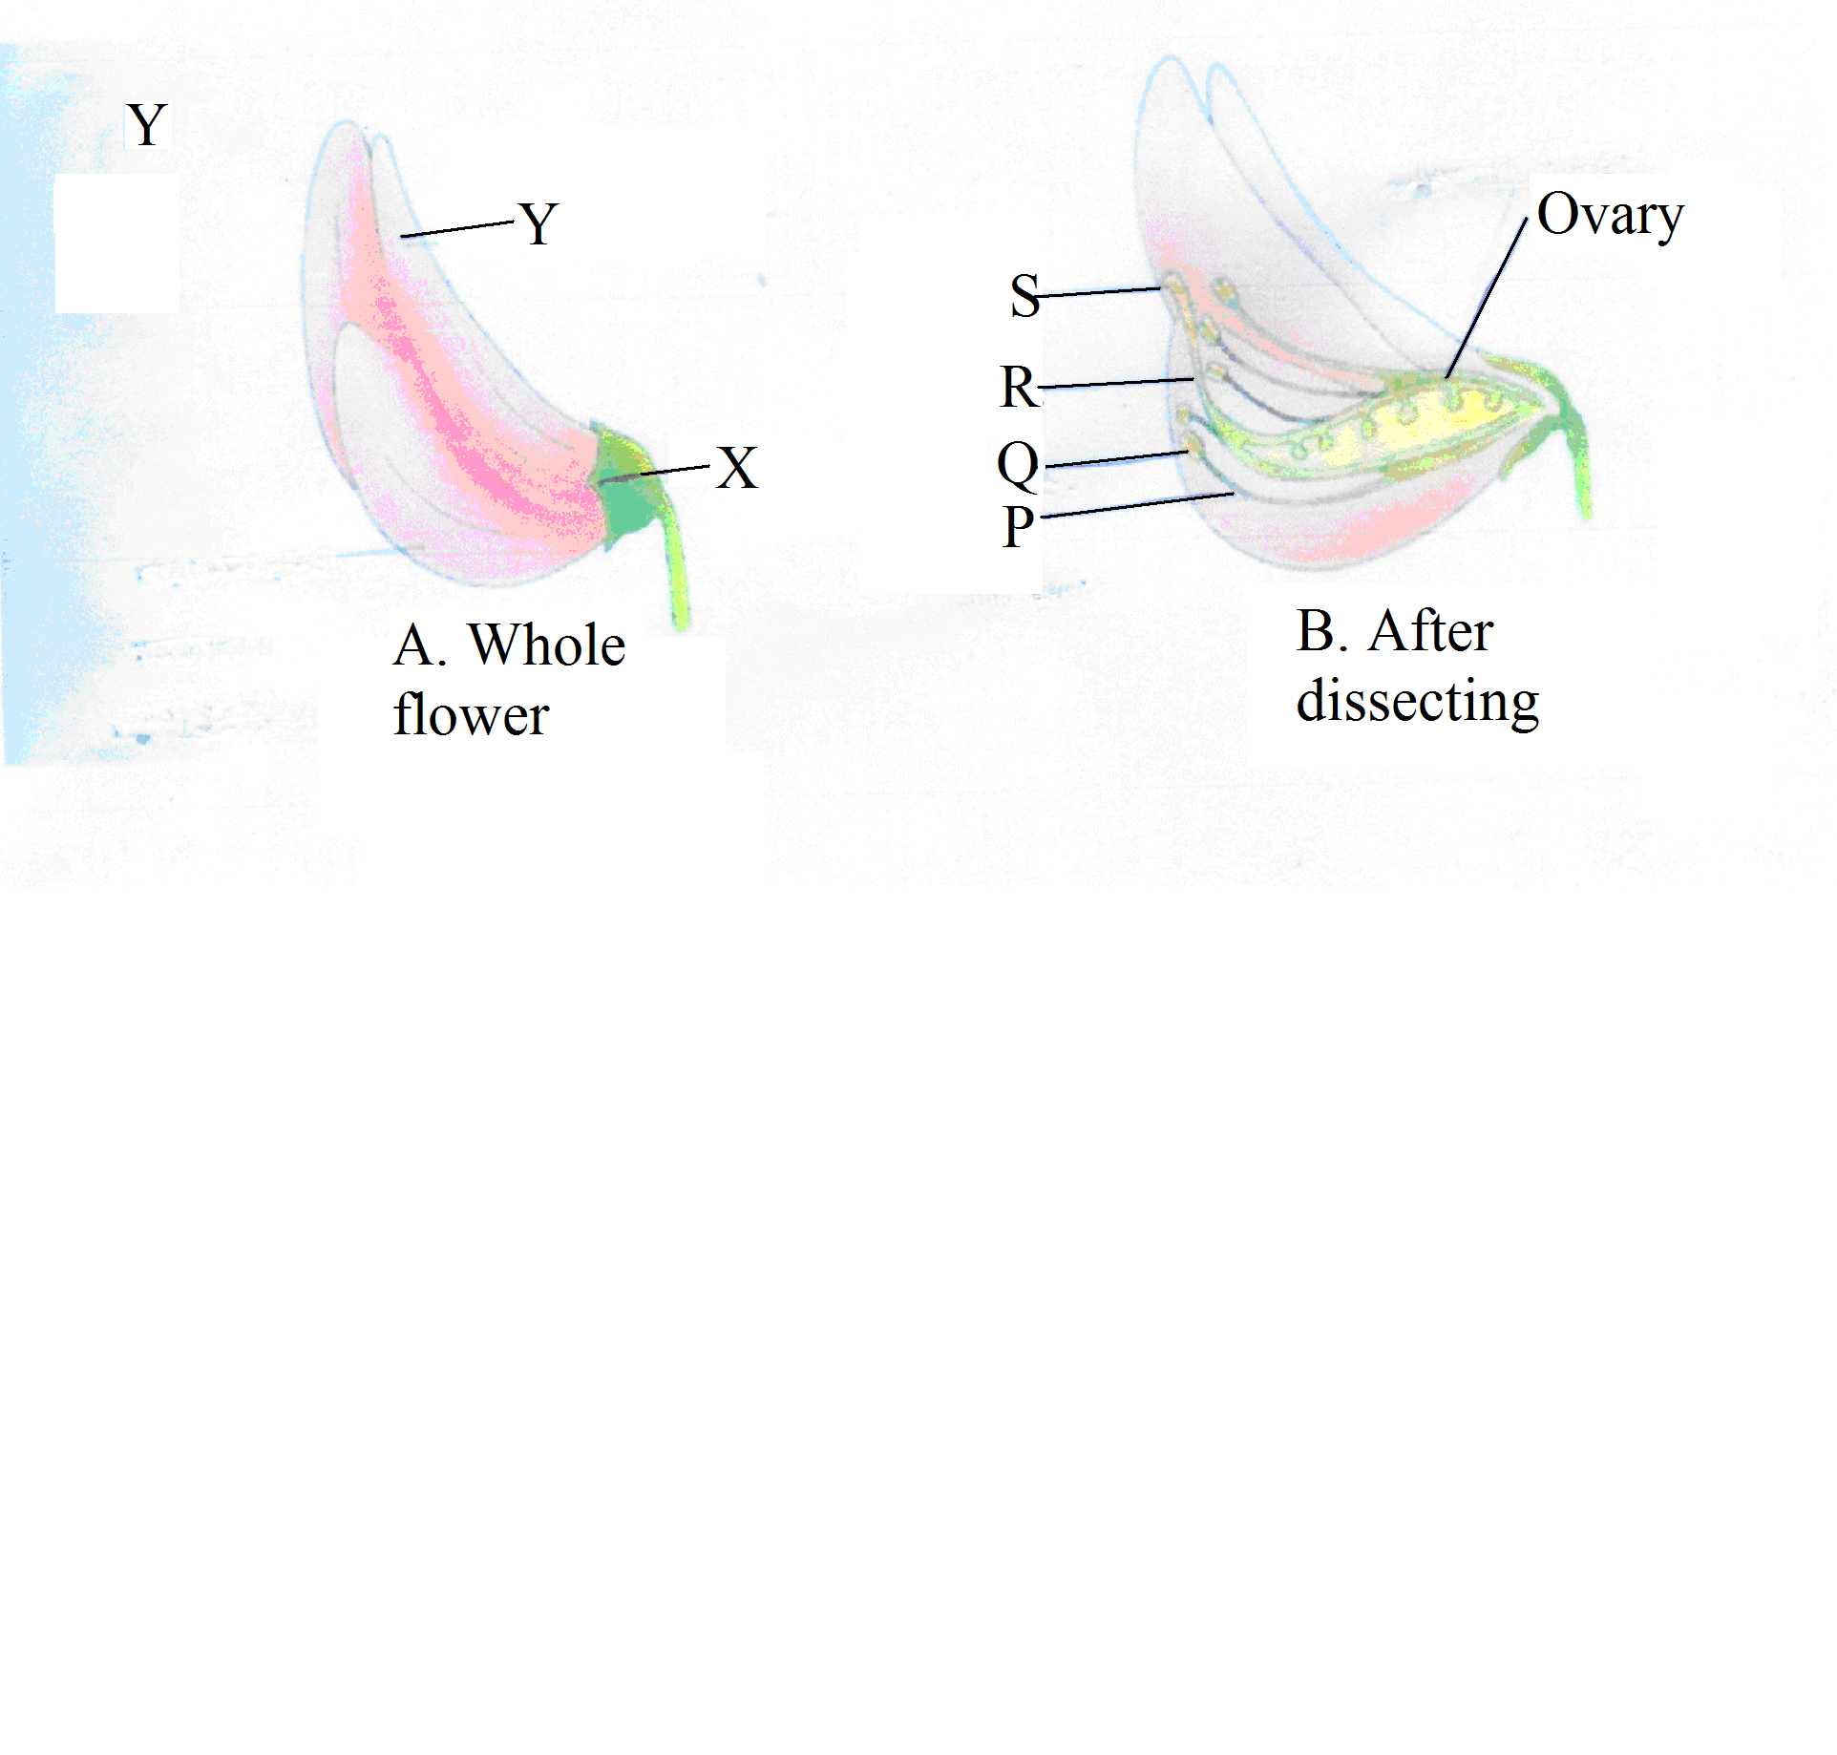

T

PHOTOGRAPH FOR QUESTION THREE (G)
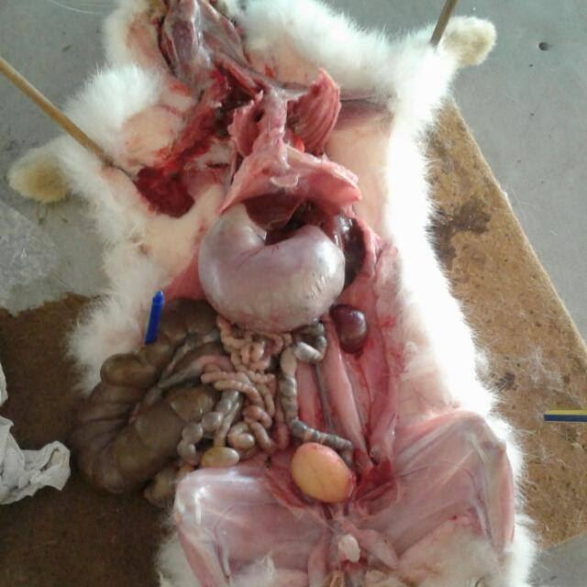
N

M

X

Z

Y

