GATUNDU SOUTH EVALUATION EXAMINATION
KENYA CERTIFICATE OF SECONDARY EDUCATION
231/1
BIOLOGY PAPER 1
JULY 2019
MARKING SCHEME
1. Name the class to which the following organisms belong. [2mks]
[i] Spider -Arachnida;
[ii] Bean plant -Dicotyledonae;
2. Give a reason why coarse adjustment knob should not be used when viewing with high power objective lens. [1 mk]
-The lens may crush the slide;
-The lens may be destroyed; mark 1
3. a) State two functions of an electron microscope. (2 marks)
-Magnification power;
-Resolving power;
b)A Student was examining cells from an unidentified rabbit organ under an electron microscope and found that most cells are rich in rough endoplasmic reticulum and golgi bodies .What conclusion can you make concerning the organ .[2mks]
-it’s a glanular organ; involved in processing and release of secretions;
4.. A student dropped a small piece of fresh liver in a beaker containing hydrogen peroxide. A lot of fizzling and frothing was observed.
a. Name the gas produced. [1mk]
-oxygen;
b. write the word equation for the reaction above. [1mk]
-Hydogen peroxide ^{catalase} water+oxygen;
5. Compare the composition of blood in umbilical artery and umbilical vein. [2mks]
UMBILICAL ARTERY UMBILICAL VEIN
-L ess food nutrients -more food nutrients ;
-less oxygen content -more oxygen content;
-more excretory waste -no/very little excretory waste;;
Total mks 3 max 2

6. Give a reason why pre mature baldness tuft of hair in the nose and ear are characteristics found in males only. [1mk]
-The genes controlling the characteristics are located on Y-chromosome only;
7. Distinguish between osmotic pressure and osmotic potential. [2mks]
OSMOTIC PRESSURE OSMOTIC POTENTIAL
-Tendancy of a solution to take up -Tendancy of a water molecule to diffuse out
water molecules[ when separated by a of a solution ;
semi permeable membrane ]

8.. State two ways in which one can investigate the rate of transpiration in plants. [2mks]
-Use of cobalt [ii ] chloride paper ;
-potometer ;
9. What is the effect of eating a meal with too much salt to urine production in human. [2mks]
-Too much salts increases the osmotic pressure of body cell; more water is drawn by osmosis from glomenular filtrate back to the body; leading to production of low volume of concentrated urine;
Total mks 3 max 2
10. Name the blood vessel that links arterioles with venues. [1mk]
-capillaries;
b. State two ways in which the blood vessel named in [a ] above is adapted to its functions. [2mks]
-numerous to increase surface area for exchange of materials;
-narrow lumen to bring about ultrafiltration;
-thin wall to reduce diffusion distance; mark first 2
11. (i) What is a dichotomous key? (1 mark)
-A dichotomous key is a biological tool for identifying unknown organism upto some taxonomic level.

(ii) State two characteristics of class Arachnida. (2 marks)
-body has two parts the cephalothorax and abdomen
-ventral side of cephalothorax has two chelicerae each having claw like structure which produce poison to paralyse press.
-End of legs has two toothed claws. No antennal but have pedipalps.
-Has eight simple eyes mark first 2

12. Outline two physiological conditions that may increase energy required per day in a woman. [2mks]
-pregnancy;
-lactation;
-menstruation; mark first 2
13. Tongue rolling is dominant over the inability to roll the tongue .In a family both the father and mother can roll their tongue of their two children one is a roller and the other is a non roller .Use letter R to represent the tongue rolling gene.
a. Write the possible genotypes of. [3mks]
i. father – Rr;
ii. mother –Rr;
iii. non –roller child –rr;
b ] Name the type of variation exhibited in the above case. [1 mk]
-Discontinuous variation;
14. Distinguish between the terms protandry and protogyny as used in reproduction in plants.
(2 marks)
-Protandry: the stamen mature before the pistil of the same flower.
-Protogyny: the pistil mature before the stamen mature of the same flower.

15. A person of blood group A cannot receive blood from a person of blood group B. Explain. [2mks]
-Blood group B has antigen B which corresponds to anti body b of the recipient; hence agglutination will occur ;
16. State two most significant factors that favour exponential growth of a population in any given habitat. (2 marks)
– availability of food
- absence of predators
- absence of pest and disease
- enough space mark first 2
17. State two economic importance of bacteria in nature. (2 marks)
– causes diseases to both plants and animals
- saprophytic bacteria help in decomposition
- of organic materials
- help in nitrogen fixation
- fermentation process mark first 2

18. A patient blood was found to have the parasite below:
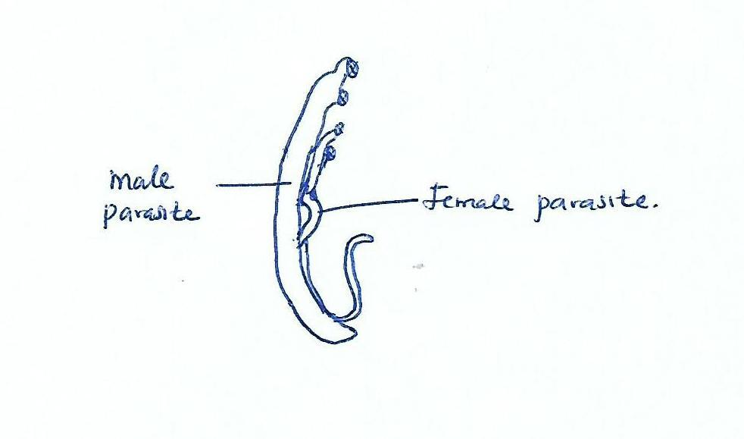
a. Name the parasite; [1mk]

-schistosoma/ bilharzia worm

b. Name the disease the patient was suffering from; [1mk]

-Schistosomiasis/ bilharzia

c. State three ways the above disease can be controlled. [3mks]

-Proper disposal of human waste;
-Treating drinking water /boiling;
-Avoid bathing /swimming in water infested by snails;
-Avoid walking bare footed in stagnant water; mark first 3

19. A human egg is described as haploid.

i. what is meant by the term haploid. [1mk]

-have one set of parental chromosomes in a gamete;

ii. What is the importance of eggs being haploid? [1mks]
-Maintain /restore same chromosomes number;
-prevent doubling /increase in number of chromosomes;
-Combining two [single]sets will restore correct number; Total 3mks max 1
20. Below is a diagram of a plant cell
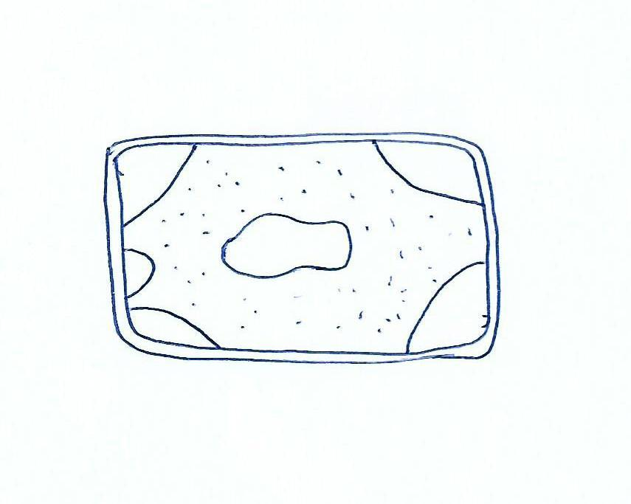
a. what name is used to describe such a cell. [1mk]
-plasmolysed cell /flaccid cell;

b. Describe what has happened to the cell [3mks]
-The cell was placed in a hypertonic solution; lose water by osmosis and shrink; and cytoplasm pulls away from the cell wall;

21. Explain how each of following affect enzyme controlled reaction;

i. Temparature (2mks)

-low temperature inactivates enzymes hence decreases enzymatic activites;
-opitimum temperature gives highest maximum enzymatic activities;
-high temperatures denatures enzyme hence decreases enzymatic activity;

ii. pH (1mk)

Enzymes work best at optimum pH; extreme pH denatures enzymes

22. Name the cartilage found in between vertebrae of vertebral column [1mk]
-Intervertebral disc;

b. State two functions of the cartilage named in [a] above [2mks]
-Allows flexibility of the bones;
-Acts as a shock absorber;

23. State two differences between smooth muscles and skeletal muscles [2mks]

SMOOTH SKELETAL MUSCLES
-spindle shaped -cylindrical shaped;
-uninucleated -multinucleated;
-Involuntary -voluntary;
-in visceral organ -located on skeleton; mark first 2

24. Give the difference between pyramid of biomass and pyramid of numbers [2mks]
- Pyramid of biomass represents the dry mass of organisms at each tropic level; pyramid of numbers represents the number of organisms at each tropic level;

b. Why is pyramid of biomass a better method of representing ecological relationships in habitats [1mk]
- It illustrates the true flow of energy from one trophic level to another in a habitat;

25. Explain why an athlete pants heavily after sprint race [2mks]
-incurs shortage of oxygen in a race; breath heavily to provide oxygen is required to oxidize lactic acid produced;

26. In an experiment a shoot tip of a young tomato plant was decapitated as shown below

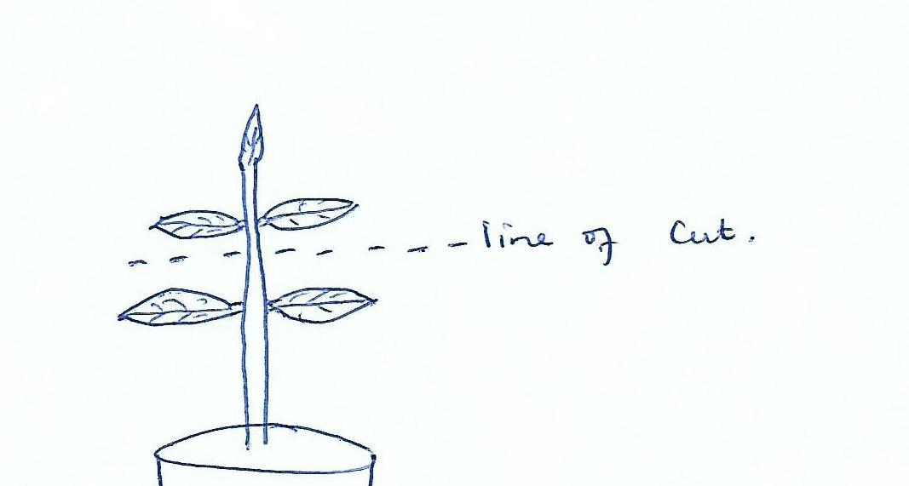

a. State the expected results after two weeks [1mk]

-The auxiliary /lateral buds will sprout/branches are formed;

b. Give a reason for your answer in [a] above [2mks]

-Decapitation removes the hormone auxin; produced at the root tip; absence of auxins promotes branching /development of axillary buds;

27. State the importance of fossils as evidence of organic evolution. [2mks]

-they give direct evidence of type organisms that existed at a certain geological age;
-it shows gradual increase in complexity of organisms over time;
-fossils show extinct animals;
28. State the importance of the following features in a respiratory surface. [2mks]
i. moist
-to dissolve the gases;
ii. thin wall
-to reduce the diffusion distance over which gases diffuse;

29. When seedlings are grown in the dark, they become tall with long internodes, yellow in Colour and weak.
a. What name is used to describe the phenomenon. (1mk)
- Etiolation;

b. Explain the observation made above:(2mks)
- In darkness synthesis of auxins increases; higher auxin concentration stimulates shoot cell elongation; (hence becoming tall).

30. a) What is glycolysis (1 mark)
-Breakdown of glucose;
b) Where in a cell does glycolysis occur. (1 mark)
- Cytoplasm;
C)Explain why patients who cannot feed orally are given glucose in a drip. (1 mark)
-Glucose is directly absorbed into cells without need for chewing and digestion;
31.State the function of the following structures in the human n ear.

- Semi – circular canals. (1mark)
Maintenance of body balance and posture;

- Eustachian tube. (1mark)
Equalizes air pressure in the outer and mid ear to prevent distortion of the ear drum;
32. The table below shows some physiological changes observed in a person in two different regions. The results were taken after the person stayed in each region for 2 weeks.

Physiological change | Region I | Region II
Heart beat per minute | 80 | 71
Breath | Very deep | Average
Breathing rate | fast | Average

- Which one of the regions was likely to be at 4,000M above sea level? Give a reason for your answer. (2 marks)

-Region I less oxygen at higher altitudes hence faster and deeper breath; to draw in more air in order to meet the deficient normal inhalation would take less oxygen to lungs;

- Why was it necessary to take results after a duration of 2 weeks? (1marks)
-Give time for the individual to acclimatize;

