AGRICULTURE PAPER TWO 443/2 2019
SECTION 30 MARKS
Answer all the questions
- Name four breeds of beef cattle (2mks)

- Name the sheep breed with a lambing percentage of 125 to 140 (1/2mk )

- State four reasons for maintain farm tools and equipment (2mks)

- Explain why it is advantageous to use adjustable spanner over ring spanner (1mks)

- Give two examples of equipment that a livestock farmer can use in administering oral antihelmithes (1mk)

- Name the camel breed that is adapted to cooler regions and a woolly body covering (1/2 mk)

- State any two channels through which beef is marketed in Kenya (1mk)

- State four factors that influence the variation of rate of respiration in various farm animals (2mks)

- Give four examples of mineral imbalances or disorders in the farm animals (2mks)

- State four reasons why farmers handle farm animals (2mks)

- State two symptoms of tapeworm attack in livestock (1mks)

- State four characteristics of succulent roughages (2mks)

- Give two signs of heat in rabbits (1mk)

- Differentiate between kidding down and kindling down (1mk)

- Give two reasons for carrying out flushing in ewes (1mk)

- State two uses of a crush in livestock production (1mk)

- Give three reasons why timber is treated before construction (1 ½mks)

- State the three parts of a building (1 ½ mks)

- State four qualities of marketable eggs (2 mks)

- Give two factors that inhibits milk let down (1mk)

- Differentiate between dehorning and disbudding as used in livestock production (1mk)

- Name the four strokes of a four stoke cycle engine in their correct order ( 2mks )

SECTION B (20MKS)
Answer all the questions

- Below is an illustration of a farm structure. Study it carefully and answer the questions that follow.

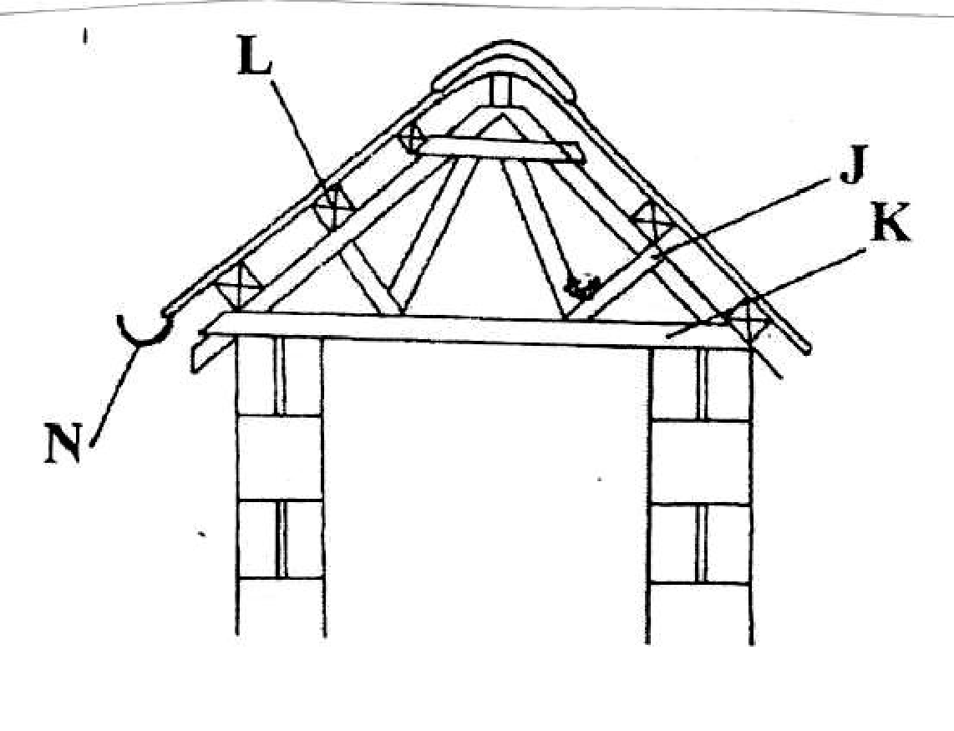

- Identify the parts labeled K,L,N and J (4mks)

K

L

N

J
- State one use of part labeled N (1mk)

- The diagram below shows a rearing practice in livestock production
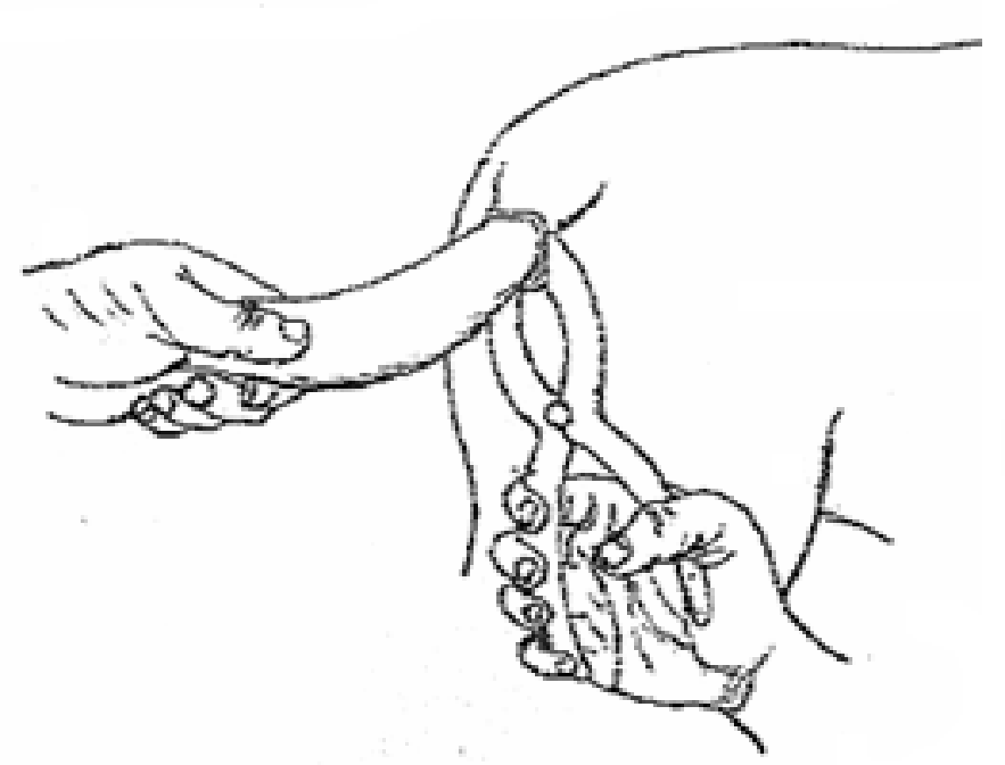

- Name the routine practice shown in the diagram above (1mk)

- Give three reasons why the above practice is carried out in farm animals (3mks)

- Name the tools being used in the above practice (1mk)

- Study the diagram below and answers the questions that follow

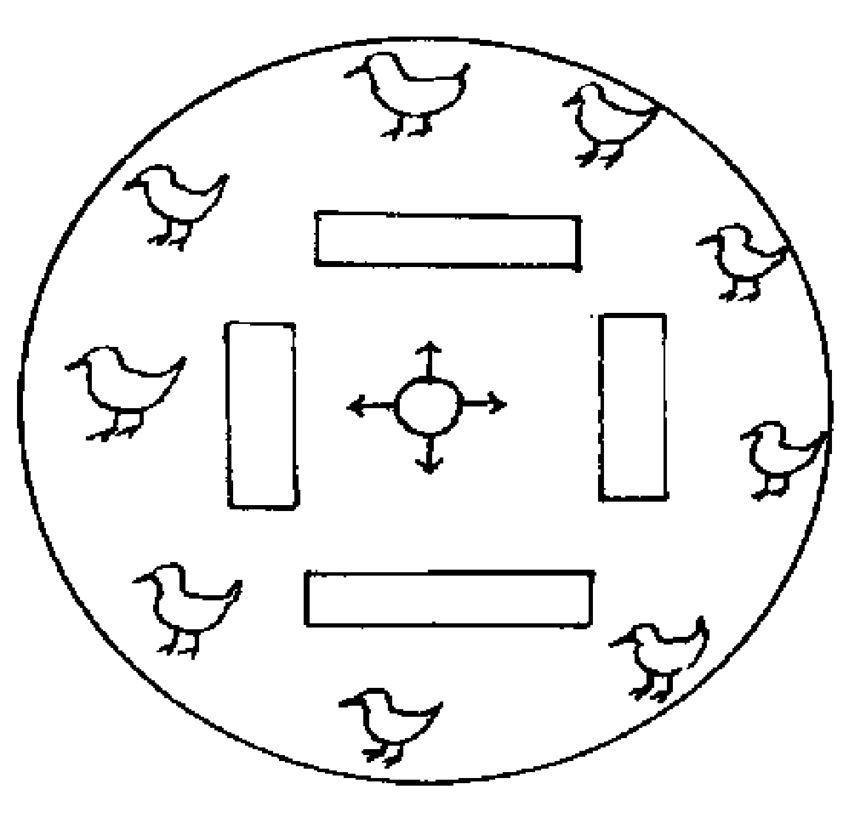

- Name the structure illustrated above (1mk)

- Why should the structure be round and not rectangular or square shaped (1mk)

- Describe the heat situation in the structure (1mk)

- Give one reason to support your answer in C above (1mk)

- Why is dust not suitable for use as litter in the structure (1mk)

- Study the diagram below and answer the questions that follow.
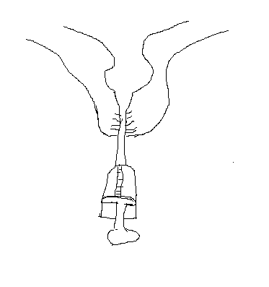
- Name the above practice as carried out in livestock production (1mk)

- State the reason why the above practice is carried out (1mk)

- In which period of gestation is the above practice carried out (1mk)

- Describe the procedure of carrying out the above practice (2mks)

SECTION C (40MARKS)
Answer any two questions

- Describe the lifecycle of a three host tick (10mks)
- Explain five reasons why culling is carried out in livestock production (5mks)
- Explain five factors that influence water requirement in a farm animal (5mks)

- Discuss Gumboro disease under the following sub heading

- Animals affected (2mks)
- Causative agent (1mks)
- Symptoms (5mks)
- Control measure (2mks)

- Explain five factors considered when siting farm structures.(5mks)
- Explain the advantages of embryo transplant as a method of services in livestock breeding (5mks)

- Explain five advantages of farm mechanization (5mks)
- Explain the practices observed in clean milk production (10mks)
- Describe the disadvantages of animal drawn implements compared to tractor drawn implements (5mks)

