GEOGRAPHY MARKING SCHEME
FORM FOUR PAPER 2
TRIAL 2, 2019
- i) Two irrigation schemes established in Kisumu county (2mks)
- Ahero
- West Kano
ii) What is a polder (1mk)
- Land reclaimed from the sea
iii) Three crops grown in the polder (3mks)
- Wheat
- Beet root
- Potatoes
- Vegetables
- Rye
- Oats
- Barley barley
- i) Distinguish Horticulture and market gardening (2mks)
market a
- Gardening
- Horticulture is an intensive cultivation of vegetables, fruits and flowers for sale while market gardening is an intensive cultivation of vegetables and fruits for sale in the nearest urban centres (2 x 1=2mks)
- Problems facing horticultural farming in Kenya (3mks)
- Muddy roads during rains hindering accessibility to collecting centres.
- Poor marketing system – farmers produce rot in farms
- Inadequate refrigeration facilities –lowers the quality and quantity of perishable products.
- pests and diseases of ten destroys crops
- stiff competition from the international markets (3 x1=3mks)
- i) Define the term mining? (2mks)
- Process of extraction of minerals from on/beneath the earth surface (2 X 1=2mks)
Only award when one/beneath are mentioned
ii)Negative effects of mining to the environment (3mks)
- Interferes with drainage systems such as barring the river course
- Causes air pollution through dust emission into the atmosphere.
- Causes land dereliction through heaping of soil on land ( 3 x 1=3mks)
- i) Give two indigenous soft wood trees grown in Kenya (2mks)
- Podo
- African pencil
ii) Problems facing forestry in Canada
- Outbreaks of fires and diseases destroying forests
- Harsh cold climates slowing down forest regeneration after felling trees.
- In accessibility of some parts of Canada in winterdue to very cold climatic conditions.
Consider only the well stated point (3 x 1=3mks)
- a) Types of fishing (2mks)
- Pelagic
- Dermersal
- Freshwater ( 2 x 1=2mks)
b)Problems facing fishing
- Pollution of water through oil spillage and other industrial effluents.
- Overfishing leading to depletion of some fish species.
- Control of territorial waters where Japan has been restricted from other nations.
( 3 x 1=3mks)
- a)
CROP/YEAR | 1998 | CT | 1999 | CT | 2000 | CT | 2001 | CT | 2002 | CT
Maize | 27.30 | 27.30 | 25.00 | 25.00 | 25.00 | 25.00 | 30.00 | 30.00 | 26.00 | 26.00
Beans | 3.00 | 30.30 | 4.00 | 29.00 | 3.70 | 28.70 | 4.10 | 34.10 | 4.00 | 30.00
Sorghum | 0.90 | 31.20 | 1.20 | 30.20 | 0.90 | 29.60 | 1.20 | 35.30 | 0.80 | 30.80
Millet | 0.37 | 31.57 | 0.66 | 30.86 | 0.40 | 30.00 | 0.50 | 35.80 | 0.60 | 31.40

i) Hint – Award general (2) for correct C.T
- Award graph – Title
- Axis
- Bars
- Key
- Variables (8mks)
ii)Totals for two years
30.00+26.00=26.00
30.00-26.00=4.00
$\frac{4.00}{56.00}×100$ = $\frac{400}{56}$ = 7.14%
iii)

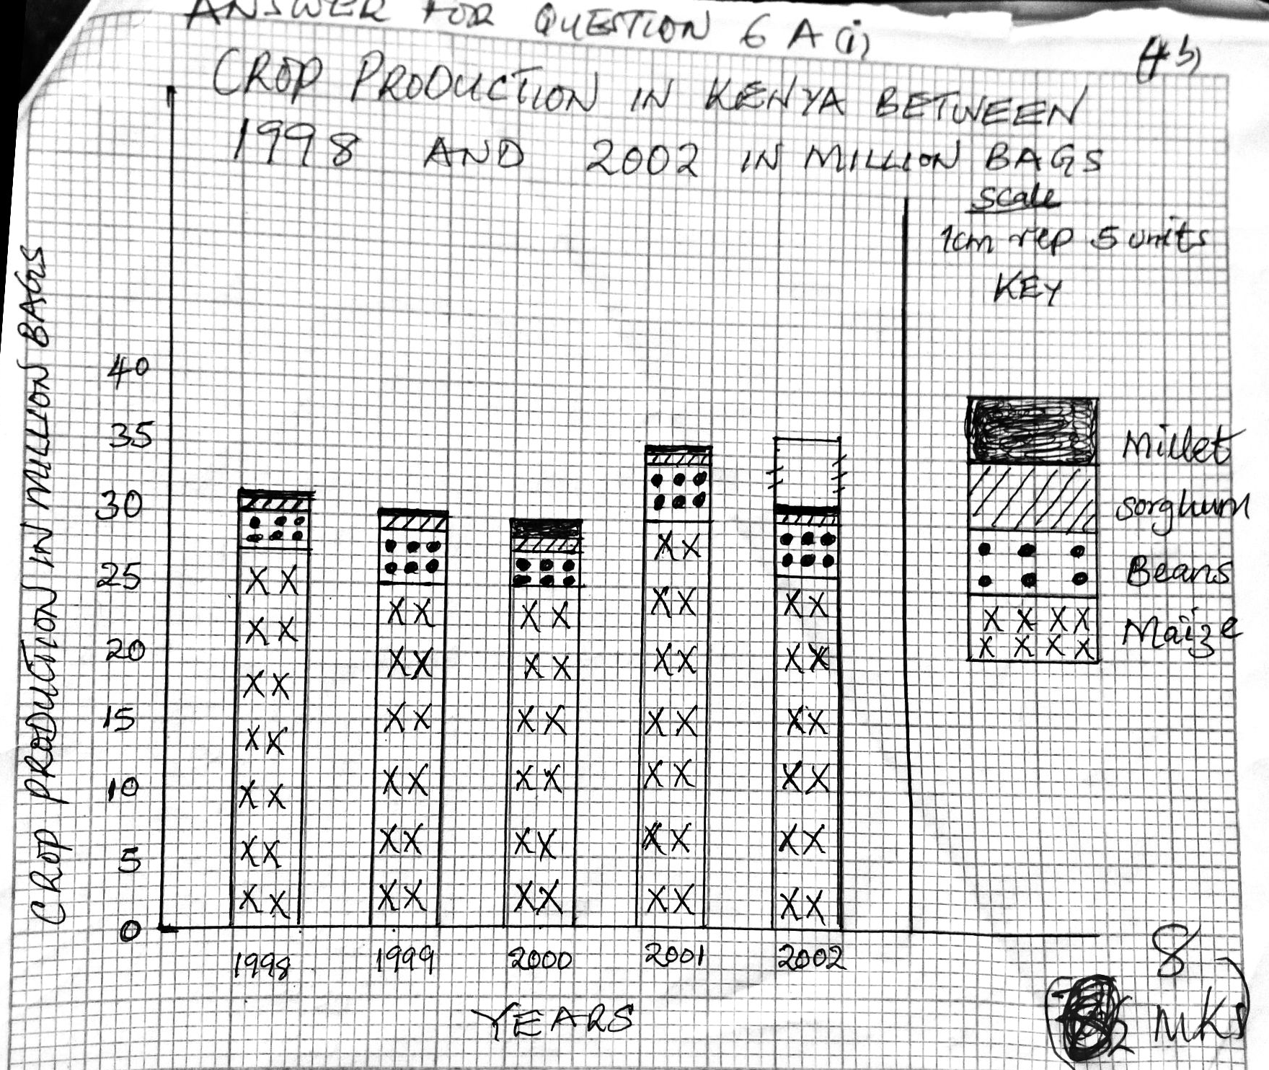

All the crops in 2001 had a higher production than in year 2000 (1 x 2=2mks)
b) i) Methods used to reclaim land in Kenya (5mks)
- Draining of swamps
- Irrigating dry lands
- Growing drought resistant crops
- Controlling soil erosion
- Afforestation/reafforestation
Award any other relevant point ( 1 x 5=5mks)
ii)Control measures applied to eliminate tsetse flies in Kenya (6mks)
- Bush clearing –This kills both the adult flies, pupae and destroy their breeding grounds.
- Use of traps in insecticide – Impregnated traps with baits the plies into the traps where they are killed by the insecticides
- Insecticide application by spraying using low flying aircraft ( 2 x 3=6mks)
- a) i) Define wildlife (2mks)
- Refers to undomesticated animals and plants (fauna and flora) found in their natural habitats (2 x1=2mks)
ii) Distinguish between a game sanctuary and a game ranch (4mks)
- A game sanctuary is an area set aside for protection of specific animals or birds/endangered species from extinction; while a games ranch is a protected large tracts of land for rearing specific kinds of animals for meat game products ( 4 x 1=4mks)
iii)National part marked A- Kisite Marine park
National park marked B – Amboseli
National park marked C – Ruwenzori ( 3 x 1=3mks)
b)i) Factors showing the future of tourism industry in Kenya
- Aggressive promotion by ministry of Tourism through KTB through exhibitions abroad to promote Kenya as a tourist destination and also marketing is being done within, targeting domestic tourists.
- Lowering of tariffs in hotels, games parks and airports taxes so as as to encourage more tourists visits Kenya.
- Strength of the Kenyan shillings depreciation of will attract more tourists since most will find it cheaper to visit Kenya.
- Opening up of new areas with untapped attraction potential eg N.E province around Lakes likeBaringo, Bogoria, turkana.
- Developing of sustainable tourism eg Eco-tourism i.e tourism that involve conservation of the environment.
- Formation of Kenya National tourism master plan to underscore the need to diversity tourist sources, attractions and opening up of new avenues. ( 4 x 2=8mks)
ii) Factors influence wildlife
- Different plants and animals are found in different vegetation zones.
- Natural forests are habitat for elephant’sgorillas, baboons, monkeys, variety of birds and insects.
- Savannah grasslands with acacia trees host a lot of herbivouseg gazelles, wildebeests.
- Woodland savannah is a home for many animals like gazelles, bees and the carnivores as well as they shelter in the busher.
- Semi deserts and desert vegetation support hardy animals which can withstand dry conditions eg hartebeest, grant gazelle. (2 x 2=4mks)
iii) Altitude determines the climate and vegetations type
- Very high mountains eg Mt Kenya and Kilimanjaro are too cold, hence absence of animals.
- Different plant formation are therefore found at different altitudes hence also determine type of animals present there.
- Savannah is found near the base then the forest, bamboo forest and heath and moon land. ( 4 x 1=4mks)
- a) i) What is fishing (2mks)
- Act of catching fish and other aquatic animals (2mks)
ii) Major fishing ground in the Pacific Ocean
- North –East pacific /West Coast of North America
- North –West pacific /North East Asia ( 2 x 1=2mks)
iii) Fresh water fisheries in Kenya
- L. Victoria
- L. Naivasha
- R. Tana
- L. Turkana (4 x 1=4mks)
b)i) Reasons why fresh water fishing is more popular than marine fishing in East Africa.
- There are enormous fishing grounds eg L. Victoria, L Albert, L. Naivasha, L Tanganyika which are accessible to many people.
- Fresh water fish are popular with high demand among the people encouraging more inland fishing.
- Fresh water fishing requires simpler methods affordable by majority of fisherman in E. Africa.
- Most inland fishing ground are rich in Plankton hence encouraging fish breeding.
- High population in some places such a L. Vitoria offers the much need market.
- Government support eg setting up processing plants ad cooing plants have encouraged more fishing ( 4 x 2=8mks)
ii) Describe trawling as a method of fishing
- Trawling involves dragging a cone shaped bad (trawl) over the sea bed behind aboat or trawler.
- A bag shaped net attached to the ship trawler is dragged along the sea bed to trap the fish
- The net is cast into the sea by a trawler.
- The upper part of the net is kept a float by floats and the bottom held down by weights.
- Then it is dragged on the sea bottom at low speed.
- The mouth of the net is kept open by the floats and weights.
- Fish swim into the net and trapped in.
- Once enough fish is caught the net is hauled into the trawler and the fish is removed.
( 7 x 1=7mks)
iii) Distinguish phytoplankton and zoo-planktons
- Phytoplanktons are tiny vegetative matter that fish feed on while zoo-planktons are the microscopic animal’s organisms that fish feed on. (2mks)
- a) i) Types of coffee grown in Kenya
- Arabica
- Robusta
- Liberica ( 2 x 1=2mks)
ii) Countries in Kenya where coffee is grown in large scale
- Kiambu
- Meru
- Kakamega
- Nyeri
- Bungoma (2 x 1=2mks)
b) i) Factors favouring growing of coffee in Kenya
- Moderate temperature/warm to hot conditions with temperature between 14-26⁰C/30⁰C
- High rainfall well distributed throughout the year.
- A dry sunny period for harvesting and drying a coffee beans.
- Deep well drained fertile volcanic soils which is slightly acidic.
- High attitudes 1500-2100m
- Gentle sloping /undulating landscape for mechanization and proper soil drainage.
- Availability of labour for planting, weeding pruning and harvesting.
- Availability of shade /shelter for directs sunlight and strong winds.
- Availability of roads within growing areas for faster transportation to the factories
Awards any (4x 1=4mks)
ii) Stages of coffee processing once it’s delivered to the factory
- Harvested barriers are taken to the factories where it is deceived and weighed.
- Barriers are put in large tanks of water to remove outer covering/pulping
- Beans are then heaped in a tank to ferment between 12-24hrs.
- Beans are then washed in clean water
- After washing, beans are cured by sun drying for a week.
- After curing the beans are peeled by removing the inner husks.
- Beans are then winngwened and sorted.
- Sorted beans are graded according to size and quality
- Packed in sacks of 60kgs ready for export ( 9 x 1=9mks)
c) i) Benefits of coffee farming in Kenya
- Earn Kenya foreign exchange from exports.
- Coffee farming – Provides employment opportunities improving standards of living.
- Coffee sales generate income/revenue hence earn farmers living.
- Coffee farming has led to establishment of processing factories. (2 x 2=4mks)
ii)Problems facing coffee farmers in Brazil
- Inappropriate conservation methods where farmers use wasteful methods.
- Soil exhaustion resulting in severe soil erosion low yields.
- Over production leading to reduced market price.
- Fluctuation to world prices discouraging farmers due to low prices and profits
- Competition from other coffee producing countries lead to low prices discouraging farmers. (4 x 1=4mks)
- a) i) By-products of crude oil
- Bitumen
- Petrol
- Diesel
- Kerosene
- Fabricating oil
ii)Ways through which occurrence of minerals is influenced
- Vulcanicity
- Weathering
- Evaporation
- Erosion
- Sedimentation
- Metamorphism (4 x 1=4mks)
b) Contribution of mining industry to economy.
- Generate revenue used to finance development
- Attracts development of transport and communication network
- Contributes to urbanization as towns develop near mining areas.
- Creates employment opportunities to miners
- Enhances development of mineral processing industries and other industries.
( 4 x 2=8mks)
c) Minerals found in the following areas in East Africa
- Kariandusi- Diatomite
- Kerio Valley – Fluorspar
- Kwale county – Titanium
- Lake Magadi – Soda Ash ( 4 x 1=4mks)
d)State four factors influencing mineral exploitation (4mks)
- Exploitation
- Value of the mineral
- Size of mineral reserve
- Quality of the ore
- Demand of the mineral
- Availability of labour
- Level of technology
- Political influence
Award only the well stated point ( 4 x 1=4mks)

- Uses of Gold
- Making Jewellary
- Used as a store wealth
- For decoration purposes ( 2 x 1=2mks)

