TRIAL ONE EVALUATION TEST
233/1 Chemistry
Marking scheme
- (a) Explain why there is effervescence when lemon juice is added to sodium hydrogen carbonate. (1Mk)
The juice contains acid/H⁺ that react with the carbonate to produce CO₂ gas.
(b) Write ionic equation for the observation made above. (1Mk)
H⁺_{(aq)} + HCO__{(aq)} H₂O_{(l)} + CO_{2 (g)}
- In an experiment a certain volume of air was passed repeatedly from syringe over heated excess copper powder as shown in the diagram below.

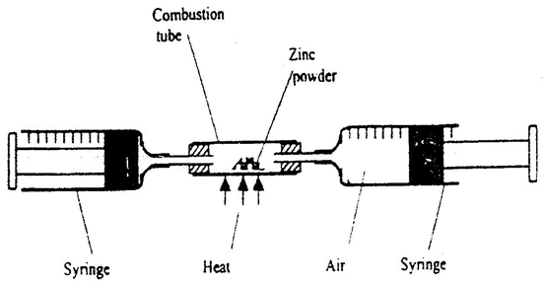
Copper powder

The experiment was repeated using excess magnesium powder. In which of the experiments was the change in volume of air greatest? Give reasons. (3mks)
When magnesium is used(1mk) because Mg reacts with other components of air/is more reactive (1mk) hence reacts with nitrogen and carbon (iv) oxide and moisture(any 2 mentioned) 1mk
- The diagram below shows an iron bar, which supports a bridge. The iron is connected to a piece of magnesium metal.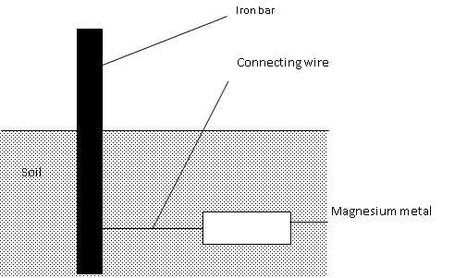
Explain why it is necessary to connect the piece of magnesium metal to the iron bar. (2mks)
Mg being more reactive(1Mk) will react in preference to iron hence protect iron(1Mk)
- The diagram below is a set up for the laboratory preparation of oxygen gas.

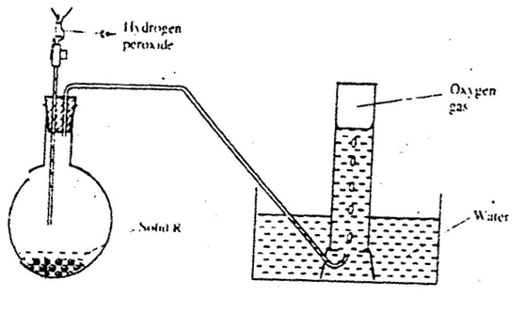
a) Name solid R. (1mk)
manganese (iv) oxide

b) Write an equation for the reaction that takes place in the flask. (1mk)
2H₂O_{2(l}) 2 H₂O_{(l )} + O_{2(g)}
c) Give one commercial use of oxygen. (1mk)

any appropriate one(1Mk)
- The diagram below represents a paper chromatogram of pure w, X, and Y. A mixture K contains W and Y only. Indicate on the diagram the chromatogram of K (2mk)

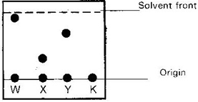(1Mk each)
- (a) Solutions may be classified as strong basic, weakly acidic, strong acidic. The information below gives solutions and their PH values. Study it and answer the questions that follow.
solutions | B | C | D
PH-value | 4 | 10 | 7
Classification | Strongly acid | Weakly base | neutral
(i)Classify the solutions in the table above using terms above (1Mk)
1Mk for all
(ii)Which ions are pre-dominantly in solution C? (1/2Mk)
OH ⁻ (1mk)

(b)In an experiment, equal amounts of magnesium powder were added into test tubes 1 and 2 as shown below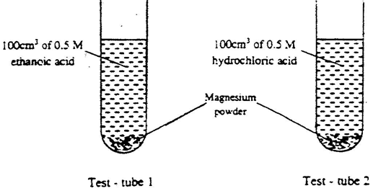
Explain the observable difference in the two test tubes. (1¹/2Mks)
more bubbles/effervescence in test-tube 2 (1/2Mk)has strong acid faster rate(1Mk
- Zinc (II) Oxide reacts with acid and alkalis.
(a) Write the equation for the reaction between Zinc (II) Oxide and
(i) Dilute Sulphuric acid (1 mk)
Basic property
(ii). Sodium hydroxide solution. (1 mk)
Acidic property
(b) What property of Zinc oxide is shown above by the reaction (a) above? (1mk)
Amphoteric property
- An indicator established the following equilibrium when dissolved in water.
OX⁻ _{(aq)} + H₂O _{(l)} HOX _{(aq)} + OH⁻ _{(aq)}
( Blue) (Yellow)
State and explain the observation made when Lime water is added? (2mks) Solution changes to blue since OH⁻ (1Mk)from the lime water shifts equilibrium to the left(1Mk)
- Study the information in the table below and answer the question the table below the table.

Bond | Energy (kJ/mol)
C-H | 414
Cl-Cl | 244
C-Cl | 326
H-Cl | 431
The enthalpy change for the reaction below is -99kJ/mol.
CH_{4 (g)} + Cl_{2 (g)} CH₃Cl_{(g )} + HCl_{(g)}
(i)What does the negative sign on 99kJ/mol mean? (1mk)
Exothermic reaction
(ii) Which bond is the strongest to break? Explain. (2mks)
H-Cl (1Mk) has the highest bond energy(1Mk for)
10. Give two reasons why spoons are electroplated. .(1Mk) , Beauty, strength or protection against rusting (any two ½ mks each)
11. a) What is an isotope?
Atoms of same element(atomic number) but with different mass number(Neutrons) (!mk)
b) Determine the relative atomic mass of argon whose isotope mixture is
36. _{Ar} (0.34%) 38_{Ar} (0.06%) 40 _{Ar} (99.6%) (2Mks)
18 18 18
0.34x36 +0.06x38 +99.6x40
100
= 0.1224 + 0.0228 +39.84
=39.98526
=39.99
12.The table below gives some information about four elements. The letters are not their actual symbols.
Elements | valences | Atomic radii(nm) | Ionic radii(nm
K | 2 | 0.136 | 0.065
L | 7 | 0.099 | 0.181
M | 1 | 0.099 | 0.181
N | 2 | 0.174 | 0.099

- Write the electron arrangement of any element in same chemical family as element L. (1Mk) 2,7 OR 2,8,7 any one
- Compare the reactivity of elements K and N. (1Mk)
N is more reactive
- Account for the difference in ionic and atomic radii of element M. (1Mk)
M reacts by gaining electron hence decrease in nuclear charge or increases electron-electron repulsion
13. Give the main reasons why:-
(i) Cryolite is added to the pure Aluminium oxide in the process of extracting the metal.
To reduce melting point.
(ii) State two properties of Aluminium that makes it suitable to be used in making over-head electrical cables. Good conductor of eletricity (1Mk) High melting pont(1mk)
14. Excess chlorine was bubbled through a solution of potassium bromide. State and explain the observation made.(2mk)
Changes to red/brown (1mk)chlorine is more reactive/stronger oxidizing hence oxidises bromide ions to bromine(1mk)
15. In an experiment, ammonium chloride was heated in test-tube. A moist red litmus paper placed at the mouth of test first changed blue then red. Explain these observations.
(H=1. N=14, Cl=35.5 ) (3mks)
On heating ammonium chloride it decomposes to HCl and NH₃ (¹/₂ Mks)
HCl=36.5 NH₃=17 (¹/₂Mks) different molar masses
The lighter basic ammonia diffuses faster(¹/₂Mks)
changing litmus papers to blue(¹/2Mks)
and the denser acidic gas diffuse out of the tube last (¹/₂Mks)
changing litmus to red (¹/₂Mks)
16. Y grams of a radioactive isotope take 120days to decay to 3.5grams. The half-life period of the isotope is 20days
(a) Find the initial mass of the isotope (2mks)
( 1/2 )^{120/20} =3.5/x
1/64= 3.5/x
X=64x3.5 =224
(b) Give one application of radioactivity in agriculture (1mk)
Any one (1MK)
17. The diagram below shows energy levels for the reaction
½ H₂(g) + ½ F₂(g) HF(g)
309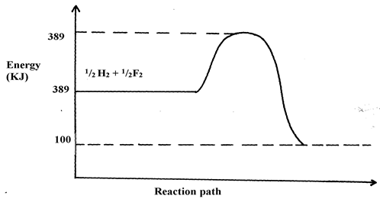
- Work out the activation energy for the reaction (1mk)
389-309

- Calculate the heat of formation of HF (1½mk)

100-309= -209
- Is the reaction endothermic or exothermic? (½mk)
Exothermic
18. a) State the use of the apparatus below. (1Mk)
(i) Conical flask
General reactions/Mixing reagent/reacting chemicals that require swirling.
(ii) separating funnel
Separating immiscible liquids
b) Highlight one precaution observed in each of the following cases:
- When evaporating Ethanol. (1mk)
Avoid naked flames/use sand bath or water bath
- When heating to dryness hydrated salts. (1m)
Slant the test tube/avoid spitting
19. Dry carbon (ii) oxide gas reacts with hot lead (II) oxide as shown in the equation below.
PbO _{(s)} + CO _{(g)} → Pb _{(s)} + CO_{2 (g)}
- Name another gas that can be used to function as carbon (ii) oxide in this experiment. (1mk)
Ammonia, Hydrogen
- With an appropriate reason, identify the oxidizing agent in the equation above. (2mks)
PbO (1mk) lost/gave oxygen to CO(1mk)
20. (a) During fractional distillation a student used glass beads. State the function of glass beads during fractional distillation in;
i) Boiling flask . (1mk)
increase surface area of evaporation
ii) Fractionating column. (1mk)
increase surface area of condensation
b) Give one industrial application of solvent extraction. (1mk)
Cleaning stains from clothes/exracting components from plants like herbal medicines
21. Calculate the percentage of nitrogen in calcium nitrate (N=14, O=16, Ca=40)
RFM=164 (1mk) mass of nitrogen=28 28x100/164 (1mk) = 17.07% (1mk)
22. 20cm³ of sodium hydroxide solution containing 8.0gdm⁻³ were required for complete neutralization of 0.18g of a dibasic acid H₂X. Calculate the relative molecular mass of the acid. (Na = 23, O = 16, H = 1) (3mks)
8/40=O.2M moles of NaOH=0,2x20/1000=0,004moles
moles of acid==1/2x0,002= 0,002moles 0,002moles=0.18/RFM
RFM=0.18/0.002=90
23.(a) Name one ore of Zinc metal
Zinc blende /any other (1mk)
(b).A sample of a colorless solution is suspected to be Zinc (II) sulphate. Describe some tests that can be carried to prove this. (2mks)
Put a sample of the solution in three separate test tubes
To one portion add ammonia solution dropwise till in excess(1/2mk) . White precipitate soluble in excess confirms zinc ions. (1/2mk)
To the second portion add barium nitrate solution(1/2mk) .white precipitate forms.(1/2mk) To the precipitate add nitric (v) acid or hydrochloric acid(1/2mk) ,if precipitate doesn’t dissolve (SO₄²⁻) confirmed(1/2mk)
24. A metal Y with atomic number 11 burns in chlorine to produce a white solid X.
(a) Describe the following properties of X.
- Solubility (1m)
soluble
- Electrical conductivity.(1mk)
Good
(b) Write an equation to show the formation of compound X. (1 mark)
2Na _{(s)} + Cl_{2 (g)} 2 NaCl_{(s)}
25. a) Define an isomer. (1mk)
Compounds with same molecular formula but with different structural formulae
b) Draw and name any two isomers of pentane. (2mks)
accept any name1/2mks and structure ½mks ( two like Methybutane, Dimethylpropane)
26 a) Name the compounds P and T below.
P - CH₃CH₂CH₂CH₃ Butane .(½ mark)
T - CH₃CHCHCH₃ But-2-ene (½ mark)
b) Describe an experiment you would carry out to distinguish T from P. (2 marks)
To a sample of each add acidified KMnO₄ or Bromine water (1mk) only T decolourises (1mk)
27. Consider the reaction below
2 CO(g) + O₂(g) 2CO₂(g) H = -110KJ
State and explain the effect of the following on the above equilibrium:-
(i) removing oxygen from the reaction above. (1¹/2mk)
Equilibrium shifts to the left for CO₂ to decompose to replace O₂
(ii) injecting helium in the reaction mixture (1¹/2Mk)
Increases pressure hence
28. (a) Name the TWO products of complete combustion of a hydrocarbon with the formula:- CH₃(CH₂)_{n} COOH.
Carbon (iv) Oxide and water
(ii) If 15.3g of the above hydrocarbon is equivalent to 0.15moles, find the value of n in the formula above. ( H=1 , C=12 , O= 16 ) (2Mks)
15.3/0.15 = 102 60+14n = 102 42/14 =3
29. Three elements P, Q and R form the following compounds P(NO₃)₂ ,Q₂SO₄ and R₂O₃
- Write down the formula of :-
- Hydroxide of Q Q(OH)
- Nitride of R RN.
Which element is likely to form a soluble carbonate Q (1mk)

