COMPUTER STUDIES
TRIAL 2, 2019
MARKING SCHEME
FORM FOUR PAPER 1

- a) Multiplexing data signal over the same
- It is the process of sending multiple medium (Give mark if diagram exist)
b) Baseband signal
It is a digital signal that is generated and applied to the transmission medium directly without modulation. (2mks)
- Analog signal is made up of continuous varying waveform while digital signal is made up of non continuous discrete waveform.
- -Boot sector viruses
- File virus
- Hoax virus
- Trojan virus
- Worms
- Backdoors (any 4@¹/₂mk)
- Below is a graphical representation of a section of a Microsoft word ®application window. Use it to answer the question that follow.

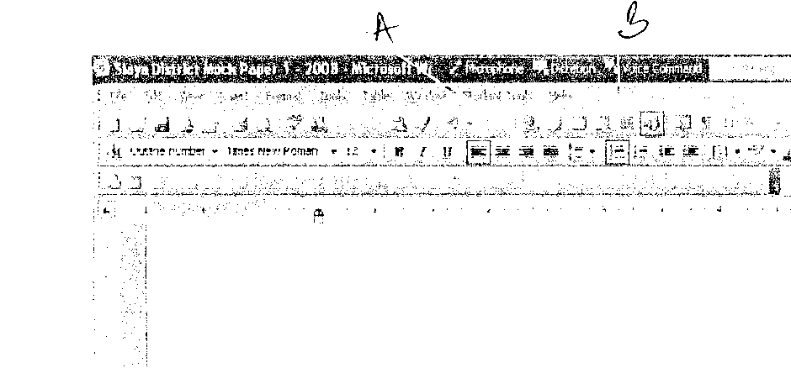
Give the uses of the icons labeled A and B
A – Right align text
B – Create columns in a document Total = 2mks)
- i) Partitioning – Creating volumes by subdividing a large physical disk.
- Refers to the process of deviating a large physical disk into two or more partitions called logical drives.
ii) Defragmenting –Consolidating fragments files into one area if the disk or so that file occupies a single, contiguous space on the above.
5. i) Sign in/Log in- When you want to access a website, type the full address of the website in the address box.
ii) Surf in/Log in-The process of accessing the website.
iii) Downloading-The process of transferring information from a remote computer to a local storage.

- - To access records of books faster.
- For faster updating of books records.
- To search title of books for someone to borrow.
- For research if there is connection to the internet. Any three@1mk. Total =3mks
- i) Uninterruptable Power Supply
ii) Explain
- It provides temporarily in the event of power failure.
- It regulates the amount of power into the computer hence eliminating power surge and brown out. Brown out is partial blackout, whereby there is low voltage flowing into the system.
- It alerts the user when there is a blackout by producing a beeping sound (2mks)
- a) Give two possible ways of fitting the document in one page:
- Reduce the line spacing
- Adjust the left and right margins
- Reduce the font size (2mks)
b) Hardware conflict or incapability possibility due to interrupt requested or missing device drivers.
- Possibility of a problem in the installation process
- Problem with hard disk boot sector due to damage or virus attack.
- Insufficient memory
- Corrupted system windows registry.
- Real time- Data is received and processed so fast and the results returned so quickly that the process is instantaneous to the user.
Batch-Data is accumulated and processed at a predetermined time. Once processing begins no amendments.
- In Kenya Tea packers Company several people are employed as record clerks, typists and messengers. The company intends to introduce a computers system in all the departments. Suggest three reasons that would make workers unhappy with the new system. (3mks)
- Job replacement
- Reatrining on the use of computers
- Side effects of using computers (1mrk each)
- It’s faster, accurate and efficient in accomplishing task.
- It offers larger virtual sheet for data entry and manipulation.
- Electronic spreadsheets have better documents formatting capabilities.
- It has in built formulae 9function) that enables the user to manipulate mathematical data quickly.
- Automatically adjusts the results the results of a formula if the values of worksheet are changed.
- It enables the user to produce neat work.
- It utilizes large storage space on computer storage devices to save and retrieve documents.
- Explain the following terms as used in information Technology with reference to software purchase:-
- User friendliness (1mk)
- Refers to how easy the software is to use for the user.
- Authenticity (1mk)
- The genuinessess, validity and / or legitimacy of.

- - Processor speed
- Memory capacity
- Cost
- Warranty
- User needs
- Upgradeability compatibility
- Portability
- i) Process
ii) Magnetic disk storage
- Any storage device
- Sort operation
- State any two features of a user-friendly program (2mks)
- Relatively easy for user to start using the software
- Amount of effort & information required of the user to get the system to complete required tasks should be kept minimum.
- System should be self-contained so that the user is not forced into accessing manuals or dealing with things that should be kept out of the system.
- System should be able to adjust to different levels of expertise between users and as users grows in competence.
- User should be made to feel in control of what is going on.

SECTION B
- a) Three qualities of good pseudocode (3mks)
- Show the ‘start’ and ‘end’ of the executable statements.
- Input, output and processing statements are clearly stated
- The statements should not have more than one meaning
- It should have clear and readable.
b) - Compilers
- Assemblers
- Interpretors
List two examples of;
- Third generation languages (1mk)
Pascal, Fortran, Cobol, C, Agog
- Object oriented languages. (1mk)
Visual basic, C++, visual Foxpro, Delhi, Java, VB, net
Start

c)
N = 0
X = 0

Is N < 3

No

Yes

X = X + 1
N = N + 1

No
Is X < 2
Yes

Stop

- a) The diagram below shows four common network topologies A, B, C and D
- Name the network topologies A, B, C and D (4mks)
A – Hierarchical /tree
B – Token-ring
C-Bus/line/multi-drop
D-Star
- Explain what happens if server X topology A fails. (1mk)
- Terminal 4, 5, 6 cease to function or cut off from the network.
- List two problems associated with network topology B. (2mks)
- Difficult to trouble shoot
- Duplication of resources
- Packets collision causing data distortion
- When a terminal fails the network fails
- To add a terminal one has to disable the network.
- List two disadvantages associated with network topology D (2mks)
- Uses many cables
- If the server fails the entire system fails
- All communication must pass through server
- Difficult to implement in a wide area of long distance.
b) Differentiate between internet and World Wide Web. (2mks)
- Internet is a global network of computer networks linked together.
- www. Is a vast collection of linked documents held on computers all over the world and is accessible via internet, it is a service of the internet.
c) Convert the following binary number, 11001011.001 into decimal form (4mks)
1*2⁷+1*2⁶+0*2⁵+0*2⁴+1*2³+0*2²+1*2¹+1*2⁰+0.2⁻¹+0*2⁻²+1*2⁻³
128+64+0+0+8+0+2+1+0.0+0.00+0.125
203.125
- a) Human activity systems are said to be soft systems. Give three reasons why they are said to be so (3mks)
- Their boundaries are fluid or keep on changing.
- Their goals and objectives usually conflict and can hardly be captured clearly at any one time
- It’s difficult to define exact measures of performance for them
b) What are hard information systems (2mks)
- One in whose goals and objective are clearly defined and the outcomes from the systems processes are predictable and can be modeled.
c) Discuss any five characteristics of a system (10mks)
- Holistic thinking: Components may be simple but the combination gives a complex whole whose overall goals are more sophisticated.
- Subsystems: systems are made up of different components
- Boundary and environment: each system has space within which the components operate.
- Purpose: each system performs a specific task.
- Process: Process data from one state to another
- System entropy: systems decay naturally over time
- Inputs and outputs: systems communicate with their environments y receiving inputs and giving outputs.
- Open and closed systems: open systems adapt to changes in the environment.
- Control: control is achieved through feedback and adjusts control signals ensuring that outputs meet set expectations.
- a) Explain what is meant by job scheduling (2mks)
- The scheduler decides which of the jobs is to be allocated to the CPU for processing.
- Allocating CPU time to jobs
- Sequencing of jobs in a queue
b) List and explain three types of user interfaces. (6mks)
- Command prompt/line interface is a form of interface between the operating system and the user in which the user types commands by using a special command languages.
- Menu driven interface operating system is a program that uses menus to prevent/list choices of commands and available options.
- GUI operating system display format to enable the user to choose commands, start programs and see lists or file and other options by pointing to pictorial representations (icons, WIMPS)
c) Firmware are – language translators resident in ROM and is used for immediate access by the user of the system.
- Software on ROM or embedded permanently or semi-permanently.
- Software buried on a microchip. (2mks)
- Proprietary software is privately owned software and can only be used under conditions. Need a licence to be used.
d) Three computer hardware specification features to consider as a measure of enhancing performance. (3mks)
- High processor speed
- High primary memory capacity
- High/enough secondary memory capacity
- High resolution output devices
- Data bus band width

16. 20(a)
- Cell-An intersection between a row and a column
- Range-A rectangular arrangement of cells specified by the address of its top left and bottom right cells, separated by colon(:)
- Value-Numbers that can be manipulated mathematically.
- Function-Inbuilt predefined formulae that the user can quickly use instead of having to create a new one each time a calculation has to be carried out. (4mks)

(b) i) Line spacing and character spacing-Indenting-Text alignment (3mks)
(c) i) Printing more than one page
-Printing several copies of the same page
(d) Work sheet is the working area in Microsoft Excel program. Work book is the file where several workbooks reside.
(e)
- (a) = (D1+E1/100)*40) (1mk)
- (b) = sum(F1:G1) (1mk)
- (c) = MAX(H1:H6) (1mk)
- (d) = MIN(H1:H6) (1mk)
- (e) = AVG (H1:H6)

