451/1 – COMPUTER STUDIES PAPER 1 - MARKING SCHEME

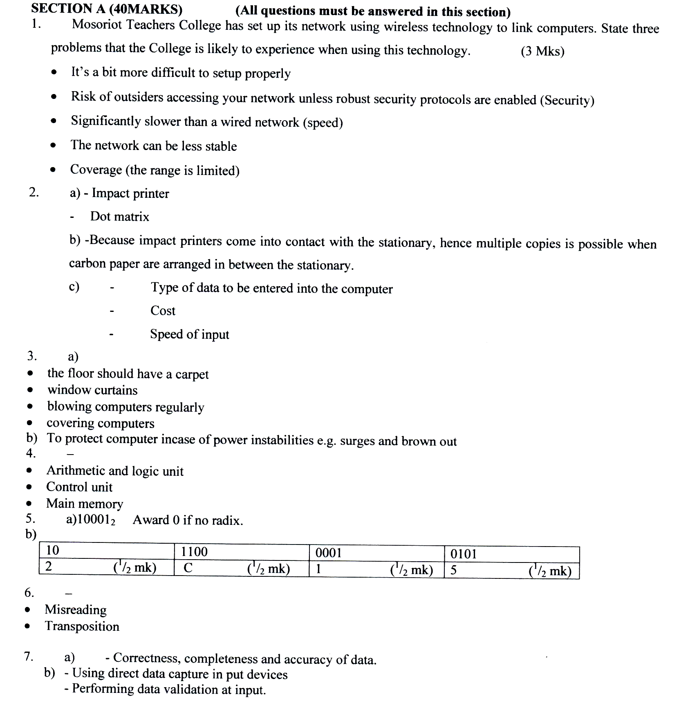
8. Count – counts cells that contain values in range of cells.
Count if – counts cells that meets a given criterion in a range of cells.

9. (i) - Physical file
- Manual ledger

(ii) Secondary storage devices such as: -
- Hard disk
- Solid state memory
- Removable such as; CD, DVD, Flash Disk, Smart Disk (D)
10. (a)
- Digital camera, video camera, web scan
- Microphone
- Speakers
- Satellite dish
- Modem
- Video bridge
- Remote control

11.
- Bridge / router.
- Router.
- Re peater
- Bridge

12. User documentation: written guide or visual on how to use it. While technical documentation guide
on how to maintain, repair and support computer system.

13. - Straight changeover
- Parallel changeover
- Phased Changeover
14.
- Jobs replacement.
- Job displacement.
- Side effects of using computers.
- Retraining on use of computers.

15. (a) Sign in: to enter password to authenticate access to your e-mail account.
(b) Search engine: Program used in searching for materials from the interest fast.
(c) Surf: Browsing or accessing the internet.
(d) Sign up: Registering to have an e-mail account.

SECTION B (60 MARKS)

Question 16 is compulsory and any other three questions of student’s choice.

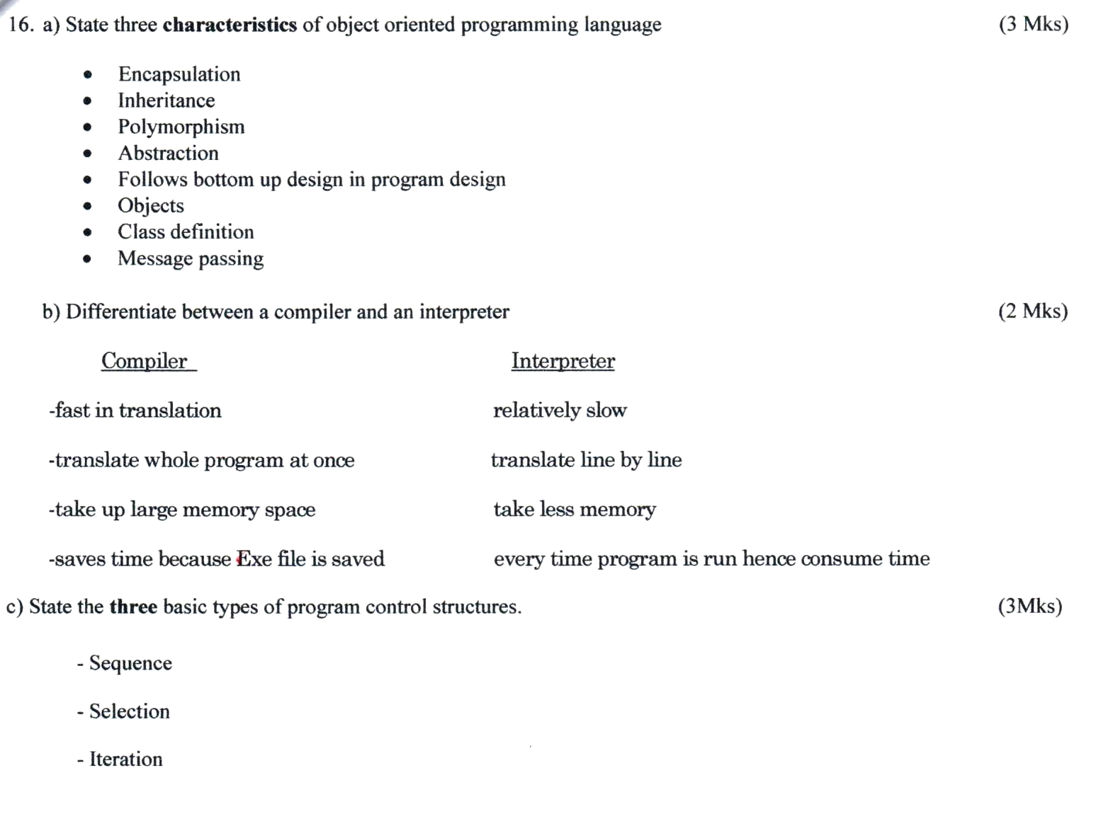

(d) Draw a flow chart which will simulate the processing of students reports. The simulation
should be such that the user repeatedly inputs marks per subject for six subjects using a looping control structure. The computer processes the total marks and mean score of the student. If the average is greater the 50% “Pass” else “Fail.”
Start

(e)

