Name………………………………………………… Index No………………../………….
School…………………………………………… Candidate’s signature………………
Date…………………………….……
233/1
Chemistry
Theory
Paper 1
March 2019
2 hrs

TRIAL ONE EVALUATION TEST 2019
Kenya Certificate of Secondary Education (K.C.S.E)

INSTRUCTIONS TO CANDIDATES:
Answer ALL the questions
Mathematical tables and electronic calculations may be used
All working MUST be clearly shown where necessary

FOR EXAMINER’S USE ONLY:
Questions | Max. score | Candidates score
1-29 | 80

- (a) Explain why there is effervescence when lemon juice is added to sodium hydrogen carbonate. (1mk)

(b) Write ionic equation for the observation made above. (1mk)

- In an experiment a certain volume of air was passed repeatedly from syringe over heated excess copper powder as shown in the diagram below.

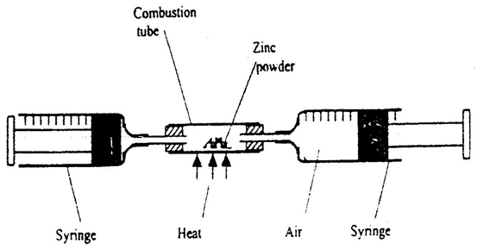
Copper powder

The experiment was repeated using excess magnesium powder. In which of the experiments was the change in volume of air greatest? Give reasons. (3mks)

- The diagram below shows an iron bar, which supports a bridge. The iron is connected to a piece of magnesium metal.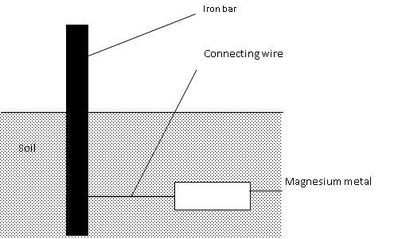
Explain why it is necessary to connect the piece of magnesium metal to the iron bar. (2mks)

- The diagram below is a set up for the laboratory preparation of oxygen gas.

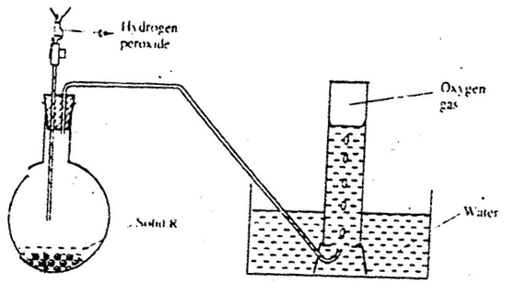
a) Name solid R. (1mk)

b) Write an equation for the reaction that takes place in the flask. (1mk)

c) Give one commercial use of oxygen. (1mk)

- The diagram below represents a paper chromatogram of pure w, X, and Y. A mixture K contains W and Y only. Indicate on the diagram the chromatogram of K (2mk)

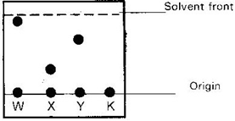
- (a) Solutions may be classified as strong basic, weakly acidic, strong acidic. The information below gives solutions and their PH values. Study it and answer the questions that follow.
solutions | B | C | D
PH-value | 4 | 10 | 7
Classification
(i)Classify the solutions in the table above using terms above (1Mk)
(ii)Which ions are pre-dominantly in solution C? (1/2Mk)
……………………………………………………………………………………………..
(b)In an experiment, equal amounts of magnesium powder were added into test tubes 1 and 2 as
Shown below

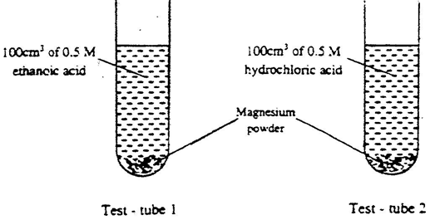
Explain the observable difference in the two test tubes. (1¹/2Mks)
……………………………………………………………………………………………………
………………………………………………………………………………………………………
………………………………………………………………………………………………………
………………………………………………………………………………………………………
- Zinc (II) Oxide reacts with acid and alkalis.
(a) Write the equation for the reaction between Zinc (II) Oxide and
(i) Dilute Sulphuric acid (1 mk)

(ii). Sodium hydroxide solution. (1 mk)

(b) What property of Zinc oxide is shown above by the reaction (a) above? (1mk)

- An indicator established the following equilibrium when dissolved in water.
OX⁻ _{(aq)} + H₂O _{(l)} HOX _{(aq)} + OH⁻ _{(aq)}
( Blue) (Yellow)
State and explain the observation made when Lime water is added? (2mks)

- Study the information in the table below and answer the question the table below the table.

Bond | Energy (kJ/mol)
C-H | 414
Cl-Cl | 244
C-Cl | 326
H-Cl | 431
The enthalpy change for the reaction below is -99kJ/mol.
CH_{4 (g)} + Cl_{2 (g)} CH₃Cl_{(g )} + HCl_{(g)}
(i)What does the negative sign on 99kJ/mol mean? (1mk)
………………………………………………………………………………………………

…………………………………………………………………………………………..
(ii) Which bond is the strongest to break? Explain. (2mks)
………………………………………………………………………………………………

………………………………………………………………………………………………

10. Give two reasons why spoons are electroplated. .(1mk)
………………………………………………………………………………………………

………………………………………………………………………………………………

11. a) What is an isotope? (!mk)
………………………………………………………………………………………………

………………………………………………………………………………………………

b) Determine the relative atomic mass of argon whose isotope mixture is
36. _{Ar} (0.34%) 38_{Ar} (0.06%) 40 _{Ar} (99.6%) (2mks)
18 18 18

12.The table below gives some information about four elements. The letters are not their actual symbols.
Elements | valences | Atomic radii(nm) | Ionic radii(nm
K | 2 | 0.136 | 0.065
L | 7 | 0.099 | 0.181
M | 1 | 0.099 | 0.181
N | 2 | 0.174 | 0.099

- Write the electron arrangement of any element in same chemical family as element L. (1mk)
.....................................................................................................................................................
- Compare the reactivity of elements K and N. (1mk)
………………………………………………………………………………………………….
………………………………………………………………………………………………..
- Account for the difference in ionic and atomic radii of element M. (1mk)
………………………………………………………………………………………………

………………………………………………………………………………………………

………………………………………………………………………………………………
13. Give the main reasons why:-
(i) Cryolite is added to the pure Aluminium oxide in the process of extracting the metal. (1mk)
………………………………………………………………………………………………………
………………………………………………………………………………………………………
(ii) State two properties of Aluminium that makes it suitable to be used in making over-head electrical cables. (2mks)
……………………………………………………………………………………………………..
………………………………………………………………………………………………………
……………………………………………………………………………………………………

14. Excess chlorine was bubbled through a solution of potassium bromide. State and explain the observation made.(2mk)
………………………………………………………………………………………………………
………………………………………………………………………………………………………
15. In an experiment, ammonium chloride was heated in test-tube. A moist red litmus paper placed at the mouth of test first changed blue then red. Explain these observations
(H=1. N=14, Cl=35.5 ) (3mks)
………………………………………………………………………………………………………
………………………………………………………………………………………………………
………………………………………………………………………………………………………
………………………………………………………………………………………………………
16. Y grams of a radioactive isotope take 120days to decay to 3.5grams. The half-life period of the isotope is 20days
(a) Find the initial mass of the isotope (2mks)

(b) Give one application of radioactivity in agriculture (1mk)
…………………………………………………………………………………………………….
17. The diagram below shows energy levels for the reaction
½ H₂(g) + ½ F₂(g) HF(g)
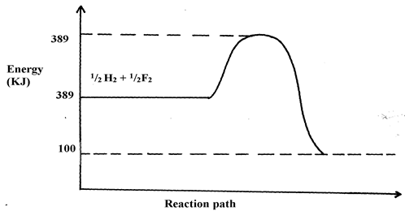
309
- Work out the activation energy for the reaction (1mk)

- Calculate the heat of formation of HF (1½mk)

- Is the reaction endothermic or exothermic? (½mk)

18. a) State the use of the apparatus below. (1mk)
(i) Conical flask

(ii) Separating funnel

b) Highlight one precaution observed in each of the following cases:
- When evaporating Ethanol. (1mk)
………………………………………………………………………………………………………
………………………………………………………………………………………………………
- When heating to dryness a hydrated salts (1mk)
………………………………………………………………………………………………………
………………………………………………………………………………………………………
19. Dry carbon (ii) oxide gas reacts with hot lead (II) oxide as shown in the equation below.
PbO _{(s)} + CO _{(g)} → Pb _{(s)} + CO_{2 (g)}
- Name another gas that can be used to function as carbon (ii) oxide in this experiment. (1mk)

- With an appropriate reason, identify the oxidizing agent in the equation above. (2mks)

20. (a) During fractional distillation a student used glass beads. State the function of glass beads during fractional distillation in;
i) Boiling flask . (1mk)
…………………………………………………………………………………………………...
ii) Fractionating column. (1mk)
…………………………………………………………………………………………………...
b) Give one industrial application of solvent extraction. (1mk)
………………………………………………………………………………………………………
21. Calculate the percentage of nitrogen in calcium nitrate (3mks)
………………………………………………………………………………………………………
………………………………………………………………………………………………………
………………………………………………………………………………………………………
………………………………………………………………………………………………..……
22. 20cm³ of sodium hydroxide solution containing 8.0gdm⁻³ were required for complete neutralization of 0.18g of a dibasic acid H₂X. Calculate the relative molecular mass of the acid. (Na = 23, O = 16, H = 1) (3mks)

23.(a) Name one ore of Zinc metal
……………………………...............………………………………………. (1mk)
(b).A sample of a colorless solution is suspected to be Zinc (II) sulphate. Describe some tests that can be carried to prove this. (2mks)

24. A metal Y with atomic number 11 burns in chlorine to produce a white solid X.
(a) Describe the following properties of X.
- Solubility (1mk)
………………………………………………………………………………………………………
………………………………………………………………………………………………………
- Electrical conductivity.(1mk)………………………………………………………
………………………………………………………………………………………………………
(b) Write an equation to show the formation of compound X. (1 mark)
………………………………………………………………………………………………………
25. a) Define an isomer. (1mk)
………………………………………………………………………………………………………
……………………………………………………………………………………………………...
b) Draw and name any two isomers of pentane. (2mks)

26 a) Name the compounds P and T below.
P - CH₃CH₂CH₂CH₃ ………………………………………...................... (1 mark)
T - CH₃CHCHCH₃ …………………………………………………………… (1 mark)

b) Describe an experiment you would carry out to distinguish T from P. (2 marks)
………………………………………………………………………………………………………
………………………………………………………………………………………………………
………………………………………………………………………………………………………
………………………………………………………………………………………………………
………………………………………………………………………………………………………
27. Consider the reaction below
2 CO(g) + O₂(g) 2CO₂(g) H = -110KJ
State and explain the effect of the following on the above equilibrium:-
(i) Removing oxygen in the reaction above. (1¹/2mk) ………………………………………………………………………………………………………
………………………………………………………………………………………………………
(ii) Injecting helium in the reaction mixture (1¹/2mk)
………………………………………………………………………………………………………
………………………………………………………………………………………………………
28. (a) Name the TWO products of complete combustion of a hydrocarbon with the formula:- CH₃(CH₂)_{n} COOH. (1mk)
………………………………………………………………………………………………………
………………………………………………………………………………………………………
(b) If 15.5g of the above hydrocarbon is equivalent to 0.15moles, find the value of n in the formula above. ( H=1 , C=12 , O= 16 )
………………………………………………………………………………………………(2mks)
…………………………………………………………………………………………………….
29. Three elements P, Q and R form the following compounds P(NO₃)₂ ,Q₂SO₄ and R₂O₃
- Write down the formula of :-
- Hydroxide of Q (1mk)
…………………………………………………………………………………………………….
……………………………………………………………………………………………………..
- Nitride of R (1mk)
…………………………………………………………………………………………………….
……………………………………………………………………………………………………..
- Which element is likely to form a soluble carbonate (1mk)

……………………………………………………………………………………………..

