Name:………………………………………………………Adm No.: ………………Index No…………..
Date: …………………………………..………………... Candidate’s Signature: …………………

231/2
BIOLOGY
Paper 2
(THEORY)
March -April 2019
Time: 2 hours
TERM 1
TRIAL ONE EVALUATION TEST
231/2
Paper 2
BIOLOGY
Instructions to candidates
(a) Write your name and index number in the spaces provided above.
(b) Sign and write the date of the examination in the spaces provided above.
(c) This paper consists of two sections; A and B.
(d) Answer all the questions in section A in the spaces provided.
(e) In section B answer question 6 (compulsory) and either question 7 or 8 in the spaces provided after question 8.
(f) This paper consists of 9 printed pages. Candidates should check the question paper to ascertain that all the pages are printed as indicated and that no questions are missing.
(g) Candidates should answer the questions in English.

For Examiner’s Use only
Section | Question | Maximum Score | Candidate’s  Score
A | 1 | 8
 | 2 | 8
 | 3 | 8
 | 4 | 8
 | 5 | 8
B | 6 | 20
 | 7 | 20
 | 8 | 20
Total score |  | 80

- The diagram below is a cross section through a part of human ileum.
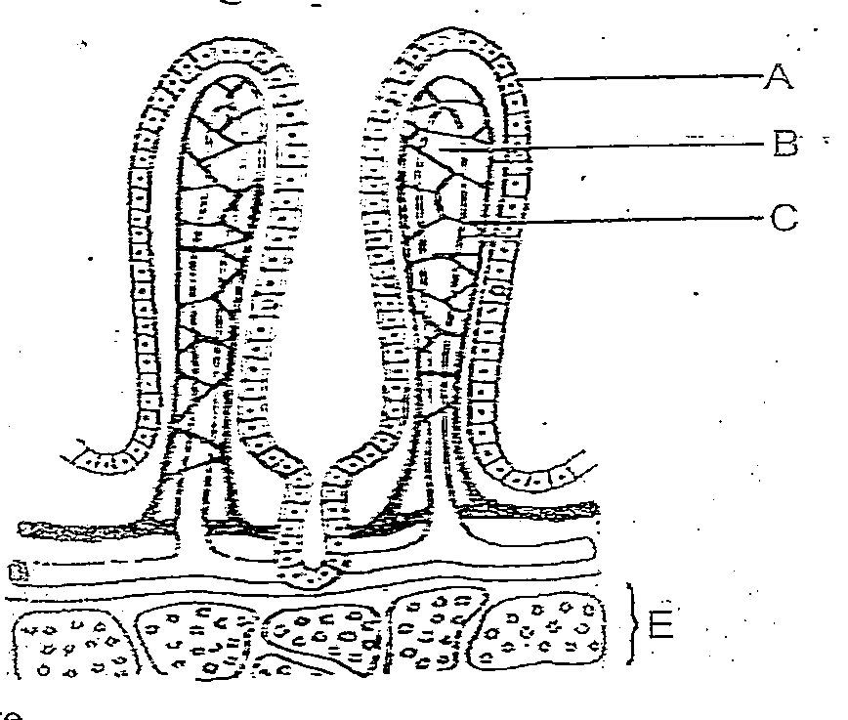

(a)(i) Identify the structure drawn above 1 mark
………………………………………………………………………………………………
(ii) Sate the significance of the structure shown above. 1 mark
………………………………………………………………………………………………………
(b) Name the parts labelled A, B and C 3 marks
A………………………………………………………………………
B………………………………………………………………………..
C………………………………………………………………………..
(c)Give the functions of the part labelled B and C 2 marks
B…………………………………………………………………………………………………
C……………………………………………………………………………………………….
(d) Describe the function of goblet cells. 1 mark
………………………………………………………………………………………………………………………………………………………………………………………………………………………………
2. An experiment was carried out to find out the concentration of ions in the cell sap of an aquatic plant and that of the pond water in which they were found.
 | Concentration in
Ions | Cell sap | Pond water
Na⁺ | 50 | 1.2
K⁺ | 49 | 0.5
Mg²⁺ | 11 | 3.0
Ca²⁺ | 13 | 1.3
Cl⁻ | 101 | 1.3
SO₄²⁻ | 13 | 0.67

(a)(i) Name the process by which the aquatic plant absorbs ions from pond water. 1 mark
…………………………………………………………………………………………………….
(ii) State the four roles of the process you have named in (a)(i) above in a mammalian body. 4 marks
……………………………………………………………………………………………………………………………………………………………………………………………………………………………………………………………………………………………………………………………………………………………………………………………………………………………………………………………………………………………………………………………………………………………………………..
(b) Name the organelle that allows passage of ions in and out of the cell. 1 mark
………………………………………………………………………………………………………..
(c)How can the rate of uptake of ions by the aquatic plant be increased. 2 marks
……………………………………………………………………………………………………………………………………………………………………………………………………………………………………………………………………………………………………………………………………………….
3. (a) Differentiate between the mode of fertilization in higher plants and in mammals. 2 marks
……………………………………………………………………….....................................................................................................................................................................................................................................................................................................................................................................................................................................................................................................................................................................................................................................................................................................................................................................................................................................................................................................................................................................................................................................................................................................................................................................................................................................................................................................................................................................................................................................................................
(b) Give the functions of the placenta during pregnancy. 2 marks
……………………………………………………………………………………………………………………………………………………………………………………………………………………………………………………………………………………………………………………………………………………………………………………………………………………………………………………………………………………………………………………………………………………………………………..

(c) Describe events that occur during anaphase II of meiosis. 1 mark
………………………………………………………………………………………………………………………………………………………………………………………………………………………………
(d) Outline the role of acrosome in human spermatozoan. 1 mark
………………………………………………………………………………………………….............................................................................................................................................................................................4. In a certain plant species, which is normally green, a recessive gene for colour (n) causes the plant to be white when present in the homozygous stat. Such plants die young at an early age. In the heterozygous state the plants are pale green and grow to maturity.
- Suggest a reason for the early death of the plants with the homozygous recessive genes. 2 marks
……………………………………………………………………………………………………………………………………………………………………………………………………………………………………………………………………………………………………………………………………………………………………………………………………………………………………………………………..
- If a normal green plant was crossed with the pale green plant, what will be the phenotypic ratio of F₁ generation? 4 marks
………………………………………………………………………………………………………………………………………………………………………………………………………………………………………………………………………………………………………………………………………………………………………………………………………………………………………………………………………………………………………………………………………………………………………………………………………………………………………………………………………………………………………………………………………………………………………………………………………………………………………………………………………………………………………………………………………………………………………………………………………………………………………………………………………………………………………………………………………………………………………………………………………………………………………………………………………………
(c)Give an explanation for the occurrence of pale green colour in the heterozygous state. 2 marks
……………………………………………………………………………………………………………………………………………………………………………………………………………………………………………………………………………………………………………………………………………………………………………………………………………………………………………………………….
5. The diagram below represents one of the joints in the mammalian skeleton.
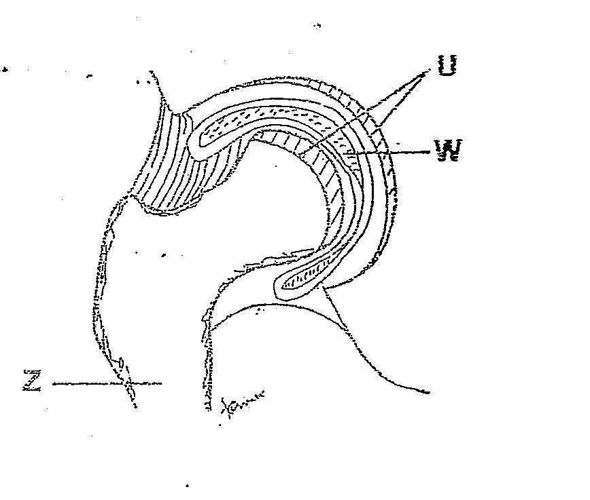

- Name the type of joint shown in the diagram. 1 mark
……………………………………………………………………………………………………..
- Name the parts labelled U and Z 2 marks
U……………………………………………….. Z ……………………………………………
(c)Name two parts of the body where this type of joint is found. 2 marks
……………………………………………………………………………………………………………………………………………………………………………………………………………………………..
(d)State the functions of the fluid found in W 2 marks
……………………………………………………………………………………………………………………………………………………………………………………………………………………………….
(e)Name the structure which attaches muscles to the bones at a joint. 1 mark
……………………………………………………………………………………………………………..

SECTION B; 40 MARKS
Answer question 6 (compulsory) and either question 7 or 8 in the spaces provided after question 8.
6. The table below shows how quantities of sweat and urine vary with external temperature.
External temperature ºC | 0 | 5 | 10 | 15 | 20 | 25 | 30 | 35
Urine , cm³/hr | 100 | 90 | 80 | 70 | 60 | 50 | 40 | 30
Sweat , cm³/hr | 5 | 6 | 10 | 15 | 30 | 60 | 120 | 125

(a Using the same axes, draw quantities of urine and sweat produced against the external temperature.
8 marks

(b) Account for the amount of sweat produced as the temperature rises. 3 marks
………………………………………………………………………………………………………………………………………………………………………………………………………………………………………………………………………………………………………………………………………………………………………………………………………………………………………………………………………………………………………………………………………………………………………………………………………………………………………………………………………………………………………………………………………………………………………………………………………………
(c)Account for the amount of urine produced as the temperature rises. 3 marks
……………………………………………………………………………………………………………………………………………………………………………………………………………………………………………………………………………………………………………………………………………………………………………………………………………………………………………………………………………………………………………………………………………………………………………………………………………………………………………………………………………………………………………………………………………………………………………………………………………….
(d) Explain how the following help in temperature regulation when it is cold.
(i) Hair 3 marks
……………………………………………………………………………………………………………………………………………………………………………………………………………………………………………………………………………………………………………………………………………………………………………………………………………………………………………………………….
(ii)Blood vessels 3 marks
………………………………………………………………………………………………………………………………………………………………………………………………………………………………………………………………………………………………………………………………………………………………………………………………………………………………………………………………
7. (a) (i) Give four modes of expressing food relationship in an ecosystem. 4 marks
(ii) Explain how food as a factor regulate the population of animals in an ecosystem. 8 marks
(b)How are desert plants adapted to conserving water? 8 marks
8.Describe the;
(i) Process of inhalation in mammals 10 marks
(ii) Mechanism of opening and closing of stomata. 10 marks
………………………………………………………………………………………………………………………………………………………………………………………………………………………………………………………………………………………………………………………………………………………………………………………………………………………………………………………………………………………………………………………………………………………………………………………………………………………………………………………………………………………………………………………………………………………………………………………………………………
………………………………………………………………………………………………………………………………………………………………………………………………………………………………………………………………………………………………………………………………………………………………………………………………………………………………………………………………………………………………………………………………………………………………………………………………………………………………………………………………………………………………………………………………………………………………………………………………………………………………………………………………………………………………………………………………………………………………………………………………………………………………………………………………………………………………………………………………………………………………………………………………………………………………………………………………………………………………………………………………………………………………………………………………………………………………………………………………………………………………………………………………………………………………………………………………………………………………………………………………………………………………………………………………………………………………………………………………………………………………………………………………………………………………………………………………………………………………………………………………………………………………………………………………………………………………………………………………………………………………………………………………………………………………………………………………………………………………………………………………………………………………………………………………………………………………………………………………………………………………………………………………………………………………………………………………………………………………………………………………………………………………………………………………………………………………………………………………………………………………………………………………………………………………………………………………………………………………………………………………………………………………………………………………………………………………………………………………………………………………………………………………………………………………………………………………………………………………………………………………………………………………………………………………………………………………………………………………………………………………………………………………………………………………………………………………………………………………………………………………………………………………………………………………………………………………………………………………………………………………………………………………………………………………………………………………………………………………………………………………………………………………………………………………………………………………………………………………………………………………………………………………………………………………………………………………………………………………………………………………………………………………………………………………………………………………………………………………………………………………………………………………………………………………………………………………………………………………………………………………………………………………………………………………………………………………………………………………………………………………………………………………………………………………………………………………………………………………………………………………………………………………………………………………………………………………………………………………………………………………………………………………………………………………………………………………………………………………………………………………………………………………………………………………………………………………………………………………………………………………………………………………………………………………………………………………………………………………………………………………………………………………………………………………………………………………………………………………………………………………………………………………………………………………………………………………………………………………………………………………………………………………………………………………………………………………………………………………………………………………………………………………………………………………………………………………………………………………………………………………………………………………………………………………………………………………………………………………………………………………………………………………………………………………………………………………………………………………………………………………………………………………………………………………………………………………………………………………………………………………………………………………………………………………………………………………………………………………………………………………

THIS IS THE LAST PRINTED PAGE

