TRIAL ONE EVALUATION TEST
MARCH-APRIL 2019
231/2 BIOLOGY (THEORY) PAPER 2 MARKING SCHEME

- (a) (i) Villi; rej. Villus
(ii) Increase surface area for absorption of digested food;
(b) A- Epithelium;
B- Lacteal;
C – Blood capillaries;
(c) B- responsible for absorption of fats; rej. Fatty acids and glycerol
C- Important for transporting digested food;
(d) Secrete mucus to lubricate food; Form a protective layer for the gut wall to prevent it from being digested;
2. (a) (i) Active transport;
(ii) Reabsorption of glucose/ salts in kidney tubules; Absorption of digested food from the alimentary canal into the blood stream; Excretion of waste materials from cell of the body; Accumulation of substances in the body to counter osmotic imbalance in saline Environment; STRICTLY IN MAMAMALS
(b) Cell membrane/Plasma membrane;
(c) Increasing supply of oxygen/ oxygen concentration;
Increasing supply of glucose/ glucose concentration;

3.(a) Fertilization in higher plants involves one male nucleus fusing with a functional egg nucleus to form a zygote; while the other male nucleus fuses with the polar nuclei to form a triploid cell; In mammals fertilization involves the fusion of the male nucleus and female ovum nucleus to form a zygote;
(b) Provide site for exchange/ diffusion of nutrients and waste products between the maternal blood and the foetal blood system;
Secretes/ produces Progesterone hormone;
Attaches the foetus to the mother`s uterus;
(c) Sister chromatids separate; Sister chromatids move to opposite ends of the pole/cell;

(d) Contain lytic enzymes which dissolves egg membrane;

4.(a) The gene for white colour are present in homozygous state; the plant will fail to manufacture chlorophyll hence no photosynthesis; they will thus die as soon as the food reserves are depleted;
(b)
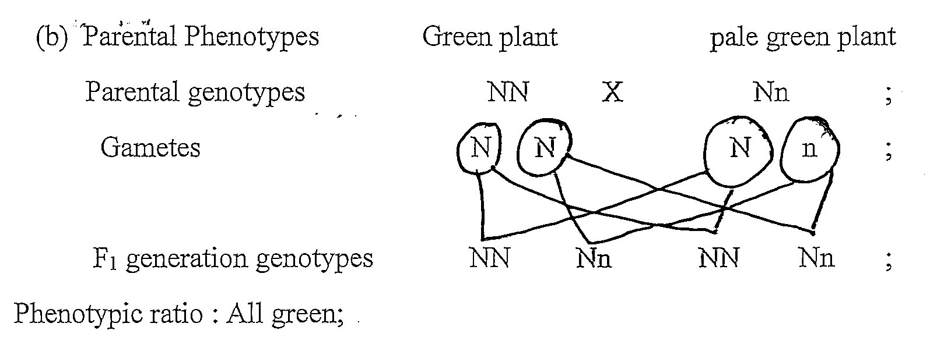

(c) Gene for white and green colour are both dominant; hence they all express themselves equally producing pale green plants/ Codominance;
5. (a) Ball and socket (joint);
(b) U- Articular cartilage; Z- Femur;
(c) Shoulder/ pectoral girdle; Hip/ pelvic girdle;
(d) Reduction of friction/ lubrication;
Absorption of shock/ distributes pressure/ shock absorber;
(e) Tendon;
6 (a) Labeling axes, A 2 marks
Scale - S 2 marks – for correct vertical and horizontal scale
Plotting P 2 marks for all points correctly plotted (missing or wrongly plotted penalize fully.
Curve C 1 mark smooth curve passing through all the plotted points
Identity of the curve, I ¹/₂ mark each for correctly identified curve
Total 8 marks
(b) Sweat produced increases with increase in temperature; increase in temperatures increases vaporization of sweat; in which latent heat of vaporization is absorbed from the body;
(c)Increase in temperature reduces the amount of urine produced; because increased sweat increases the osmotic pressure of blood; more water is reabsorbed into the blood stream from the kidney tubules (resulting to production of little and concentrated urine);
(d) (i) Erector pilli muscles contract; hair stands erect trapping air; which insulate the body against heat loss;
(ii) Blood vessels constrict; blood is diverted to a shunt system; les blood flows to the skin surface; and less heat is lost;

7.(a) (i) Food web; Food chain; Pyramid of biomass; Pyramid of numbers;
(ii) A lot of food; causes population increase; leading to high rate of reproduction; and immigration;
Little food ; leads to stiff competition (for food) ; leading to low rate of reproduction; high rates of deaths; and emigration; thus reducing the population.

(b) Leaves are modified to spines/ thorns; to reduce surface area over which transpiration can occur; Shed their leaves during the dry season; to reduce the surface area exposed to transpiration; Leaves have thick , waxy cuticles; to minimize rate of cuticular transpiration. Leaves for some plants can roll or fold; to reduce rate of transpiration by not exposing stomata to environmental factors. Have sunken stomata; which accumulates moisture in sub-stomatal air spaces hence low diffusion gradient thus reducing transpiration rate. Reduced number of stomata; hence low rate of transpiration. Some plants have reversed stomatal rhythm; to prevent excessive water loss by transpiration. Possession of very deep roots; to absorb water from deep in the soil surface; Possession of parenchyma cells in swollen stems and leaves; for storage of water; Many leaves are sclerophylous/ possess resin coatings; to increase reflection of solar radiation ; hence lower transpiration rate.
NB Award transpiration once

8.(i) Process of inhalation in mammals
External intercostal muscles contract; while internal intercostal muscles relax; Pulls ribs upwards and outwards; the diaphragm muscles contract; and the diaphragm flattens; This increases the volume of thoracic cavity; and decreases its pressure; atmospheric pressure being higher than thoracic cavity pressure; forces the air to rush into the lungs; (through the nose and trachea ) the lungs are inflated;
Maximum 10 marks
(ii) Mechanism of opening and closing of stomata
During the day chloroplast of guard cells accumulate sugar/ glucose produced through the process of photosynthesis; Accumulated sugar/ glucose in the guard cells increases osmotic pressure of the cell sap of the guard cells; Water is drawn from neighbouring epidermal cells by osmosis; guard cells become turgid and bulges outward; this opens the stomata;
At night, sugar / glucose levels which had accumulated in guard cells is converted to starch; Osmotic pressure of guard cells falls; the cells lose water to the neighbouring epidermal cells by osmosis; become flaccid; the guard cells are drawn towards one another; the stomata closes;
Maximum 10 marks

