BUSINESS STUDIES
TRIAL 2, 2019
MARKING SCHEME
FORM FOUR PAPER 2
- a) Differentiate between Private limited company and public limited liability company (10mks)
Private limited company | Public limited liability company
- can be formed by minimum of 2 shareholders | a) Can be formed by a minimum of 7 shareholders
- Formed by a maximum of 50 shareholders | b) Has no set maximum
- Does not sell or advertise its shares to the public | c) Advertise and sells its shares to the public
- Does not allow the transfer of shares without consent from other shareholders | d) Shares can be freely transferred from one person to the other in the stock exchange
- Can start operating after receiving a certificate of incorporation | e) Cannot start operating until it is issued with the license of trading and approval of the prospectus.
- Audited financial statements need not be published and filed with the registered of companies | f) Audited financial statements must be published and filed with register of companies

b) – Invoice – Document sent by the seller to the buyer demand payment for goods supplied.
- Debit note – A document sent from the seller to the buyer to correct undercharge in the invoices.
- Credit note – Document sent by the seller to the buyer to correct overcharge.
- Receipt – It is a document issued from the seller to the buyer when payment is made for goods
- Statement of account – Is a document sent from the seller to buyer showing details or balances of tra-sections for the month
- Payment voucher – A document used to validate payment for goods and services rendered
- Consignment note – To support hire of carrier services
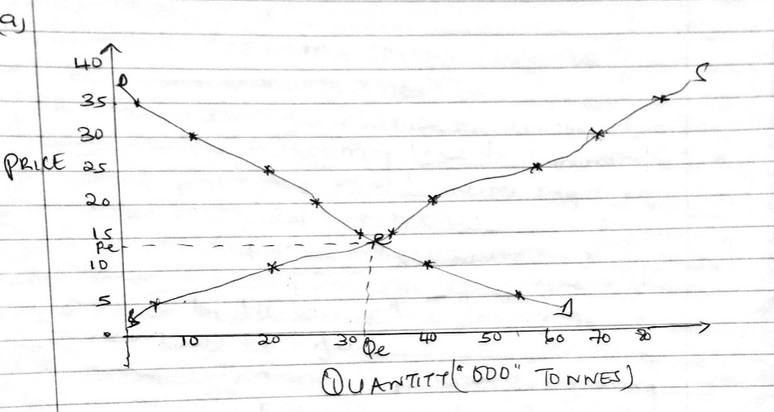
- a)

b) – Used in sourcing for finance /capital/loans/credit – It can be used to convince - financial Institutions and investors to fund the firm’scooperation. (10mks)
- A tool of evaluation / help in avoiding mistakes – can be used to determine whether the firm is achieving its goals.
- A tool of management/help in avoiding mistakes – can be used for structuring /implementation of firm’s activities.
- Give a firm competitive edge – Enable the firm to get better understanding of the market.
- Motivational tools/creates team work – In accomplishing the objectives of the firm.
- Adaptability tool – Creates room to cope with changes
Any other relevant well explained 5 x 2=10mks
- a) – To avoid misleading consumers – By not making false claim about their products.
- To ensure that consumers are not offended – By not making use of appeal that goes against their cultural values.
- To avoid exploiting certain vulnerable groups since they lack the knowledge.
- To avoid negative influence on consumer (value and lifestyle) – That may lead to immorality /ill health.
- To avoid portraying viral businesses negatively – In an attempt to capture market.
- To create a positive image /reputation of the business hence maintaining customers loyalty / retain market share
- To abide by the law of the country so as to avoid lawsuit/conflict.
- To avoid environmental pollution – By using environmentally friendly promotional materials.
Any other relevant well explained 5 x 2=10mks

b) – Benefits that may be realized by a country as a result of government policy of relocating industries to rural areas.
- Reduced income disparities/inequalities/even distribution income- As more people have access to jobs/income generating activities.
- Availability of auxiliary services / subsidiary/service industry – which lead to (faster) development of rural areas.
- Creates jobs/increased job opportunities / more jobs available/reduce unemployment – In all regions of the country.
- Increased utilization of resources /factors of production – Locally available factors of production (will be used) that would otherwise be idle.
- Balanced economic development – As economic activities/firms are spread throughout the country.
- Minimizes pollution in one area- Thus believing the extreme/severe impact.
- Creation/expansion of market – For goods and services/raw materials produced in rural areas
Any other relevant well explained 5 x 2=10mks
- a) Factors to consider when locating a warehouse
- Availability of adequate security
- Availability of auxiliary services eg banks
- Enough land for future expansion
- Nearness to the point of production, sale or supply.
- Compliance with the government regulations
- Good means of transport – easily accessible to bring goods in and out of the warehouse
- Good communications network – To easily pass information between the warehouse and the customers/suppliers
Any other relevant well explained 5 x 2=10mks

b) Miriam
3 column cash book

Date | Details | L.F | Discount allowed | Cash | Bank | Date | Details | L.F | Discount received | Cash | Bank
2015  Sep 1  Sept 2  Sept 12  Sept 25  Sept 28  Sep 30  Sept 30 | Balance Sales  Wetu  Bank  Anyango  Cash  Balance | b/d  C  b/d | 1200  7500 | 55000  50000 | 250000  35260  58800  67500  52800 | 2015  Sep 3  Sep 8  Sep 9  Sep 25  Sep 30  Sep 30 | Ribbons  Wangila  Salaries  Cash  Bank  Balance | C  c/d | 6000 | 4500  34000  52800  13700 | 94000  50000  320360
 |  |  | 8700 | 105000 | 464360 |  |  |  | 6000 | 105000 | 464360
 |  |  |  | 13700 | 320360

- a) Uses of National income
- Used to determine the performance of the economy – An increase of the N.1 may mean better performance of the economy and vice versa.
- The country is able to determine the level of economic growth – By comparing the GDP over several years.
- Helps investors to make informed decisions – On which sector to invest and when to invest.
- Used by government as a tool of supporting their request for foreign aid.
- Comparing economic performance of different countries.
- Helps compete the standards of living between two countries.
- Helps government to understand the income distribution in the country.
Any other relevant well explained 5 x 2=10mks

b) TAI TRADERS
TRADING PROFIT AND LOSS ACCOUNT
FOR THE YEAR ENDED 31ST DECEMBER 2014
Sh sh
Opening stock 10000  Add purchases 15,000  Add carriage inwards 1,200  Less returns outwards 1,100  Net purchases 15,100  CGAFS 25,100  Less closing stock 2,500  C.G.S 22600  Gross profit c/d 4600  27,200  EXPENSES  Carriage outwards 1,200  Discount allowed 300  Insurance 950  Net profit c/d 4,350  6,800 | Sales 28,000  Less sales returns 800  Net sales 27,200  27,200  Gross profit b/d 4,600  Add; Rent received 580  Discount received 1,600  6,800

NB: Wrong gross profit correctly brought down to the P & L account a word.
Net profit derived from wrong gross profit award , but all other entries must be correct to attract awarding.
- a) – Road transport is suitable over short distances since it is relatively fast compared to rail transport. (10mks)
- There is flexibility in road transport since collection and delivery can be done at the convenience of the owner of the goods.
- Road transport can provide door to door service. This reduces the amount of handling and increases the safety of the goods.
- Road transport provides for specially designed vehicles to transport specialized goods e.g takers to transport oil etc
- Road transport does not have a fixed schedule hence one can transport his goods at any time.
- One can decide to own the vehicle so as to have more control since it is relatively cheap compared to a train.
- If the quantity to be transported is small then road transport is mot appropriate.
- The road network in this country is better than that of the rail network.
Any other relevant well explained 5 x 2=10mks

b)
CASH IN HAND A/C
Dr Cr
1993  Jan 1 capital 120,000  Jan 10 sales 35,000  Jan 20 Bank 40,000  195,000  Jan 20 Balance b/d 87,000 | 1993  Jan 14 purchases 90,000  Jan 18 wages 18,000  Jan 20 Balance c/d 87,000  195,000

CASH AT BANK A/C
Dr Cr
1993  Jan 1 capital 20,000  200,000  Jan 20 Balance b/d 100,000 | 1993  Jan 5 purchases 60,000  Jan 120cash 40,000  Jan 20 Balance c/d 100,000  200,000

CAPITAL A/C
Dr Cr
1993  Jan 20 Balance c/d320,000 | 1993  Jan 1 cash 120,000  Jan 1 Bank200,000  320,000  Jan 20 Balance b/d 320,000

PURCHASES A/C
Dr Cr
1993  Jan 5 Bank 60,000  Jan 14 Cash 90,000  150,000  Jan 20 Balance b/d 150,000 | 1993  Jan 20 Balance c/d 150,000  150,000

SALES A/C
Dr Cr
1993  Jan 20 Balance c/d35,000 | 1993  Jan 10 Cash 35,000  Jan 20 Balance b/d 35,000

WAGES A/C
Dr Cr
1993  Jan 18 Cash 18,000  Jan 20 Balance b/d 18,000 | 1993  Jan 20Balance c/d 18,000

Each entry 1 tick

MAKENA
TRIAL BALANCE
AS AT 20TH JANUARY 1983
Details | Dr | Cr
Cash  Bank  Capital  Purchases  Sales  Wages | 87,000  100,000  150,000  18,000 | 320,000  35,000
 | 355,000 | 355,000

Total ticks = 30
Total marks 30 x ¹/₃ = 10mks

