NAME-------------------------------------------------------------------INDEX NO.---------------------
SCHOOL---------------------------------------------------------------------------------------------------
CANDIDATE’S SIGNATURE-------------------------------------------------------------------------
DATE--------------------------------------------------------------------------------------------------------

231/1
BIOLOGY
THEORY
PAPER 1
MARCH 2019
2 HOURS

TRIAL ONE EVALUATION TEST
231/1
Paper 1
BIOLOGY

1.Ascaris lumbricaoides is an example of an endoparasite. The name Ascaris refer to (1mk)
------------------------------------------------------------------------------------------------------------------------------------------------------------------------------------------------------------------------------------------------------------------------------------------------------------------------------------------------
2.State the function of cristae in mitochedrion (1mk)
---------------------------------------------------------------------------------------------------------------------------------------------------------------------------------------------------------------------------------------------------------------------------------------------------------------------------------------------------------------------------------------------------------------------------------------------------------------
3.An experiment was set up as shown below. Use it to answer the following questions
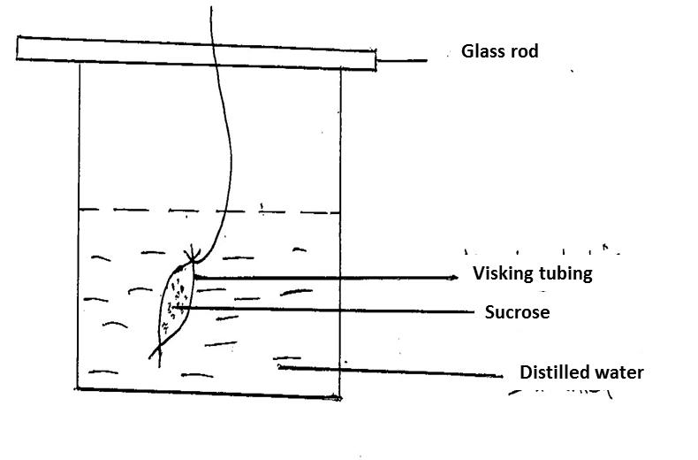

The set up was left for 30 minutes.
a).State the expected results (2mks)
------------------------------------------------------------------------------------------------------------------------------------------------------------------------------------------------------------------------------------------------------------------------------------------------------------------------------------------------------------------------------------------------------------------------------------------------------------------------------------------------------------------------------------------------------------------------------------------------------------------------------------------------------------------------------------------------
b) Explain the observation above (2mks)
------------------------------------------------------------------------------------------------------------------------------------------------------------------------------------------------------------------------------------------------------------------------------------------------------------------------------------------------------------------------------------------------------------------------------------------------------------------------------------------------------------------------------------------------------------------------------------------------------------------------------------------------------------------------------------------------
4 a. Photosynthesis take place in two stages . Name the part of the chloroplast cohere
- Light stage occurs (1mk)
---------------------------------------------------------------------------------------------------------------------------------------------------------------------------------------------------------------------------------------------------------------------------------------------------------------------------------------------------------------------------------------------------------------------------------------------------------------
ii.Dark state occurs (1mk)
---------------------------------------------------------------------------------------------------------------------------------------------------------------------------------------------------------------------------------------------------------------------------------------------------------------------------------------------------------------------------------------------------------------------------------------------------------------
b.Use the equation below to answer the following question
K
Co₂ + H₂0 C₆H₁₂O₆ + 0₂ + ATP
L
i..Identify process K and L (2mks)
K------------------------------------------------------------------------------------------------------------------------------------------------------------------------------------------------------------------------------
L------------------------------------------------------------------------------------------------------------------------------------------------------------------------------------------------------------------------------

5ai) Define the following terms (3mks)
i).Mastication
---------------------------------------------------------------------------------------------------------------------------------------------------------------------------------------------------------------------------------------------------------------------------------------------------------------------------------------------------------------------------------------------------------------------------------------------------------------
iii.Peristalysis
---------------------------------------------------------------------------------------------------------------------------------------------------------------------------------------------------------------------------------------------------------------------------------------------------------------------------------------------------------------------------------------------------------------------------------------------------------------
iii).Churning
---------------------------------------------------------------------------------------------------------------------------------------------------------------------------------------------------------------------------------------------------------------------------------------------------------------------------------------------------------------------------------------------------------------------------------------------------------------
b. Explain why pepsin is produced in form of pepsinogen (1mk)
------------------------------------------------------------------------------------------------------------------------------------------------------------------------------------------------------------------------------------------------------------------------------------------------------------------------------------------------
6a.State the role of the following plant vessels
- Xylem (1mk)
-----------------------------------------------------------------------------------------------------------------------------------------------------------------------------------------------------------------------------------------------------------------------------------------------------------------------------------------------
ii). Phloem (1mk)
-----------------------------------------------------------------------------------------------------------------------------------------------------------------------------------------------------------------------------------------------------------------------------------------------------------------------------------------------
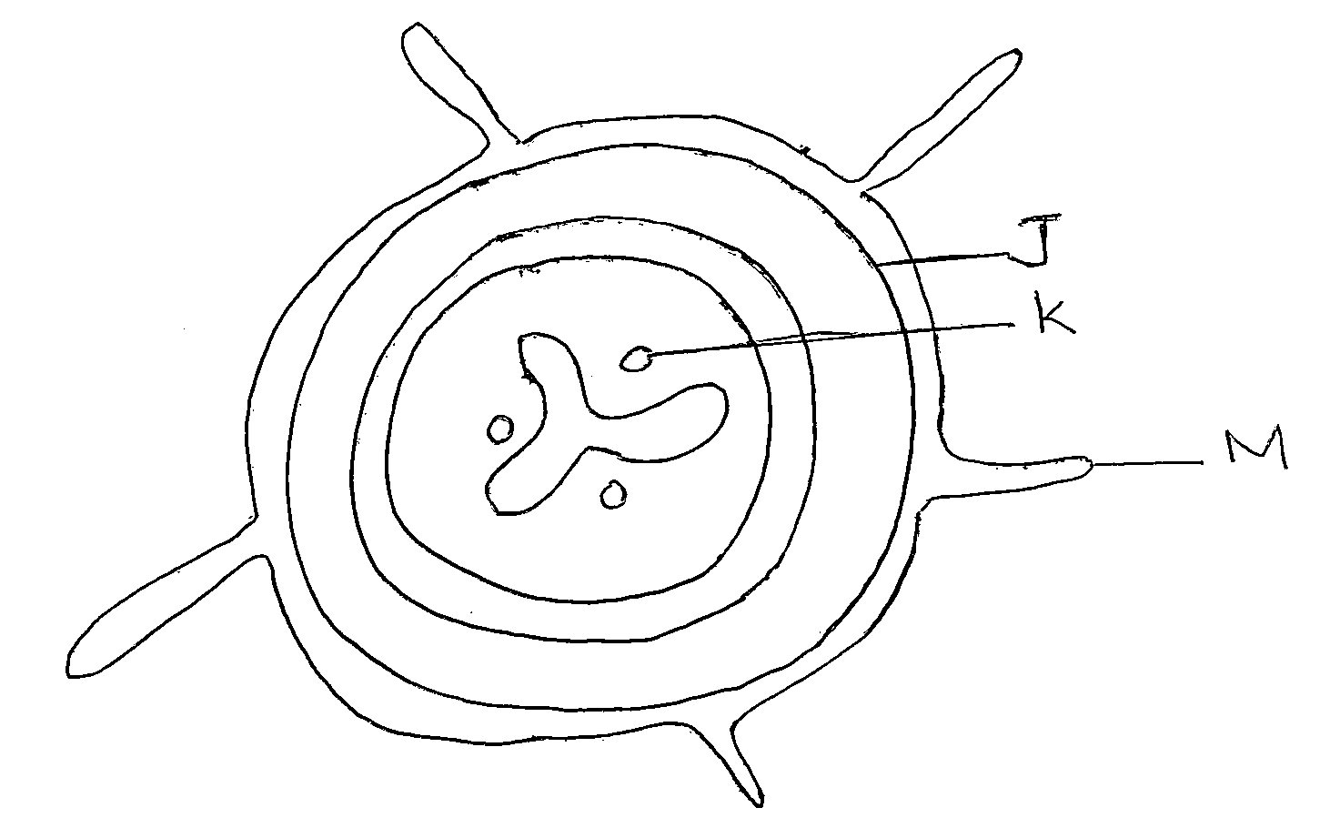

b.

i.From which plant organ was the section obtained (1mk)
-----------------------------------------------------------------------------------------------------------------------------------------------------------------------------------------------------------------------------------------------------------------------------------------------------------------------------------------------
ii.Give two reasons for your answer in (a) above (2mks)
------------------------------------------------------------------------------------------------------------------------------------------------------------------------------------------------------------------------------------------------------------------------------------------------------------------------------------------------------------------------------------------------------------------------------------------------------------------------------------------------------------------------------------------------------------------------------------------------------------------------------------------------------------------------------------------------
c.Name the parts labelled J, K, and l (3mks)
J-------------------------------------------------------------------------------------------
K------------------------------------------------------------------------------------------
L------------------------------------------------------------------------------------------
d.State two functions of the part labelled M (2mks)
---------------------------------------------------------------------------------------------------------------------------------------------------------------------------------------------------------------------------------------------------------------------------------------------------------------------------------------------------------------------------------------------------------------------------------------------------------------
7.State one difference between open and closed circulatory system (1mk)
---------------------------------------------------------------------------------------------------------------------------------------------------------------------------------------------------------------------------------------------------------------------------------------------------------------------------------------------------------------------------------------------------------------------------------------------------------------
8.Differentiate between serum and sebum (2mks)
------------------------------------------------------------------------------------------------------------------------------------------------------------------------------------------------------------------------------------------------------------------------------------------------------------------------------------------------------------------------------------------------------------------------------------------------------------------------------------------------------------------------------------------------------------------------------------------------------------------------------------------------------------------------------------------------
9. State the function of vitamin K and calcium ions in blood clotting (2mks)
------------------------------------------------------------------------------------------------------------------------------------------------------------------------------------------------------------------------------------------------------------------------------------------------------------------------------------------------------------------------------------------------------------------------------------------------------------------------------------------------------------------------------------------------------------------------------------------------------------------------------------------------------------------------------------------------
10.The chart below shows a feeding relationship in a certain ecosystem

Locust lizards Snakes

Grass Hawks

Mice Domestic cats
a. Construct two food chains ending with a tertiary consumer in each case (2mks)

------------------------------------------------------------------------------------------------------------------------------------------------------------------------------------------------------------------------------------------------------------------------------------------------------------------------------------------------------------------------------------------------------------------------------------------------------------------------------------------------------------------------------------------------------------------------------------------------------------------------------------------------------------------------------------------------
b. Which organism has the largest variety of predators in the food web (1mks)
--------------------------------------------------------------------------------------------------------------------------------------------------------------------------------------------------------------------------------------------------------------------------------------------------------------------------------------------------------------------------------------------------------------------------------------------------------------

c. Name secondary consumers in the food web (2mks)
--------------------------------------------------------------------------------------------------------------------------------------------------------------------------------------------------------------------------------------------------------------------------------------------------------------------------------------------------------------------------------------------------------------------------------------------------------------
11ai).State the melodic stage where crossing over occurs (1mk)
--------------------------------------------------------------------------------------------------------------------------------------------------------------------------------------------------------------------------------------------------------------------------------------------------------------------------------------------------------------------------------------------------------------------------------------------------------------
ii).What is the significance of crossing over (1mk)
--------------------------------------------------------------------------------------------------------------------------------------------------------------------------------------------------------------------------------------------------------------------------------------------------------------------------------------------------------------------------------------------------------------------------------------------------------------
bi).Explain why pregnancy persists even when ovaries are removed after the fourth month of pregnancy (2mks)
------------------------------------------------------------------------------------------------------------------------------------------------------------------------------------------------------------------------------------------------------------------------------------------------------------------------------------------------------------------------------------------------------------------------------------------------------------------------------------------------------------------------------------------------------------------------------------------------------------------------------------------------------------------------------------------------
ii).Why do pregnant women excrete less urea (2mks)
------------------------------------------------------------------------------------------------------------------------------------------------------------------------------------------------------------------------------------------------------------------------------------------------------------------------------------------------------------------------------------------------------------------------------------------------------------------------------------------------------------------------------------------------------------------------------------------------------------------------------------------------------------------------------------------------

12.
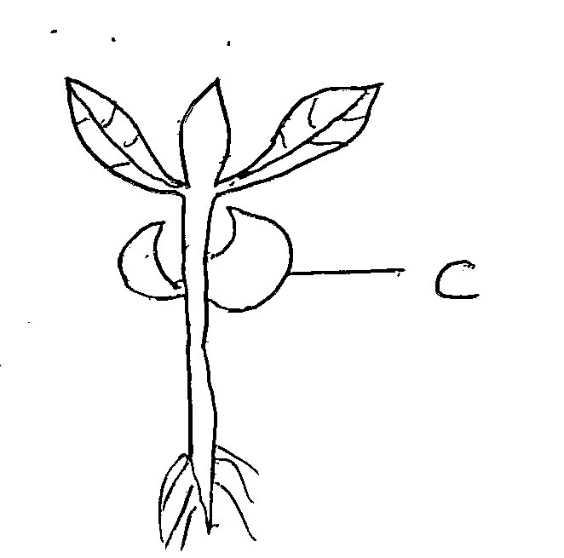

ai. Suggest the types of germination exhibited by the seedling above (1mks)
----------------------------------------------------------------------------------------------------------------------------------------------------------------------------------------------------------------------------------------------------------------------------------------------------------------------------------------------------------------------------------------------------------------------------------------------------------------
ii).State 3 roles of part C (3mks)
-------------------------------------------------------------------------------------------------------------------------------------------------------------------------------------------------------------------------------------------------------------------------------------------------------------------------------------------------------------------------------------------------------------------------------------------------------------------------------------------------------------------------------------------------------------------------------------------------------------------------------------------------------------------------------------------------------------------------------------------------------------------------------------------------------------------------------------------------------------------------------------------------------------------------------
13.Describe the discontinuous growth among members of class insect (2mks)
----------------------------------------------------------------------------------------------------------------------------------------------------------------------------------------------------------------------------------------------------------------------------------------------------------------------------------------------------------------------------------------------------------------------------------------------------------------------------------------------------------------------------------------------------------------------------------------------------------------------------------------------------------------------------------------------------------------------------------------------------------------------------------------------------------------
14a.i.Describe the adaptations of the guard cells to opening and closing of stomata (2mks)
----------------------------------------------------------------------------------------------------------------------------------------------------------------------------------------------------------------------------------------------------------------------------------------------------------------------------------------------------------------------------------------------------------------------------------------------------------------------------------------------------------------------------------------------------------------------------------------------------------------------------------------------------------------------------------------------------------------------------------------------------------------------------------------------------------------
ii. State two theories that explain the opening and closing of stomata (2mks)
----------------------------------------------------------------------------------------------------------------------------------------------------------------------------------------------------------------------------------------------------------------------------------------------------------------------------------------------------------------------------------------------------------------------------------------------------------------------------------------------------------------------------------------------------------------------------------------------------------------------------------------------------------------------------------------------------------------------------------------------------------------------------------------------------------------
b. State two gaseous exchange structures in plants (2mks)
------------------------------------------------------------------------------------------------------------------------------------------------------------------------------------------------------------------------------------------------------------------------------------------------------------------------------------------------------------------------------------------------------------------------------------------------------------------------------------------------------------------------------------------------------------------------------------------------------------------------------------------------------------------------------------------------------------------------------------------------------------------------------------------------------------------------------------------------------------------------------------------------------------------------------------------------------------------------------------------------------------------------------------------------
15a.Draw and label the structure of a gill (3mks)

b. Explain the counter current follow system across the gills (2mks)
------------------------------------------------------------------------------------------------------------------------------------------------------------------------------------------------------------------------------------------------------------------------------------------------------------------------------------------------------------------------------------------------------------------------------------------------------------------------------------------------------------------------------------------------------------------------------------------------------------------------------------------------------------------------------------------------------------------------------------------------------------------------------------------------------------------------------------------------------------------------------------------------------------------------------------------------------------------------------------------------------------------------------------------------
16.Name two categories of anaerobes (2mks)
----------------------------------------------------------------------------------------------------------------------------------------------------------------------------------------------------------------------------------------------------------------------------------------------------------------------------------------------------------------------------------------------------------------------------------------------------------------------------------------------------------------------------------------------------------------------------------------------------------------------------------------------------------------------------------------------------------------------------------------------------------------------------------------------------------------
17.The equation below shows an oxidation reaction of food substances
5 C₅₁H₉₈O₆ + 145O₂ 102 CO₂ + 98 H₂0 + energy
- Determine respiratory quotient of the oxidation of food substance (2mks)

- Identify the food substance (1mk)
----------------------------------------------------------------------------------------------------------------------------------------------------------------------------------------------------------------------------------------------------------------------------------------------------------------------------------------------------------------------------------------------------------------------------------------------------------------
A
B
18.Glucose Glycogen (2mks)
Name i. A---------------------------------------------------------------------------------------------------
ii B---------------------------------------------------------------------------------------------------
19.The figure below show a portion of nucleic acid
C – U – G – C
- Name the nucleic acid (1mk)
----------------------------------------------------------------------------------------------------------------------------------------------------------------------------------------------------------------------------------------------------------------------------------------------------------------------------------------------------------------------------------------------------------------------------------------------------------------
ii).Give a reason (1mk)
----------------------------------------------------------------------------------------------------------------------------------------------------------------------------------------------------------------------------------------------------------------------------------------------------------------------------------------------------------------------------------------------------------------------------------------------------------------
20a.What are analogous structures (1mk)
----------------------------------------------------------------------------------------------------------------------------------------------------------------------------------------------------------------------------------------------------------------------------------------------------------------------------------------------------------------------------------------------------------------------------------------------------------------
b.State two examples of analogous structures (2mks)
---------------------------------------------------------------------------------------------------------------------------------------------------------------------------------------------------------------------------------------------------------------------------------------------------------------------------------------------------------------------------------------------------------------------------------------------------------------------------------------------------------------------------------------------------------------------------------------------------------------------------------------------------------------------------------------------------------------------------------------------------------------------------------------------------------------
21.In mice the allele for black fur is dominat to the allele for brown fur.
What percentage offspring would have brown fur from a cross between hetero zygous black mice and brown mice. Show your working. Use letter B to represent the allele for black colour (4mks)

22.Significance of the following practices during preparation of temporary slide (2mks)
i).Staining.
----------------------------------------------------------------------------------------------------------------------------------------------------------------------------------------------------------------------------------------------------------------------------------------------------------------------------------------------------------------------------------------------------------------------------------------------------------------
ii. Cutting thin section
----------------------------------------------------------------------------------------------------------------------------------------------------------------------------------------------------------------------------------------------------------------------------------------------------------------------------------------------------------------------------------------------------------------------------------------------------------------
23. State the Causitive agent of typhoid (1mk)
----------------------------------------------------------------------------------------------------------------------------------------------------------------------------------------------------------------------------------------------------------------------------------------------------------------------------------------------------------------------------------------------------------------------------------------------------------------
24.Other than using quadrant method gives one methods of estimating population of grass (1mk)

