TRIAL ONE EVALUATION TEST
BIOLOGY PAPER 1 MARKING SCHEME

- Generic name/Genus
- Site for attachment of respiratory enzymes
3a. Visking tubing swell/turgid
b. Water molecules more into the visking tubing by osmosis
4a. i) Granna
ii) Stroma
b. K- Photosynthesis
L- Respiration
5a. i) Mostication- crushing of food by teeth in the mouth
ii) Peristalysis – movement of food through oesophogus by aid of contraction and relaxation of
muscles.
iii) Churning - Mixing of food in the stomach
b. To prevent it from digesting cells that produces it.
6a. Xylem – Transportation of water & mineral salts
Phloem – Transportation of manufactured food
b. Root
Root hairs
Absence of pith
8. Serum – plasma witout blood proteins
Sebum- substance released by skin that it keep it moist & flexible
9a). Vit K – Formation of prothrombiu
C_{a}²⁺ conversion of thromboplastiun to plastin
10a. Grass mice snakes Hawks
Grass mice snakes Domestic cats
b. Mice
c. Lizard, Snakes, Domestic cats
11. i) Pophase 1
ii) Causes variation.
b i) The placenta takes over the role of the hormone production
ii) Most amino acids are used to formation of new tissues of the foetus
12a i) Epigeal
ii) – Storage of food
- Protection of phunule & radicle
- Photosynthesic role during early stages of germination
13. Growth occurs immediately after monthly and stops when the hard exoskeleton forms again
14ai) - Chloroplasts presence
- Thin outer and thick inner layer

ii) Starch sugar interconversion theory
Photosynthetic theory
Pottasium ion theory
b. Stomata
Lenticells
Pneumatophores
15a.
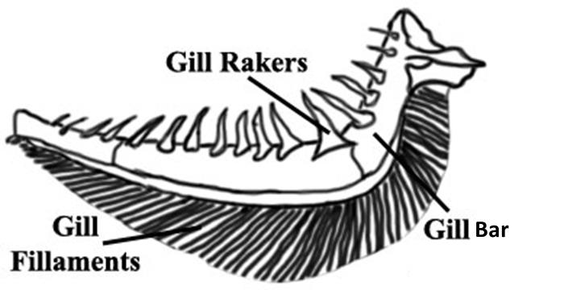

b. Water flows in an opposite direction in relation to the flow of blood
i. This increases conc gradient of O₂ & CO₂

16. Obligate
Facultative

17a. 102
145 = 0.703
b. Lipid
18. A- lusulin
B- Glucagon
19. Ribonucleic acid ( RNA)
Presence of Uracil
20a. Structures with different origin but modified to perform same function
b) Mark any relevant examples
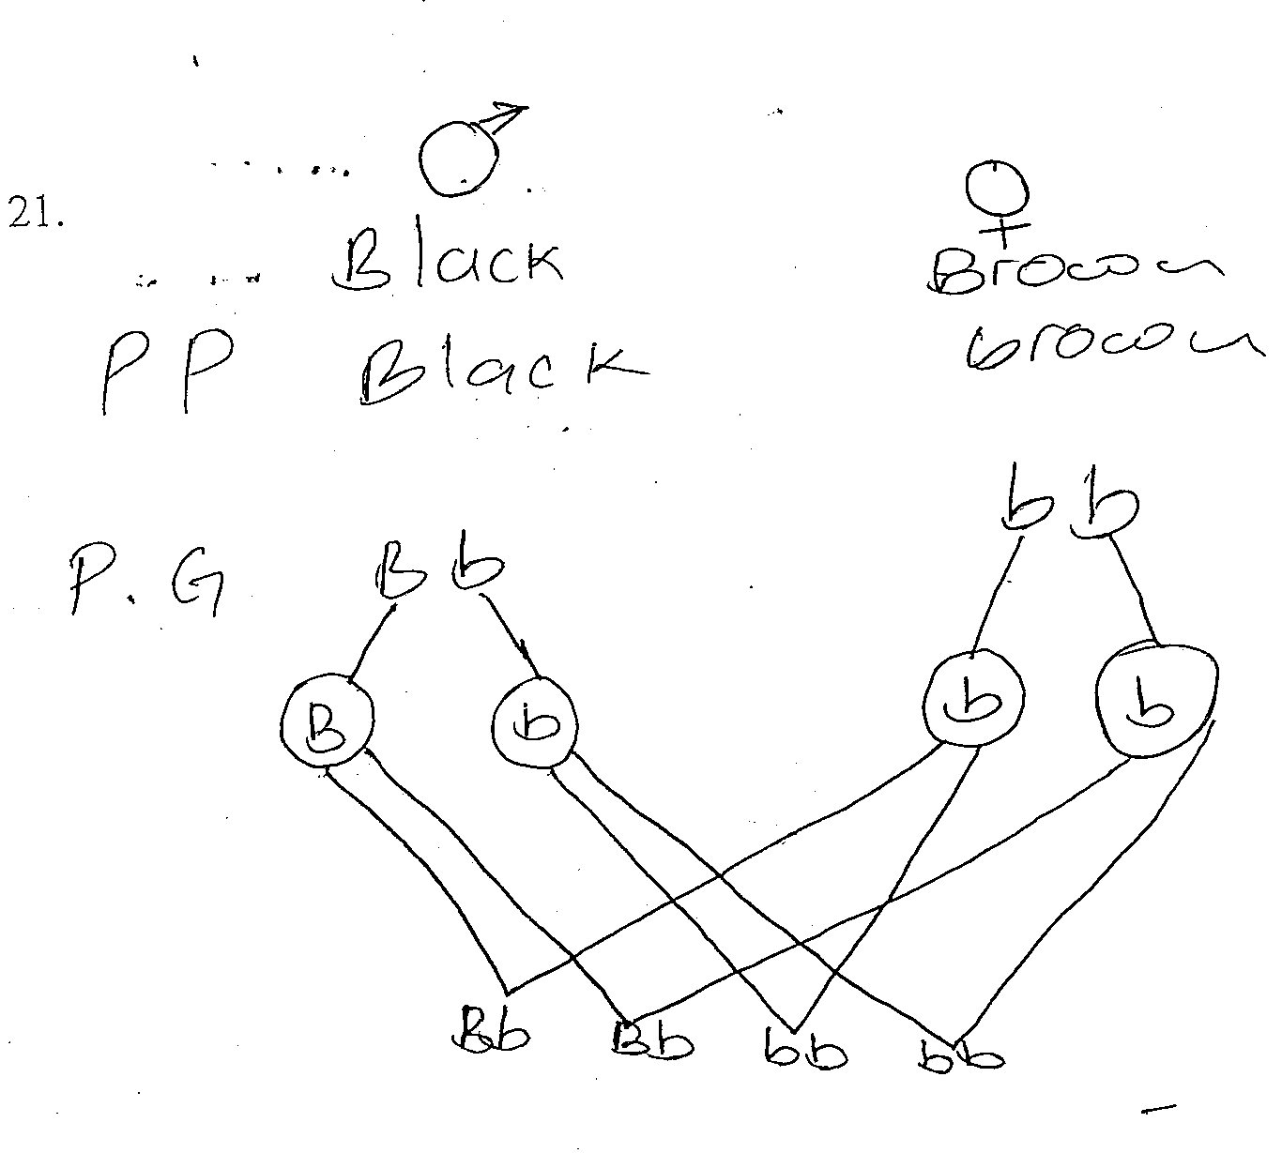
21.

50%

22. Make structure more clear
Allow penetration of light
Salmonella typhi

