442/1
ART AND DESIGN
Paper 1
March 2019
Time: 1 ½ hours
TRIAL ONE EVALUATION TEST 2019

ART AND DESIGN MARKING SCHEME

SECTION A: 20MKS
1.a) Distinguish between subject and content as components of a work of art (2mks)
-Subject is the image that viewers can easily identify. Subject maybe a person, place, thing event.
-Content- message, feeling or idea an artwork communicates. What the artwork means.
b) Define rhythm in Art and Design. (1mk)
- Flow of elements having a regular repeat pattern.
-Flowing movement having a regularly repeated pattern.
c) What is a design brief? (2mks)
It is a clients specification containing
-problem –analysis
-choice –budget

d) What type of balance is employed in the picture below (1mk)
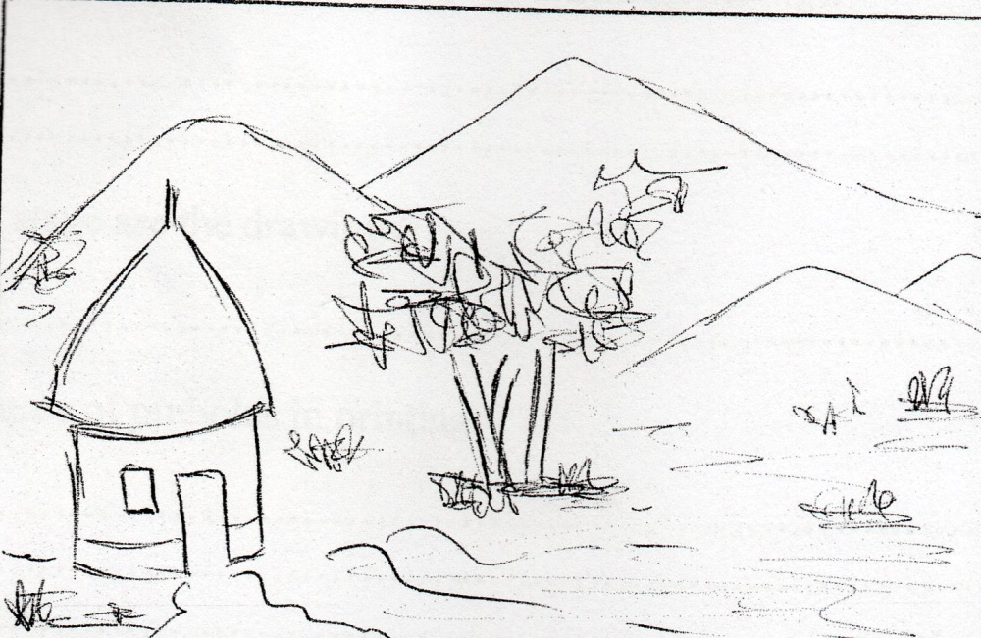

e) Explain the term “character” with reference to line as an element of Art and Design. (1mk)
-Distinctive qualities
f) Name any two ingredients required to form glaze. (1mk)
-Feldspar/Alumina
-Whiting/ Flux
-Silica/ Flint
g) Study the drawings below and answer the questions that follow.
(a)
(b)

- State the category to which each of the drawings belongs. (2mks)
………………………………………………………………………………………………………………………………………………………………………………………………………………
- At which stage are the drawings? (1mk)
………………………………………………………………………………………………………
h) Give two causes of pinholes in printing. (2mks)
-Touching the screen while its still wet
-Application of blocking media on a dirty screen.
-Uneven application of blocking media on the screen
i) What is a cartoon strip? (1mk)
-A drawing that creates humour in more than one frame. It tends to tell a story.
j) List two main uses of voids in a sculpture. (2mks)
-Define form
-Make sculpture light
-For beauty.
k) Briefly describe the following terms as used in mosaic (2mks)
- Tesserae
………………………………………………………………………………………………………………………………………………………………………………………………………………
- Interstices
………………………………………………………………………………………………………………………………………………………………………………………………………………
l) Why are fabrics decorated with random patterns preferred for making clothes. (2mks)
-No pattern is interfered with when the fabric is cut to make cloth, making it easier to work with.

SECTION B: 25MKS
2. Below are tools used in the weaving process.
a) Name the tool.(1mk)
-Shuttle.
b) State its function.(1mk)
-Pass weft thread through a shed during weaving.
c) List any three factors to be considered when calculating the length of warps before the weaving process. (3mks)
-Length of fabric
-Loom size
-Allowance for shrinkage
-Allowance for finishing(twisting, frills)
3. Study the process below and carefully answer the questions that follow.
a) Name the process (2mks)
-Casting
b) Name the main equipment used in the process. (1mk)
-Press mould
c) Give two advantages of using the above technique over others.(2mks)
-Fast way of producing identical items.
-Accurate in terms of putting details.
4. a) State the function of common salt (Sodium chloride) in the fabric dyeing process.(1mk)
b) Draw and label a tjanting in the space below.(3mks)
c) Name two ways in which texture can be achieved on fabric decorated using batik.(1mk)
5. Rewrite the first stanza of the Kenya National Anthem in calligraphy.(5mks) (English version)
6. Outline the process of firing bone dry clay items using the open firing process.(5mks)
-Dig a shallow pit
-Arrange wood/stick/twigs/straws/dry grass in the pit
-Arrange the clay items starting with the big ones, pile up as you put the small ones.
-Cover the clay items with grass/twigs
-Light the fire and let it burn till all the firewood is consumed
-Let it cool, remove from the pit.
SECTION C:
7. a) Differentiate an Ornament from Jewellery.(2mks)
-Ornament- Object used to enhance the appearance of a person, another object, surface etc.
-Jewellery- Ornaments worn on the human body.
b) Explain any 4 factors that should be considered in designing ornaments.(4mks)
-Function
-Material
-Style
-Tool
-Technique
c) State three properties of copper that make it a suitable metal for ornament making.(3mks)
-Does not rust
-Malleable
-Can be polished to a high shine
d) When is a shield considered an ornament?(2mks)
-When displayed on the wall for beauty
e) What is a spacer?(2mks)
-Decorative shaped metal component which has rings or loops.
f) What is the function of spacers?(2mks)
-Used to separate bands of colour and keep the necklace rigid in shape.
8. a) What is collage?(2mks)
-Technique of creating a composition by pasting a variety of art materials on a surface.
b) State 3 reasons why montage is regarded as a type of collage. (3mks)
-Both involve pasting of materials
-Done a flat surface
-Can be combined with other techniques
-Involve cutting of materials/ materials are in irregular shape.
c) Distinguish Mosaic and Collage.(10mks)
Mosaic Collage
-Mono-media - Multi-media
-Juxtaposition -Superimposition
-Colour is emphasized - Texture is emphasized
-Materials are cut regular in shape -Irregular
-Shimmering effect -Textural effect

