KAKAMEGA SUB-COUNTY EXAMINATION
Kenya Certificate of Secondary Education (KCSE)
AGRICULTURE 443/2
INSTRUCTIONS TO CANDIDATES.
- Write your name and index number in the spaces provided above
- Sign and write the date of examination in the spaces provided.
- This paper consists of THREE sections; A, B, and C.
- Answer all questions in sections A and B.
- Answer any TWO questions in section C.
- All the questions should be answered in the spaces provided
For Examiners’ Use Only
SECTION | MAXIMUM SCORE | CANDIDATES SCORE
A | 30
B | 20
C | 20
 | 20
TOTAL | 90

1 Name the intermediate hos t of the following parasites:. (1mk)
(i) Tape worm ------------------------------------------------------------------------------------------------------------
(ii)Liverflluke -----------------------------------------------------------------------------------------------------------
2 Why are goats suited to dry parts of Kenya (1½mk)
--------------------------------------------------------------------------------------------------------------------------------------------------------------------------------------------------------------------------------------------------------------------------------------------------------------------------------------------------------------------------------------------------------------------------------------------------------------------------------------------------------------------------------
3 State three practices that make ranching an improved system of pastoral nomadism. (1½mk)
--------------------------------------------------------------------------------------------------------------------------------------------------------------------------------------------------------------------------------------------------------------------------------------------------------------------------------------------------------------------------------------------------------------------------------------------------------------------------------------------------------------------------------
4a) Give four precautions taken by farmers when using tools for farm operations (2mks)
--------------------------------------------------------------------------------------------------------------------------------------------------------------------------------------------------------------------------------------------------------------------------------------------------------------------------------------------------------------------------------------------------------------------------------------------------------------------------------------------------------------------------------
b) Give two examples of plumbing tools. (1mk)
------------------------------------------------------------------------------------------------------------------------------------------------------------------------------------------------------------------------------------------------------------------------------------------------------------------------------------------------------------------------------------------------
5 State three factors that influence the digestibility of food in livestock. (1½mk)
--------------------------------------------------------------------------------------------------------------------------------------------------------------------------------------------------------------------------------------------------------------------------------------------------------------------------------------------------------------------------------------------------------------------------------------------------------------------------------------------------------------------------------
6 Differentiate between cross breeding and out crossing . (1mk)
------------------------------------------------------------------------------------------------------------------------------------------------------------------------------------------------------------------------------------------------------------------------------------------------------------------------------------------------------------------------------------------------
7a) What is embryo transplant. (1mk)
--------------------------------------------------------------------------------------------------------------------------------------------------------------------------------------------------------------------------------------------------------------------------------------------------------------------------------------------------------------------------------------------------------------------------------------------------------------------------------------------------------------------------------
b) Give two advantages of embryo transplant. (2mks)
------------------------------------------------------------------------------------------------------------------------------------------------------------------------------------------------------------------------------------------------------------------------------------------------------------------------------------------------------------------------------------------------

8 How does docking sheep help prevent spread of diseases in sheep management. (1mk)
------------------------------------------------------------------------------------------------------------------------------------------------------------------------------------------------------------------------------------------------------------------------------------------------------------------------------------------------------------------------------------------------
9 State three reasons of feeding calves on colostrum (1½mk)
------------------------------------------------------------------------------------------------------------------------------------------------------------------------------------------------------------------------------------------------------------------------------------------------------------------------------------------------------------------------------------------------
10 List two types of calf pens. (1mk)
------------------------------------------------------------------------------------------------------------------------------------------------------------------------------------------------------------------------------------------------------------------------------------------------------------------------------------------------------------------------------------------------
11 State four qualities of eggs for incubation (2mks)
-----------------------------------------------------------------------------------------------------------------------------------------------------------------------------------------------------------------------------------------------------------------------------------------------------------------------------------------------------------------------------------------------------------------------------------------------------------------------------------------------------------------------------------------------
12 Outline any three digestive processes that occur in the rumen of cattle (1½mk)
--------------------------------------------------------------------------------------------------------------------------------------------------------------------------------------------------------------------------------------------------------------------------------------------------------------------------------------------------------------------------------------------------------------------------------------------------------------------------------------------------------------------------------
13 State three disadvantages of a hedge as a fence (1½mk)
--------------------------------------------------------------------------------------------------------------------------------------------------------------------------------------------------------------------------------------------------------------------------------------------------------------------------------------------------------------------------------------------------------------------------------------------------------------------------------------------------------------------------------
14 State four roles of worker bees in a colony. (2mks)
------------------------------------------------------------------------------------------------------------------------------------------------------------------------------------------------------------------------------------------------------------------------------------------------------------------------------------------------------------------------------------------------
15 Give two signs that would indicate that a cow died of anthrax (2mks)
----------------------------------------------------------------------------------------------------------------------------------------------------------------------------------------------------------------------------------------------------------------
--------------------------------------------------------------------------------------------------------------------------------
16 Give two examples of succulent roughages (1mk) ----------------------------------------------------------------------------------------------------------------------------------------------------------------------------------------------------------------------------------------------------------------
--------------------------------------------------------------------------------------------------------------------------------
17 State the functions of the following tractor parts (1mk)
(i) Carburrator ----------------------------------------------------------------------------------------------------------
(ii)IInduction coil --------------------------------------------------------------------------------------------------------
(iii) Spark plug --------------------------------------------------------------------------------------------------------

18a State four ways of controlling cannibalism in a deep liter poultry house (2mks)
------------------------------------------------------------------------------------------------------------------------------------ ------------------------------------------------------------------------------------------------------------------------------------------------------------------------------------------------------------------------------------------------------------------------------------------------------------------------------------------------------------------------------------------------------------
19 Name any one dual purpose breed of cattle (½ mk)
----------------------------------------------------------------------------------------------------------------------------------------------------------------------------------------------------------------------------------------------------------------

SECTION B (20MKS)

Answer All questions in this section in the spaces provided

19 The diagram drawn shows the cross section of a fish pond. Study it and answer questions that follow.
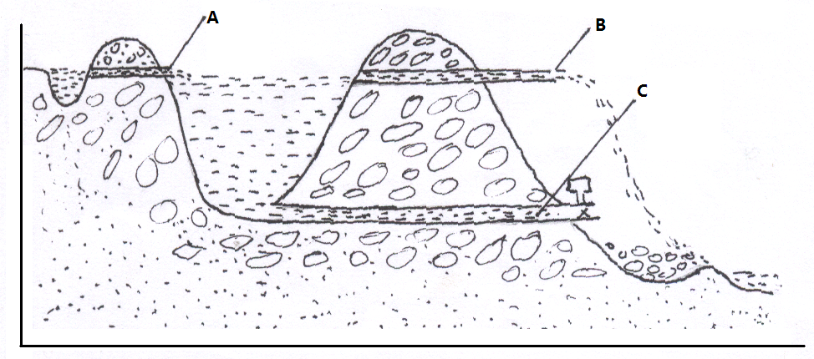
a) State the function of the parts A ,B, and C (3mks)
A……………………………………………………………………………………………………
B……………………………………………………………………………………………………
C……………………………………………………………………………………………………

b) State three practices carried out in the structure before stocking it. (1½mks)
------------------------------------------------------------------------------------------------------------------
--------------------------------------------------------------------------------------------------------------------
----------------------------------------------------------------------------------------------------------------------
c) What is cropping in fish rearing? (½mrk)
-----------------------------------------------------------------------------------------------------------------------
------------------------------------------------------------------------------------------------------------------------
20 Below is a diagram of a sheep with some parts labelled J, K and L. Study the diagram and answer the question that follow
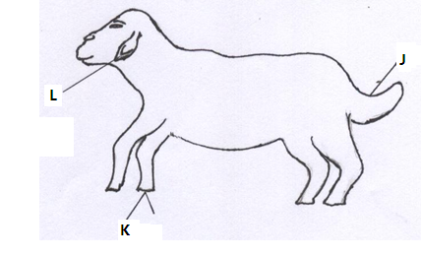
- Name the operation usually carried out on the part labeled J during the early stages of sheep life (½ mk)

------------------------------------------------------------------------------------------------------------

- Give two reasons for carrying out the above operation ie in (a) above (2mks)

------------------------------------------------------------------------------------------------------------------------------------------------------------------------------------------------------------------------

- Name two methods of carrying out the above operation ie (in (a) above). (1mk)

------------------------------------------------------------------------------------------------------------------------------------------------------------------------------------------------------------------------

- Which routine operation is usually carried out on the part labelled K. (½mk)

------------------------------------------------------------------------------------------------------------

21 Name two tools used in the construction of a rabbit hutch. (1mk)
----------------------------------------------------------------------------------------------------------------------------------------------------------------------------------------------------------------------------------------------------------------
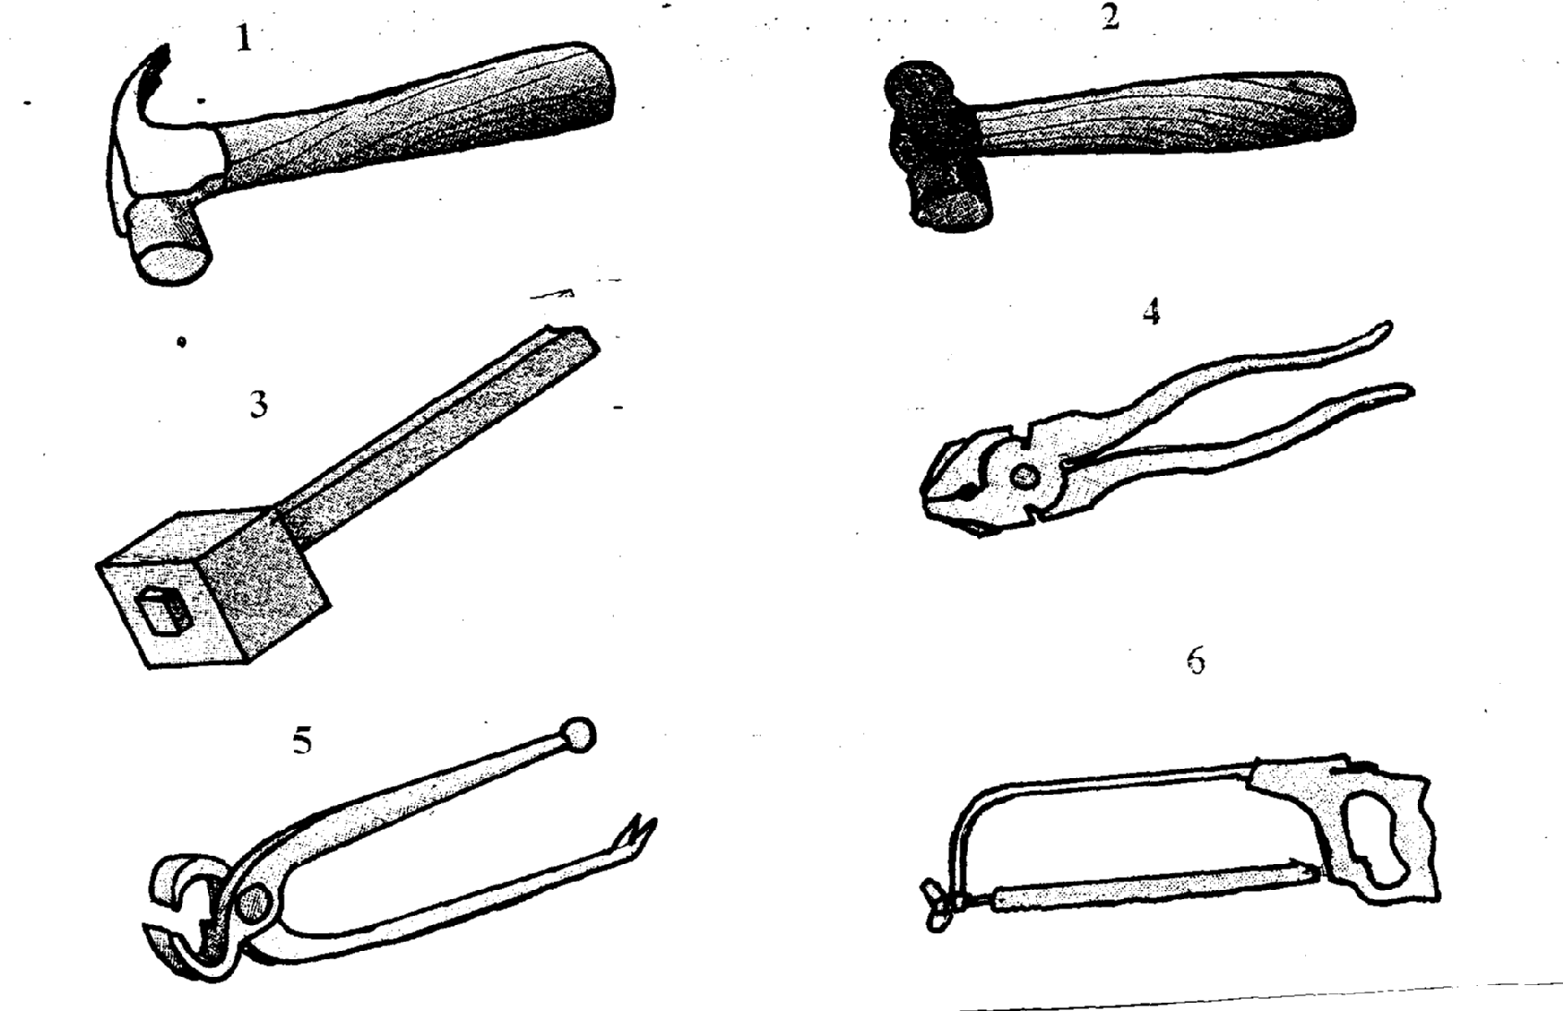
(i) Name the tools labeled 1-6 (3mks)

1..................................................

2...................................................

3..................................................

4..................................................

5...................................................

6..................................................

(ii) What is the function of the tool labeled 1 and 2

1..................................... ( ½ mk)

2..................................... ( ½ mk)
22. The diagram below represents the reproductive system of a ball. Study it and answer the questions that follow.
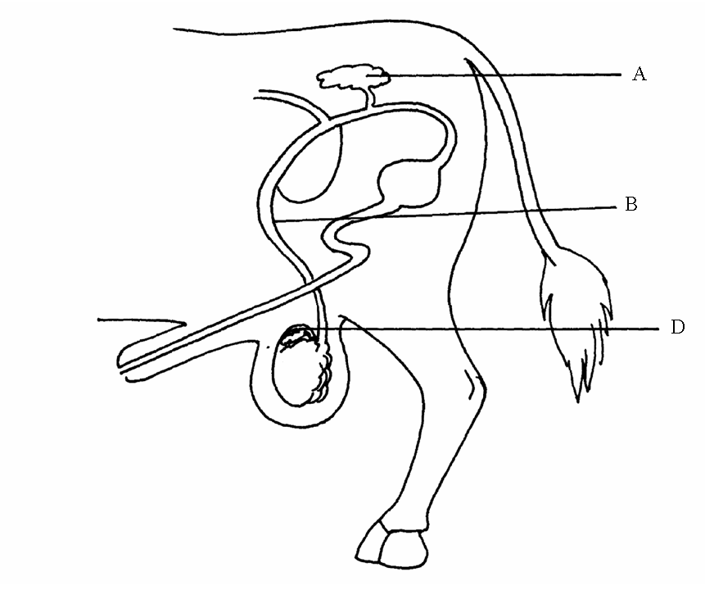
(a) Identify the parts A, B and D. (3 mks)

A………………………………………………………………………………………

B………………………………………………………………………………………

D………………………………………………………………………………………

(b) What is the function of part A (1 mk)
………………………………………………………………………………………………………………………………………

------------------------------------------------------------------------------------------------------------------

- Name the type of cell division that occurs in the part labeled D (1mk)

------------------------------------------------------------------------------------------------------------------

SECTION C (40mks)
Answer Both questions from this section in the spaces provided
23a) State factors considered when choosing building materials on the farm. (6mks)
-------------------------------------------------------------------------------------------------------------------------------------------------------------------------------------------------------------------------------------------------------------------------------------------------------------------------------------------------------------------------------------------------------------------------------------------------------------------------------------------------------------------------------------------------------------------------------------------------------------------------------------------------------------------------------------------------------------------------------------------------------------------------------------------------------------------------------------------------------------------------------------------------------------------------------------------------------------------------------------------------------------------------------------------------------------------------------------------------------------------------------------------------------------------------------------------------------------------------------------------------------------------------------------------------------------------------------------------------------------------------------------------------------------------------------------------------------------------------------------
- Describe the operational mechanism of a four stroke cycle engine (12mks)
----------------------------------------------------------------------------------------------------------------------------------------------------------------------------------------------------------------------------------------------------------------------------------------------------------------------------------------------------------------------------------------------------------------------------------------------------------------------------------------------------------------------------------------------------------------------------------------------------------------------------------------------------------------------------------------------------------------------------------------------------------------------------------------------------------------------------------------------------------------------------------------------------------------------------------------------------------------------------------------------------------------------------------------------------------------------------------------------------------------------------------------------------------------------------------------------------------------------------------------------------------------------------------------------------------------------------------------------------------------------------------------------------------------------------------------------------------------------------------------------------------------------------------------------------------------------------------------------------------------------------------------------------------------------------------------------------------------------------------------------------------------------------------------------------------------------------------------------------------------------------------------------------------------------------------------------------------------------------------------------------------------------------------------------------------------------------------------------------------------------------------------------------------------------------------------------------------------------------------------------------------------------------------------------------------------------------------------------------------------
- State two disadvantages of a two stroke engine (2mks)
------------------------------------------------------------------------------------------------------------------------------------------------------------------------------------------------------------------------------------------------------------------------------------------------------------------------------------------------------------------------------------------------------------------------------------------------------------------------------------------------------------------------------------------------------------------------

24a) Explain six physiological body functions of a healthy animal. (6mks)

-----------------------------------------------------------------------------------------------------------------------------------------------------------------------------------------------------------------------------------------------------------------------------------------------------------------------------------------------------------------------------------------------------------------------------------------------------------------------------------------------------------------------------------------------------------------------------------------------------------------------------------------------------------------------------------------------------------------------------------------------------------------------------------------------------------------------------------------------------------------------------------------------------------------------------------------------------------------------------------------------------------------------------------------------------------------------------------------------------------------------------------------------------------------------------------------------------------------------------------------------------------------------------------------------------------------------------------------------------------------------------------------------------------------------------------------------------------------------------------------------------------------------------------------------------------------------------------------------------------------------------------------------------------------------------------------------------------------------------------------------------------------------------------------------------------------------------------------------------------------------------------------------------------------------------------------------------------------------------------------------------------------------------------------------------------------------------------------------------------------------------------------------------------------------------------------------------------------------------------------------------------------------------------------------------------------------------------------------------
c) Explain eight general disease control measures (8mk s) ----------------------------------------------------------------------------------------------------------------------------------------------------------------------------------------------------------------------------------------------------------------------------------------------------------------------------------------------------------------------------------------------------------------------------------------------------------------------------------------------------------------------------------------------------------------------------------------------------------------------------------------------------------------------------------------------------------------------------------------------------------------------------------------------------------------------------------------------------------------------------------------------------------------------------------------------------------------------------------------------------------------------------------------------------------------------------------------------------------------------------------------------------------------------------------------------------------------------------------------------------------------------------------------------------------------------------------------------------------------------------------------------------------------------------------------------------------------------------------------------------------------------------------------------------------------------------------------------------------------------------------------------------------------------------------------------------------------------------------------------------------------------------------------------------------------------------------------------------------------------------------------------------------------------------------------------------------------------------------------------------------------------------------------------------------------------------------------------------------------------------------------------------------------------------------------------
c) Explain six ways of controlling tsetse flies (6mks)
----------------------------------------------------------------------------------------------------------------------------------------------------------------------------------------------------------------------------------------------------------------------------------------------------------------------------------------------------------------------------------------------------------------------------------------------------------------------------------------------------------------------------------------------------------------------------------------------------------------------------------------------------------------------------------------------------------------------------------------------------------------------------------------------------------------------------------------------------------------------------------------------------------------------------------------------------------------------------------------------------------------------------------------------------------------------------------------------------------------------------------------------------------------------------------------------------------------------------------------------------------------------------------------------------------------------------------------------------------------------------------------------------------------------------------------------------------------------------------------------------------------------------------------------------------------------------------------------------------------------------------------------------------------------------------------------------------------------------------------------------------------------------------------------------------------------------------------------------------------------------------------------------------------------------------------------------------------------------------------------------------------------------------------------------------------------------------------------------------------------------------------------------------------------------------------------

25a) Describe the process of milk let down (6mks)
------------------------------------------------------------------------------------------------------------------------------------------------------------------------------------------------------------------------------------------------------------------------------------------------------------------------------------------------------------------------------------------------------------------------------------------------------------------------------------------------------------------------------- ----------------------------------------------------------------------------------------------------------------------------------------------------------------------------------------------------------------------------------------------------------------------------------------------------------------------------------------------------------------------------------------------------------------------------------------------------------------------------------------------------------------------------------------------------------------------------------------------------------------------------------------------------------------------------------------------------------------------------------------------------------------------------------------------------------------------------------------------------------------------------------------------------------------------------------------------------------------------------------------------------------------------------------------------------------------
b) State eight characteristics of indigenous cattle. (8mks)
-----------------------------------------------------------------------------------------------------------------------------------------------------------------------------------------------------------------------------------------------------------------------------------------------------------------------------------------------------------------------------------------------------------------------------------------------------------------------------------------------------------------------------------------------------------------------------------------------------------------------------------------------------------------------------------------------------------------------------------------------------------------------------------------------------------------------------------------------------------------------------------------------------------------------------------------------------------------------------------------------------------------------------------------------------------------------------------------------------------------------------------------------------------------------------------------------------------------------------------------------------------------------------------------------------------------------------------------------------------------------------------------------------------------------------------------------------------------------------------------------------------------------------------------------------------------------------------------------------------------------------------------------------------------------------------------------------------------------------------------------------------------------------------------------------------------------------------------------------------------------------------------------------------------------------------------------------------------------------------------------------------------------------------------------------------------------------------------------------------------------------------------------------------------------------------------------

- State the differences between ruminants and non-ruminants (4mks)
------------------------------------------------------------------------------------------------------------------------------------------------------------------------------------------------------------------------------------------------------------------------------------------------------------------------------------------------------------------------------------------------------------------------------------------------------------------------------------------------------------------------------------------------------------------------------------------------------------------------------------------------------------------------------------------------------------------------------------------------------------------------------------------------------------------------------------------------------------------------------------------------------------------------------------------------------------------------------------------------------------------------------------------------------------------------------------------------------------------------------------------------------------------------------------------------------------------------------------------------------------------------------------------------------------------------------------------------------------------------

