FORM FOUR TRIAL 2, 2019
Kenya Certificate of Secondary Education Trial 2
443/2 AGRICULTURE
PAPER TWO
TIME: 2HRS

INSTRUCTIONS
- This paper consist of three sections A, B and C
- Candidate to answer all questions in section A and B
- Answer any two questions only in section C on the booklet provided.
CANDIDATE SCORE
 | QUESTIONS | MAXIMUM SCORE | CAND.SCORE
A | 1-14 | 30
B | 15-18 | 20
C | 19 | 20
 | 20 | 20
 | 21 | 20
 | TOTAL | 90

SECTION A (30MKS|)
Answer all questions in this section on spaces provided.
- State four non-chemical method used to control ticks (2mks)
i)………………………………………………………………………………………………………………………………………
ii)…………………………………………………………………………………………………………………………………….
iii)……………………………………………………………………………………………………………………………………
iv)……………………………………………………………………………………………………………………………………
- Highlight two management practices carried out on a broody hen (2mks)
i)………………………………………………………………………………………………………………………………………
ii)…………………………………………………………………………………………………………………………………….
- Give four characteristics of a good fish pond (2mks)
i)………………………………………………………………………………………………………………………………………
ii)…………………………………………………………………………………………………………………………………….
iii)……………………………………………………………………………………………………………………………………
iv)……………………………………………………………………………………………………………………………………
- Mention four physical characteristics of exotic beef cattle breeds (2mks)
i)………………………………………………………………………………………………………………………………………
ii)…………………………………………………………………………………………………………………………………….
iii)……………………………………………………………………………………………………………………………………
iv)……………………………………………………………………………………………………………………………………
- Give four features of calf pen that help to control calf diseases (2mks)
i)………………………………………………………………………………………………………………………………………
ii)…………………………………………………………………………………………………………………………………….
iii)……………………………………………………………………………………………………………………………………
iv)……………………………………………………………………………………………………………………………………
- a) What is dry cow therapy (1mk)
……………………………………………………………………………………………………………………………………………………………………………………………………………………………………………………………………………………
b) At what stage of gestation is dry cow therapy practiced (1mk)
………………………………………………………………………………………………………………………………………
- Name four farm structures used for handling livestock (2mks)
i)………………………………………………………………………………………………………………………………………
ii)…………………………………………………………………………………………………………………………………….
iii)……………………………………………………………………………………………………………………………………
iv)……………………………………………………………………………………………………………………………………
- Give four symptoms of respiratory disorder in a sick cow (2mks)
i)………………………………………………………………………………………………………………………………………
ii)…………………………………………………………………………………………………………………………………….
iii)……………………………………………………………………………………………………………………………………
iv)……………………………………………………………………………………………………………………………………
- Mention two characteristics of abdomen of a poor layers ( 2msk)
i)………………………………………………………………………………………………………………………………………
ii)…………………………………………………………………………………………………………………………………….
- Distinguish between mothering ability and prolificacy (2mks)
………………………………………………………………………………………………………………………………………………………………………………………………………………………………………………………………………………………………………………………………………………………………………………………………………………………………
- List two factors that can lead to conception failure after female cow has been served (2mks)
i)………………………………………………………………………………………………………………………………………
ii)…………………………………………………………………………………………………………………………………….
- Give four factors that may lead to a farmer culling dairy cattle (2mks)
i)………………………………………………………………………………………………………………………………………
ii)…………………………………………………………………………………………………………………………………….
iii)……………………………………………………………………………………………………………………………………
iv)……………………………………………………………………………………………………………………………………
- State four reasons for doing Agriculture as a discipline (2mks)
i)………………………………………………………………………………………………………………………………………
ii)…………………………………………………………………………………………………………………………………….
iii)……………………………………………………………………………………………………………………………………
iv)…………………………………………………………………………………………………………………………………..
- Name four tools that are used when laying concrete blocks during construction of a wall
(2mks)
i)………………………………………………………………………………………………………………………………………
ii)…………………………………………………………………………………………………………………………………….
iii)……………………………………………………………………………………………………………………………………
iv)……………………………………………………………………………………………………………………………………
- State four features on the animal which may pre-dispose it to livestock diseases (2mks)
i)………………………………………………………………………………………………………………………………………
ii)…………………………………………………………………………………………………………………………………….
iii)……………………………………………………………………………………………………………………………………
iv)……………………………………………………………………………………………………………………………………

SECTION B (20MKS)
Answer all the questions from this section.
- Diagram below show a plunge dip.

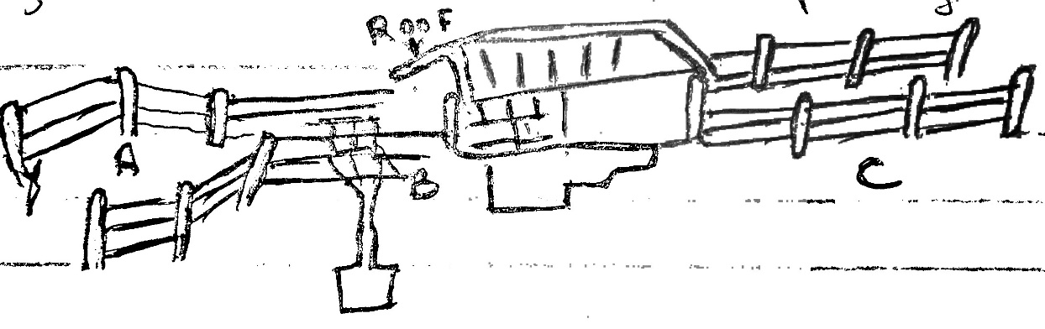

- Using a arrow on the diagram show the movement of cattle (½mk)

- State one use of parts A, B and C (3mks)
A ………………………………………………………………………………………………………………………………
B ………………………………………………………………………………………………………………………………
C ……………………………………………………………………………………………………………………………….
- State two precautions a farmer should take on dip to ensure effective dipping (2mks)
i)…………………………………………………………………………………………………………………………………
ii)………………………………………………………………………………………………………………………………
- State two uses of the roof of the dip (2mks)
i)…………………………………………………………………………………………………………………………………
ii)………………………………………………………………………………………………………………………………
b) Apart from use of acaricides explain other methods used to control ticks (3mks)……………………………………………………………………………………………………………………………………………………………………………………………………………………………………………………………………………………………………………………………………………………………………………………………………………………………………………..
- a) i) Identify the tools below (1mk)

X ………………………………………………………………………..
Y ……………………………………………………………………….
ii) State the use of tools x and y (2mks)
X ………………………………………………………………………………………………………………………………………
Y ………………………………………………………………………………………………………………………………………
iii) Explain two maintenance practices carried on tool X (2mks)
i)………………………………………………………………………………………………………………………………………
ii)…………………………………………………………………………………………………………………………………….
b) Name the tools used in conjuction of following tools (2mks)
- Troca …………………………………………………………………………………………………………………….
- Hand drill……………………………………………………………………………………………………………
- Leading stick ………………………………………………………………………………………………………
- Mallet …………………………………………………………………………………………………………………

- a) Diagram below show reproductive system of a female cow

- Name the part marked (1mk)
D ……………………………………………………………………………………………………………………………………
F ……………………………………………………………………………………………………………………………………..
- State the function of parts marked (1mk)
C …………………………………………………………………………………………………………………………………….
E …………………………………………………………………………………………………………………………………..
b) At what stage should a gilt be mated? (½mk)
……………………………………………………………………………………………………………………………………….

SECTION C (40MKS)
Answer ONLY TWO questions on answer booklets provided.
- a) Explain features of ideal calf pen (6mks)
b) Outline various feeding practices a farmer undertake on calves up to weaning (8mks)
c) Describe uses of water in the animals body (6mks)
- a) Describe mastitis disease under the following sub-headings
- Causal organism (1mk)
- Disease pre-disposing factors (4mks)
- Symptoms (3mks)
- Control measures (6mks)
b) Describe factors to consider when culling a female (Cow) breeding stock (6mks)
- a) Describe the artificial rearing of layers chick from one day up to the end of brooding
(10mks)
b) Name three types of fences (3mks)
c) Explain the procedure of establishing wire fence (7mks)

