NAME: ………………………………………………..…CLASS:….…ADM NO:…………
SIGNATURE:…………………………………INDEX NO:…………………………………
DATE…………………………………………
232/1
Physics
Paper 1
GOLDEN ELITE EXAMINATIONS

Kenya Certificate of Secondary Education (KCSE)
Physics Paper 1

Instructions to candidates

- This paper consists of two sections A and B.
- Answer all the questions in the two sections in the spaces provided after each question
- All working must be clearly shown.
- Electronic calculators and Mathematical tables may be used.
- All numerical answers should be expressed in the decimal notations.

For Examiner use only
SECTION | QUESTION | MAX MARKS | CANDIDATE’S SCORE
A | 1 – 11 | 25
B | 12 | 08
 | 13 | 07
 | 14 | 10
 | 15 | 06
 | 16 | 09
 | 17 | 07
 | 18 | 08
TOTAL |  | 80
This paper consists of 14 printed pages. Candidates should check to ascertain that all pages are printed as indicated and that no questions are missing.
Section A (25Marks)
1. The diagram below shows a micrometer screw gauge. What is the reading in SI units? (2 marks)
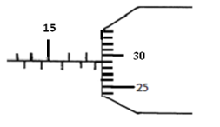

2. Apart from friction, name another factor that reduces efficiency in machines. (1 mark)

3. Diffusion in gases is faster than in liquids; state two reasons why this is so. (2 marks)

4. A tube of radius 9 mm has a constriction of diameter 10mm. Water flows in the tube at 3ms⁻¹. Determine the velocity of water in the constriction. (3 marks)

5. (a) A student obtained ice at 0ºCfrom a refrigerator and placed it in a beaker on a bench. After 4 minutes, the temperature rose to 4ºC. State the changes that would be observed in the water in terms of;
(i) density (1 mark)

(ii) mass (1 mark)

(ii) volume (1 mark)

6. The diagram below shows a uniform 5m long metal rod of mass 800g. It is suspended by a string tied at a point 3.5m from one end. Determine the load which should be hung at point X to keep the plank horizontal. (3 marks)
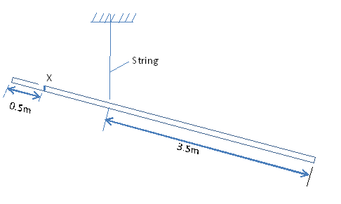

7. Explain why ice skaters use sharp-edged shoes to slide on ice (2 marks)

8. The diagram below shows a braking system.
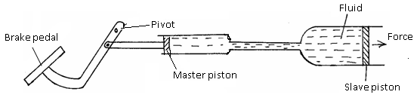
Why is the master piston, made smaller than the slave piston? (1 mark)

9. A faulty thermometer reads 2ºC when dipped in ice at 0ºC and 95ºC when dipped in steam at 100ºC. What would this thermometer read if placed in water at room temperature at 18ºC? (3 marks)

10. The figure below shows a machine being used to raise a load. Use the information given in the figure to answer questions below.
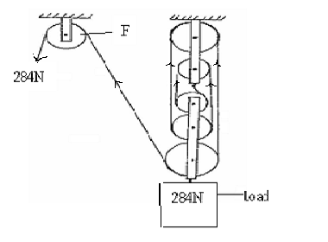

(a) Determine the efficiency of the machine. (3 marks)

11. Using Kinetic theory of matter, explain why solids expand when heated (2 marks)

Section B (55 Marks)
12. A bullet of mass 24g travelling in a horizontal path with a velocity of 450ms⁻¹ strikes a wooden block of wood of mass 976g resting on a rough horizontal surface. After impact, the bullet and the block move together for a distance of 7.5m before coming rest.
(a) Name the type of collision which takes place above (1 mark)

(b) What’s the velocity of the two bodies when they start sliding (2marks)

(c) Calculate the force which brings the two bodies to rest (3 marks)

(d) Determine the coefficient of friction between the block and the surface during this motion.
(2 marks)

13 (a) Give reason why a body moving in a circular path with constant speed is said to be accelerating. (1mk)

(b) A stone of mass 40g is tied to the end of a string 50cm long such that it is 20m above the ground at its lowest level as shown in the diagram below. It is whirled in a vertical circle at 2rev/s.
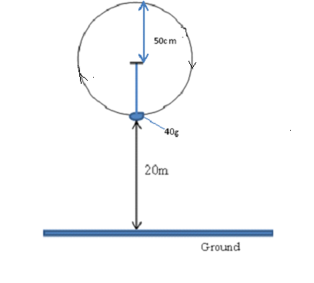
(i) If the string breaks at its lowest levelas shown, what is the velocity with which it travels?
(2 mark)

Calculate the maximum tension in the string. (3mks)

(ii) Calculate the maximum tension in the string. (2 mks)

(d) Determine the maximum horizontal distance it travels from the breaking point (2 marks)

14 (a) Give reason why ink is most likely to ooze out of a pen when one is up in an airplane.
(1mark)

(b) The figure below is a simple hydraulic machine used to raise heavy loads.
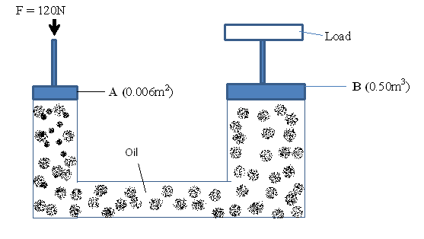
Calculate;
(i) The pressure exerted on the oil by the force applied at A (2marks)

(ii) The load raised at B (2marks)

(iii) Give two properties which make the oil suitable for use in this machine (2marks)

(c) The height of a mountain is 1360m. The barometer reading at the base of the mountain is 74cmHg. Given that the densities of mercury and air are 13,600Kgm⁻³ and 1.25Kgm⁻³ respectively, determine the barometer reading at the top of the mountain. (3 marks)

15 (a) State Hooke’s Law (1mark)

(b) The diagram below shows a graph of force against extension for a certain spring.
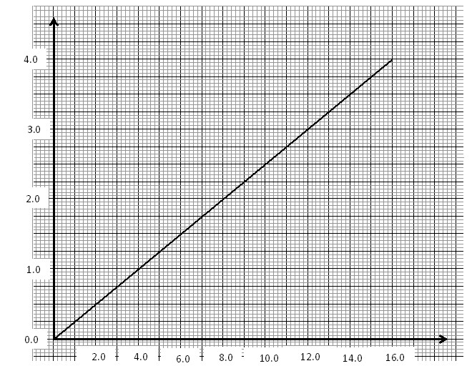
Extension (cm)
Force (N)

- What is the spring constant of the spring? (2 marks)

- What force would cause two such springs placed side by side to stretch by10cm
(3 marks)

16. (a) What is meant by specific latent heat of fusion of a substance? (1mk)

(b) In an experiment to determine the specific latent heat of vaporization of water, steam at 100ºC was passed into water contained in a well-lagged copper calorimeter. The following measurements were made:
- Mass of calorimeter = 60g
- mass of water + calorimeter = 145g
- Final mass of calorimeter + water + condensed steam = 156g
- Final temperature of the mixture = 48ºC
[Specific heat capacity of water = 4200JKgˉ¹kˉ¹ and specific heat capacity of copper = 390JKgˉ¹kˉ¹]
Determine the;
(i) mass of condensed steam. (1mk)

(ii) The heat gained by the water and calorimeter if the initial temperature of the calorimeter and water is 20ºC. (3mks)

(iii) Given that L_{v}is the specific latent heat of vaporization of steam, write an expression for the heat given out by steam. (1mark)

(iv) Determine the value of L_{v} above (2mks)

(v) State the assumption made in the above experiment (1 mark)

17. A cork of volume 100cm³ is floating on water. If the density of the cork is 0.25 gcm⁻³ and that of water is 1 gcm⁻¹;
- Calculate the mass of the cork (2 marks)

- Hence, find the upthrust force on the cork (2 marks)

- What minimum force is required to immerse the cork completely (2 marks)

- What is the effect on the upthrust force in a liquid when the temperature of the liquid is reduced? (1mark)

18. (a) State Pressure Law (1mark)

(b) The following diagram shows a set up of apparatus used to verify Charles Law.
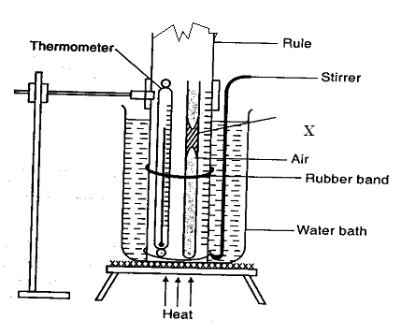
X

- Give the name of part labelled X (1 mark)

- What is the function of the part named in (i) above? (1 mark)

- Briefly explain how the set up above is used to verify Charles Law (3 marks)

(c) A certain mass of hydrogen gas occupies a volume of 1.6m³ at a pressure of 1.5x10⁵Pa and a temperature of 12⁰c. Determine the volume when the temperature is 0⁰c at a pressure of 1.0x10³Pa.
(2 marks)

